

CS0980a
Applied Mathematics 3

Solutions for 2007/08 Examination

A1. (a) 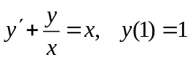; use integrating factor 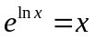 to give
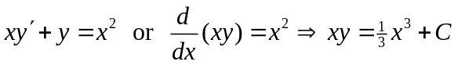
[2]
[2]
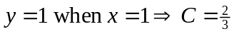, hence 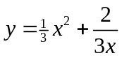.
[3]

(b) 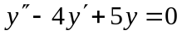, giving the auxiliary equation 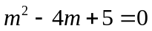, which solves to
[3]
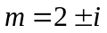.
The general solution is then 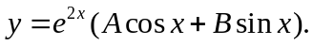
[2]

(c) 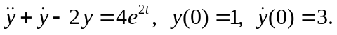
Auxiliary equation is 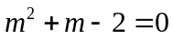, which solves to give m = 1, −2.
[3]
CF is 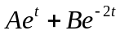
For the PI, try 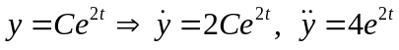 and equation becomes
[6]
General solution is then 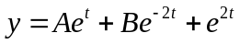.
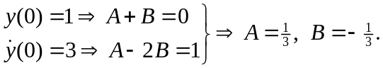
[4]
Particular solution is then 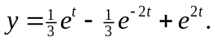

A2. (a)
Auxiliary equation is 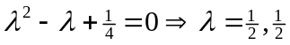, giving the CF as
[3]
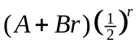.
For the inhomogeneous equation try 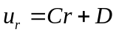 to give
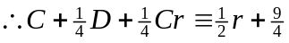.
Equating coefficients gives C = 2 and D = 1.
The general solution is
[6]
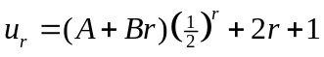.
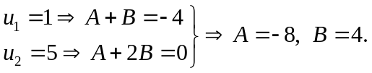
[4]
The particular solution is therefore 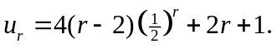
y
(b)
2
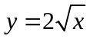

[2]

x
0
1

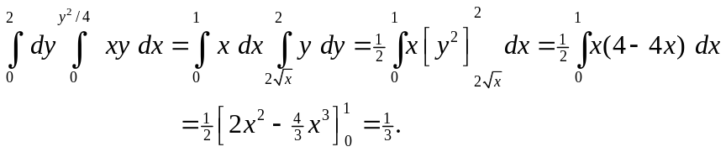
[5]

(c) 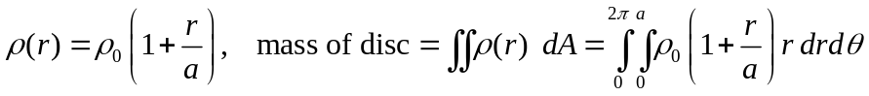
[3]
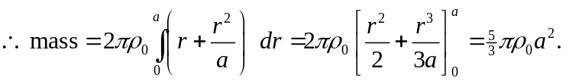
[2]

A3. (a) 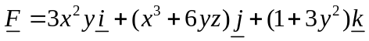
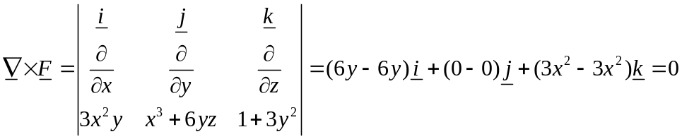
[3]
hence 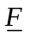 is conservative and 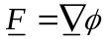 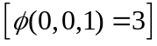.
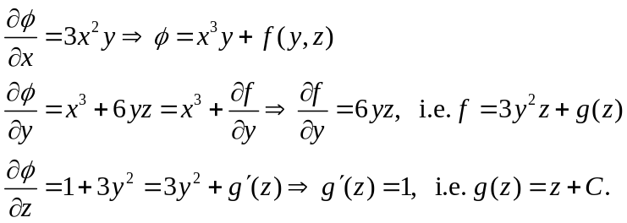
[7]
Hence, 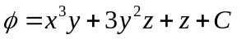 where C = 2.
[2]
Then 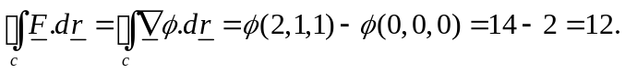

(b) 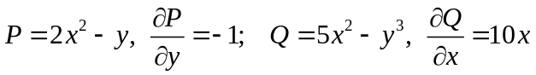
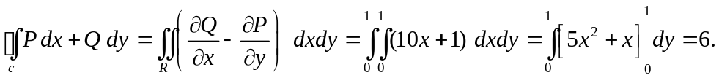
[7]
[3]
(c)
By Gauss’s theorem,
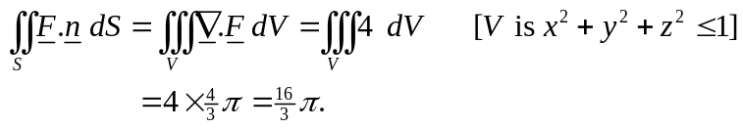
[3]

B1. (a)

v
w
v, w are components of velocity of A after string becomes tight again, parallel and perpendicular to BA respectively.

A(m)
30°

u
[3]
30°
v

B(2m)

Notice B’s speed is also v along BA after string becomes tight again.

Momentum equation along BA direction: 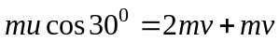
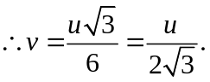 (1)
[3]
Momentum equation perpendicular to BA: 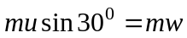 (conserved)
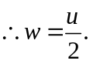 (2)
[3]
Hence speed of B is 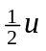and speed of A = 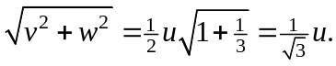
[2]

(b)
5 kg
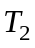
A

A = accel. of 5 kg mass
a = accel. of other masses relative to pulley. Tensions are as shown.
A
[4]
a
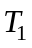
a
g
g
3g

Equations of motion: 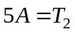 (1)
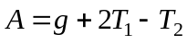 (2)
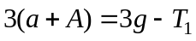 (3)
[6]
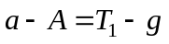 (4)
Solving these, (3) + (4) 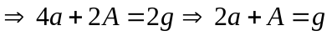 (5)
(1) & (2)  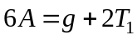 (6)
and (4) gives (6) as 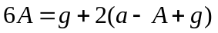
or 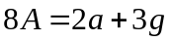 (7)
[4]
Finally, (7) − (5) gives 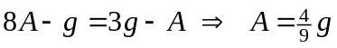m/s² (= 4⋅36 m/s²).
B2. (a)
X
Y
P
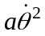
X and Y are components of thrust on P as shown. Accelerations (transverse and radial) of the mass centre are as shown.

Transverse eqn.: 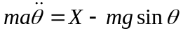 (1)
Radial eqn.: 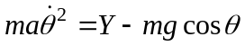 (2)
[3]
a
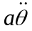

O
a

mg
Rotational eqn. (moments about P): 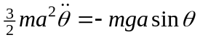 (3)
and integrating this gives 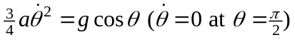
[4]
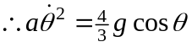 (4)
Now, (1) & (3) give
[3]
(2) & (4) give .
When 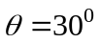, 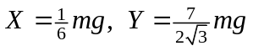 with magnitude 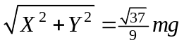 and direction 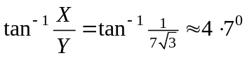 with OP.
[2]
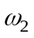
(b)
u
I
B
1 kg
C
a
A
B
½ a
3 kg
a
a

v
10
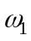
I

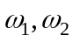 are the angular velocities of rods as shown after impulse, u, v are the velocities of the centres of mass of the rods after impulse as shown, I is the impulsive reaction at the joint B (must be in same direction as original impulse).
[2]

Linear momentum eqn. of AB: 10 + I = 3u (1)
Linear momentum eqn. of BC: I = v (2)
Angular momentum eqn. of AB: 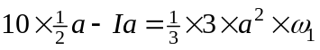
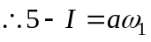 (3)
Angular momentum eqn. of BC: 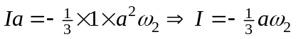 (4)
[5]
Also, common velocity at B gives: 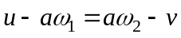 (5)
Substituting (1) – (4) into (5) then gives
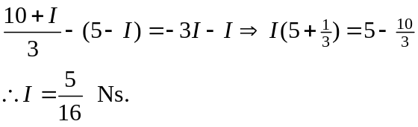
[2]
Velocity of A = 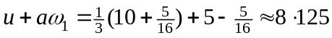m/s (using above)
[4]
and velocity of C = 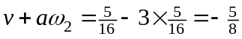 m/s.
B3. (a)
R
Forces act as shown because cylinder slips up plane initially, hence 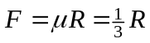 during this time.

Normal to plane:
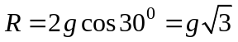 (1)

[3]
2g
F
30°

Eqn. of motion of c of g : 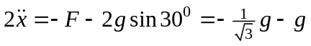 (from above)
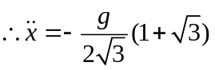 (2)
[2]
Integrating this eqn. gives, 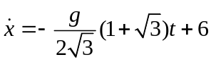 (3)
[2]
Rotational eqn. is (moments about centre): 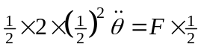
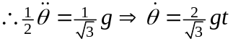 (4)
[3]
Cylinder stops slipping when 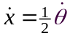, so (3) & (4) give
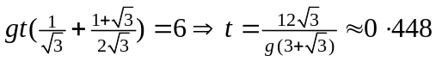 seconds.
[2]
For distance slipped, integrate (3): 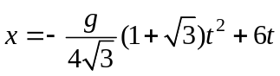 and at t = 0⋅448,
[2]
x = 1⋅912 m.
v
(b)
50
J is impulsive frictional force, u and v are the velocity components of centre after impact, is the angular velocity after impact.

u
4 m/s
2 m/s
2 kg
[2]
J

Horizontal momentum equation: 2u − 8 = −J (1)
Angular momentum equation: 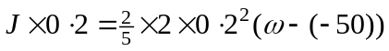
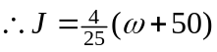 (2)
[6]
No slipping on impact 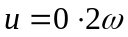 (3)

(1), (2) & (3) then give: 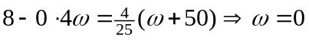 hence no spin and (3)
[3]
gives u = 0, hence sphere rises vertically after impact.

