
School of Computing & Creative Technologies
Subject Group: Mathematics
CS0980a : Applied Mathematics 3
2008/09
Term 2 - Terminal Examination
2 hours duration plus five minutes reading time

The paper contains 3 questions in Section A and 3 questions in Section B
Answer 2 questions from each section (4 in total)
Calculators with no remote external connection and no computer algebra/programming facility may be used in this examination. The removal of a calculator from any candidate must be approved by the Examiner or, if not available, by any member of the Mathematics staff.

Additional Materials
Mathematical Formulae Booklets
Examination Date |  | May 2009 |  | - |  | (reading time)
 |  |  |  | - |  | (examination time)
Examiner(s) | T N Lucas/R B Paris
Moderator(s) | R B Paris/T N Lucas
Section A – Answer any TWO questions from this section

A1. | (a) | Determine the solution of the difference equation  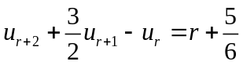, 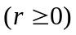  subject to the conditions 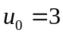, 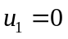. | (48%)

 | (b) | Sketch the region of integration over which the double integral  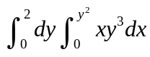  is to be evaluated. Evaluate this integral by reversing the order of integration. | (28%)

 | (c) | A disc of radius has a surface density 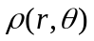 per unit area given by  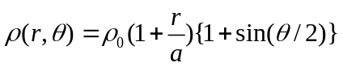,  where 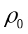 is a constant and 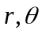 are polar coordinates with origin at the centre of the disc. By evaluating an appropriate double integral, show that the mass of the disc is  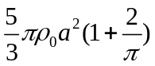. | (24%)

A2. | (a) | Show that the vector field 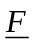 given by  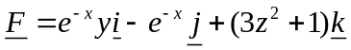  is conservative. Determine the scalar potential 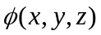 such that 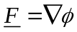, given that 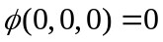.  Hence evaluate the integral  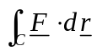  along any path  joining the points (0,1,0) and 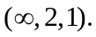 | (48%)

 | (b) | Use Green’s theorem to evaluate the integral  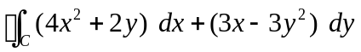,  where is the boundary of the rectangle with vertices at (0,0), (3,0), (3,2) and (0,2) in the positive sense. | (24%)

 | (c) | Use Stokes’ theorem to evaluate the surface integral  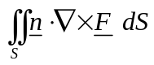,  where 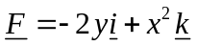, is the curved surface of the hemisphere 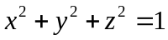, 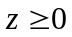 and is the outward-pointing unit normal to . | (28%)

A3. | (a) | Obtain the continuous solution of the first-order differential equation  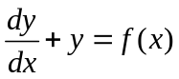, where 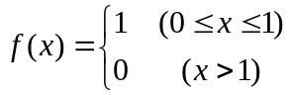  on the interval 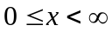 subject to the boundary condition 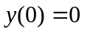. | (32%)

 | (b) | Use the method of characteristics to solve the partial differential equation  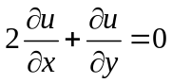, 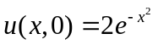.  Sketch the characteristics in the  plane, indicating clearly the characteristic along which 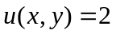.  Determine the value of the solution at the point (3,1). | (36%)

 | (c) | Consider Laplace’s equation  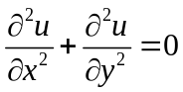  on the unit square 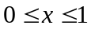, 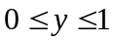 subject to the boundary conditions  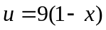 on , 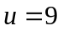 on , 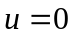 on  and .  Using the mesh size 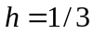 in both directions (so that there are 4 internal points), set up the discretised equations for 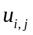 (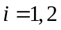; 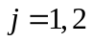) following the scheme  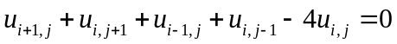.  Express this system of equations in matrix form 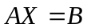, clearly identifying ,  and . [Do not attempt to solve this system.] | (32%)

Section B – Answer any TWO questions from this section
(Use g = 9⋅8 m/s² where necessary)

B1. | (a) |  | Two masses A and B of 1 kg and 3 kg respectively lie on a smooth horizontal table attached to the opposite ends of a light inelastic string. The string is initially taut when A is acted upon by an impulse of 4 Ns in the horizontal plane at 60° to AB. Determine the speeds of A and B immediately after the string becomes taut again and also the impulsive tension set up in the string. | (48%)

 | (b) |  | A mass of 8 kg lies on a smooth horizontal table and is attached to a light inelastic string, which passes over the edge of the table to a smooth pulley of mass 2 kg attached to its other end (see diagram).

8 kg

2 kg

4 kg
6 kg

 |  |  | Masses of 4 kg and 6 kg are then connected by another light inelastic string passing over the pulley and allowed to move freely. If the parts of the latter string not in contact with the pulley are assumed vertical then calculate the acceleration of the 4 kg mass. | (52%)

B2. | (a) |  | A uniform straight rod of mass 3 kg and length 2 metres hangs vertically from a smooth hinge fixed to one of its ends. An impulse at its lower end gives the rod an initial angular velocity of 2 rads/sec. in the vertical plane.  When the rod makes an angle of 30° with its original vertical position, show that the radial and transverse components of the thrust exerted on the hinge are given approximately by 31⋅553 N and 3⋅675 N respectively. | (60%)

 | (b) |  | A truck is modelled by a rectangular block of mass M and four identical uniform hoops (the wheels) each of mass m and radius a. The hoops (with light spokes) can rotate freely about the light connecting axles.  The truck is placed on a rough horizontal surface and is pushed without slipping by a constant horizontal force F applied in a direction along its length. Use the work-energy relationship to show that the speed of the truck after travelling a distance x along the surface is given by  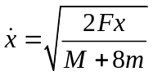.  Hence derive its acceleration. | (40%)

B3. | (a) |  | A uniform solid circular cylinder of mass 4 kg and radius 1 metre is projected with speed 6 m/s and no initial angular velocity up the line of greatest slope of a plane, coefficient of friction 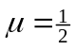, inclined at 45° to the horizontal. Calculate the time that elapses from this point until the disc stops slipping on the plane. | (56%)

 | (b) |  | A uniform straight rod AB of mass m and length 2a lies at rest on a smooth horizontal surface. A horizontal impulse J is applied to the end-point B of the rod (see the diagram), making an angle with the rod.

B
a
A
a
m

J

 |  |  | Using the appropriate momentum equations, show that the speed of the point B immediately after the impulse is applied is given by  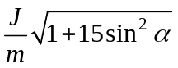. | (44%)

END OF QUESTION PAPER

