

CS0980a – Applied Mathematics 3

Examination Solutions

2008/09

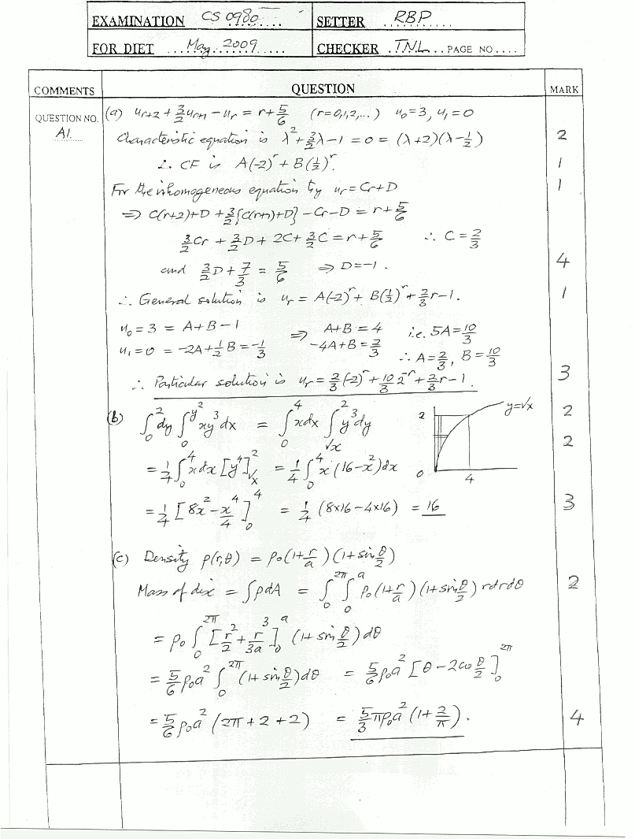
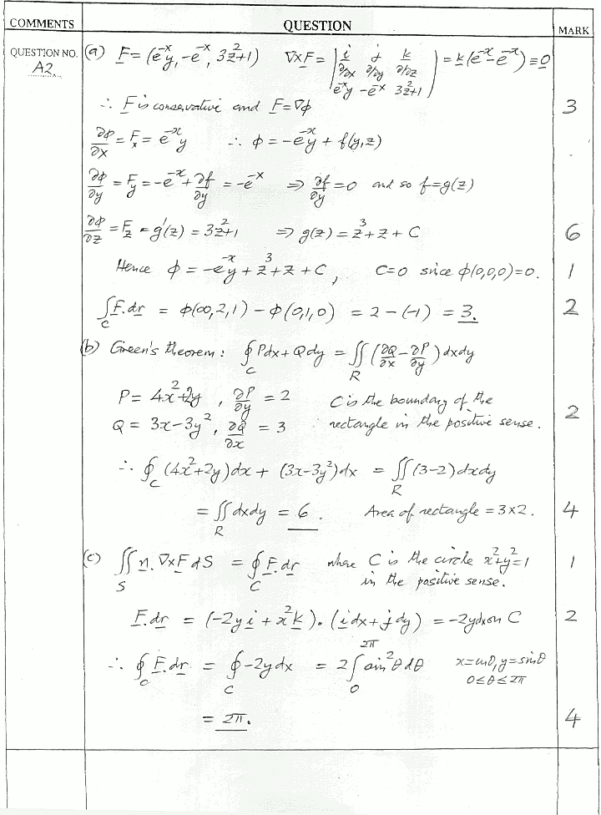
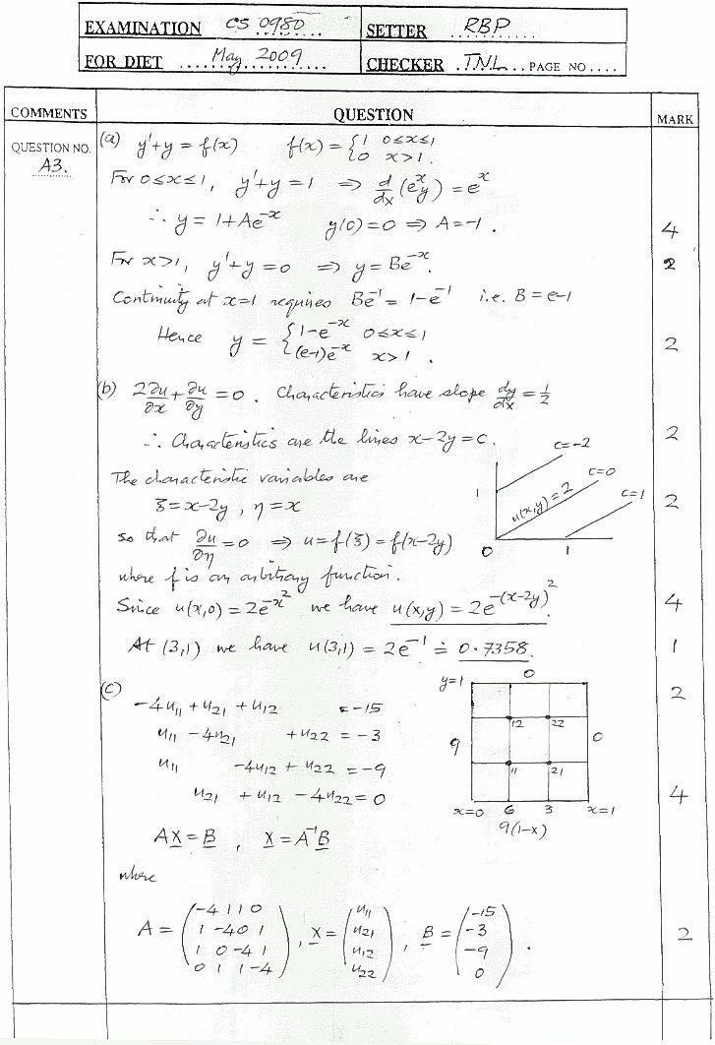
B1. (a)
A (1 kg)
v
u
60°
Angles will be as shown. Let u, v be velocity components of A perp. and parallel to string after it becomes taut as shown – B’s speed is also v along BA.

4 Ns
v
[3]

60°
60°
A’
B (3 kg)

Momentum eqn. along BA direction (Impulse = change in momentum):
[3]
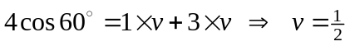m/s.
Momentum eqn. perpendicular to BA:
[2]
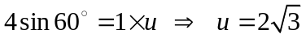m/s.
[2]
Hence, speed of B = v = ½ m/s and speed of A = 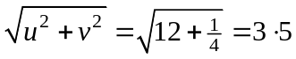m/s.
Impulsive tension set up in string given by using mass B, i.e.
[2]
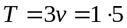Ns.

A
(b)
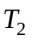
8 kg
A = accel. of pulley
a = accel. of masses relative to pulley
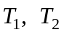 are tensions in strings as shown.
A
[4]

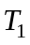
a
a
4 g
2 g
6 g

Using Newton’s 2nd law:
mass on table - 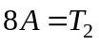 (1)
pulley - 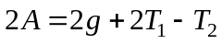 (2)
4 kg mass - 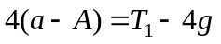 (3)
6 kg mass - 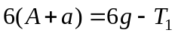 (4)
[4]

(1) + (2)  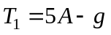 (5)
(3) + (4) 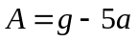 (6)
Using (5) and (6) in (4) gives
m/s²
[4]
and (6) gives 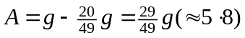m/s².
Hence, acceleration of the 4 kg mass is 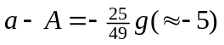m/s² (accelerates downwards)
[1]

B2. (a)
Y
X
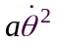
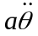
1
X and Y are the components of thrust at axis as shown along and perp. to rod. Accel. of centre of mass has components as shown.

[2]
1

2 r/s
3g

Radial eqn. of motion: 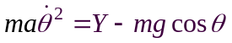 (m = 3, a = 1)
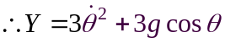 (1)
[2]
Transverse eqn. of motion: 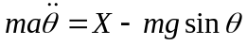
[2]
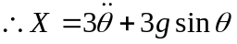 (2)
Rotational eqn. of motion: 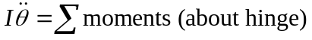
[2]
(3)
Integrating (3) gives 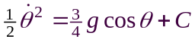 and 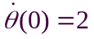 gives
[3]
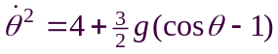 (4)
(2) and (3) 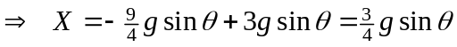 and
[2]
(1) and (4) .
Putting 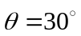 gives,
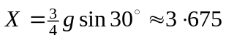N and 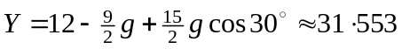N.
[2]

(b) Truck does not slip, so no work done by frictional forces on wheels, hence
[2]
work done by force F = KE attained by body + 4 wheels, i.e.,
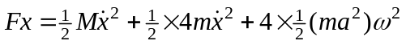 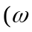 is ang. vel.)
[3]
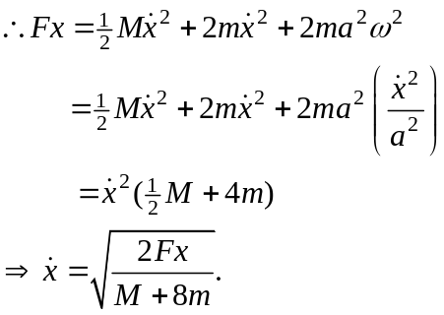
[3]
For acceleration, 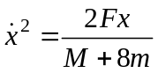 and differentiation gives
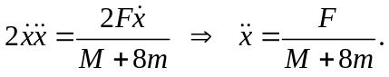
[2]

B3. (a)
R
First check for eventual rolling condition, i.e. 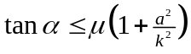, (k is radius of gyration), hence 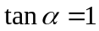 and 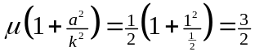, which satisfies the condition.
F
[2]

4g
45°

Initially cylinder slides up the plane and so direction of F is as shown and during this phase, 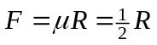. Also, resolving perpendicular to plane gives, 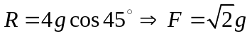.
[3]
Eqn. of motion of cylinder up the plane:
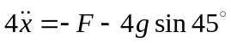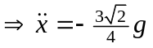 and integrating gives
[4]
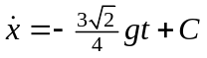, but 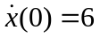 yields 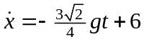 (1)
Rotational eqn. of motion (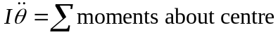):
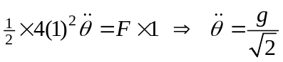.
Integrating, 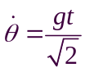 (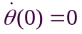) (2)
[3]
Cylinder starts to roll when 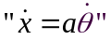, i.e. when 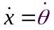, and so from (1) and (2)
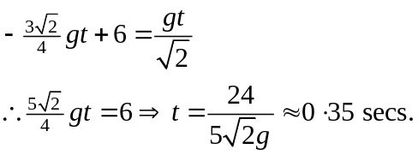
[2]

(b)
v
u, v = components of velocity of centre of mass of rod after impulse.
= angular velocity of rod after impulse.
u
B
a
a
[3]
A
m
J

Momentum eqn. perpendicular to rod: 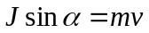 (1)
[2]
Momentum eqn. along rod: 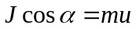 (2)
Moments about centre of rod: 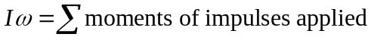 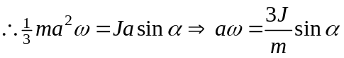 (3)
[2]
[2]
Velocity of B has components of u along the rod and 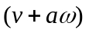 perp. to rod. speed of B = 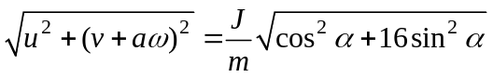 (from (1) to (3)) 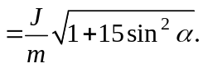
[2]

