
School of Computing & Engineering Systems
Subject Group: Mathematics
CS0980a : Applied Mathematics 3
2009/10
Term 2 - Terminal Examination
2 hours duration plus five minutes reading time

The paper contains 3 questions in Section A and 3 questions in Section B
Answer 2 questions from each section (4 in total)
Calculators with no remote external connection and no computer algebra/programming facility may be used in this examination. The removal of a calculator from any candidate must be approved by the Examiner or, if not available, by any member of the Mathematics staff.

Additional Materials
Mathematical Formulae Booklets
Examination Date |  | April 2010 |  | - |  | (reading time)
 |  |  |  | - |  | (examination time)
Examiner(s) | T N Lucas/R B Paris
Moderator(s) | R B Paris/T N Lucas
Section A – Answer any TWO questions from this section

A1. | (a) | Determine the solution of the difference equation  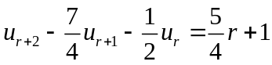, 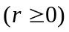  subject to the conditions 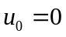, 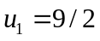. | (48%)

 | (b) | Sketch the region of integration over which the double integral  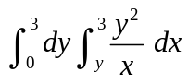  is to be evaluated. Evaluate this integral by reversing the order of integration. | (28%)

 | (c) | A disc of radius has a surface density 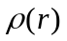 per unit area given by  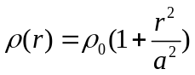,  where 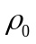 is a constant and is the radial polar coordinate with origin at the centre of the disc. By evaluating an appropriate double integral, determine the mass of the disc. | (24%)

A2. | (a) | Show that the vector field 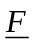 given by  is conservative. Determine the scalar potential 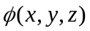 such that 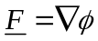, given that 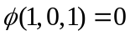.  Hence evaluate the integral  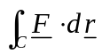  along any path  joining the points (1,0,1) and 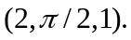 | (48%)

 | (b) | Use Green’s theorem to evaluate the integral  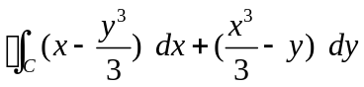,  where is the boundary of the circle of radius centred at (0,0) described in the positive sense. | (28%)

 | (c) | Use Gauss’ theorem to evaluate the surface integral  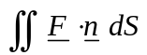,  over the surface of the sphere given by 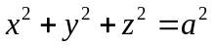, where  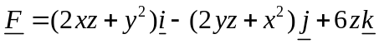 and is the outward pointing normal to . | (24%)

A3. | (a) | Use the integrating factor to obtain the solution of the first-order differential equation  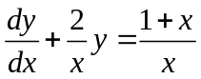  subject to the condition 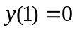. | (28%)

 | (b) | Use the method of characteristics to solve the partial differential equation  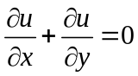, 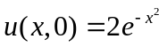.  Sketch the characteristics in the  plane, indicating clearly the characteristic along which 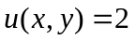.  Determine the value of the solution at the point (2,1). | (32%)

 | (c) | Consider the one-dimensional heat diffusion equation  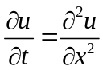, 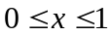, 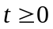  subject to the boundary conditions  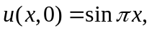 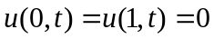 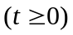.  Use the Crank-Nicholson scheme with 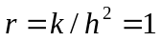, where and are the grid sizes in the and directions respectively, given by  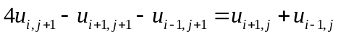.  Express the system of discretised equations for 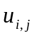 corresponding to the first time step 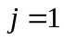 with 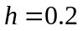 (so that 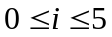) in matrix form 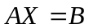, clearly identifying ,  and . [Do not attempt to solve this system.]  State the value of corresponding to the first time step. | (40%)

Section B – Answer any TWO questions from this section
(Use g = 9⋅8 m/s² where necessary)

B1. | (a) | Three masses A, B and C of 1, 2 and 3 kg respectively lie on a smooth horizontal table. Mass A is connected to B by a light inelastic string and C is connected to B likewise. Both strings are taut and angle ABC is 45°.  An impulse of 5 Nm is applied to B in the direction of AB. Calculate the initial speed and direction of the mass B. | (52%)

 | (b) | A light inelastic string has one end fixed in the vertical plane, passes under a smooth moveable pulley of mass 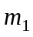, then over a smooth fixed pulley and there is a mass of 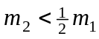 attached to its other end (see diagram).

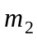

 |  | If the parts of the string not in contact with the pulleys are vertical and the system is released from rest, show from the equations of motion of the mass and pulley respectively that the pulley descends with acceleration  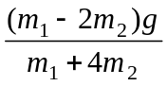.  Show also that the tension in the string is 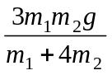 and obtain the velocity of the mass when it has travelled a distance x vertically. | (48%)

B2. | (a) | A uniform circular hoop of mass 1 kg and radius 0⋅5 metres hangs vertically from a smooth fixed point on its circumference. An impulse gives the hoop an initial angular velocity of 4 rads/sec. in the vertical plane of the hoop.  Calculate the components of thrust on the fixed point along and perpendicular to the diameter through the point when this diameter makes an angle of 30° with the downward vertical. | (56%)

 | (b) | Uniform straight rods AB and BC of equal masses m and lengths 2a lie at rest on a smooth horizontal surface. The rods are joined at B by a smooth hinge and they are aligned such that ABC is a straight line.  If a horizontal impulse J is applied perpendicular to the mid-point of AB, determine the velocity of the end C at this instant. | (44%)

B3. | (a) | A uniform hoop of mass 2 kg and radius ½ metre is projected horizontally along the rough horizontal ground with speed 3 m/s and a backspin of 8 rads/sec. The plane of the hoop is perpendicular to the ground, which has coefficient of friction 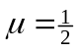.

 |  | (i) | Show that the time that elapses from this point until the disc stops slipping is secs. | (40%)
 |  | (ii) | Obtain the time at which the linear velocity is zero and calculate the angular velocity at this point. | (8%)
 |  | (iii) | Hence determine the furthest distance the hoop travels from the release point before reversing direction. | (16%)
 |  | (iv) | Obtain the final linear and angular velocities of the hoop (when it stops slipping). | (12%)
 |  | (v) | Determine the total time taken for the hoop to return to its original position. | (12%)
 |  | (vi) | After the hoop has passed its original position it mounts a step without slipping. Describe briefly how you would determine the velocity of the hoop at the top of the step (do not try to calculate it). | (12%)

END OF QUESTION PAPER

