

CS0980a – Applied Mathematics 3

Examination Solutions

2009/10

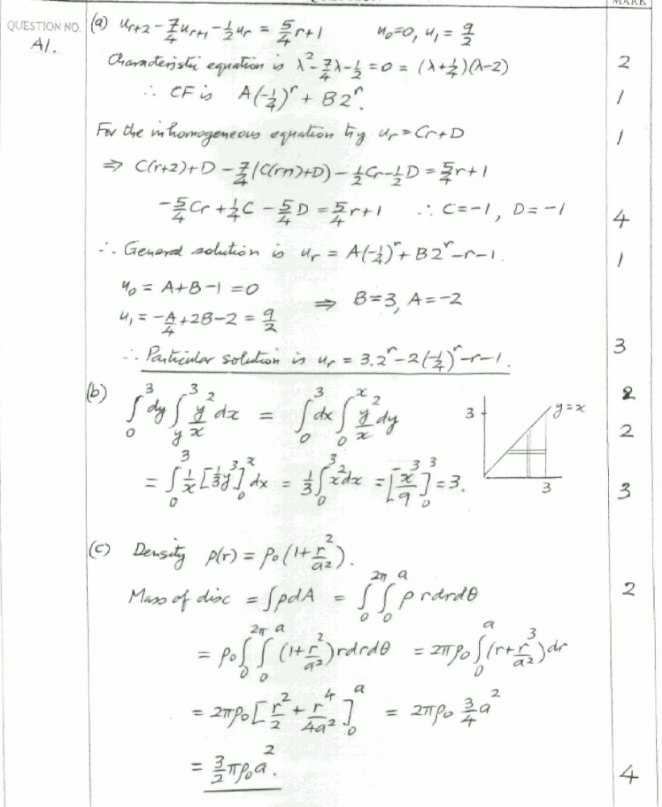
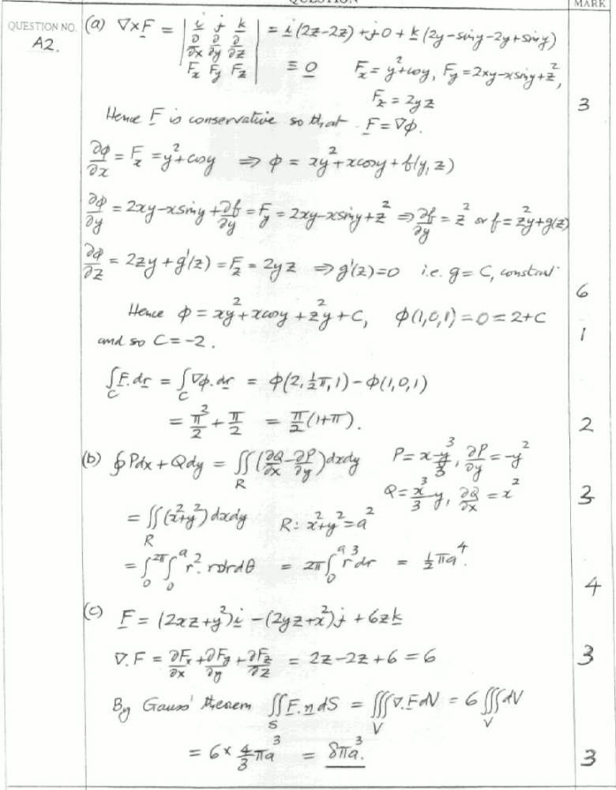
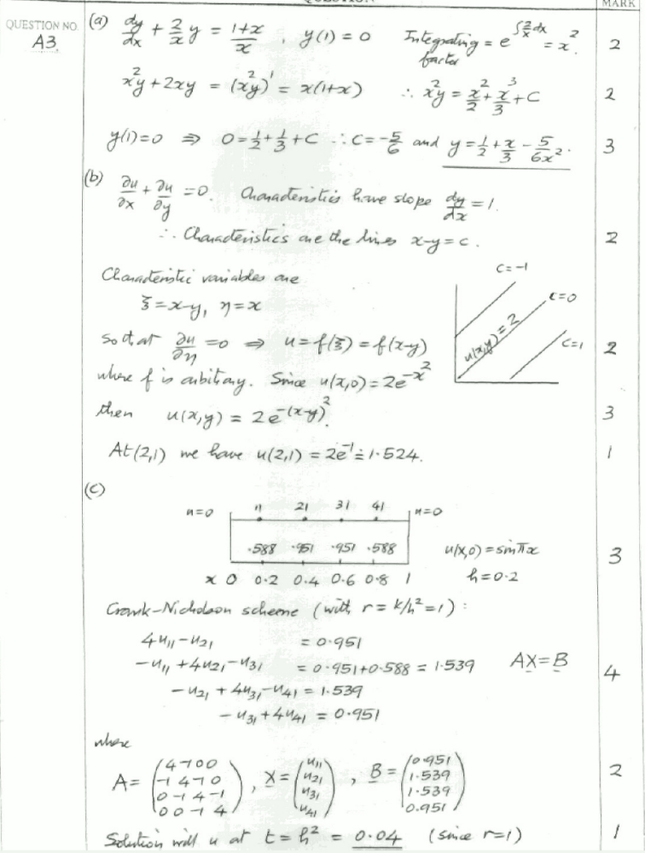
B1. (a)
C (3 kg)
Let u, v be velocity components of B along and perp. to string AB after the impulse – A’s speed is also u along AB. Let w be speed of C along CB after impulse also.
v
w

[2]
u
u
45°

B (2 kg)
A (1 kg)
5 Nm

Momentum eqn. along AB direction (Impulse = change in momentum):
[2]
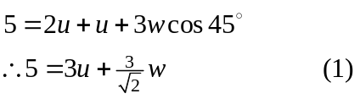
Momentum eqn. perpendicular to AB:
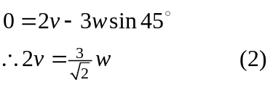
[2]
Equating velocities along CB:
[3]
(3)
Using (1) and (2) in (3) gives
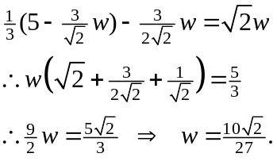
(2) then gives 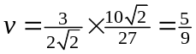m/s.
(1) gives 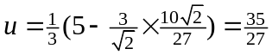m/s.
Hence speed of B =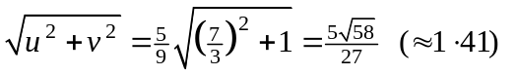m/s and the angle it makes with the BA direction is 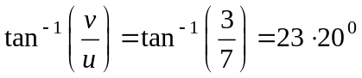.
[3]
[1]

(b)

A = accel. of pulley
2A = accel. of mass
is tension in string
A
2A
[2]

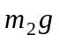
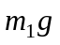

Equations of motion:

Pulley - 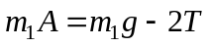 (1)
[4]
mass - 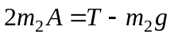 (2)

(1) + 2×(2)  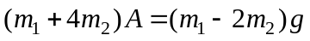
giving 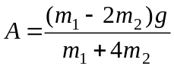 as required.
[2]

Equation (2) gives 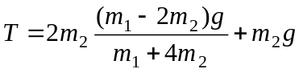
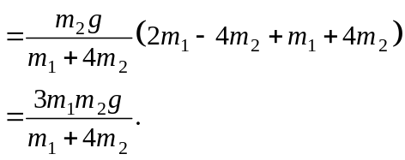
[2]
When mass has travelled a distance x, use 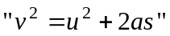 to get
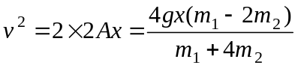
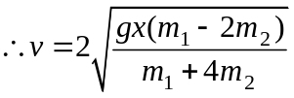.
[2]

B2. (a)
Y
X
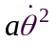
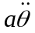
½
X and Y are the components of thrust at axis as shown along and perp. to diameter. Accel. of centre of mass has components as shown.

[2]
½

g

Radial eqn. of motion: 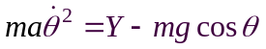 (m = 1, a = ½ )
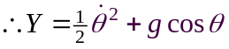 (1)
[2]
Transverse eqn. of motion: 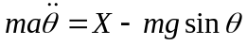
[2]
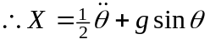 (2)
Rotational eqn. of motion: 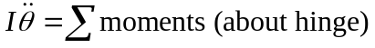
[2]
(3)
Integrating (3) gives 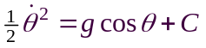 and 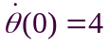 gives
[2]
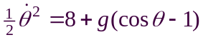 (4)
(2) and (3) 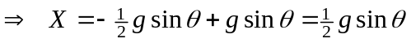 and
[2]
(1) and (4) .
Putting 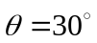 gives,
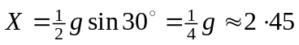N
[2]
and N.

u
v
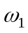
I
I
u, v are speeds of rods after impulse as shown, I is the reaction impulse at hinge B (must be vertical as J is); ,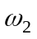 are the angular velocities of rods.
(b)
[2]
a
a
a
a
m
m
A
B
B
C
J

Linear momentum equations of rods:
[2]
AB - 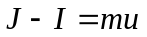 (1)
BC - I = mv (2)

Angular momentum equations 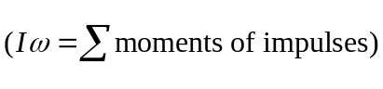:
(moments about centres of rods) 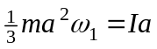 (3)
[2]
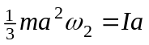 (4)

Velocity of B is the same for both rods, i.e.
[2]
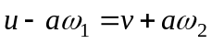 (5)

Using (1) to (4) in (5) gives

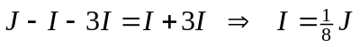

Now velocity of end C is 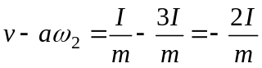 using (2) and (4), i.e.
velocity of C = 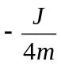 (opposite direction).
[3]

B3. (a)
R
As initial spin is backwards then F acts as shown. Notice that R = 2g and so the frictional force is
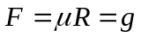.

[2]
2g
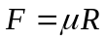

(i) Linear equation of motion is: 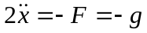
[3]
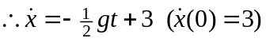 (1)

Rotational eqn. of motion (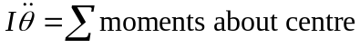):
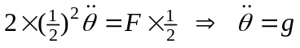.
[3]
Integrating, 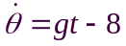 (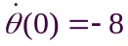) (2)

Cylinder starts to roll when 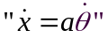, i.e. when 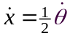, and so from (1) and (2)
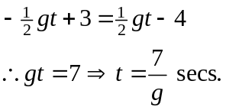
[2]
(ii) When velocity is zero, eqn (1) gives 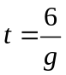, hence angular velocity is then from (2), 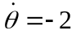rads/sec.
[2]
(iii) Furthest distance from the release point is when vel. = 0, i.e. at , and integrating (1) we have 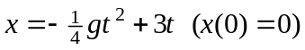, giving the distance as
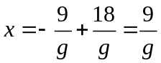m (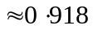m).
[4]
(iv) Final velocity of hoop is when there is no more slipping, i.e. at 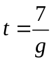, and so (1) gives final velocity as = −0⋅5 m/s. Also (2) gives final angular velocity as 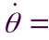−1 rad/sec.
[3]
(v) Total time to return to original position is 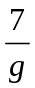 sec. plus time to travel remainder at constant speed of −0⋅5 m/s. Distance travelled at constant speed is 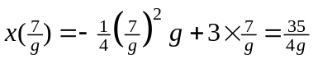 (from (iii)), hence time is
[3]
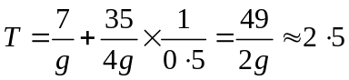secs.
(vi) Use angular momentum principle to calculate the angular velocity of hoop immediately after impact with step. Then equate energy at this point (KE) to that at the top of the step (KE – rotational and linear plus PE due to step height) thus giving velocity.
[3]

