ELG 5228
TurtleBot3 Bridge
Technical Reference Manual
Prof. Wail Gueaieb
Version 1.1
Last updated: June 7, 2026

Table of Contents
Table of Contents 2
1. Purpose and Scope 3
2. System Architecture Overview 3
2.1 The three layers 3
2.2 Why two protocols (WebSocket and DDS) 4
3. The Wrapper (roslib_wrapper.py) 4
3.1 Bidirectional translation 4
3.2 Sim / real mode switch 4
3.3 API reference 5
3.4 Unsupported rclpy features 5
4. Humble and Jazzy Compatibility 5
4.1 Current setup 5
4.2 Migrating to a Jazzy-only container 6
5. The Bridge Package 6
5.1 Topic remapping 6
5.2 Safety features 6
6. Topic and Service Reference 7
7. The Student Template 7
8. The Bridge Test 7
9. Setting Up a New Bridge 8
9.1 Hardware requirements 8
9.2 Flash the OS 8
9.3 Install dependencies and build 8

1. Purpose and Scope
This manual describes the TurtleBot3 bridge system used in ELG 5228: how student code reaches the robot, how the wrapper and bridge translate between them, how to operate the safety features, and how to set up a new bridge.

2. System Architecture Overview
The system has three layers connected over a shared Wi-Fi hotspot. Student code talks to a bridge, and the bridge talks to the robot. Each side uses a different communication protocol, and the bridge is what makes them communicate with each other.
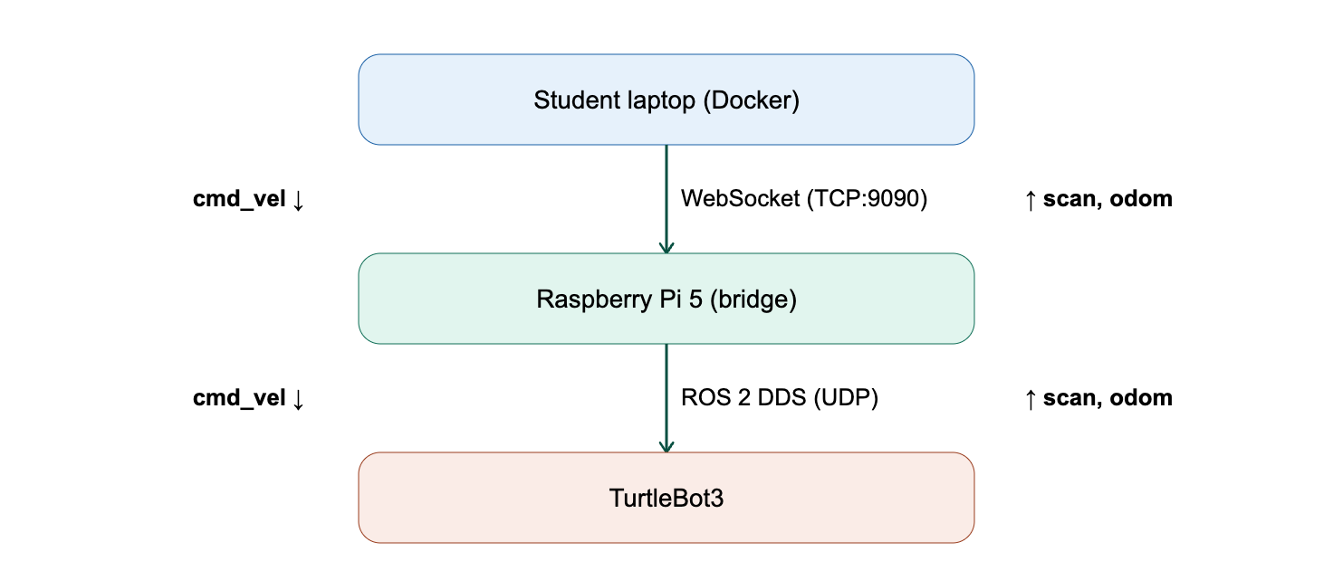
Figure 1. System architecture diagram.

2.1 The three layers
Student laptop (Docker container). Students write Python algorithms inside a Docker container. Their code publishes velocity commands (cmd_vel) and subscribes to sensor data (scan, odom) through roslib_wrapper.py.
Raspberry Pi 5 bridge. The bridge receives student commands over a WebSocket connection on TCP port 9090. It runs two ROS 2 nodes:
- rosbridge_websocket: translates between WebSocket JSON and native ROS 2 messages.
- tb3_bridge_node: enforces safety checks (watchdog timeout, emergency stop, enable/disable) and converts the student’s plain Twist messages into the TwistStamped format the Jazzy TurtleBot3 driver requires.
TurtleBot3 robot. The robot communicates with the bridge over ROS 2 DDS (UDP multicast), the native ROS 2 protocol. It publishes LiDAR scan data and odometry, which flow upward through the bridge to the student; velocity commands flow downward from the student through the bridge to the robot’s motors.

2.2 Why two protocols (WebSocket and DDS)
This is the most important design decision in the system. ROS 2 nodes normally discover each other using DDS over UDP multicast — they broadcast on the network and listen for replies. A Docker container sits on an isolated virtual network that blocks these broadcasts, so a ROS 2 node inside Docker cannot see or be seen by ROS 2 nodes outside it. The usual workaround, --net=host, only works on Linux, not on the macOS and Windows laptops students use.
The bridge goes around this entirely. Student traffic travels over a WebSocket (TCP port 9090), which Docker passes through identically on every operating system with no special configuration. The bridge then relays that traffic to the robot over DDS, which works natively between the Pi 5 and the robot on the same network. From the student’s perspective they are talking directly to a robot; the translation is invisible.

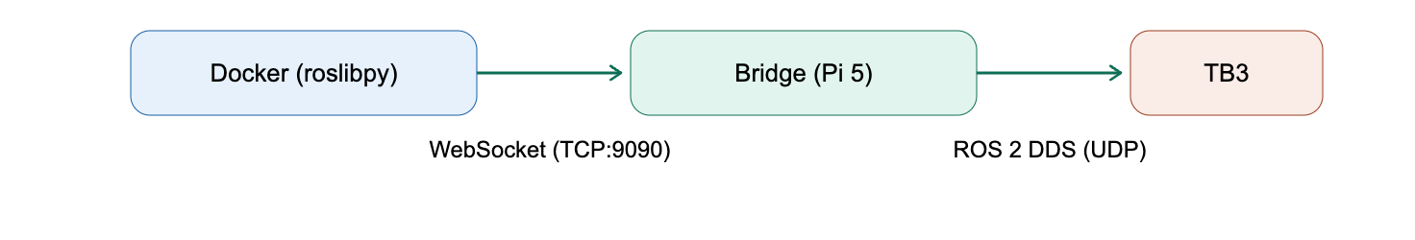
Figure 2. Network communication pathway.

3. The Wrapper (roslib_wrapper.py)
roslib_wrapper.py is a translation layer between the student’s code and the roslibpy WebSocket library. It lets students write standard ROS 2-style Python while roslibpy handles the actual communication underneath. Students never interact with roslibpy directly.

3.1 Bidirectional translation
Publishing. When a student publishes a command, the wrapper converts their dot-notation object (cmd.linear.x = 0.1) into a nested dictionary ({"linear": {"x": 0.1, ...}}), which roslibpy serializes to JSON and sends over the WebSocket.
Subscribing. When sensor data arrives, the reverse happens: roslibpy receives a JSON dictionary and the wrapper converts it into a dot-notation object, so the student can write msg.ranges[0] and msg.pose.pose.position.x exactly as in native ROS 2.

3.2 Sim / real mode switch
Every topic name passes through _resolve_topic(), which checks the TB3_MODE environment variable. In simulation mode the /student/ prefix is stripped so names match Gazebo’s native topics (/cmd_vel, /scan, /odom). In real-robot mode the names pass through unchanged to the bridge, which expects the /student/ prefix. The student’s code is identical in both modes — only the environment variable changes.

3.3 API reference
The wrapper mirrors the rclpy API surface. The table below lists everything it exposes.
Symbol | Description | Mirrors rclpy?
Node | Base class students subclass. | Yes
create_publisher() | Create a publisher for a topic. | Yes
create_subscription() | Subscribe to a topic with a callback. | Yes
create_timer() | Periodic callback (control loop). | Yes
spin() / spin_once() | Block and process timer callbacks until Ctrl-C. | Yes
Twist / LaserScan / Odometry | Message types importable from the wrapper. | Yes
init() | Connect to rosbridge. Replaces rclpy.init(). | Yes
shutdown() | Close the WebSocket connection. | Yes
ok() | Returns True while connected. Only works inside spin(). | Yes
get_logger() | Returns a logger with .info(), .warn(), .error(). | Partial
destroy_node() | No-op placeholder for compatibility. | Stub only
Vector3 | Sub-message used inside Twist (.x, .y, .z). | Yes
Point | Sub-message used inside Pose. | Yes
Quaternion | Sub-message used inside orientation. | Yes
Pose | Sub-message used inside Odometry. | Yes
Header | Sub-message with stamp and frame_id. | Yes
BRIDGE_HOST | Configurable via TB3_BRIDGE_HOST env var. | Wrapper-specific
BRIDGE_PORT | Default 9090. Configurable via TB3_BRIDGE_PORT. | Wrapper-specific
MODE | "sim" or "real". Configurable via TB3_MODE. | Wrapper-specific

3.4 Unsupported rclpy features
The wrapper only implements the slice of rclpy that this course needs. A student who reaches for an rclpy feature the wrapper does not implement will get a confusing AttributeError or similar failure rather than a clear “not supported” message. Known gaps:
Unsupported Feature | What happens if a student tries it
Services (create_service, create_client) | AttributeError — the Node class does not have these methods.
Actions (action server, action client) | AttributeError — not implemented.
Parameters (declare_parameter, get_parameter) | AttributeError — not implemented.
QoS profiles (QoSProfile, ReliabilityPolicy) | Cannot be imported from the wrapper. The qos_depth argument in create_publisher and create_subscription is accepted but ignored.
spin_once() | AttributeError — only spin() is available.
Rate / sleep | Not available. Students should use time.sleep() or create_timer() instead.
Clock / Time types (get_clock(), rclpy.time.Time) | Not implemented. Use Python's time.time() instead.
Multi-threaded executors (MultiThreadedExecutor) | Not implemented. The wrapper is single-threaded.
Lifecycle nodes | Not implemented.
Additional message types (PoseStamped, Int32, String, Image) | Not included. New types can be added by extending _DotDict.
Launch system integration | The wrapper is a standalone Python module, not a ROS 2 package.
Topic type discovery (ros2 topic info, ros2 node list) | Not available. These require a full ROS 2 installation.

4. Humble and Jazzy Compatibility

4.1 Current setup
Students run ROS 2 Humble inside the Docker container. The TurtleBot3 and bridge Pi 5 both run ROS 2 Jazzy. These two versions use different DDS implementations and cannot communicate directly.
The wrapper avoids the version mismatch by never using DDS. Everything travels over the WebSocket: the Humble container sends JSON to the bridge’s rosbridge node (Jazzy), which converts it into native Jazzy messages. The two ROS 2 versions never interact, the WebSocket sits between them and speaks to each side in its own language. (See Section 2.2.)
Jazzy also changed the velocity message type: the TurtleBot3 driver requires TwistStamped on /cmd_vel instead of the plain Twist used in Humble. The wrapper does not handle this. Instead, tb3_bridge_node on the Pi 5 receives the student’s plain Twist, adds a timestamp and frame ID, and republishes it as TwistStamped. Students always send simple Twist messages regardless of what the robot expects.

4.2 Migrating to a Jazzy-only container
If the Docker image is updated from Humble to Jazzy, the wrapper, student code, and bridge package all remain unchanged, because the wrapper communicates over WebSocket rather than DDS, the ROS 2 version inside the container does not affect how it functions. In real-robot mode the bridge node continues to handle the Twist to TwistStamped conversion as before.
The one area to verify is simulation mode. Gazebo in the Humble image accepts plain Twist on /cmd_vel, which the wrapper sends directly. If the Jazzy Gazebo TurtleBot3 plugin changes to require TwistStamped, sim mode will break. In that case, add a TwistStamped path to the wrapper for sim mode.

5. The Bridge Package
The bridge is a ROS 2 Jazzy C++ package running on the Raspberry Pi 5. Its launch file starts two nodes together: rosbridge_websocket (WebSocket JSON ↔ ROS 2 topics) and tb3_bridge_node (safety and message conversion).
Throughout this manual, tb3_bridge_node is the canonical name for the safety/conversion node; “the bridge node” and “the C++ node” refer to the same thing.

5.1 Topic remapping
The bridge node sits between the student-side names and the robot-side names. The full mapping is given in Section 6. In brief: it strips the /student/ prefix on the command path (so /student/cmd_vel reaches the robot as /cmd_vel) and adds the /student/ prefix on the sensor path (so the robot’s /scan and /odom reach the student as /student/scan and /student/odom). The two directions move the prefix opposite ways — this is intentional, not a typo.

5.2 Safety features
Feature | Topic / service | Behaviour
Watchdog | (internal) | Stops the robot if no command arrives within 0.5 s. Auto-clears when the student resumes publishing.
E-stop | /bridge/e_stop | Latching kill switch. Requires explicit reset.
E-stop reset | /bridge/e_stop_reset | Clears a latched e-stop.
Enable / disable | /bridge/enable | Lets instructors pause student control while sensor data keeps flowing.
Three safety features protect the robot. The watchdog stops the robot if no command arrives within 0.5 seconds and auto-clears when the student resumes publishing. The e-stop (/bridge/e_stop) is a latching kill switch that requires an explicit reset via /bridge/e_stop_reset. The enable/disable service (/bridge/enable) lets instructors pause student control while sensor data keeps flowing. The bridge publishes /bridge/diagnostics at 1 Hz with the state of all safety features and message counters. All parameters are configurable via bridge_params.yaml.

6. Topic and Service Reference
This is the single authoritative mapping of names across the system. Verify each row against the launch file and bridge source; correct anything that has drifted.
Student-side name | Robot-side name | Type | Direction
/student/cmd_vel | /cmd_vel | Twist → TwistStamped | Student → robot
/student/scan | /scan | LaserScan | Robot → student
/student/odom | /odom | Odometry | Robot → student
/bridge/e_stop | — | std_srvs/srv/Trigger | Latching emergency stop.
/bridge/e_stop_reset | — | std_srvs/srv/Trigger | Clears the e-stop and resumes forwarding.
/bridge/enable | — | std_srvs/srv/SetBool | data: false disables forwarding (soft pause). data: true re-enables. Sensor data continues flowing in both states.
/bridge/diagnostics | — | diagnostic_msgs/DiagnosticArray | Bridge status published at 1 Hz.

7. The Student Template
student_template.py handles connecting to the bridge, subscribing to sensors, publishing velocities, and stopping the robot on exit. Students edit only the control_loop() method.
The imports are the only difference from standard rclpy:
import roslib_wrapper as rclpy
from roslib_wrapper import Node, Twist, LaserScan, Odometry # message types
Everything else, Node, create_publisher, create_subscription, create_timer, msg.ranges[0], cmd.linear.x, rclpy.spin() are identical to native ROS 2 code.
The control_loop runs at 10 Hz. Students read self.latest_scan.ranges for LiDAR distances and self.latest_odom.pose.pose.position for position, then publish a Twist with their computed velocities. The finally block sends a zero Twist on exit so the robot never coasts after the script stops.
Students switch between simulation and real robot with environment variables only, the code is identical in both modes.

8. The Bridge Test
bridge_test_terminal.py verifies the full data pipeline by driving the robot through a fixed movement pattern (forward 2 m, turn right, forward 1 m, turn left, forward 1 m, turn right, forward 1 m) while displaying live LiDAR distances, odometry, and data-flow status in the terminal.
Each step uses odometry feedback to measure actual distance or angle, confirming the complete loop: commands go out, the robot moves, and updated position comes back. If all three data-flow indicators show OK and the robot completes the pattern, the system is verified. The test uses the same wrapper and environment variables as student code and works in both simulation and real-robot modes.

9. Setting Up a New Bridge

9.1 Hardware requirements
- Raspberry Pi 5 (4 GB RAM or more)
- Quality microSD card (SanDisk Extreme recommended)
- USB-C 5 V / 3 A power supply
Operating system: Ubuntu Desktop 24.04 LTS, running ROS 2 Jazzy.

9.2 Flash the OS
- Flash Ubuntu Desktop 24.04 LTS with Raspberry Pi Imager.
- In the Imager settings, set the hostname, the username/password, and enable SSH.

9.3 Install dependencies and build
- Install ROS 2 Jazzy: Follow the official installation guide at (docs.ros.org/en/jazzy/Installation/Ubuntu-Install-Debs.html). Install the ros-jazzy-desktop version.
- Install additional packages:
  - sudo apt install -y ros-jazzy-rosbridge-suite ros-dev-tools openssh-server
  - sudo systemctl enable ssh --now
- Make workspace and add the tb3_bridge folder
  - mkdir -p ~/ros2_ws/src
  - cd ~/ros2_ws/src
  - git clone https://github.com/your-repo/tb3_bridge.git
- Build Package:
  - source /opt/ros/jazzy/setup.bash
  - cd ~/ros2_ws
  - sudo rosdep init && rosdep update && rosdep install --from-paths src --ignore-src -r -y
  - colcon build --packages-select tb3_bridge --cmake-args -DCMAKE_BUILD_TYPE=Release
- Configure Environment:
  - echo 'source /opt/ros/jazzy/setup.bash' >> ~/.bashrc
  - echo 'source ~/ros2_ws/install/setup.bash' >> ~/.bashrc
  - echo 'export ROS_DOMAIN_ID=42' >> ~/.bashrc
  - source ~/.bashrc
- Configure Wi-Fi auto-connect:
The bridge and TB3 must share a subnet. Students create a phone hotspot named tb3_hotspot each session. Configure the Pi 5 to auto-connect:
  - sudo nmcli device wifi connect "tb3_hotspot" password "tb3_password"
  - sudo nmcli connection modify "tb3_hotspot" connection.autoconnect yes
  - sudo nmcli connection modify "tb3_hotspot" connection.autoconnect-priority 100
- Verify:
Confirm the startup banner appears and rosbridge reports port 9090. Then from a student Docker container, run the bridge test (Section 8):
  - ros2 launch tb3_bridge tb3_bridge.launch.py

