Group 7 Book Club - One Page Report
Project Title: Group 7 Book Club Website
Course: Back-End Web Development

FEATURES IMPLEMENTED:
Home page with book info and day-based switch messages
Registration form with name, email, password, favorite book, membership type
Profile picture upload (JPG/PNG only, unique filename)
Login system with session management
Protected dashboard showing user profile and book recommendations
Logout function destroys session
Form validation (required fields, email format, password length ≥5, password match)
CSS styling with hover effects and responsive layout
CONDITIONAL STATEMENTS USED:

if – Check empty fields (register.php)
elseif – Multiple field validation (register.php)
if-else – File upload success/failure (register.php)
switch – Day messages (index.php) and book recommendations (dashboard.php)
TECHNOLOGIES: HTML5, CSS3, PHP, XAMPP, Git/GitHub

CHALLENGES FACED:

Session management – Fixed by placing session_start() at the very top of all PHP files
File upload – Added type validation and unique naming to prevent overwrites
Git authentication – GitHub no longer accepts passwords; used Personal Access Token instead
GitHub Pages – PHP doesn't run; added index.html for submission while keeping PHP files
Password validation – Moved validation before file upload to block short passwords
CONCLUSION: All requirements met – HTML semantics, CSS, form handling, conditional statements (if, elseif, else, switch), session management, file upload, and validation.

SCREENSHOTS OF PAGES
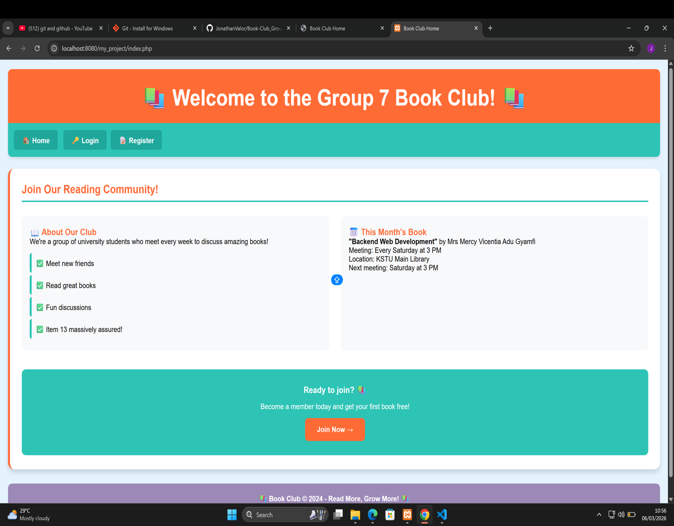

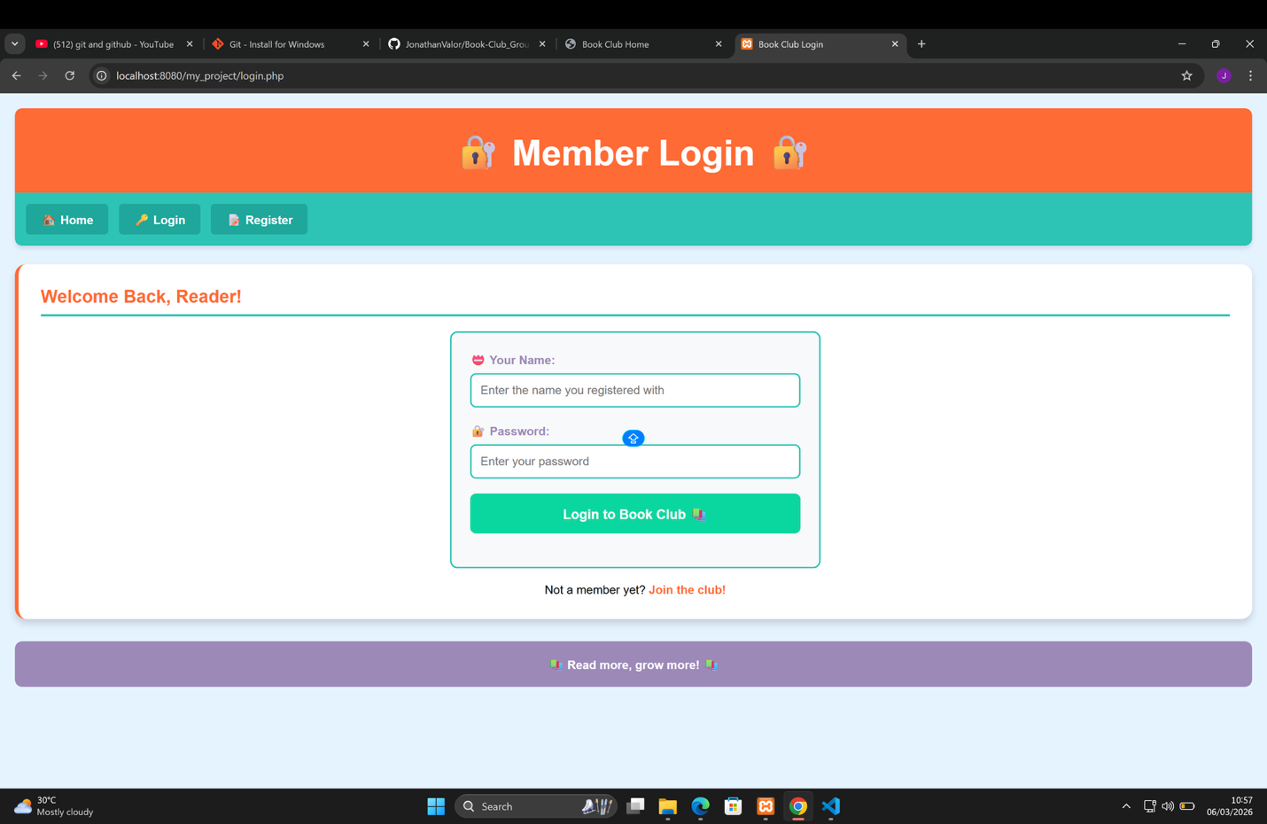
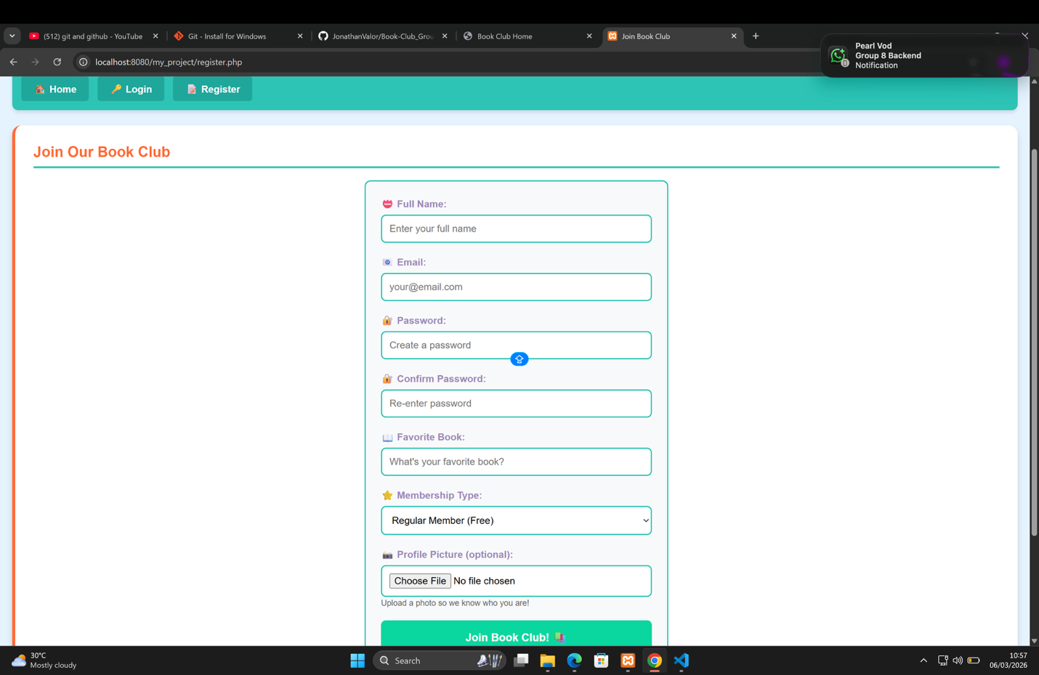
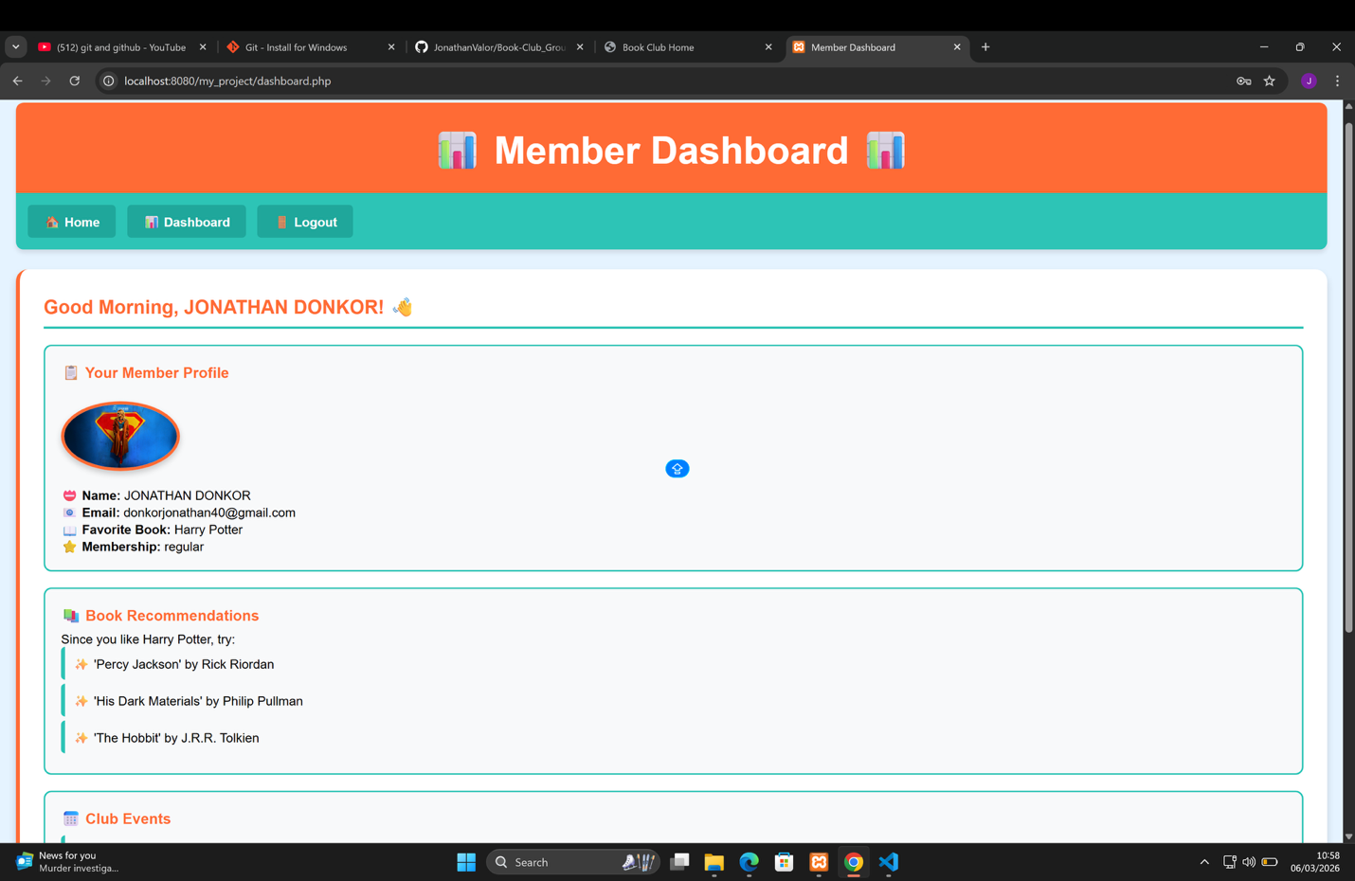

GROUP MEMBERS
Animayaw Donkor Jonathan – 052441360111
Afia Twumwaa Asokwa – 052441360111
Buabeng Georgina – 052541360376
Amponsah Gideon – 052441360131
Perry Frimpong

