Merged Model setup guide
Follow the pictures from cloning to your first scenario.
For Windows, with GitHub Desktop, VS Code, Julia and the Julia extension already installed. Numbers beside each instruction match the circles in the pictures.

Copy the repository link
Open this page in your browser:
Repository https://github.com/JonathanWPedersen/Vietnam-Merged-Model
1 Click the green Code button.
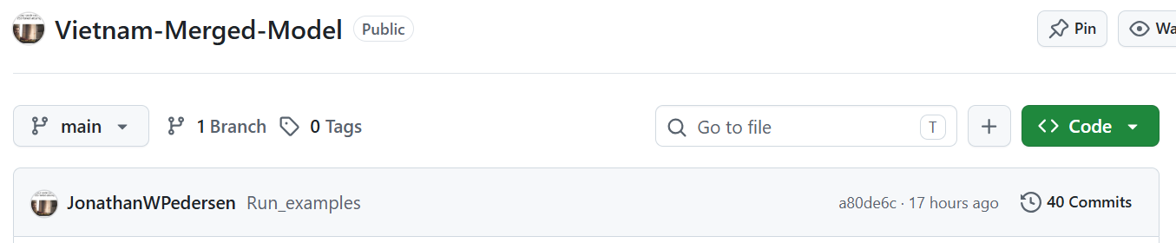
1
2 Select HTTPS.
3 Click the copy icon beside the link.
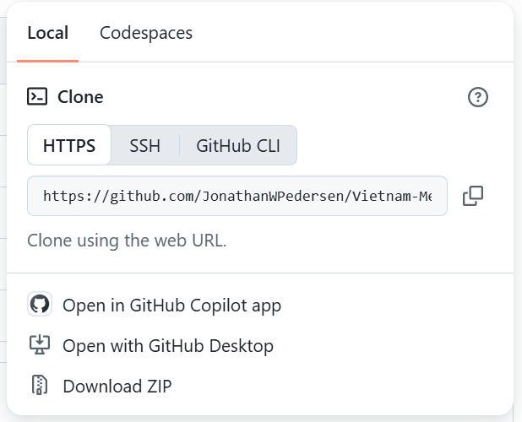
2
3
The copy icon looks like two overlapping squares. Your link is now ready to paste into GitHub Desktop.

Paste the link into GitHub Desktop
1 Open GitHub Desktop. Click File, then Clone repository…
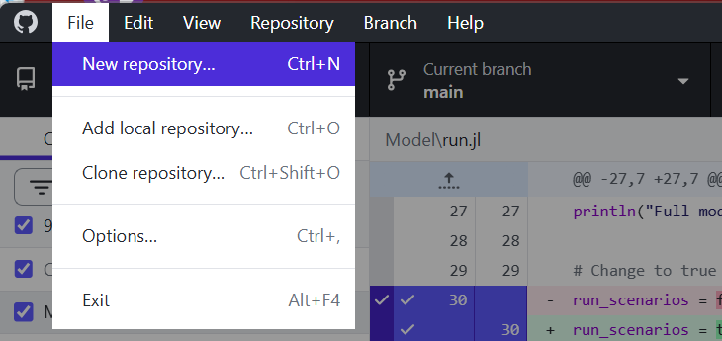
1
2 Select the URL tab.
3 Click the repository address box and press Ctrl + V.
4 Beside Local path, click Choose…
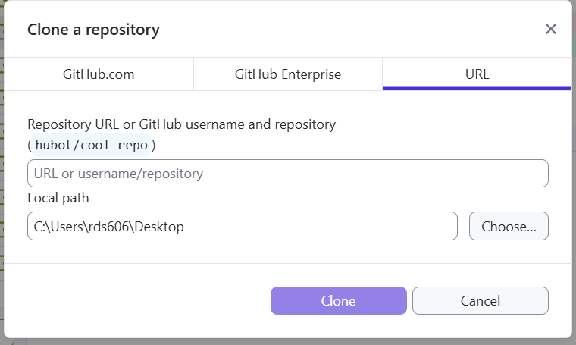
2
3
4
A red “folder contains files” message is solved by choosing a new empty folder on the next page. Keep your existing files.

Create a new folder on your Desktop
1 Click Desktop on the left.
2 Right-click an empty space in the folder list, below the existing folders.
3 Move your mouse over New in the menu that appears.
4 Click Folder in the menu beside it.
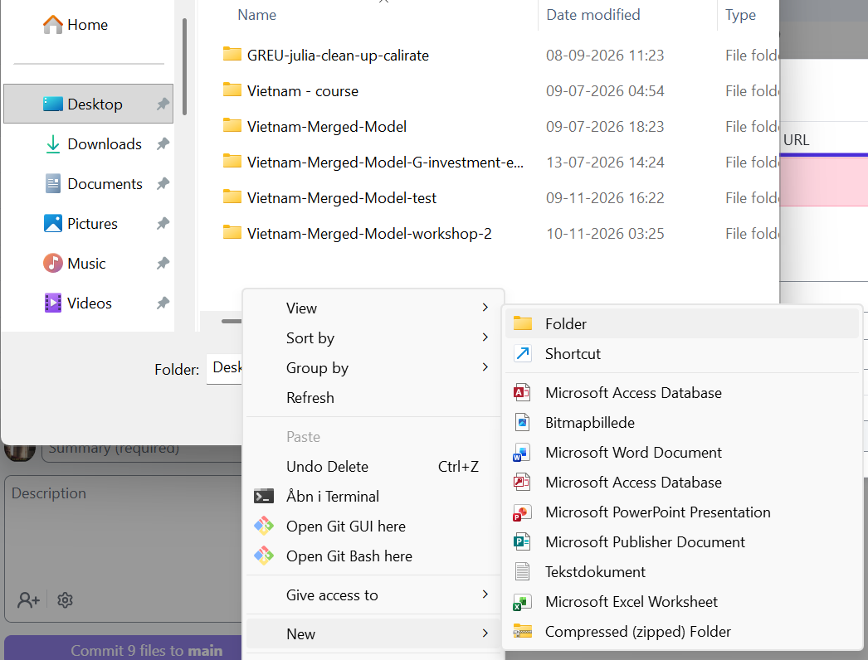
1
3
4
5 Type the new name over the highlighted words New folder.
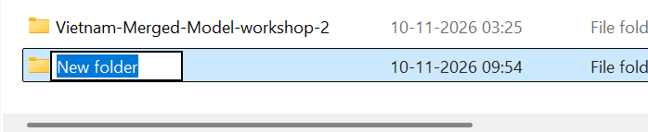
5
Type beside the yellow folder icon, not in the Folder box at the bottom. Use:
Vietnam-Merged-Model-workshop-2-day-2
If that name already exists, add -new to the end. Do not reuse an existing folder.
6 Press Enter to finish naming the folder.

Select the new folder and clone
1 Click your new folder once to select it.
2 Click Select Folder.
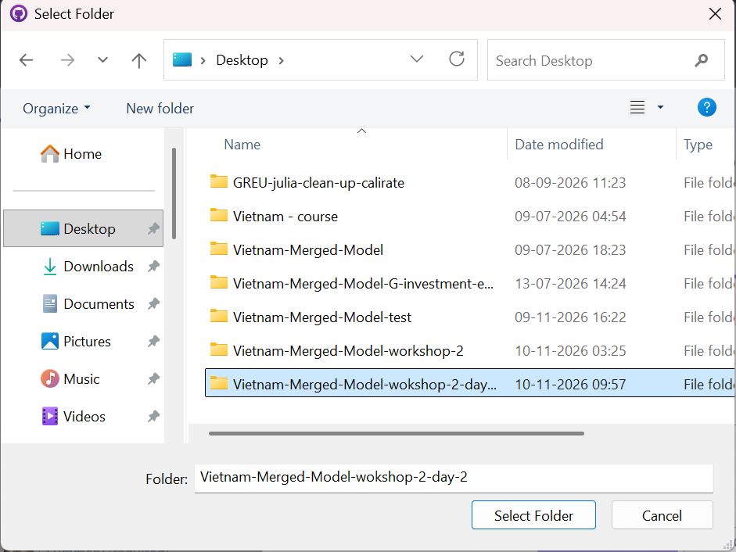
1
2
3 Check that Local path ends with your new folder name.
4 Click Clone and wait for the copying to finish.
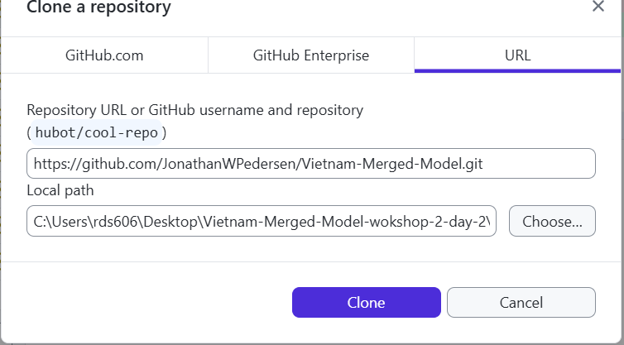
3
4
Ready to continue Cloning has finished. Your model files are now on your computer.

Open the Model folder in VS Code
1 Open VS Code. Click File, then Open Folder…
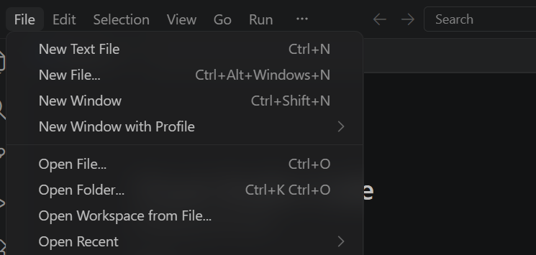
1
2 Click Desktop. Double-click the workshop folder you created.
Use your own folder name. In this guide it is Vietnam-Merged-Model-workshop-2-day-2.
3 Click the Model folder once.
4 Click Select folder.
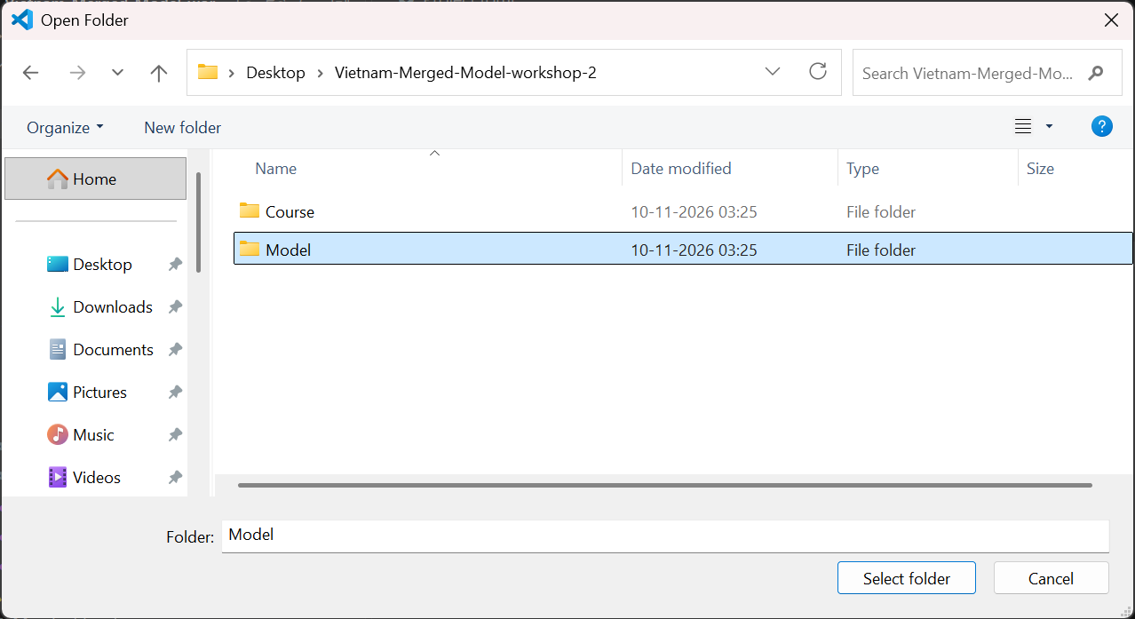
2
3
4
The screenshot uses a shorter workshop folder name. Select Model inside your own workshop copy.

Check that you opened the correct folder
1 Look at the top of Explorer. The folder should be Model.
2 Find Project.toml, run.jl and settings.jl underneath it.
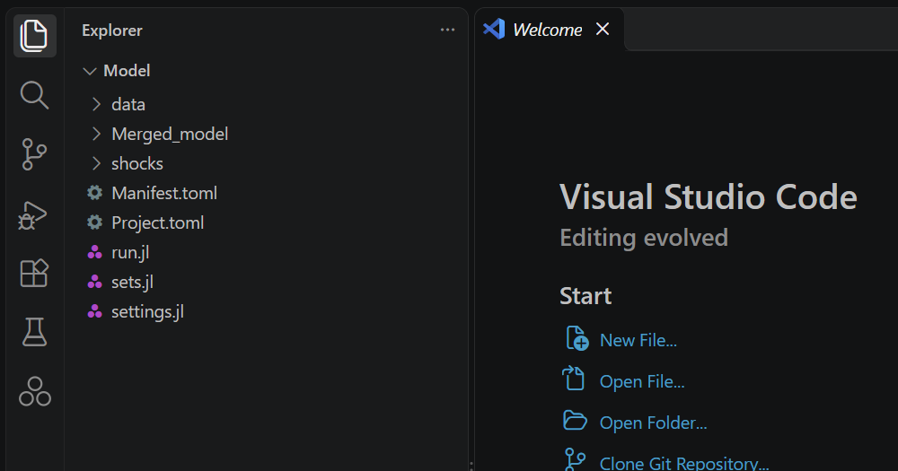
1
2
Ready to continue Model is open and the three files are visible. Continue to the next page to start Julia.

Start the Julia REPL
Begin with the Model folder open in VS Code.
1 Press Ctrl + Shift + P to open the Command Palette.
2 Find Julia: Start REPL and click it.
You may need to scroll down the list to find it. It may not appear at the top as it does in this screenshot.
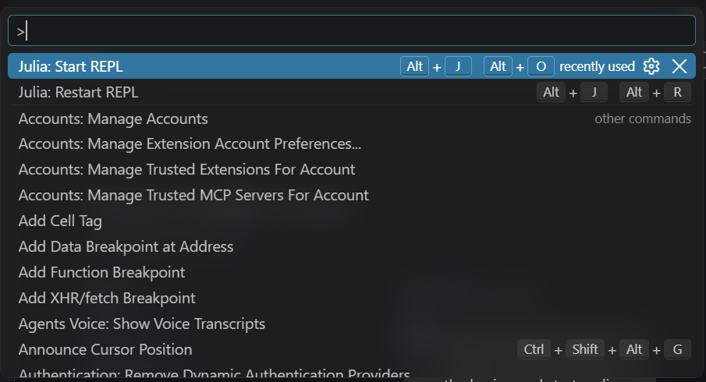
2
3 Wait until julia> appears in the terminal.
Julia may display startup messages first. Wait for the prompt shown below.
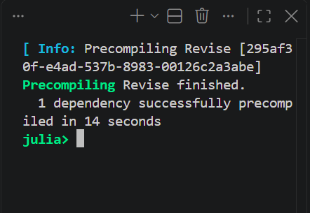
3
Ready to continue You can see julia>. Julia is ready for commands.

Activate the project environment
Begin with Model open in VS Code and the Julia REPL ready. These steps prepare the packages the model needs.
1 Click beside julia> and type ] to enter package mode.
The REPL may appear at the bottom of VS Code or on the right, as in this picture. The prompt changes to pkg>. You do not need to press Enter after ].
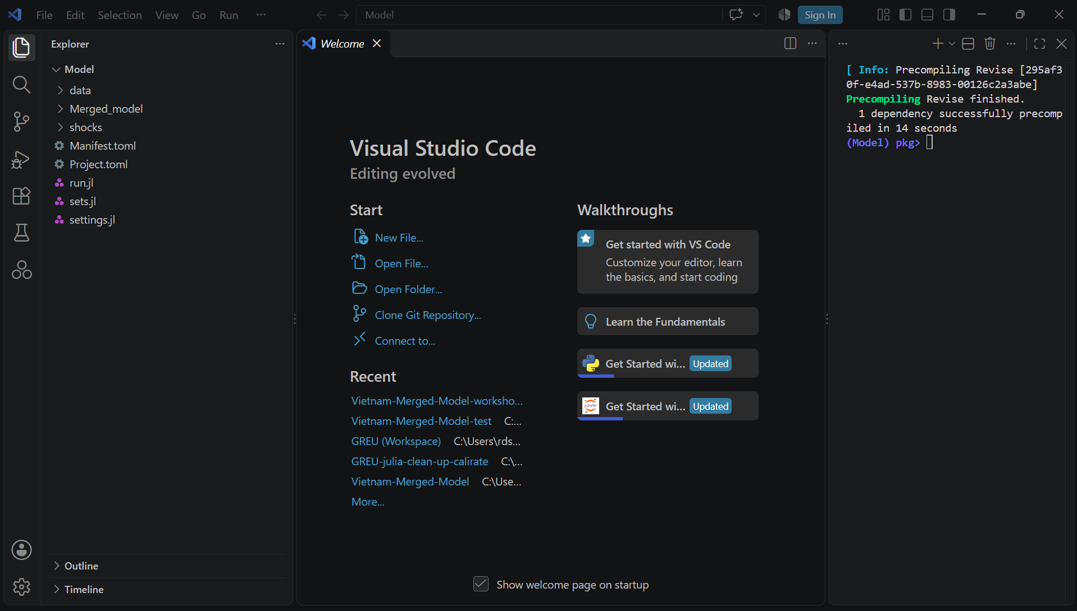
1
2 Type activate . and press Enter.
Include the space and the dot. This selects the project in the current folder.
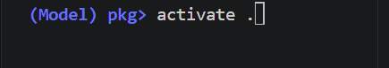
2
The activation message should show a path ending in Model, as in the next picture.

Prepare the project packages
3 Type instantiate and press Enter. Wait until it finishes.
Keep your internet connection active. The first time can take several minutes. Wait for the (Model) pkg> prompt to return.
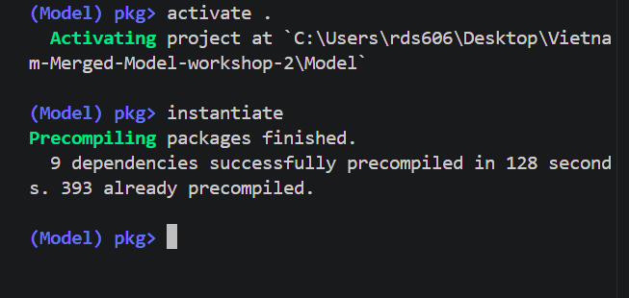
3
4
4 At the empty package prompt, press Backspace to return to julia>.
Ready to continue Package preparation has finished without an error, and you can see julia> again.
Run the model for the first time
Run the baseline model from the code editor using Shift + Enter. Keep scenarios switched off for this first run.
1 Click run.jl in the file list on the left.
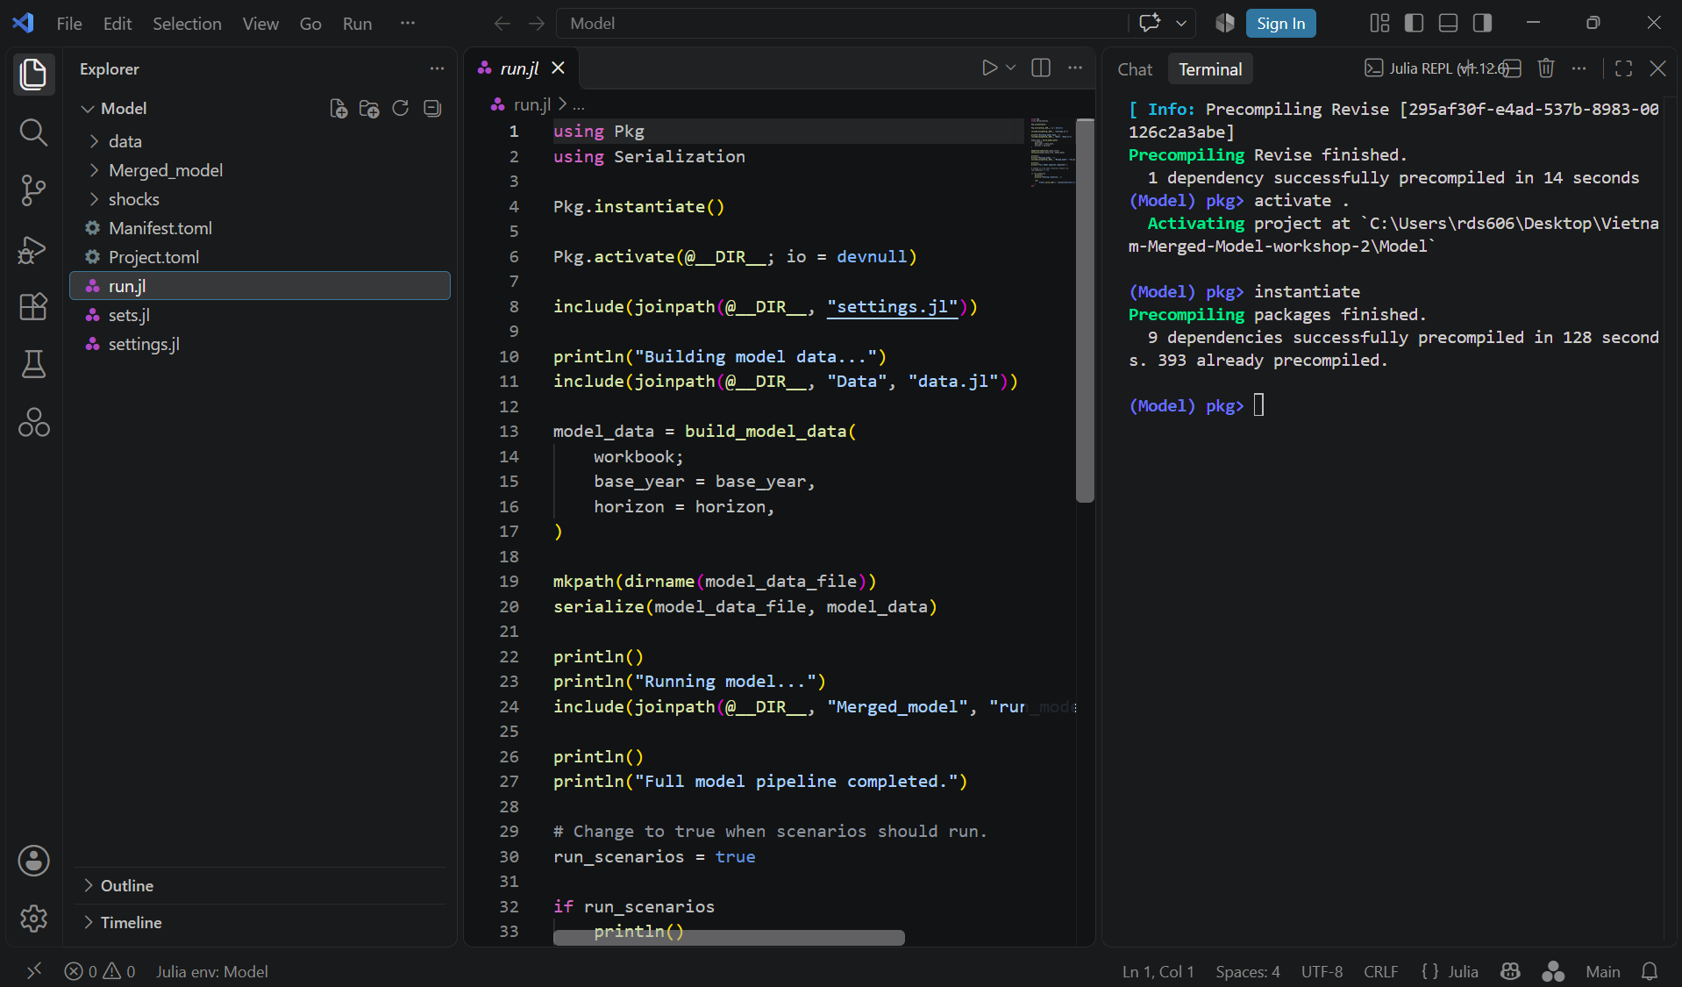
1
2 Find run_scenarios = true near the bottom of the file. Change true to false.
If it already says false, leave it as it is. Press Ctrl + S to save.
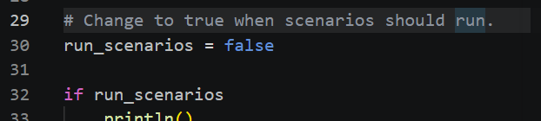
2

Select the code and run it
3 Click inside the code in run.jl. Press Ctrl + A to select all the code.
The code should be highlighted, as in the picture. Make sure you clicked inside the code before pressing Ctrl + A.
4 With all the code selected, press Shift + Enter once.
Wait for the model to finish. The first run may take several minutes. Progress appears in the terminal at the bottom or on the right.
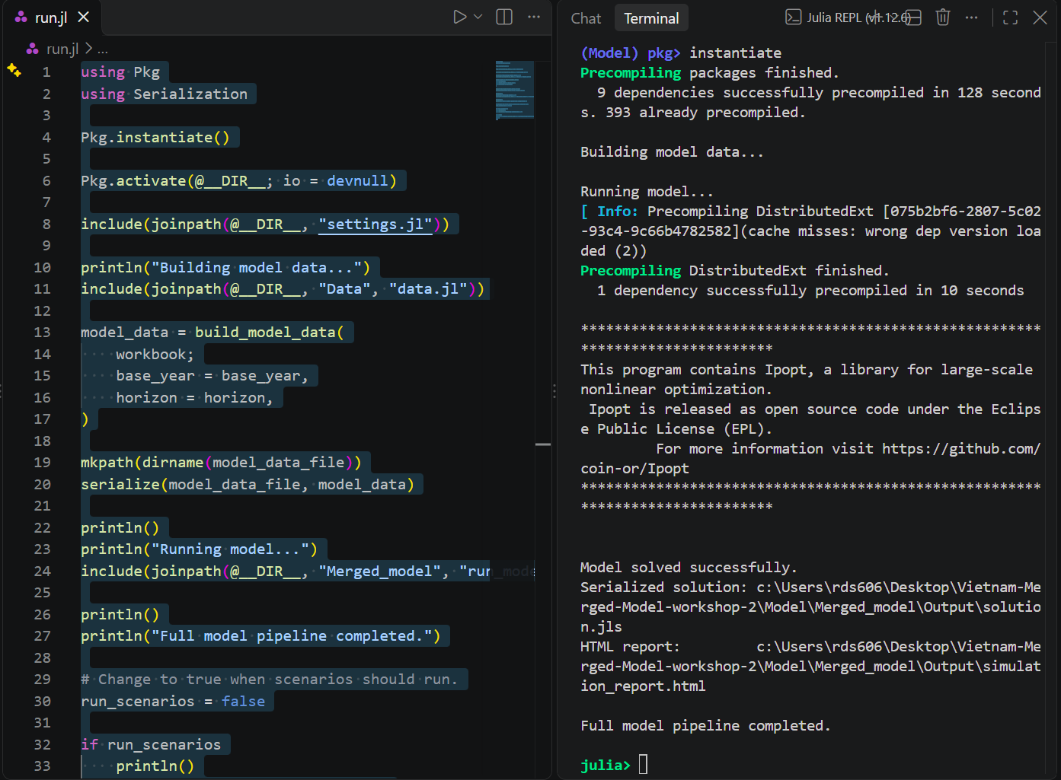
3
5
5 Check for Model solved successfully and Full model pipeline completed.
The picture above shows the completed run. Wait until julia> appears again before continuing.
Ready to continue The baseline model has finished. You are ready to view its results.
Open the baseline results
After the model has finished, open its report through Windows File Explorer.
1 Press the Windows key + E to open File Explorer. Click Desktop on the left.
2 Double-click the workshop folder you used to run the model.
Use your own workshop folder name. The pictures use Vietnam-Merged-Model-workshop-2.
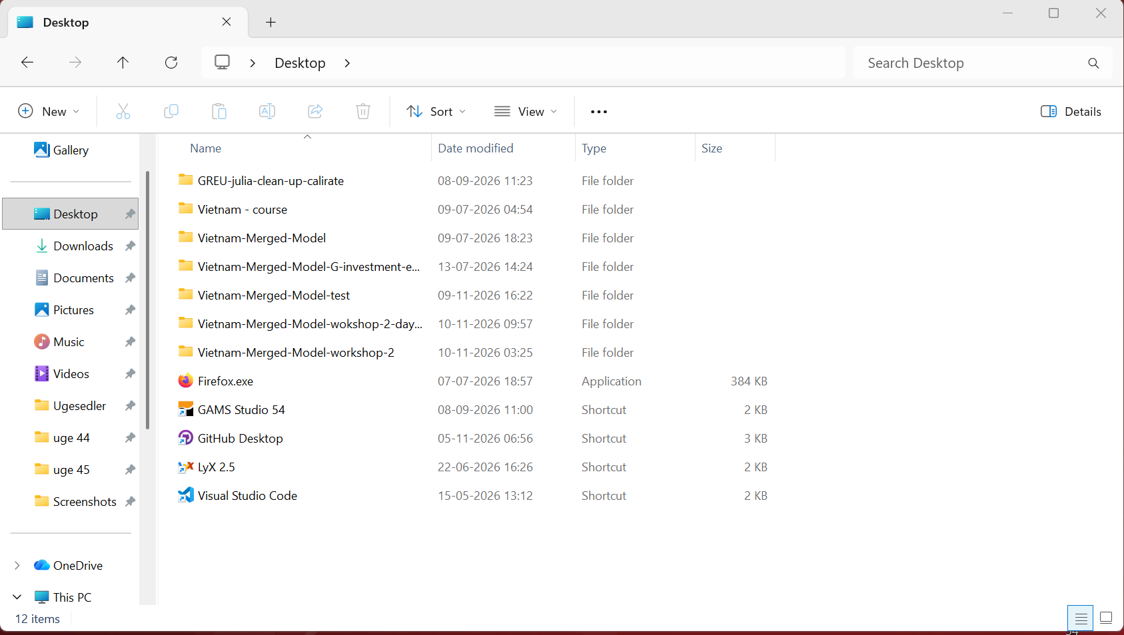
1
2
3 Double-click Model.
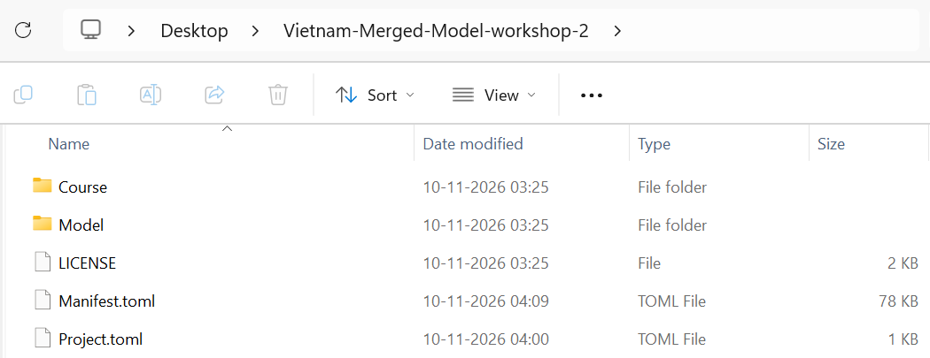
3

Find the output folder
4 Inside Model, double-click Merged_model.
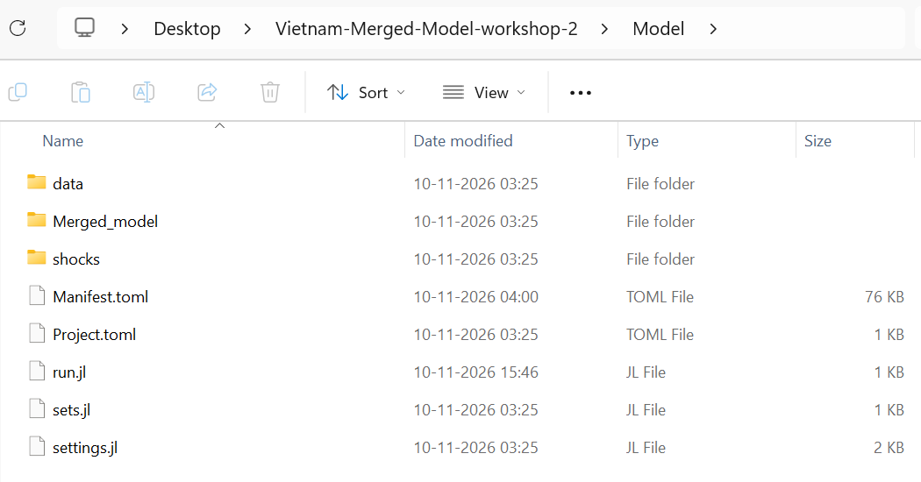
4
5 Inside Merged_model, double-click output.
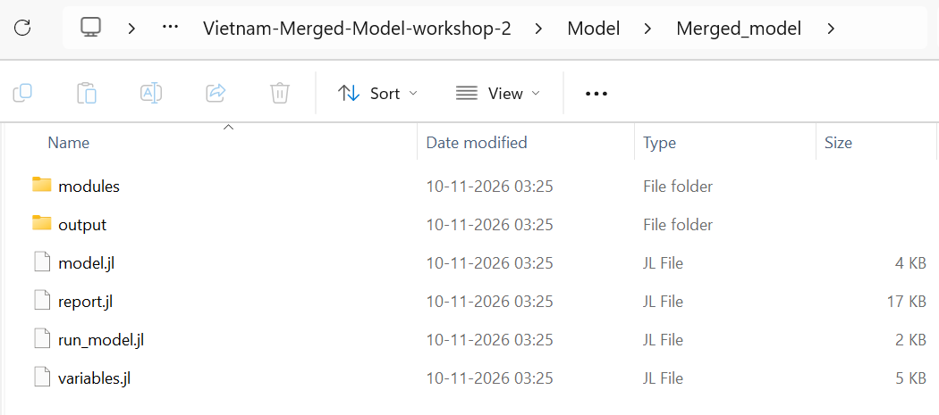
5

Open the report in your browser
6 Double-click simulation_report.html.
This opens the report in your web browser.
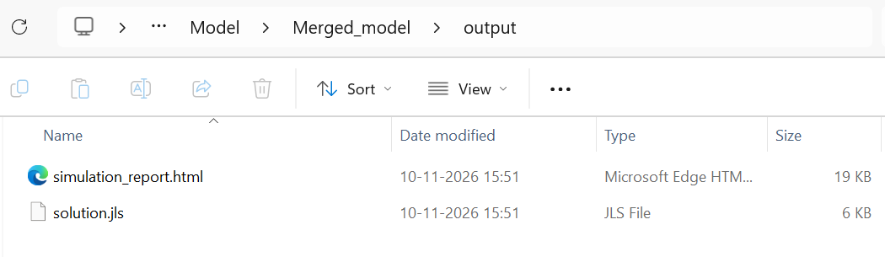
6
7 Check that the page title says Vietnam Merged Model — Simulation Report.
Scroll down to see more of the report. The tables show variable names on the left and years across the top.
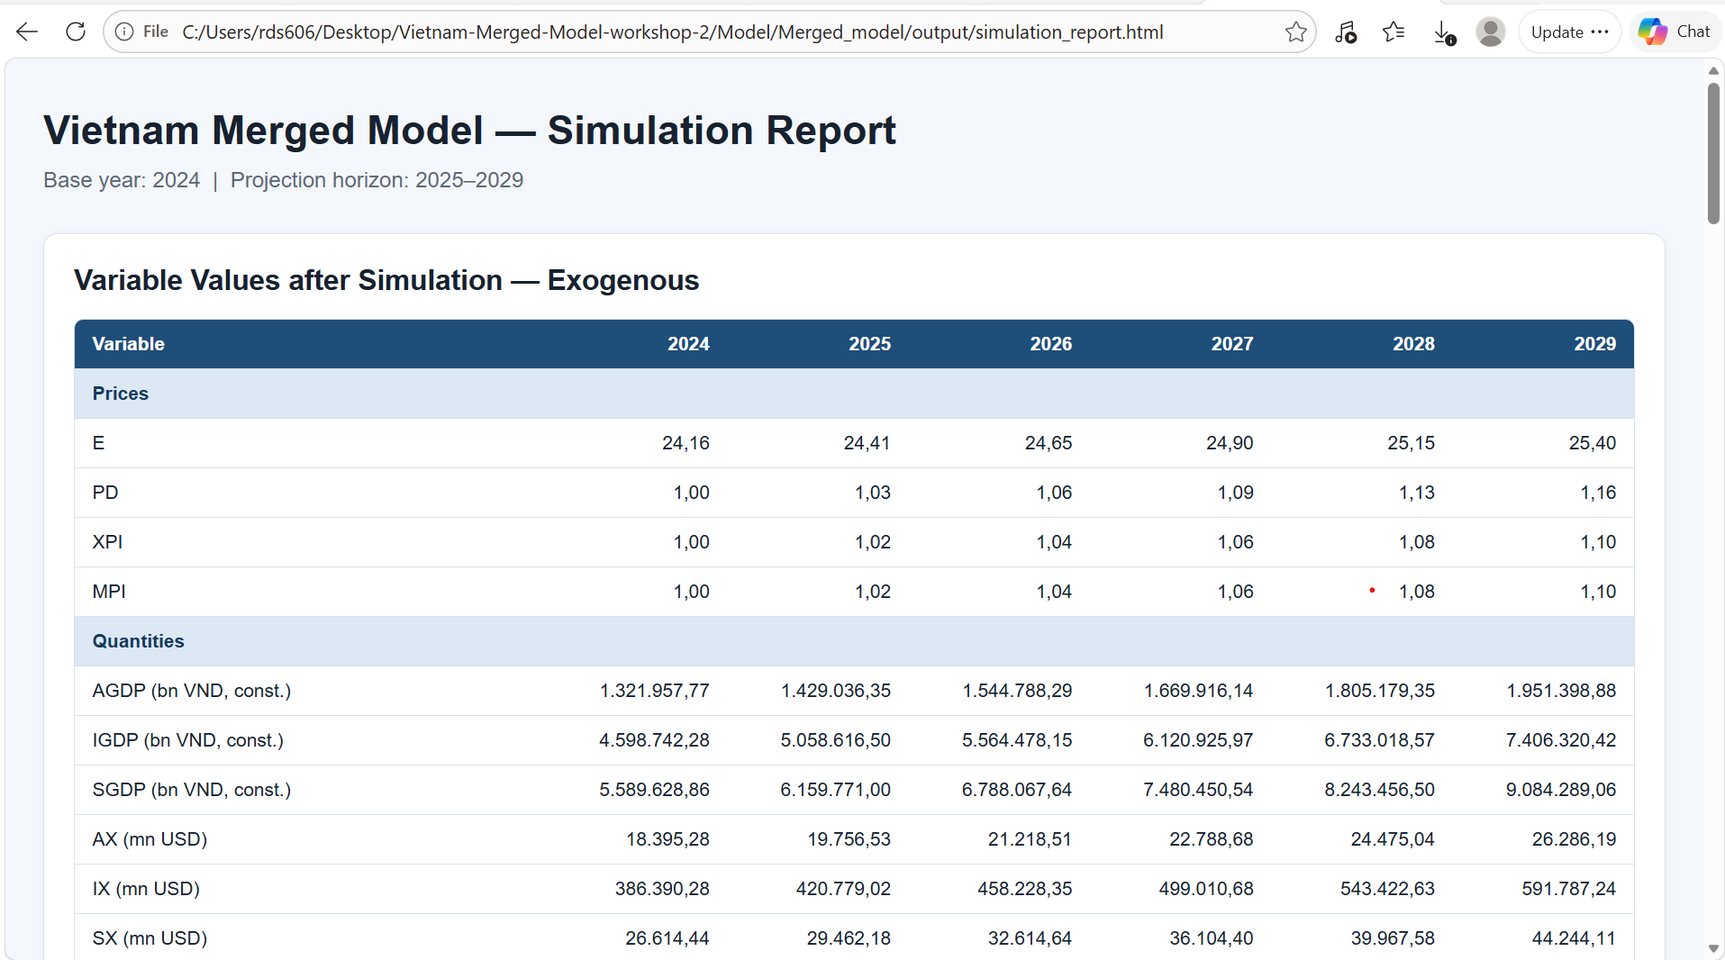
7
Ready to continue The baseline report is open and you can view the results.
Set up and run a model scenario
A scenario asks what the model would show under a different assumption. The baseline is the comparison run using the original assumptions. In this guide, we use an industrial export slowdown to show how to build a scenario of your own.
Start with a question. What happens to industrial exports, total exports and imports if industrial export growth slows in 2026 and picks up again in 2029? For your own scenario, write down what changes, who or what it affects, when it happens, and what results you want to compare.
1 After your first model run, open the Model folder in VS Code. Click the arrow beside shocks, then click scenario.jl.
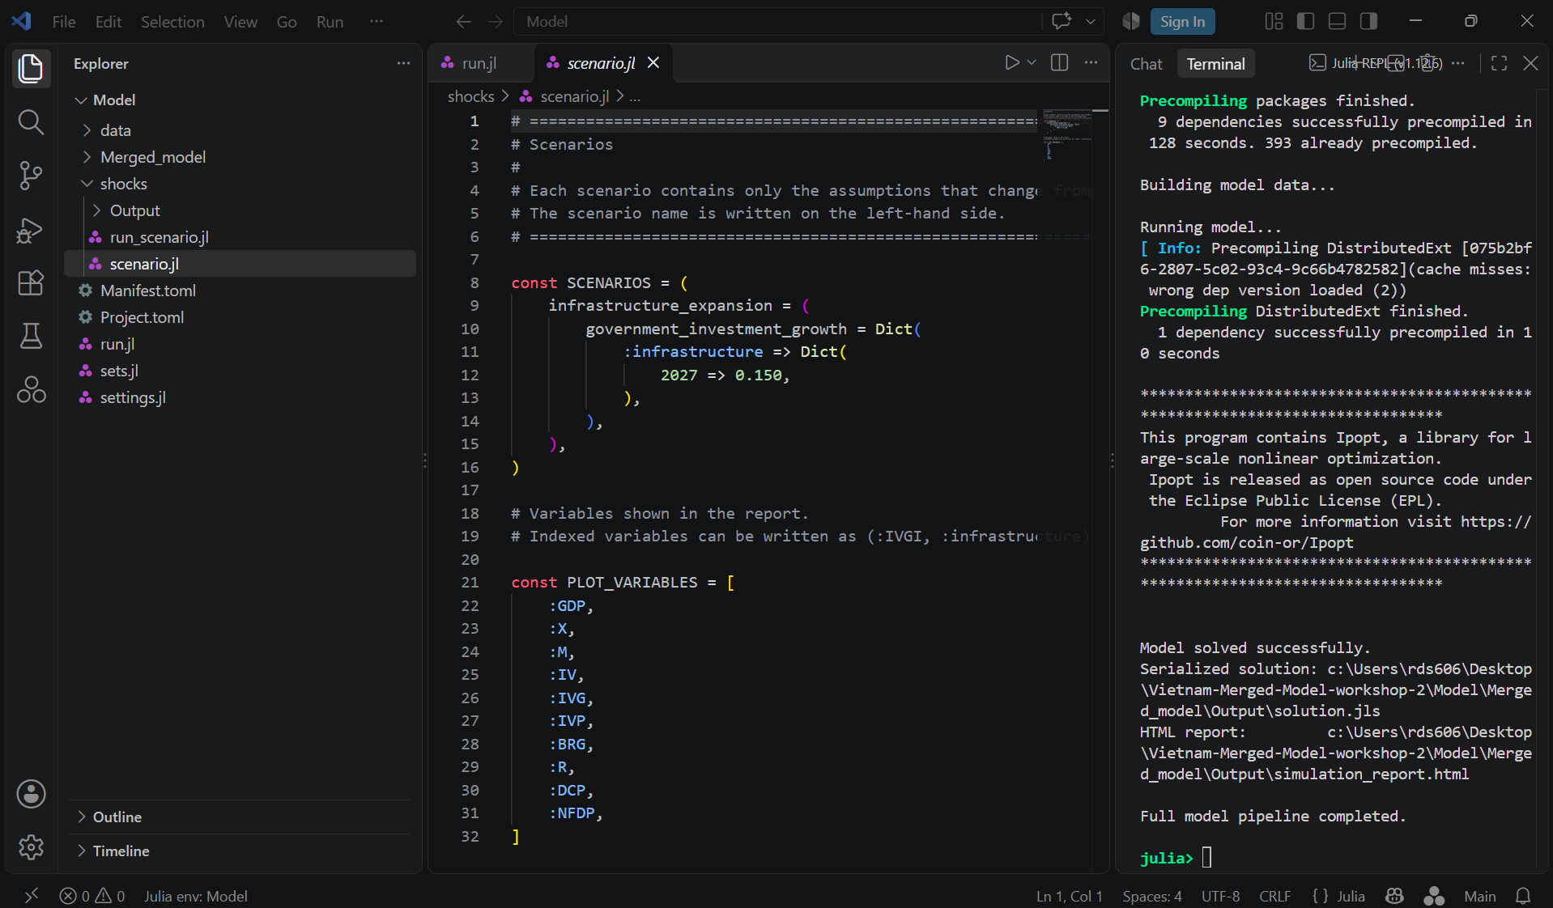
1
2 Give the experiment a name.
Why it matters. Choose a name that tells readers what experiment they are looking at. Julia uses it to label the scenario in the report and name its results folder. The assumptions below the name determine what the model calculates.
In this example. On line 9, highlight infrastructure_expansion and type industrial_export_slowdown. Use underscores between words and keep “=” ( after the name. The report will display Industrial Export Slowdown.
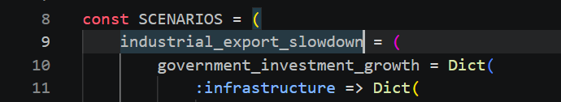
2

Choose what changes and where
3 Choose the model input that represents your experiment.
Why it matters. An assumption is an input the model uses to calculate results. The assumption name tells the model which input to override. Look in Model → data → assumptions.jl for the exact name and its baseline value. Make the scenario edit in scenario.jl so the comparison still uses the original baseline.
In this example. The starting scenario changes public investment growth. We want to test weaker export growth, so on line 10 highlight government_investment_growth and type export_growth. Keep “= Dict(“ after it. This assumption sets the annual export growth rate by sector.
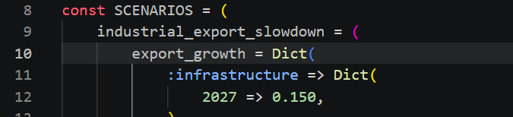
3
4 If the input is split into categories, choose the one affected.
Why it matters. The category tells the model which part of the input gets the new value. Read the categories listed under the assumption you picked. Export growth is split into agriculture, industry and services. Public investment growth has its own categories, such as infrastructure.
In this example. The slowdown is in industry, so replace :infrastructure with :industry on the next line. Keep “=> Dict(“ after it. Agriculture and services use their own baseline export growth rates. For an assumption with a single value, such as exchange_rate_growth, the year entries go directly under the assumption with no category line.
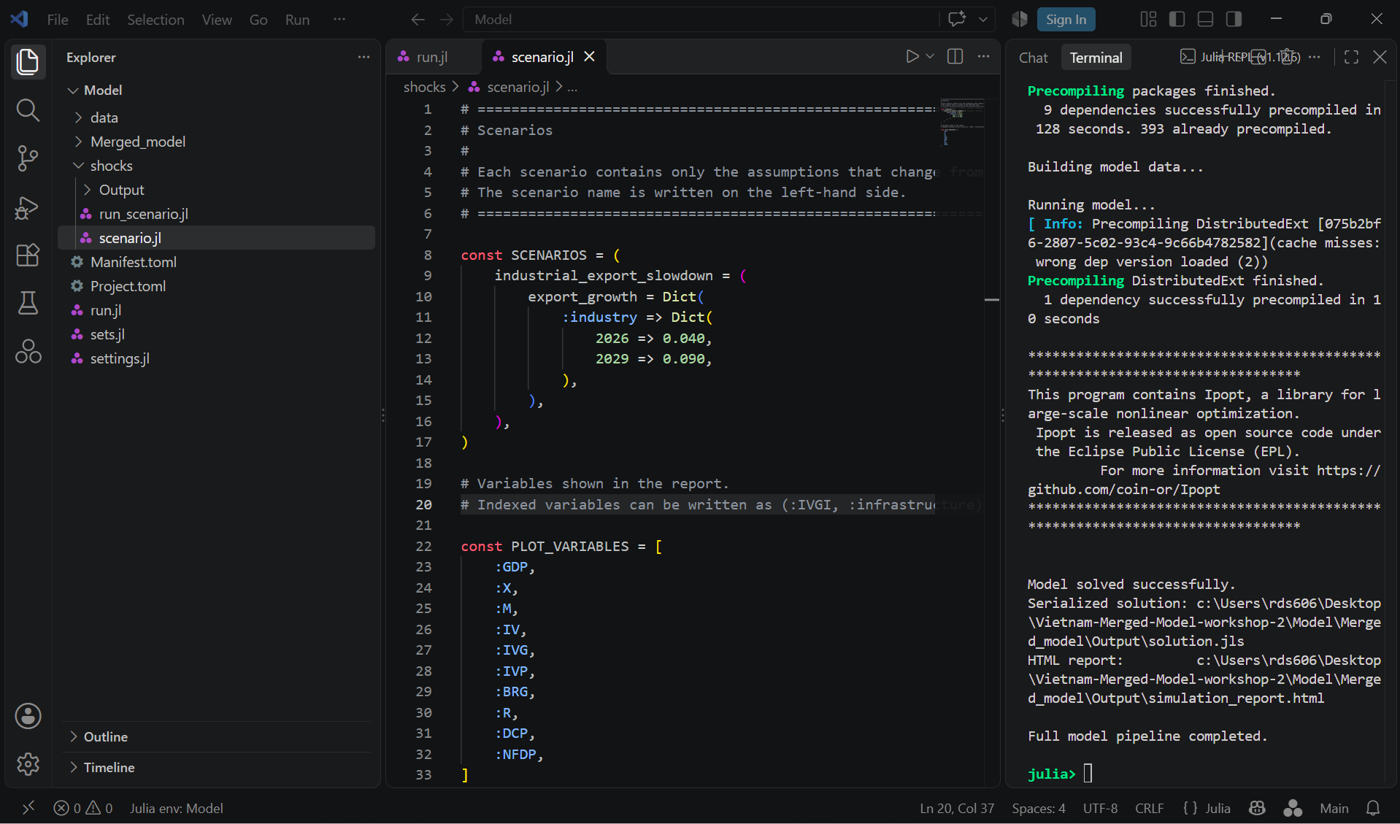
4

Decide when and by how much
5 Enter each year and its new value.
Why it matters. The year on the left tells the model when the change applies. The value on the right tells the model what to use in that year. Pick years in your projection period and check how the assumption is measured. For an annual growth rate, write 4% as 0.040. The model uses 4% as the full rate for that year.
In this example. Industrial export growth is 8.9% per year in the baseline. We test a slowdown to 4% in 2026 (4.9 percentage points below baseline) and a later increase to 9% in 2029 (0.1 percentage points above baseline). Highlight 2027 => 0.150, and enter these two lines in its place.
2026 => 0.040,
2029 => 0.090,
Put one year on each line. Keep the decimal point, arrow, comma and closing parentheses as shown.
5
What the model does. Each year, the model applies that year’s growth rate to the previous year’s exports. Industry uses the baseline rate of 8.9% in years we leave out, including 2027 and 2028. Those years still start from a lower export level after the slowdown in 2026.

Choose the charts and turn scenarios on
6 Choose the results that answer your scenario question.
Why it matters. SCENARIOS sets the inputs used by the model. PLOT_VARIABLES selects the charts to include in the report. You can keep useful entries, add new ones or remove entries you do not need. The report follows the order in the list.
In this example. Use the list below to see the effect on industrial exports first, then on total exports, then on imports. The pair (:XS, :industry) picks one sector from exports by sector. X adds up exports across all three sectors, so it shows how the industry change carries into the total. M lets you check how imports respond.
To match the example, edit the entries between [ and ] so they read as follows. Keep the brackets, colons, commas and parentheses.
(:XS, :industry),
:X,
:M,
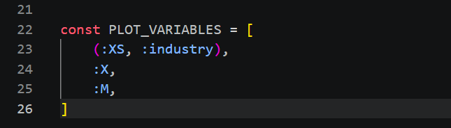
6
7 Press Ctrl + S to save scenario.jl.
8 Open run.jl from the main Model file list. Scroll near the bottom to find run_scenarios.
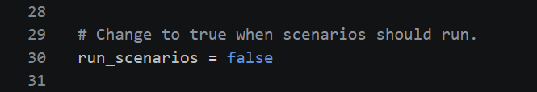
8
9 Change false to true on that line and press Ctrl + S. This tells run.jl to run the scenario comparison after the main model run.
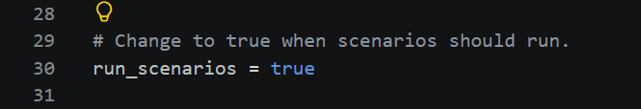
9

Run the scenario from the editor
10 Click inside the code in run.jl. Press Ctrl + A to select the whole file.
11 With the code highlighted, press Shift + Enter once.
Watch the terminal at the bottom or on the right. It will show Running baseline… and then Running Industrial Export Slowdown…
12 Wait for Scenario runs completed. Check that the Report line ends in scenario_report.html.
Full model pipeline completed appears earlier, before the scenario finishes. The browser may open automatically when the scenario report is ready.
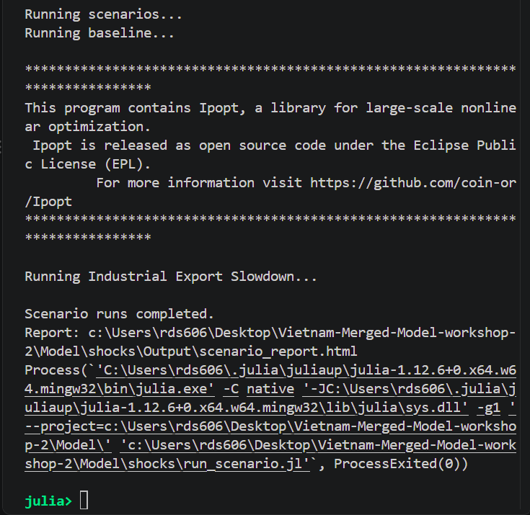
12

Find the scenario report in File Explorer
13 Press Windows key + E. Click Desktop on the left, then double-click the workshop folder you used to run the model. Double-click Model.
Use your own workshop folder name. The screenshots show Vietnam-Merged-Model-workshop-2.
14 Inside Model, double-click shocks.
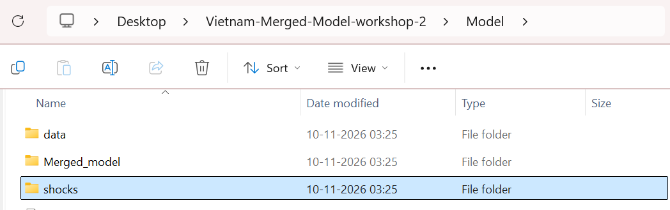
14
15 Inside shocks, double-click Output.
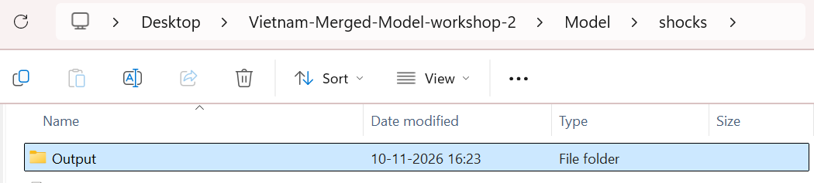
15
16 Inside Output, double-click scenario_report.html.
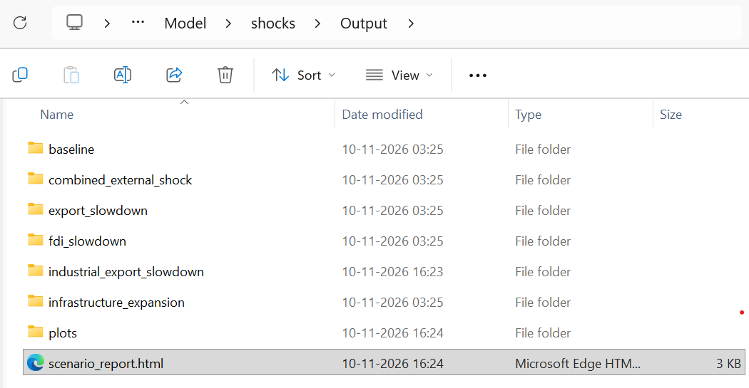
16

Read the scenario report
17 Check that the report shows Industrial Export Slowdown. Scroll down to see both XS – industry charts in full.
The report may list 2029 before 2026 in the assumptions. The year beside each value tells you when the rate applies.
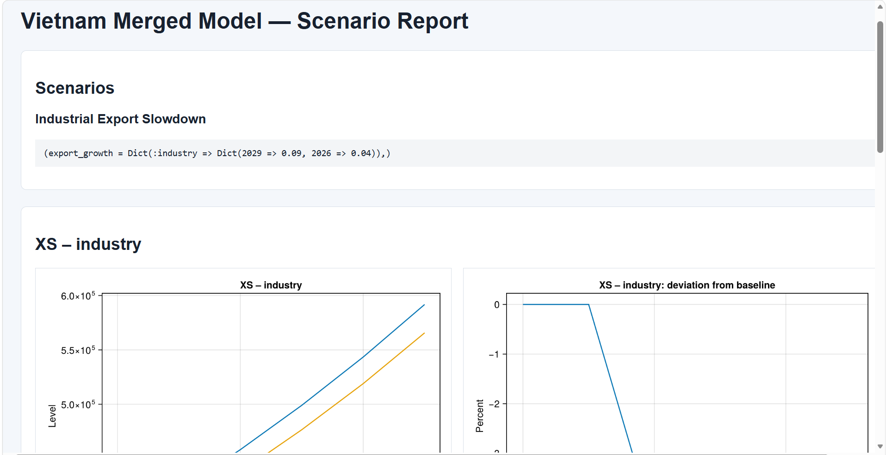
17
A
B
18 Compare the two charts for industrial exports.
A Levels. Compare the blue baseline line with the orange scenario line. Both can rise over time while the scenario stays below the baseline.
B Deviation from baseline. Read the gap as a percentage of the baseline level in each year. A reading near −4.5% means industrial exports are about 4.5% below baseline for that year.
In 2026, the scenario grows by 4% while the baseline grows by 8.9%. Both grow by 8.9% in 2027 and 2028, so the percentage gap stays about the same. In 2029, the scenario grows slightly faster than the baseline (9% versus 8.9%), so the percentage gap narrows to about 4.4%. Exports are still below baseline because they started the year from a lower level.
Ready to continue Scroll down to X and M to compare total exports and imports with the baseline.

