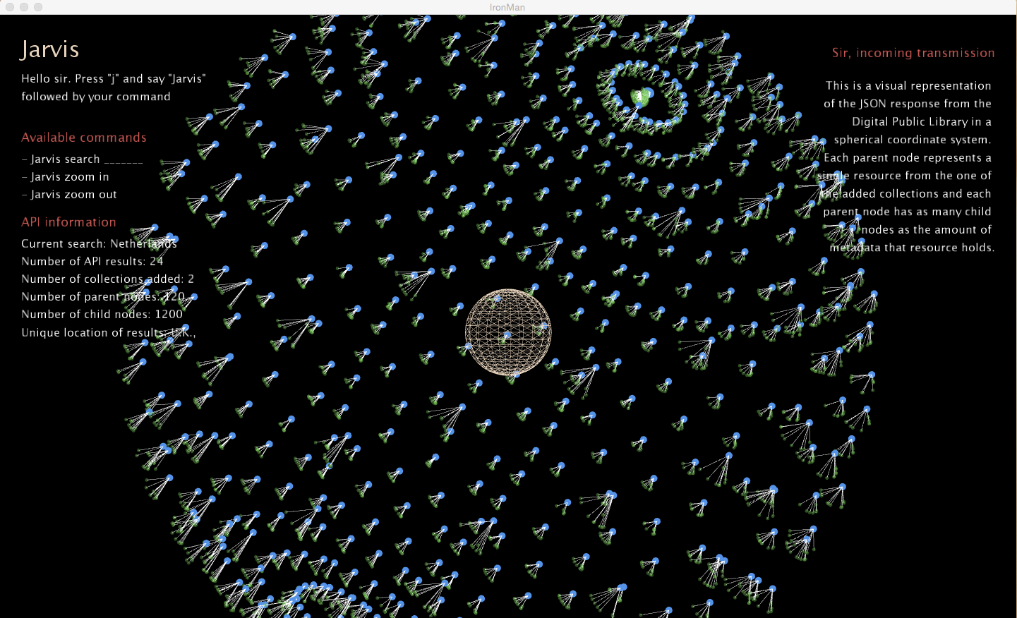**Project 3: Data Portrait**

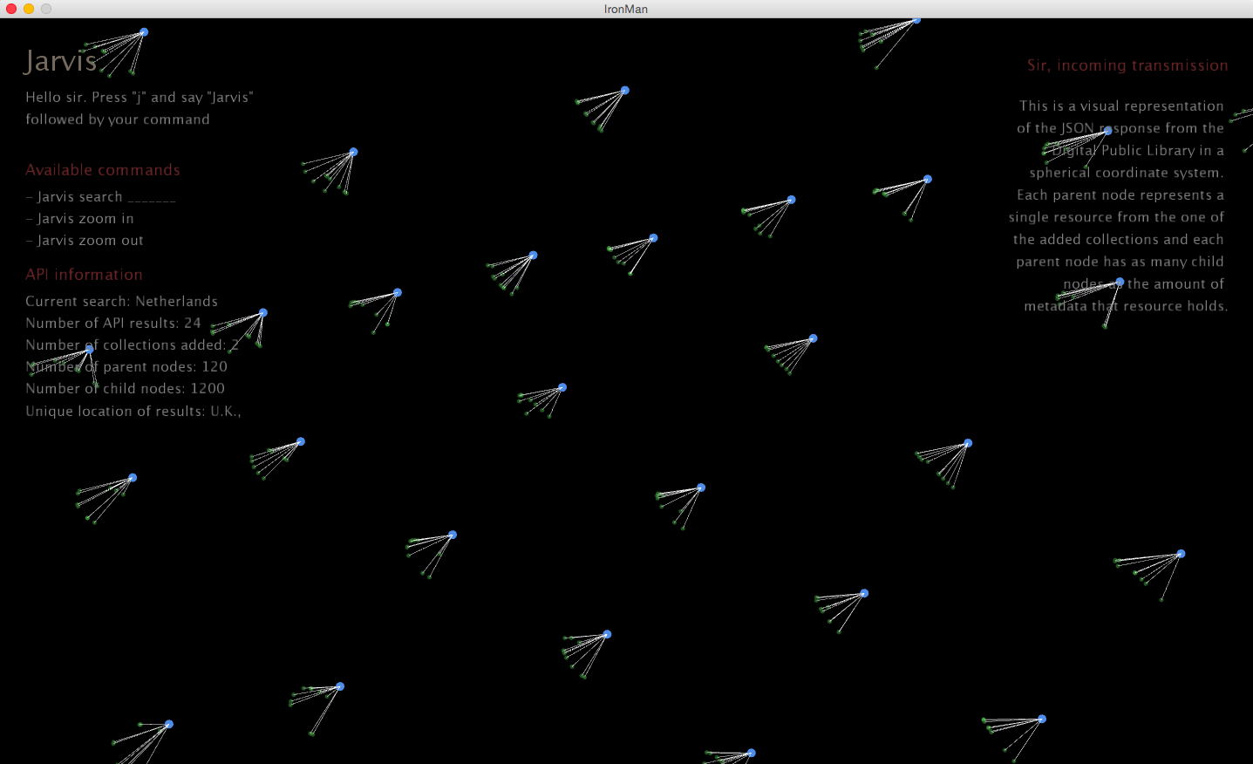

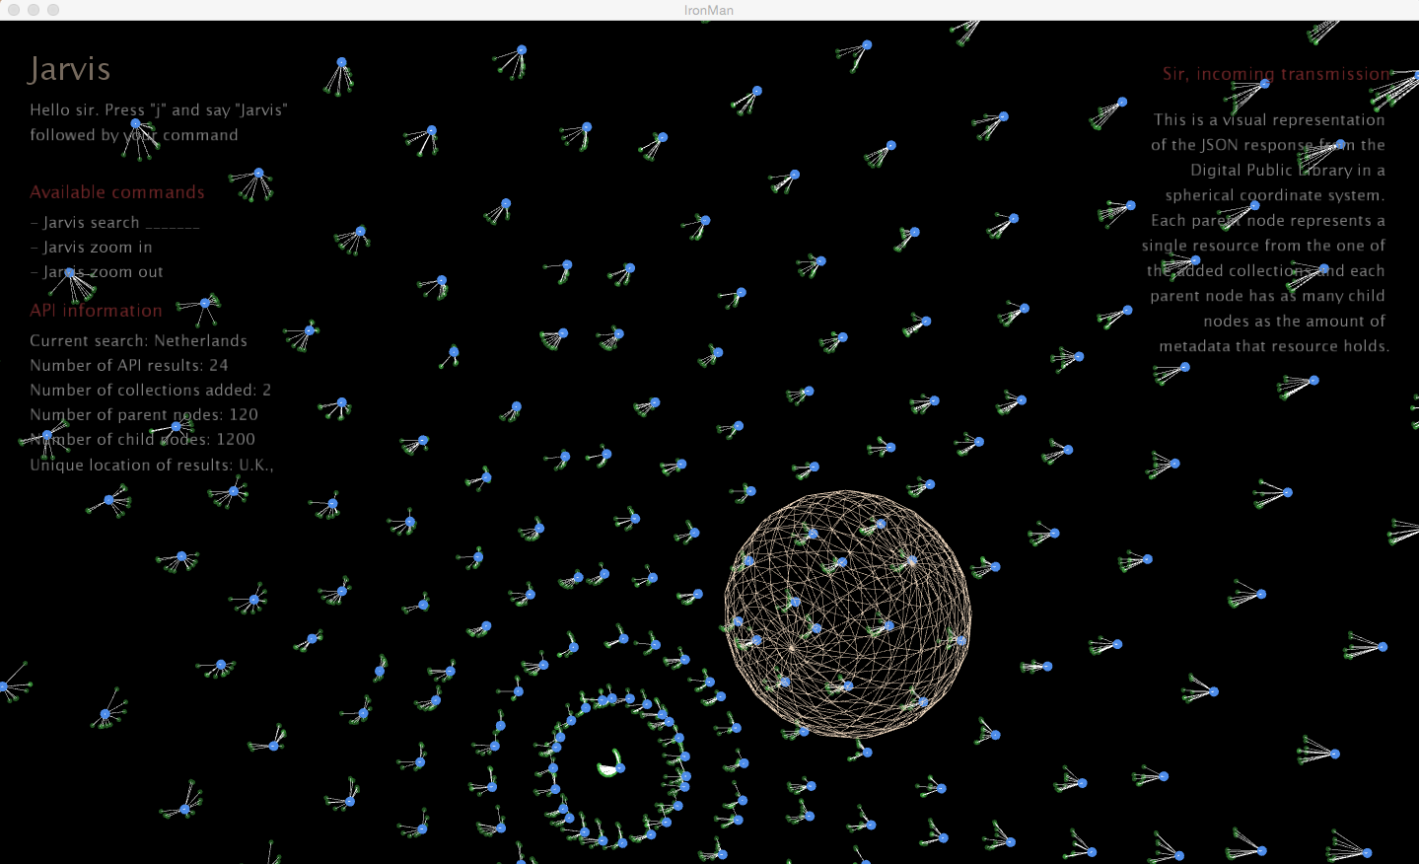

The design and user interaction of the interfaces in the Iron Man movies inspired project 3, hence the name of the piece is *IronMan*. The goal of this piece was to bridge the gap between the physical realm where the user is and virtual realm where the data is. To achieve this goal, I took a page from the Iron Man playbook and incorporated Jarvis translates verbal commands in the physical realm into interactions within the virtual realm.

What you see in the screenshots is a visual representation of the JSON response from the Digital Public Library’s RESTful API mapped to a spherical coordinate system. Each parent node represents a single resource from one of the collections and each parent node has as many child nodes as the amount of metadata that resource holds. During the initial stages of this piece, I wanted to track hand gestures and map those to interactions with the spherical matrix. Unfortunately, after researching the way that OpenCV uses Haar Cascades in order to train for detection, I realized that the available cascades for hands lacked the precision and accuracy that I desired. One of the issues of the hand cascades was that they often picked up on other objects such as your face or the wall behind you, translating into a very messy user experience. After realizing that hand gestures were not going to be the answer, I decided to build Jarvis. Jarvis, Iron Man’s assistant, allows you to interface with the spherical matrix by adding more collections and manipulating the perspective.

A lot of the design choices I made in this piece were inspired by some of the color schemes and layouts of the interfaces found in Iron Man. For example, the color scheme for the text matches the one that makes up Tony Stark’s suit. Also, the layout of the information was designed to imitate the interface of the heads-up-display found inside the suit. The design choices behind nodes were much more conceptual. The parent nodes have opacity of 1, assuming a scale of 0 to 1, while the child nodes have opacity of 0.1. This distinction was made under the belief that, in this case, metadata is much less concrete than the data it describes. However, given enough metadata, you will be able to identify trends and patterns not apparent in the original data. This concept is seen in the fact that as you add more collections via Jarvis, the metadata density increases and thereby becomes more visible. The design choice behind Jarvis, the sphere in the center, was equally conceptual. In relational information systems, while a bit of a buzzword, the term source of truth often refers to the original data source. In this case, Jarvis serves to proxy the origin of truth i.e. the Digital Public Library API, hence why it is in the center. Also, Jarvis changes color according to the Iron Man color scheme, letting you know that he is ready to listen to your next command.

One interesting pattern that I discovered was the phenomenon that I described earlier about data density and metadata. As more collections are added by Jarvis, the more prominent the metadata becomes.