Número de empleados
La compañía HAP lo está contratando para organizar un proyecto, necesita iniciar y desea saber si la estimación de empleados es correcta
Contratacion nueva $250 +300 Costo Fijo
Exceso 450
Tarea Etapa 1 y 2 respuesta
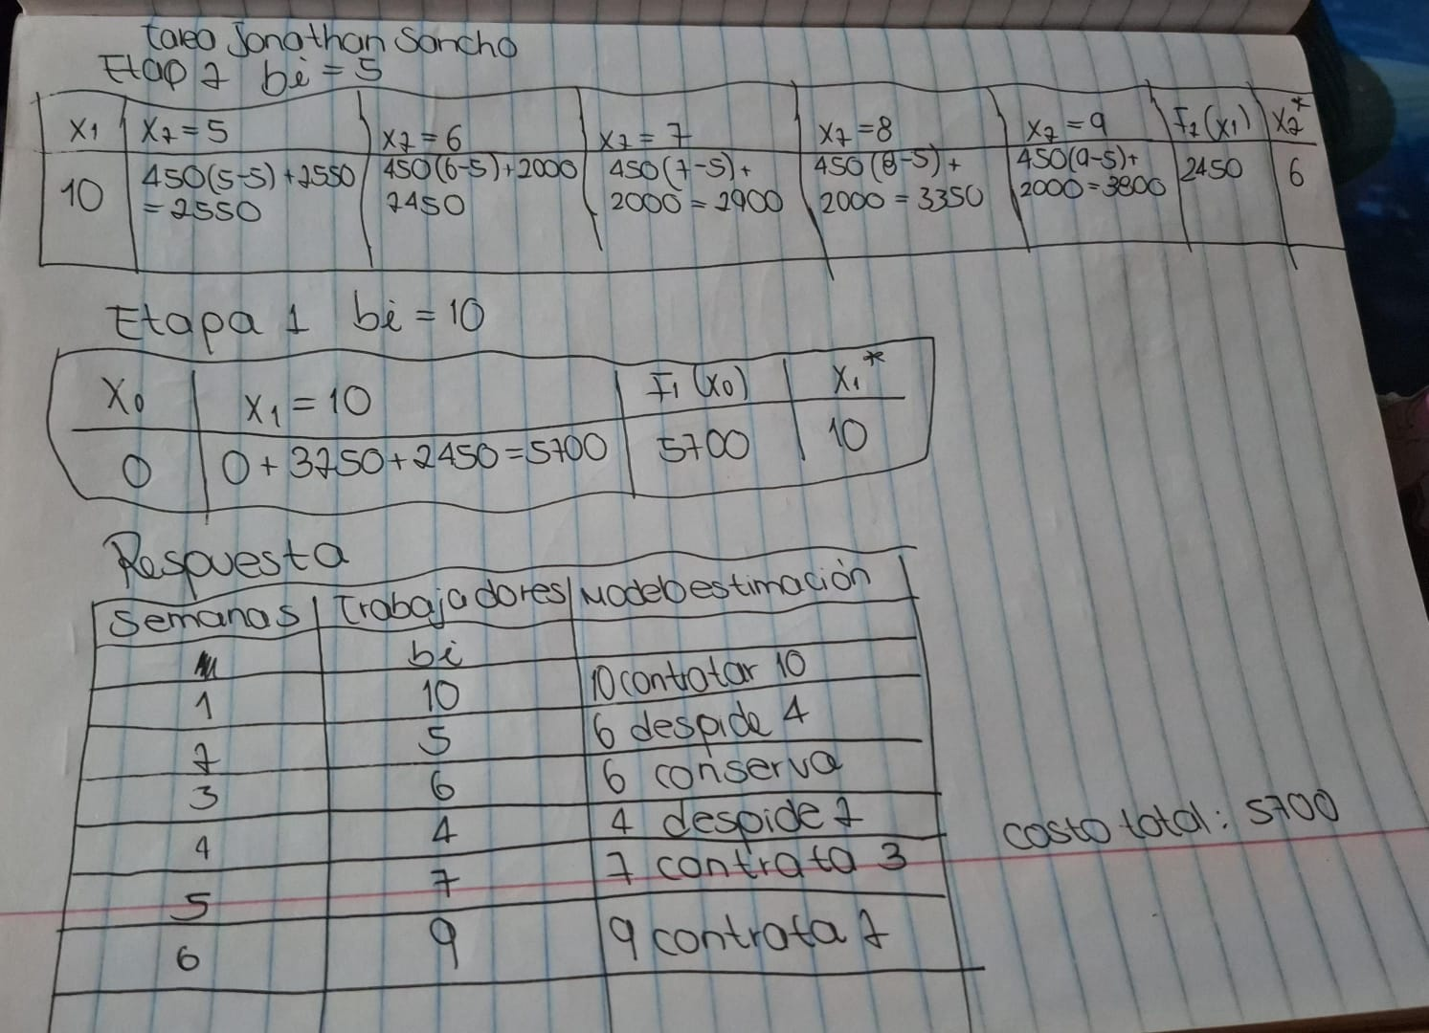
Semana | Fuerza Laboral | Rangos | bi
1 | 10 | 0 | b1
2 | 5 | 10 | b2
3 | 6 | 5-6-7-8-9 | b3
4 | 4 | 6-7-8-9 | b4
5 | 7 | 4-5-6-7-8-9 | b5
6 | 9 | 7-8-9 | b6

Costo de exceso= C1(x_{i}-b_{i}) C1=250
Costo de contratar= C2(x_{i}-x_{i-1}) C2=150
Costo de contratación puede tener ligado <opcional> un valor fijo 300

Etapa6 (bi=9)

X5(xi-1) | Xi=x6=9(require)  450(x_{i}-b_{i})+[250+300 (x_{i}-x_{i-1})] | F6(x5) | X6*
7 | 450(9-9)+[250+300(9-7)]=  0+250+300*2=850 | 850 | 9
8 | 450(9-9)+[250+300(9-8)]=  0+250+300*1=550 | 550 | 9
9 | 450(9-9)+0=0 | 0 | 9

Etapa 5(bi=7) 450(x_{i}-b_{i})+[250+300 (x_{i}-x_{i-1})]+f6(x5)

X4  (xi-1) | Xi=x5=7(require)  450(x_{i}-b_{i})+[250+300 (x_{i}-x_{i-1})]+f6(x5) | Xi=x5=8(require) | Xi=x5=9(require) | F5(x4) | X5*
4 | 450(7-7)+[250+300*(7-4)]+850=  0+250+300*3+850=2000 | 450(8-7)+[250+300(8-4)]+550=  2450 | 450(9-7)+[250+300(9-4)]+0=2650 | 2000 | 7
5 | 450(7-7)+ )+[250+300*(7-5)]+850=  0+250+300*2+850=1700 | 450(8-7)+ [250+300(8-5)]+550=  2150 | 450(9-7)+ [250+300(9-5)]+0=2350 | 1700 | 7
6 | 450(7-7)+ )+[250+300*(7-6)]+850=  0+250+300*1+850=1400 | 450(8-7)+ [250+300(8-6)]+550=  1850 | 450(9-7)+ [250+300(9-6)]+0=2050 | 1400 | 7
7 | 450(7-7)+ )+0+850=850 | 450(8-7)+ [250+300(8-7)]+550=  1550 | 450(9-7)+ [250+300(9-7)]+0=1750 | 850 | 7
8 | 450(7-7)+ )+0+850=850 | 450(8-7)+0+550=1000 | 450(9-7)+ [250+300(9-8)]+0=1450 | 850 | 7
9 | 450(7-7)+ )+0+850=850 | 450(8-7)+0+550=1000 | 450(9-7)+0+0=900 | 850 | 7

Etapa 4(bi=4) 450(x_{i}-b_{i})+[250+300 (x_{i}-x_{i-1})]+f6(x5)

X3  (xi-1) | Xi=x4=4(require)  450(x_{i}-b_{i})+[250+300 (x_{i}-x_{i-1})]+f5(x4) | Xi=x4=5(require) | Xi=x4=6(require) | Xi=x4=7(require) | Xi=x4=8(require)
6 | 450(4-4)+0+2000=2000 | 450(5-4)+0+1700=2150 | 450(6-4)+0+1400=2300 | 450(7-4)+[250+300(7-6)]+850=  2750 | 450(8-4)+[250+300(8-6)]+850=  3500
7 | 450(4-4)+0+2000=2000 | 450(5-4)+0+1700=2150 | 450(6-4)+0+1400=2300 | 450(7-4)+0+850=2200 | 450(8-4)+[250+300(8-7)]+850=  3200
8 | 450(4-4)+0+2000=2000 | 450(5-4)+0+1700=2150 | 450(6-4)+0+1400=2300 | 450(7-4)+0+850=2200 | 450(8-4)+0+850= 2650
9 | 450(4-4)+0+2000=2000 | 450(5-4)+0-1700=2150 | 450(6-4)+0+1400=2300 | 450(7-4)+0+850=2200 | 450(8-4)+0+850=2659

X3  (xi-1) | Xi=x4=9(require) | F4(x3) | X4*
6 | 450(9-4)+[250+300(9-6)]+850=4250 | 2000 | 4
7 | 450(9-4)+[250+300(9-7)]+850=3950 | 2000 | 4
8 | 450(9-4)+[250+300(9-8)]+850=3650 | 2000 | 4
9 | 450(9-4)+0+850=3100 | 2000 | 4

Etapa3 (bi=6)

X2  (xi-1) | Xi=x3=6  6(require)  450(x_{i}-b_{i})+[250+300 (x_{i}-x_{i-1})]+f5(x4) | Xi=x3=7(require) | Xi=x3=8(require) | Xi=x3=9(require) | F3(x2) | X34*
5 | 450(6-6)+[250+300(6-5)]+2000=  2550 | 450(7-6)+[250+300(7-5)]+2000=  3300 | 450(8-6)+[250+300(8-5)]+2000=4050 | 450(9-6)+[250+300(9-5)]+2000=4800 | 2550 | 6
6 | 450(6-6)+0+2000=2000 | 450(7-6)+[250+300(7-6)]+2000=  3000 | 450(8-6)+[250+300(8-6)]+2000=3750 | 450(9-6)+[250+300(9-6)]+2000=4500 | 2000 | 6
7 | 450(6-6) +0+2000=2000 | 450(7-6)+0+2000=2450 | 450(8-6)+[250+300(8-7)]+2000=3450 | 450(9-6)+[250+300(9-7)]+2000=4200 | 2000 | 6
8 | 450(6-6) +0+2000=2000 | 450(7-5)+0+2000=2450 | 450(8-6)+0+2000=2900 | 450(9-6)+[250+300(9-8)]+2000=3900 | 2000 | 6
9 | 450(6-6)+0+2000=2000 | 450(7-5)+0+2000=2450 | 450(8-6)+0+2000=2900 | 450(9-6)+0+2000=3350 | 2000 | 6
Etapa 2
5-6-7-8-9 columnas
Filas
10

Etapa 10 columnas
0

Respuesta

