**~ The Church In Brielle ~**

**821 Riverview Dr. ~ Brielle, NJ, 08730**

**Weekly Announcements May 14, 2023**

**Join Us For Worship at 10:00 AM Sunday Mornings**

**In The CIB Sanctuary and Facebook Live**



**The Church In Brielle Directory Project**

It is time to create a church directory **with pictures** – and we need you!! We currently have a spreadsheet of names, addresses, telephone numbers, and email addresses that is somewhat functional. We want to make an easy access directory for all (online and print).

**Two Requests:**

1 - Complete the form at this link and upload your favorite individual or family photo - and submit. <https://docs.google.com/forms/d/1UYVYPUvivIzLRHCcxJQv-5yXprDTwZMNeOCpXajvqKI/edit?pli=1>

2 - Let us know if you would like to work on compiling the information as it is submitted. We are using Google Forms to gather the info - open to how to organize and print / post.

Have ideas or time to help? Contact Shannon Nish at [shannonscott11@gmail.com](mailto:shannonscott11@gmail.com) or Lori Keasel at [lorik86@gmail.com](mailto:lorik86@gmail.com)

**It’s Gentle Meditative Yoga Time:**



Join us for **Gentle Meditative Yoga** with Tom Manni, on Wednesdays, from 4:00-5:00 PM in Fellowship Hall.

All futures classes will be $10.00/ per class. Tom has an extensive background in yoga and is well known within the local communities.

***Bring a mat and enjoy tranquil stretching & relaxation of yoga.***

**Qi Gong Is Back!**

**With Deborah Kehoe**

**Starting Wednesday,**

**May 24, 2023, 5:00 – 6:00pm**

**What is Qi Gong? (chee-gong) A form of traditional Chinese mind/body exercise and meditation that uses slow and precise body movements with controlled breathing and mental focusing to improve balance, flexibility, muscle strength, and overall health.**

**You will experience movement, breathing, self-massage, and short meditations in the class.**

**Classes are $10.00.**

**For more information, please see our Qi Gong Instructor, Debbie Kehoe’s website.** [**https://www.mindfulnessmovementmusic.com/**](https://www.mindfulnessmovementmusic.com/)

**F E L L O W S H I P**



**Strawberry Shortcake Fellowship and First Friday Night Fire Pit: Join us on June 2nd from 6:30 to 7:30 for Strawberry Shortcake Night. Hosted by our Grief Support Group. Fun for the whole family!**



**Then at 7:30 PM for a time of fun and fellowship for young and old at the Fire Pit! We will gather in the side yard. We will make smores, roast marshmallows and have a great time getting to know each other and having fun! Please bring a chair, blanket or towel!**



**Join us after worship for refreshments and fellowship after worship. Our Fellowship Ministry is looking for people groups in the church to host a coffee hour on the First Sunday of each month. We will set up the coffee and tea pots.**

**GROUNDS FOR SCULPTURE**

**HAMILTON, NJ**

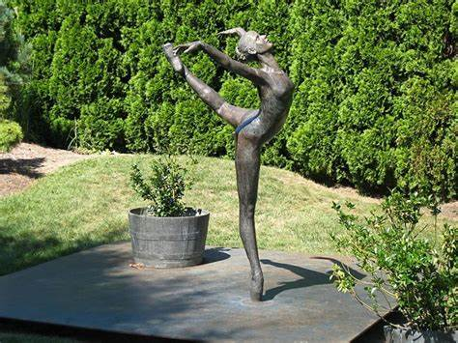

**W O M E N ’ S M I N I S T R Y**

The Church in Brielle Women’s Ministries will be hosting their first field excursion on **Wednesday, May 17, 2023**, to **The Grounds for Sculpture**, Hamilton, New Jersey.

Our trip be open to the ladies of all ages in our church family. We plan to arrive at the Sculpture Gardens at **11:30 am**. We are asking everyone to purchase tickets on their own. You may do so online at: www.groundsforsculpture.com

There you will find a complete pricing breakdown.

Admission is timed so make sure that you select the correct date and time. Transportation will also be on your own.

If you need a ride or are able to car pool reach out either Betsy Cross; 732-688-3630, [bcross17@aol.com](mailto:bcross17@aol.com) or Denise Sala: 732-616-0184, [colours8490@gmail.com](mailto:colours8490@gmail.com) who will help coordinate transportation if needed.

There are two cafes on the premises: the “Van Gogh Café” and the “Peacock Café” where you will be able to enjoy a lovely lunch dining inside or outside in a park like setting.

You are on your own if you wish to dine at “Rats”. Lunch is served from 11-3.

They require reservations: 609-584-7800. You are on your own to make arrangements.

NO OUTSIDE FOOD IS ALLOWED ON SITE! Please RSVP to both Betsy and Denise if you plan to attend. If you have any further questions reach out to them as well.

Please join us for a lovely day full of wonderful works of art, fun and fellowship!

**THANK YOU!**

**To all who contributed to our Cow fundraiser on May 7th.**

**Whether you made food and/or made a monetary contribution we couldn't have done it without you.  We made our $450 goal plus some with a total of $456. We will purchase a cow to give to a family in a third-world country. I will make sure to keep everyone updated on the status of our Cow.**

**The children are super excited!!!!**

**Shannon Nish**

**Vacation Bible School:**



**Save the date for July 10-13, 2023, 9:00 AM – 12:00 PM**



**Ways to Give:**

* Place your offering in one of the offering plates in the sanctuary
* Mail in check
* Arrange with your bank to mail in a check
* Vanco Mobile Faith Engagement
* Coming soon – donate button on new website



**June 4th is**

**Communion Sunday:**

**Virtual worshipers at home, please gather the elements of the Sacrament, the bread and the juice, before worship and we will consecrate all the elements together and feast at Jesus’ table. Celebrate the real presence of the Risen Christ!**

MISSION OF THE QUARTER: APRIL, MAY AND JUNE

Dear Church Family,

We’ve been asked by Rev Seth Kaper-Dale of The Reformed Church of Highland Park and the Immigration Program we’ve been supporting, to raise money for a local family with an unexpected rent increase. The family has been in financial need but now, the primary breadwinner is receiving chemotherapy for cancer treatment. Our mission’s support for the second quarter will be for this family. Please indicate on your check, “Missions” when supporting this important need.



***Plumpy Nut Ongoing …***

We have resumed collecting money for ***Plumpy Nut***!!! Each $1.50 worth of nutrition rich nut-based food bars (3 packets) provides a days’ worth of nourishment and calories for a child.

***Plumpy Nut*** is sweeping the world and can literally eliminate child hunger in the whole world in 2 decades!

**More On Missions…**

**We Have Opportunities To Assist Asylum Seekers, Refugees And Immigrant People Fleeing Inhuman Living Conditions With The Items Below… Please Bring These To The Church As You Come Across Them Or Acquire Them.**

6 can openers

9    8 x 5 rugs

8 first aid kits

15 kitchen trash cans

6 irons

8 mops and buckets

5 shopping carts

8. Kitchen trash bags

7 canister vacuums, no bags

9 sets steak knives

8 sewing machines

8 instant pots

15 twin bed sheet sets, new

11 twin blankets, new

9 new Queen blankets or comforters

10 new Queen sheet sets

5 microwaves

8 sets pots and pans

10 large pkgs toilet paper

14 sets cooking utensils

3 tea kettles

12 dish soap

13 bathroom cleanser

10 each plastic wrap and aluminum foil

5 thermometers

6 toilet cleaner and plunger

12 shampoo and conditioners

8 booster seats

9 infant car seats

4 baby security gates

5 cribs or bassinets

10 baby sheets and blankets

10 cold and flu medication

9 sets of mixing bowls

6 colanders

7 baking sheets

30 spiral notebooks

13 pencil cases

20 bath towels

1 dish drying mat

16, 8 qt pots or larger

20 sauce pans

15 frying pans

4 rice cookers

8 slots deep baking pans

5 diapers- all sizes

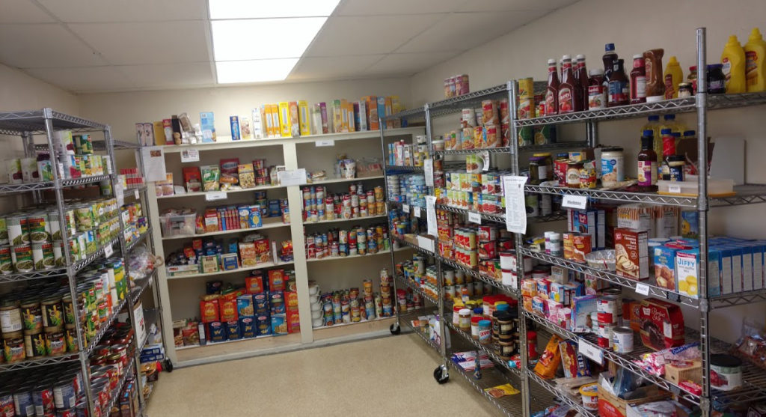

**FOOD PANTRY:**

***Please Will* *You Donate?*** Thanks to all of you who answered the pantry’s request last month for spring cleaning supplies! During May, we’re thinking “***p’s*** ***- peas, pears. pineapple, pet food, pasta sauce and pork & beans.*** Also appreciated are monetary donations and gift cards from Aldi or ShopRite to help with necessary purchases that may not be available from Fulfill. Thank you for remembering those families new to the pantry and those who are now visiting us more frequently.

**DO YOU WORSHIP WITH US MOSTLY REMOTELY????**

**Worshiping with us on Facebook Live?**

**You are important to us! Please let us know who you are, your contact information, and any questions you have.**

**Worshiping with us on Facebook Live?**

**Let us know how you would complete the following…**

**\* The greatest need of my community is…**

**\* My greatest need is…**

**And be sure to give us your approximate age for our survey results.**

**Cypress Missions:**

As Cypress continues our work and presence in Fort Myers and other states, our focus on local needs continues to be a priority and “loving our neighbors” has become more important than ever.

Senior citizens, military vets, and families struggling with challenges daily has been a big part of our activity these last few months. The relationship between the staff at Asbury Towers and a social worker network has provided us with individuals who now have what they need, and it has been a blessing to be part of this.

**Upcoming Events/Projects:**

**Gretna Glen Camp, Lebanon, PA – Planning Meeting**

Ø  April 19th - 6:15pm – Meeting at St. Paul’s UMC, Brick, NJ

·         Trip dates – August 21-25

·         Discussing cost, work projects and other important details of trip

·         Website:  [www.gretnaglen.org](http://www.gretnaglen.org/)

**Spotswood Pixie Preschool, Spotswood, NJ**

Ø  April 22nd – 9:00am

·         Lunch provided

·         Various work projects including painting

·         Demolition of shed and general cleanup

**Miss Beverly’s home,**[**63 Howard Ave, Tinton Falls**](https://www.google.com/maps/search/63+Howard+Ave,%0D%0ATinton+Falls?entry=gmail&source=g)

Ø  May 6th and 7th – 9:00am

·         Lunch provided

·         Ongoing work and repairs

·         Painting, back deck repairs and beginning of interior repairs

**Bethel AME Church, Asbury Park, NJ**

Ø  Saturday May 20th – 8:30am

·         Lunch provided

·         Parsonage repairs and completion of [126 Atkins Ave](https://www.google.com/maps/search/126+Atkins%0D%0AAve?entry=gmail&source=g)

**Bethel Clothing Closet, Asbury Park, NJ**

Ø  1st and 3rd Saturday each month - 10am-12noon

We look forward to seeing you and working together on some of these projects.

As always we remain thankful for your support and involvement. Freddie

Sunday Mornings and Children at The Church In Brielle



**We are so excited for 2023 & what it will bring for our children’s ministry.**

**In this new year we would love for you to be part of our wonderful Sunday School program and run/assist a Sunday School lesson.  You will find the Sunday School teacher/assistant sign up** [**HERE.**](https://docs.google.com/spreadsheets/d/1mwDDEZERe_gkNi7v1j7sbd46UFo_9Uey5YKDN1S5M-8/edit?usp=sharing)**If you have any questions, never hesitate to contact me. God’s Very Best, *Shannon Nish***

**Our curriculum is *“Godly Play ~ Children And Worship”*, a Montessori based program that engages all the senses.**

**1st Sunday - Communion Sunday.**  Students will leave for the sermon for a special time of fun fellowship to create closer bonds with each other (either on the playground or inside).  Children will then be welcomed back in for Communion. All children are welcome to celebrate the Sacrament!

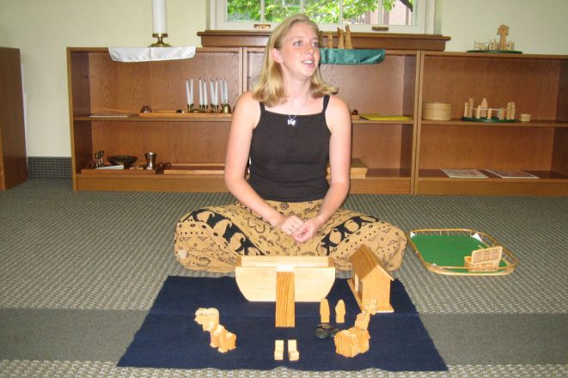 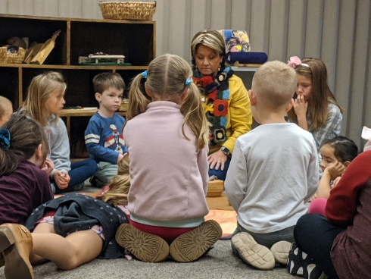

**2nd and 4th Sundays – ”Godly Play ~ Children and Worship” Lesson**

Children experience Bible Stories slowly coming to life, and then they respond to what they experienced in their own way using a variety of art mediums and active learning. Learners see themselves in God’s unfolding stories and experience God’s love firsthand. The focus is not on people made rules but on the stories God gave us in the Bible.

**3rd and 5th Sunday - Monthly project** (mission based, service oriented, inclusivity minded, seasonal activities)

**Join us for community, faith formation, fellowship!**

**ONGOING ONGOING ONGOING ONGOING**

**Support and Discipleship and More**



**Friday Grief**

**Support Group:**

**Got Grief?**

**Join fellow grievers each**

**Friday at 10 AM to learn**

**tools of coping & living**

**and to support each other.**



**Weekly Bible Study:**

**Not meeting on May 16th, May 23rd or June 6th**

**Join us on Tuesday Mornings at 10:00 AM for our weekly Bible Study. We are taking a deeper look into The Book of Psalms in the Old Testament– The Bible’s Hymnbook! Many Psalms are well known like Psalm 23, *“The Lord is my shepherd, I shall not want.”* Want to know more about God’s Word and being a disciple of Jesus? Then join us on Tuesdays in person or virtually!**

**Invite Link** <https://us02web.zoom.us/j/85492832954?pwd=RCsyYWM5dm8yQUMyaUFxaVZYMGI4QT09>

**Weekly Thursday Evening**

**Not meeting on May 25th or June 8th**

**“Basics For Believers and Seekers”**

**Our series of “basics…” explores**

**the messages of two of the greatest productions of Jesus:**

 

***Godspell and Jesus Christ Superstar.***

***Just perfect if you are new to the group!!!***

**Thursdays with dinner (usually pizza but maybe a surprise) at 6:00 PM, we discuss basic understandings about the Bible, prayer, faith, The Reformed Church in America (the denomination we belong to) and more, like the Sacraments and whatever question you have. It is an informal, setting where questions are asked and discussion happens and opinions count. Come as you are in this casual, safe and laughter filled time together.**



**Daily Devotions:**

**Weaving scripture and prayer, these short – n – sweet devotions will be a great way to begin or end your day! Find them in your emails each day! If you are not receiving these daily inspirational messages email** [**pastorlou@churchinbrielle.org**](mailto:pastorlou@churchinbrielle.org)**.**

**Employment Opportunities – Perfect For People Seeking Employment And Making A Difference In People's Lives!**

**North, Central and South New Jersey!**

Hi Friends,

As many of you know, the Reformed Church of Highland Park Affordable Housing Corporation has grown dramatically over the past couple of years.  We are proud of the work that is occurring through the programs that live under this 501c3, programs like Interfaith-RISE, Still Waters Anti Trafficking, ReEntry Housing, Asylum Seeker Housing, Global Grace Health and Accompany Now.

Our staff is growing, but in no arena are we growing faster, right now, than in our program for Unaccompanied Minors.  There is a huge need to meet in NJ, and our funding has increased from a team of 8 to a team of 38 in a 6 month period.  We have not yet filled all our positions.

We are looking for excellence in Spanish/English, a college degree and some experience in the helping professions.  Some of the jobs we are filling require years of experience, and an MSW, but others do not need that high a level of experience and education.

We have positions open in Jersey City, in Trenton, in Vineland and, due to the fact that we are serving youth all over the state, we can hire people from all over the state.  2-days a week staff will be required to be in the office nearest to them, but the other three days are spent in client homes and helping with the requirements of the program (school registration, legal consultations, mental health support, benefits, health care sign up).

Please take a look at the listings here:   <https://rchp-ahc.org/employment-opportunities/>

We are hiring NOW and seeking your help in finding good candidates.

Peace, Seth Kaper-Dale,

Highland Park Reformed Church

**Joys, Gratitude & Concerns And Prayer**

**Please share your joys - births, birthdays, anniversaries, graduations –**

**and concerns - pictures are welcome! Contact Pastor Lou at** [**pastorlou@churchinbrielle.org**](mailto:pastorlou@churchinbrielle.org)

**Church Triumphant:** Our thoughts and prayers are with Beth Sauerbray and her family in the passing of their dear friend, Chris Porter into the nearer presence of God. And as we offer our condolences we celebrate with them in the birth of Hailey Stephenson, Beth Sauerbray’s 10th great grandchild and Sue Stephenson’s fourth granddaughter!

**Do not worry about anything, but in everything by prayer and supplication with thanksgiving let your requests be made known to God. And the peace of God, which surpasses all understanding, will guard your hearts and your minds in Christ Jesus.**

Philippians 4:6-7

**Prayer Concerns:**

Pat Stenson

Eddie Edwards

Andrea Huber

Jeff Huber

John and the Oswald Family

Glenn Herb

Candace Moose

Gerald Morie

Dr. Bob & Joanne Evans

Al Olesky

Pat Stefan

Henrietta Kiser Fox

Holden Messler (7)

Betsy Ewertsen

Rodney Thomas

Vincent Higginbotham

Glenn Zadroga

Patty Parra, Betsy Cross’

Mom

Trisha Reo. Nancy

LeBlanc’s friend

Bob and Patty Grover

Carl Flohs

Beth Sauerbrey

Jayne Linfante

Mary Ann Rowe

Beverly Hoffman

Addison, the Wohlt-

man’s niece

Marcy VanZile

Al Comire

Sheryl Guerrero

James Bitzer (3)

Olivia Cole

Cynthia Farley

Rosemarie Pagliuca

June Parrott

Erin Rebas (young mom

being treated for

cancer)

Geraldine (Gerry) Ciullo,

sister of Rose-

marie Pagliuca

Katherine Herold, Cathy

Conover’s mom

Masie DePalma, Leslie

Duerr’s mom

Eddie Edward’s Parents

Jean Hyrinkawitz

Marilyn (Linfante) Eisser

Russel Wester, Pat Stefan’s brother

**Pray For: Turkish and Syrian victims of earthquake devastation**

**For Peace In Ukraine! Military Serving in the US and Abroad!**

**Safe Schools, Churches, Places of Worship, Communities!**

**All Impacted By COVID~19 – Physically, Emotionally & Financially,**

**Immigrants and Refugees, like those involved in DIRE and Accompany Now,**

**and the families of Family Promise and the Food Insecure**