**Main Page**

(going to add profile icon at top right)

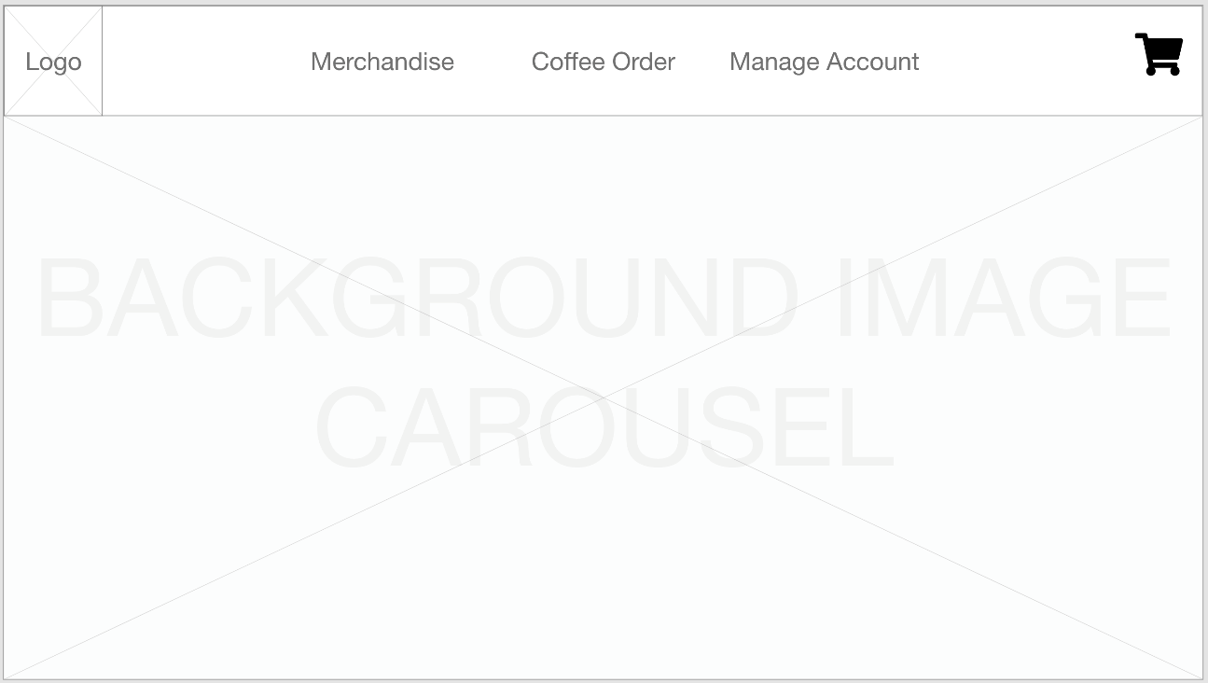

**Profile**

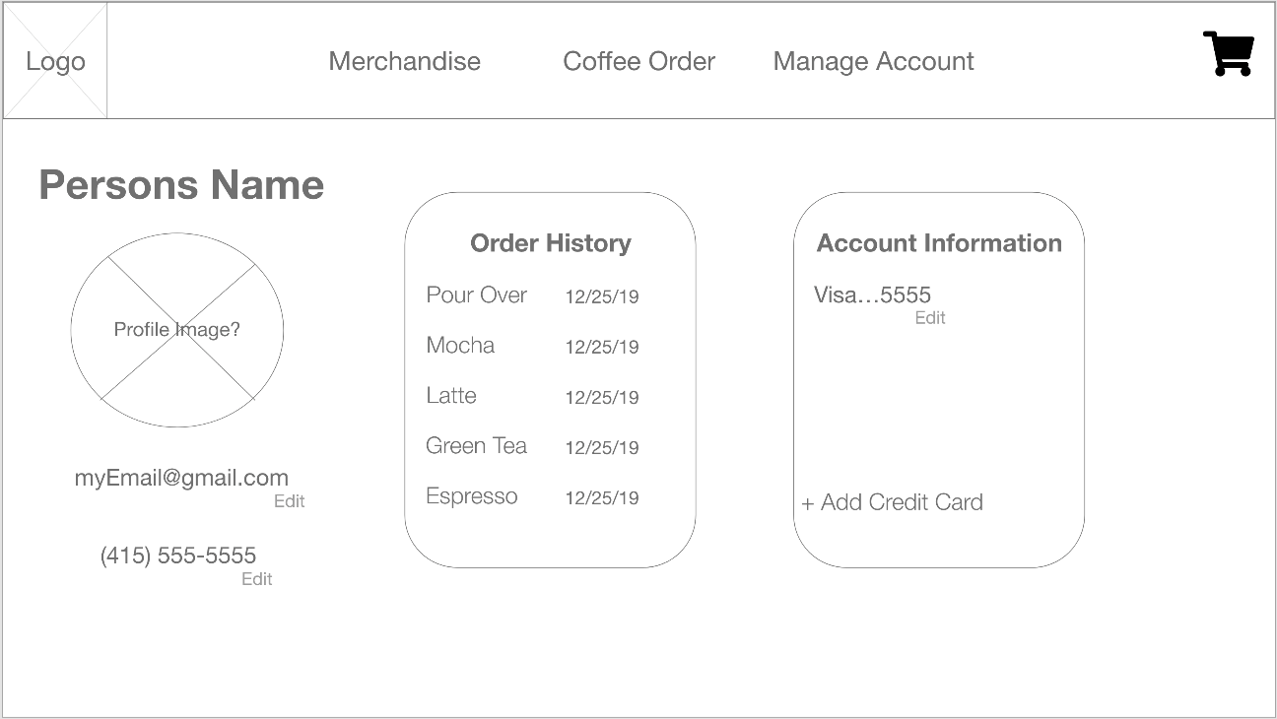

**Cart**

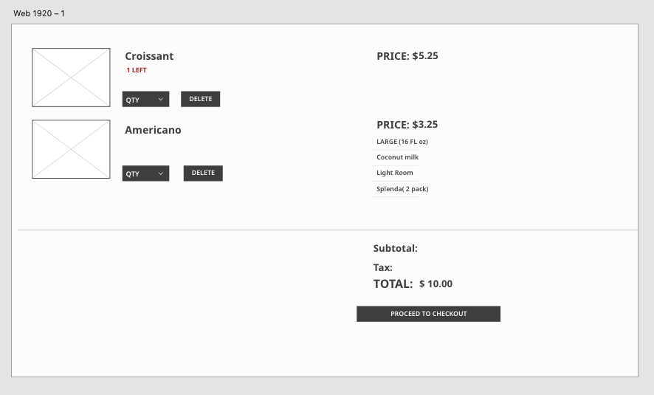

**Admin Drink/Baked Good Creator**

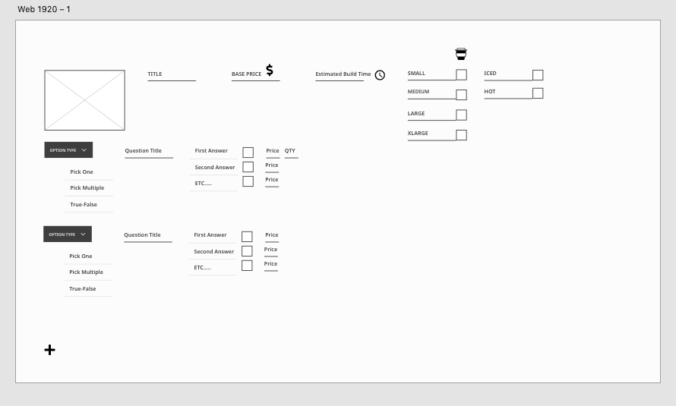

**Checkout**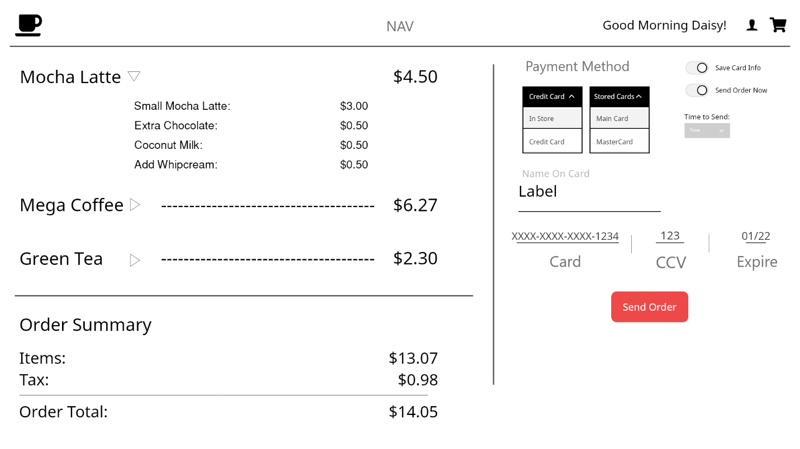

**Admin Orders (Barista View)**

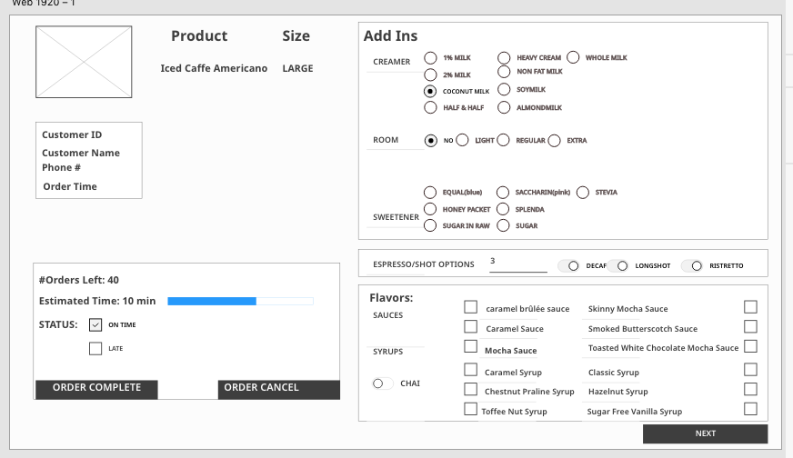

**Still need to add Order drink and Order Merch, those are working.**