CHAPTER FOUR: IMPLEMENTATION AND DOCUMENTATION

4.1 Introduction
This chapter presents the implementation, results and evaluation of the power-aware machine learning system developed for edge battery monitoring. It follows the methodology in Chapter Three and reports only what the software produced. Every value in the tables and figures was taken from the result files generated by the project software.
Three differences from the proposed methodology must be stated at the outset. First, no physical battery, sensor circuit or microcontroller was used; the experiments were run offline on the public Panasonic 18650PF dataset [Author to add the APA citation for the dataset, as given in the dataset readme]. Second, the dataset contains no measured State of Charge (SoC), so a derived, capacity-referenced coulomb-counting proxy was used as the target. All accuracy figures therefore describe agreement with this proxy and not validated SoC accuracy. Third, electrical power consumption was not measured. Model size, inference latency and process memory, measured on the host computer, were used as software resource indicators.

4.2 Implementation

4.2.1 Software Components
The system was implemented in Python 3.10 using NumPy and scikit-learn. Figure 4.1 shows the eight stages that exist in the repository and the result file each produces. Stages 1 to 3 read the dataset, audit and derive the SoC proxy, and prepare the data. Stage 4 compares three candidate models: ridge regression, Random Forest and Extra Trees. Stage 5 reduces the selected Random Forest by lowering its number of trees and leaf nodes. Stage 6 measures model size, inference latency and process memory on the host. Stage 7 exports the models as standalone C99 code and checks them against the scikit-learn originals. Stage 8 repeats the evaluation with leave-one-cycle-out validation and tests the sensitivity of the proxy to the capacity reference.
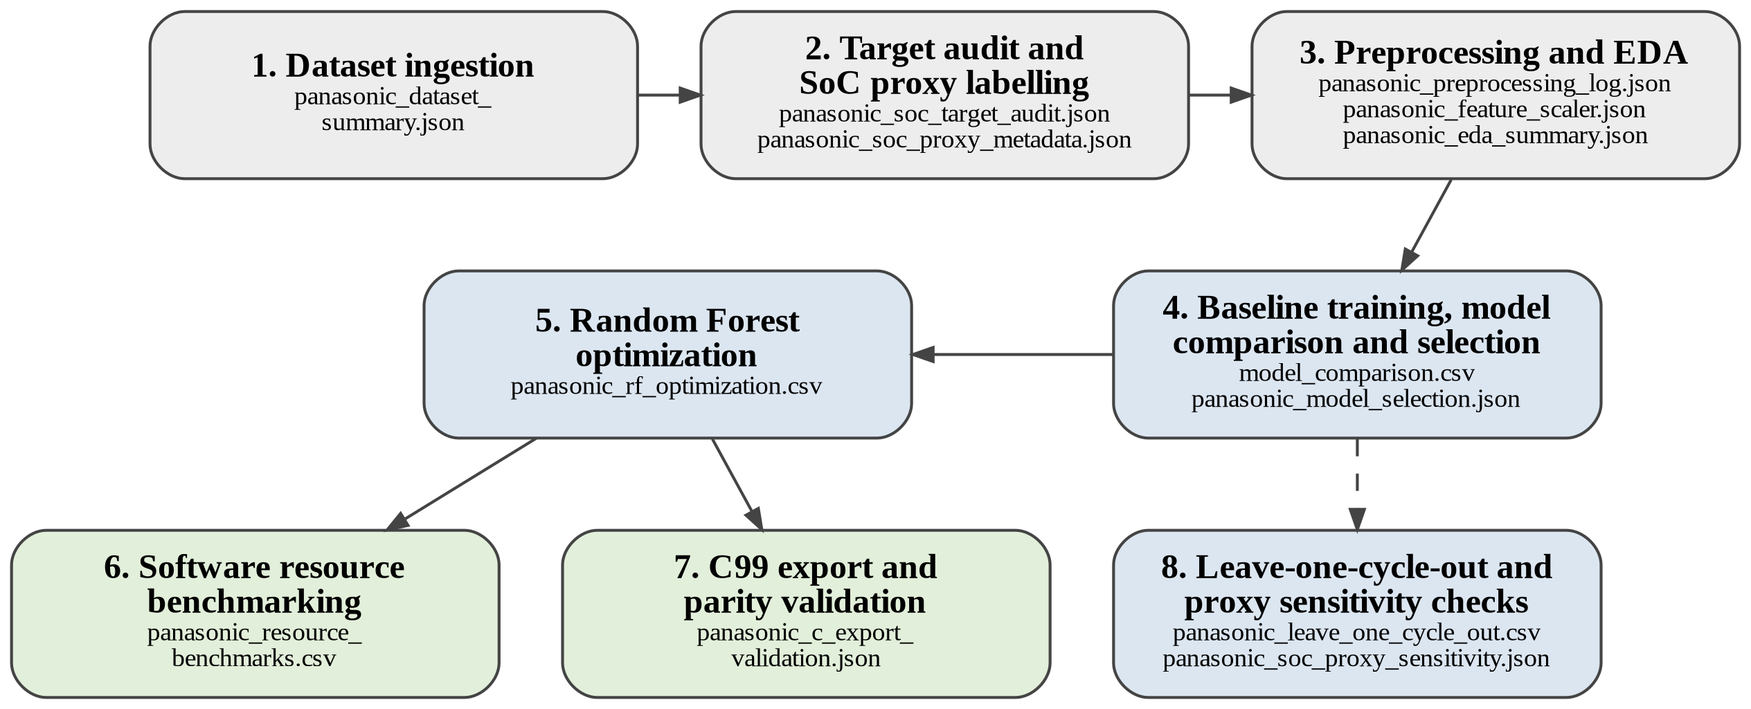
Figure 4.1: Component diagram of the implemented software pipeline. Grey: data preparation; blue: modelling; green: host-side resource and edge-oriented evaluation. File names are the result files generated by each stage. The dashed arrow shows that stage 8 extends the stage 4 candidates.
The model inputs were battery voltage (V), current (A), battery temperature (°C) and elapsed time (s). The target was the approximate SoC proxy (%). The recorded Ah channel was used only to derive the target and was never used as an input. Evaluation used complete drive cycles, so no cycle contributed rows to both training and testing. The fixed holdout used seven cycles for training (75,375 rows) and three for testing (Cycle 2, Cycle 4 and LA92; 37,326 rows), with a random seed of 42. An earlier baseline run used a grouped split with Cycle 2 and LA92 as test cycles; the fixed holdout was used for all later comparisons so that every model was tested on identical data.

4.2.2 Differences between the Methodology and the Implementation
Table 4.1 lists where the implementation differs from Chapter Three. The results in this chapter should be read accordingly.
Table 4.1: Methodology (Chapter Three) compared with the implementation
Aspect | Chapter Three | Implementation
Battery data | Voltage, current and temperature measured by sensors on a rechargeable battery (Sections 3.2.3 and 3.2.4) | Recorded data from the public Panasonic 18650PF dataset: one cell, 25 °C drive cycles
Target | SoC recorded with each observation | Derived coulomb-counting proxy; no measured SoC
Candidate models | Decision trees, random forests, linear regression, SVM, lightweight neural networks (Section 3.2.8) | Ridge regression, Random Forest, Extra Trees
Optimization | Feature reduction, model simplification, pruning, quantization (Section 3.2.9) | Model simplification by reducing trees and leaf nodes; features unchanged; no quantization
Edge implementation | Model deployed on a microcontroller (Section 3.2.10) | Standalone C99 export compiled and checked on the host; no hardware deployment
Power measurement | P = VI measured on the device (Section 3.2.11) | Not measured; size, host latency and process memory used as indicators
Test conditions | Charging, discharging and varying temperature (Section 3.2.14) | Discharge drive cycles at 25 °C only
Error metrics | MAE, MSE, RMSE (Section 3.2.12) | MAE, RMSE and R²; MSE not reported separately

4.3 Result
The results are reported as generated, without interpretation, which is left to Section 4.4. Errors are in percentage points (pp) of the SoC proxy.

4.3.1 Test Case 1: Dataset and Preprocessing
Table 4.2 summarizes the data. All 112,701 prepared rows passed the integrity checks and none was removed. Cycle 4 had 506 rows with proxy values outside 0 to 100%; these were kept and not clipped.
Table 4.2: Summary of the dataset and the prepared data
Item | Value
Raw archive | 198 MATLAB files; 8,532,692 file-row observations (includes duplicated drive-cycle records, so not a unique count)
Subset used | Ten separate 25 °C drive-cycle files; 1,126,083 source observations
Prepared data | 112,701 rows at about 1 Hz; 0 rows removed
Input features | Voltage, current, battery temperature, elapsed time
Input ranges | Voltage 2.50 to 4.24 V; current −19.94 to 9.88 A; temperature 21.78 to 32.77 °C; elapsed time 0 to 22,447 s
Proxy target | 100 × (1 + (Ah − Ah_first) / Q_ref); Q_ref = 2.77493 Ah, the mean of two measured 1C discharge capacities (2.79826 and 2.7516 Ah)
Proxy range | −0.84% to 100%; 506 rows (0.45%) outside 0 to 100%, all from Cycle 4

An audit of the ten drive-cycle files found that the recorded Ah channel agreed with the integrated current to within 0.0040 Ah in every file. This confirms the internal charge accounting only. It does not validate the starting SoC or the capacity, so the proxy remains approximate. Replacing the capacity reference with either measured value changed the proxy by a mean of about 0.4 pp (maximum 0.85 pp). With 2.79826 Ah no row fell outside 0 to 100%, and with 2.7516 Ah 672 rows (0.60%) did.
Figure 4.2 shows the input and proxy distributions. Voltage and elapsed time had the strongest pooled correlations with the proxy (0.95 and −0.78), followed by battery temperature (−0.41); current showed almost none (0.00) (Figure 4.3). These are descriptive pooled-row values and do not show causation.
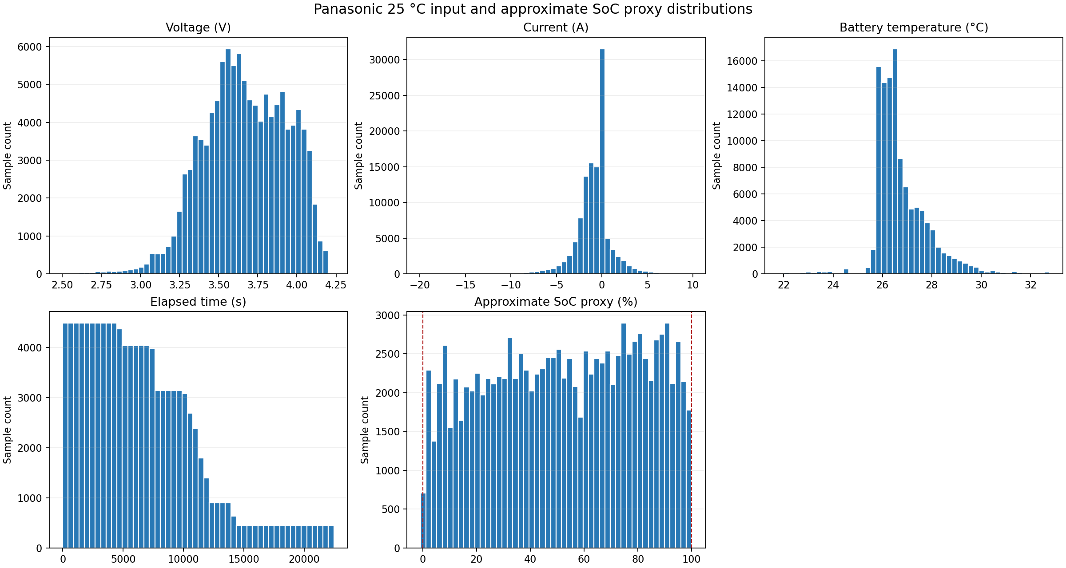
Figure 4.2: Distributions of the model inputs and the approximate SoC proxy for the ten 25 °C drive cycles. Dashed lines mark 0% and 100%.
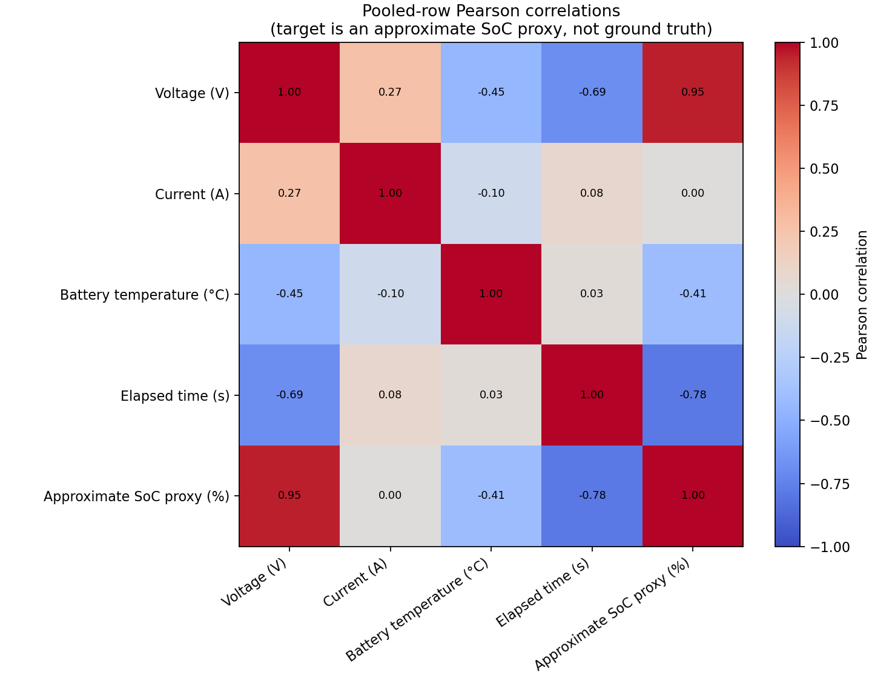
Figure 4.3: Pooled-row Pearson correlations between the inputs and the approximate SoC proxy.

4.3.2 Test Case 2: Baseline Model Comparison and Selection
Table 4.3 gives the results of the three candidates on the fixed holdout and in leave-one-cycle-out validation, in which each of the ten cycles was held out in turn and the metrics were pooled over all out-of-fold rows.
Table 4.3: Candidate model results against the SoC proxy
Model | Holdout MAE (pp) | Holdout RMSE (pp) | Holdout R² | Pooled MAE (pp) | Pooled RMSE (pp) | Pooled R²
Ridge regression | 3.126 | 5.075 | 0.9700 | 4.008 | 5.870 | 0.9570
Random Forest (100 trees) | 2.258 | 3.070 | 0.9890 | 3.111 | 4.680 | 0.9727
Extra Trees (100 trees) | 3.222 | 4.309 | 0.9784 | 4.523 | 6.873 | 0.9410

Random Forest had the lowest MAE on each of the three holdout cycles (2.32, 2.25 and 2.21 pp for Cycle 2, Cycle 4 and LA92) and was provisionally selected as the baseline model. In the earlier grouped-split run it gave an MAE of 2.32 pp, an RMSE of 3.14 pp and an R² of 0.9875 on Cycle 2 and LA92. In leave-one-cycle-out validation its MAE ranged from 1.78 pp (HWFTb) to 6.49 pp (UDDS) across cycles; US06 gave 5.56 pp.

4.3.3 Test Case 3: Model Optimization and Resource Evaluation
Four reduced Random Forest variants were trained on the same training cycles and tested on the same holdout (Table 4.4). Size is the exact on-disk size of the serialized model.
Table 4.4: Random Forest optimization variants on the fixed holdout
Variant (trees / max leaves) | MAE (pp) | RMSE (pp) | R² | Size (bytes) | Size reduction (%) | MAE change (pp)
Baseline (100 / 128) | 2.258 | 3.070 | 0.9890 | 1,868,529 | 0.0 | 0.000
50 / 128 | 2.295 | 3.112 | 0.9887 | 934,929 | 50.0 | +0.037
100 / 64 | 2.681 | 3.626 | 0.9847 | 946,929 | 49.3 | +0.423
50 / 64 | 2.719 | 3.673 | 0.9843 | 474,129 | 74.6 | +0.461
25 / 32 | 3.470 | 4.636 | 0.9750 | 122,529 | 93.4 | +1.212

The 50-tree variant was carried forward for resource benchmarking and C export. Table 4.5 compares it with the baseline. Latency was measured on the host computer (Intel Core i5-4210U, 1.70 GHz; Linux; Python 3.10.20; scikit-learn 1.7.2) by timing only the prediction call. Each model ran in its own process, with 500, 200 and 100 timed calls after 50, 20 and 10 warm-up calls for batch sizes 1, 32 and 256. Memory is the peak resident set size of the process, which includes the Python runtime and the test data.
Table 4.5: Baseline and optimized (50-tree) models: host-side resource comparison
Metric | Baseline (100 trees) | Optimized (50 trees) | Change
Serialized model size (bytes) | 1,868,529 | 934,929 | −50.0%
Tree nodes | 25,500 | 12,750 | −50.0%
Exported C header size (bytes) | 1,210,081 | 606,478 | −49.9%
Holdout MAE / RMSE (pp) | 2.258 / 3.070 | 2.295 / 3.112 | +0.037 / +0.042 pp
Latency, batch 1: median / p95 (ms) | 39.01 / 65.80 | 43.05 / 82.76 | +10.4% / +25.8%
Latency, batch 32: median / p95 (ms) | 38.69 / 63.08 | 24.91 / 36.71 | −35.6% / −41.8%
Latency, batch 256: median / p95 (ms) | 47.72 / 63.09 | 25.34 / 40.03 | −46.9% / −36.6%
Median time per sample, batch 256 (µs) | 186.4 | 99.0 | −46.9%
Peak process memory (bytes) | 300,896,256 | 301,068,288 | +0.06%

Both models were also exported as standalone C99 headers, compiled with the system C compiler using -std=c99 -O2 -Wall -Wextra -Werror, and compared with the scikit-learn predictions on all 37,326 held-out rows. The largest absolute difference was 4.26 × 10⁻¹⁴ for both models, against a tolerance of 10⁻⁹. No physical hardware was tested and no power was measured.

4.4 Discussion of Result

4.4.1 Prediction Performance
Random Forest was the most accurate candidate in both evaluation designs, which supports its selection as the baseline. Its holdout MAE of 2.26 pp and R² of 0.989 show close agreement with the proxy. The holdout result was more favourable than the pooled leave-one-cycle-out result (MAE 3.11 pp, R² 0.973), and error varied strongly between cycles. UDDS was the hardest cycle (6.49 pp). It is also much longer than the others (22,431 rows against at most 14,094), so elapsed-time values above about 14,100 s were absent from the training folds when it was held out. This may have contributed, although the experiments did not test it. The holdout figure should therefore not be read as the expected error on unseen cycles. The holdout cycles also guided model selection and optimization, so these results are exploratory and not an independent test.
The proxy is itself uncertain. The capacity reference alone moves proxy values by about 0.4 pp on average. This is smaller than the model error, so it does not explain the errors, but it is not negligible against them.

4.4.2 Optimization and Resource Trade-off
Halving the number of trees gave the smallest accuracy cost for a halving of model size: the serialized model was 49.96% smaller, MAE rose by only 0.037 pp (1.6%) and R² fell from 0.9890 to 0.9887. Halving the leaf limit gave a similar size reduction (49.3%) but a much larger MAE increase (0.42 pp). The most compressed variant (25 trees, 32 leaves) was 93.4% smaller but 1.21 pp less accurate. Only the 50-tree variant was benchmarked and exported, so the latency and memory of the other variants are unknown.
Latency fell with the smaller model only when predictions were batched: the median time per call was 35.6% lower at batch size 32 and 46.9% lower at batch size 256. At batch size 1 the median rose from 39.0 to 43.0 ms. The baseline took almost the same time per call at batch sizes 1 and 32 (39.0 and 38.7 ms), which suggests that a fixed per-call overhead of the software library dominated these measurements. The batch-size-1 difference should therefore not be read as a real slowdown without repeated runs. Process memory was unchanged in practice (+0.06%) because the 287 MiB peak is dominated by the Python runtime and the test data, not by models smaller than 2 MB, so model-only memory was not isolated. Each model was benchmarked once on one host computer.

4.4.3 Local Inference and Power Awareness
The C99 export shows that both trained models can be written as dependency-free code that reproduces the scikit-learn predictions to within 4.3 × 10⁻¹⁴. This supports the feasibility of local inference without a Python runtime. The export contains model parameters only: sensor drivers, filtering, SoC initialization and charge integration are not implemented, and no microcontroller flash, RAM, latency or energy figure was measured. The 50-tree model has half the nodes and half the serialized size, and Section 2.5.1 noted that fewer parameters reduce storage and computation. However, no electrical power or energy was measured, so no energy saving can be claimed. Whether either model fits a given microcontroller depends on that board's memory, which was not selected in this study. The results show a model-level step towards power-aware edge monitoring, not a demonstrated reduction in device power.

4.4.4 Relation to the Research Objectives
Table 4.6: Evidence for each research objective
Obj. | Evidence in this chapter | Extent
i | Software pipeline processes recorded voltage, current and temperature (Section 4.2). No sensors, acquisition circuit or on-device operation. | Partly addressed (software only)
ii | 112,701 rows prepared and checked from a public dataset (Section 4.3.1). | Addressed, using a public dataset rather than data collected by the author
iii | Three models compared; Random Forest selected; leave-one-cycle-out check (Section 4.3.2). | Addressed for the SoC proxy; State of Health not estimated
iv | Tree and leaf reduction; 50-tree model about 50% smaller; C99 export (Section 4.3.3). | Partly addressed; quantization and feature reduction not applied
v | Accuracy, host latency, host memory and size measured (Table 4.5). | Partly addressed; power not measured

4.4.5 Limitations of the Results
The results come from one cell at one temperature on discharge drive cycles, and the target is a derived proxy. The model uses elapsed time from the start of each cycle as an input, which assumes that each cycle starts from full charge, the same assumption used to build the proxy; a deployed monitor would need an equivalent reference. The selection holdout was reused for optimization, the benchmarks are single host-side runs, and no hardware was used. The results are therefore exploratory evidence of the trade-off between accuracy and resource use.

4.5 System Testing
System testing checked the integrated pipeline from data preparation to the exported C code. Table 4.7 lists the test cases and the outcomes recorded in the result files.
Table 4.7: System test cases and results
S/N | Test case | Test activity | Test result
1 | Data integrity | Check columns, finite values, monotonic time and duplicate time keys on 112,701 rows | Passed; 0 rows removed; 0 duplicate keys
2 | Leakage control | Fit the scaler on training rows only; exclude the Ah channel from the inputs | Confirmed in the preprocessing record
3 | Cycle-level split | Check that training and test cycles do not overlap | Passed; 7 training and 3 test cycles
4 | Prediction validity | Predict at batch sizes 1, 32 and 256 for both models | All predictions finite
5 | C99 compilation | Compile exports with -std=c99 -O2 -Wall -Wextra -Werror | Compiled without warnings or errors
6 | C99 parity | Compare C output with scikit-learn on 37,326 held-out rows (both models) | Passed; maximum error 4.26 × 10⁻¹⁴ (tolerance 10⁻⁹)
7 | Hardware and power | Run on a physical device and measure power | Not performed

[Author to add: summary of the automated unit-test run, once confirmed]

4.6 Conversion
The conversion approaches in the project guide apply to replacing an operating system, and this study did not replace an existing battery monitor. The conversion carried out was one of model format: the scikit-learn models were converted to standalone C99 headers (Section 4.3.3) so that inference no longer needs Python. Deployment on a microcontroller was not carried out. If it is attempted later, a phase-in approach is appropriate, running the C code alongside an existing estimator and comparing outputs before relying on it.

4.7 Documentation
Each experiment writes a result file that records the dataset, split method, input features, model parameters, metrics and limitations. The JSON files also state that no physical hardware was tested and no power was measured. These files, listed in Figure 4.1, form the technical record of the experiments. [Author to confirm and add: the repository README and run instructions that serve as the user and operational manual]

4.8 System Maintenance
The project is kept in a Git repository. Maintenance would consist of the following:
a. retraining the models when new data are added, then repeating the comparison, optimization and benchmark stages;
b. regenerating the C99 headers and repeating the parity check after any model change;
c. replacing the derived proxy with validated SoC labels if they become available; and
d. repeating the resource benchmarks and measuring power on the chosen microcontroller.
Items a to c are maintenance of the existing software. Item d is the enhancement needed to address the hardware objectives fully.

