THE FEDERAL POLYTECHNIC, BAUCHI
SCHOOL OF SCIENCE AND TECHNOLOGY
DEPARTMENT OF COMPUTER SCIENCE
[INSTITUTION LOGO, IF REQUIRED]
POWER-AWARE MACHINE LEARNING FOR EDGE BATTERY MONITORING DEVICES
BY
[STUDENT FULL NAME]
[REGISTRATION NUMBER]
A PROJECT REPORT SUBMITTED TO THE DEPARTMENT OF COMPUTER SCIENCE,
SCHOOL OF SCIENCE AND TECHNOLOGY, THE FEDERAL POLYTECHNIC, BAUCHI,
IN PARTIAL FULFILMENT OF THE REQUIREMENTS FOR THE AWARD OF THE
HIGHER NATIONAL DIPLOMA IN COMPUTER SCIENCE
[MONTH, YEAR]

THE FEDERAL POLYTECHNIC, BAUCHI
SCHOOL OF SCIENCE AND TECHNOLOGY
DEPARTMENT OF COMPUTER SCIENCE
[INSTITUTION LOGO, IF REQUIRED]
POWER-AWARE MACHINE LEARNING FOR EDGE BATTERY MONITORING DEVICES
BY
[STUDENT FULL NAME]
[REGISTRATION NUMBER]
SUBMITTED TO THE DEPARTMENT OF COMPUTER SCIENCE, SCHOOL OF SCIENCE AND TECHNOLOGY, THE FEDERAL POLYTECHNIC, BAUCHI, IN PARTIAL FULFILMENT OF THE REQUIREMENTS FOR THE AWARD OF THE HIGHER NATIONAL DIPLOMA IN COMPUTER SCIENCE
[MONTH, YEAR]

APPROVAL
This project report has been read and approved as meeting the requirements of the Department of Computer Science, School of Science and Technology, The Federal Polytechnic, Bauchi, for the award of the Higher National Diploma in Computer Science.
Role | Name | Signature | Date
Project Supervisor | [Name] | ________________________ | ____________
Project Coordinator | [Name] | ________________________ | ____________
Head of Department | [Name] | ________________________ | ____________
External Supervisor | [Name] | ________________________ | ____________

DECLARATION
I declare that Chapters One to Three of this report are the student’s supplied original research work. Chapters Four onward document the software implementation and experimental results described in the project repository. The software and report preparation included AI-assisted development; the student must review the complete report, verify all claims and sources, and accept responsibility for the final submission before signing this declaration. No statement in this template should be signed unless it is true.
__________________________________ __________________
[STUDENT FULL NAME AND SIGNATURE] Date

DEDICATION
[Insert a personal dedication here, if desired. Replace this instruction with a dedication that reflects the student’s own choice.]

ACKNOWLEDGEMENT
I acknowledge the guidance and academic support provided by [PROJECT SUPERVISOR NAME], the Department of Computer Science, and the staff who contributed to the completion of this project. I also acknowledge the assistance of my family, colleagues, and other supporters. Please replace or personalize these placeholders so that the final acknowledgement names only people and organizations whose contributions are genuine.

ABSTRACT
This project addressed the gap between machine-learning battery monitoring proposals and a verifiable implementation suitable for later edge evaluation. An offline software prototype was developed using Python, scikit-learn, pandas, NumPy, a Streamlit dashboard, and a C99 host simulator. The work followed an iterative, experiment-led development process: Panasonic 18650PF data were inspected, a capacity-referenced state-of-charge (SoC) proxy was constructed and audited, ten 25 °C drive cycles were prepared, three regressors were compared using complete-cycle holdout, and a Random Forest was provisionally selected and reduced from 100 to 50 trees. The prepared table contained 112,701 records. On the fixed 37,326-row holdout, the 100-tree Random Forest achieved a proxy mean absolute error of 2.258 percentage points; the 50-tree candidate reduced the serialized artifact by 49.96% with a 0.037-point increase in proxy MAE. A compiled C99 export matched the Python predictions to a maximum absolute difference of 4.27 × 10⁻¹⁴ over the holdout. The dashboard and command-line simulator demonstrate dataset replay and local inference only. The target is not validated physical SoC, the data represent one cell at one ambient temperature, the holdout informed model selection, and no microcontroller deployment or electrical power measurement was performed. Accordingly, the results establish a reproducible software prototype, not a validated battery monitor or measured low-power edge system.
Keywords: battery monitoring; state-of-charge proxy; Random Forest; edge inference; C99; offline simulation

TABLE OF CONTENTS
CHAPTER ONE: INTRODUCTION 2
CHAPTER TWO: LITERATURE REVIEW 6
CHAPTER THREE: MATERIALS AND METHODS 23
[Open in Word and update fields to populate Chapters Four–Five and appendices.]

LIST OF FIGURES
[Update fields in Word to populate figure page numbers.]

LIST OF TABLES
[Update fields in Word to populate table page numbers.]

LIST OF APPENDICES
Appendix A. Project structure and reproducibility
Appendix B. Verified source-code excerpts
Appendix C. Host C99 simulator example
Appendix D. Actual dashboard screenshot
Appendix E. Automated test evidence
Appendix F. Extended results and limitations

DEFINITION OF TERMS
Ah: Ampere-hour, a measure of transferred electric charge.
C99: The ISO C language standard published in 1999; the exported forest and simulator are compiled as C99.
Coulomb counting: Charge integration used here to create an approximate proxy from recorded Ah change and a reference capacity.
Cycle holdout: An evaluation split in which every row from a selected drive-cycle group is kept out of model training.
MAE: Mean absolute error; reported here in percentage points of the derived proxy.
Proxy target: An estimated reference label constructed from data and assumptions, not an independently validated physical measurement.
RSS: Resident set size, the amount of physical memory attributed to a process at a measurement point.
SoC: State of charge; in this project the model target is a derived SoC proxy rather than validated SoC.
SoH: State of health; it was discussed in the research motivation but not estimated by the implemented model.
RMSE: Root mean squared error; reported in percentage points of the derived proxy.
R²: Coefficient of determination for agreement with the derived proxy.







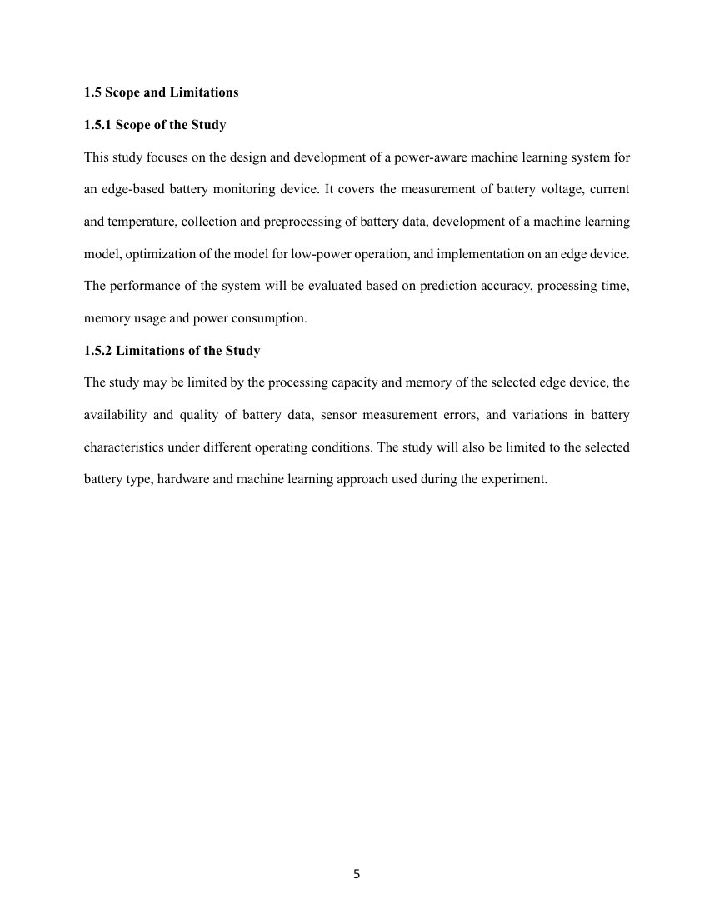





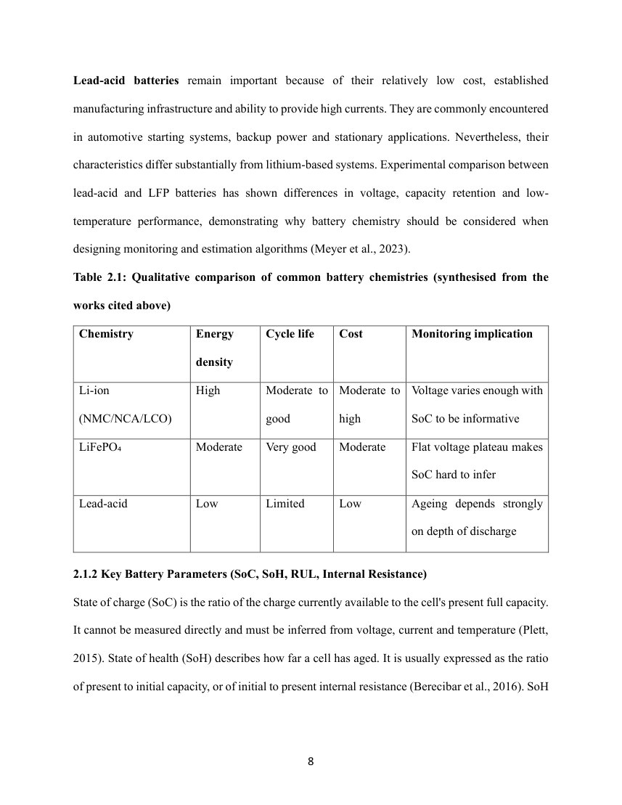





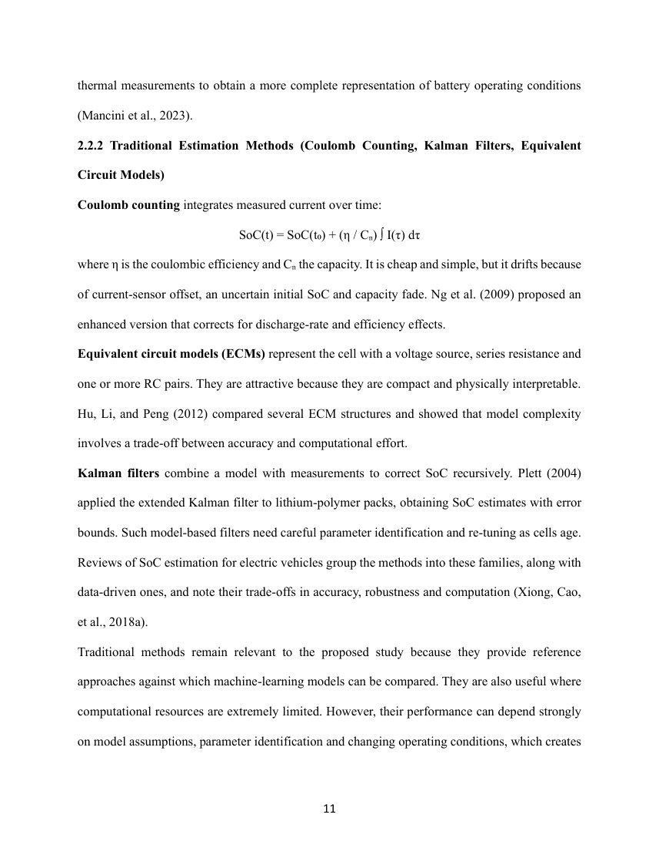



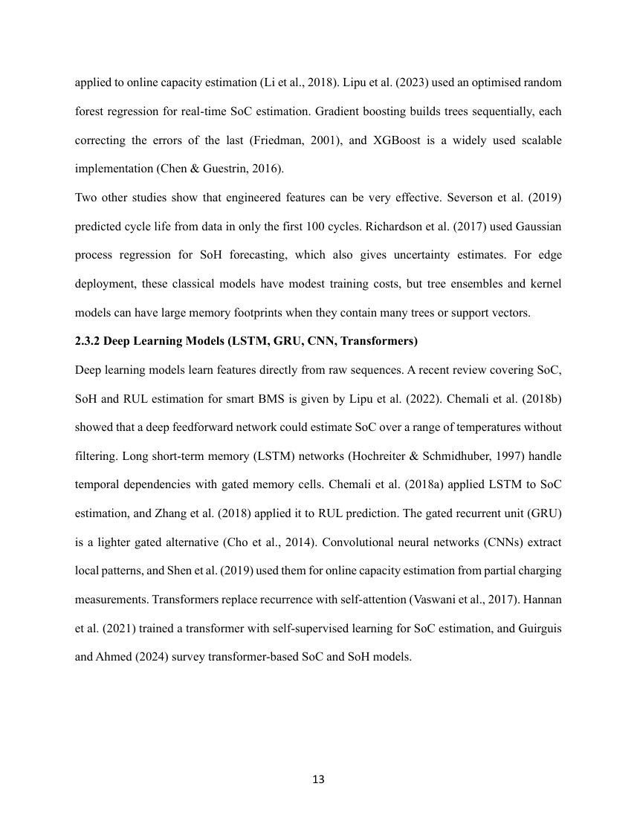

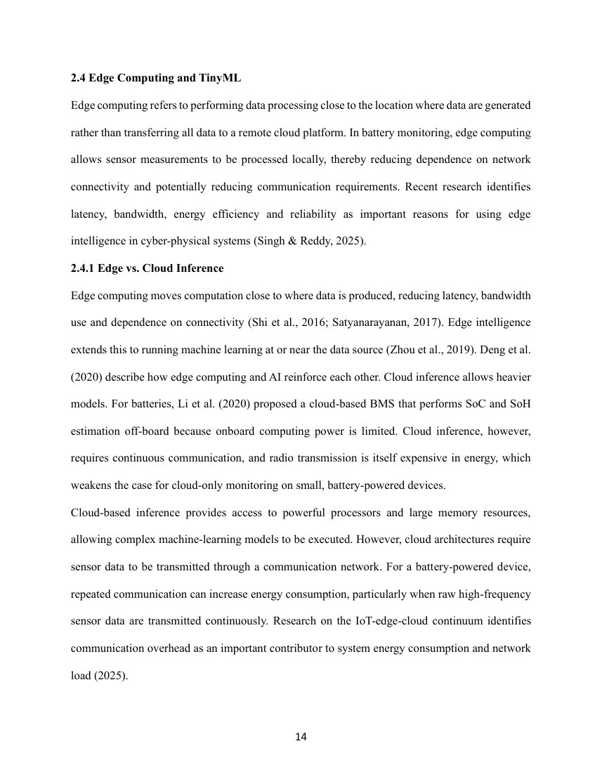

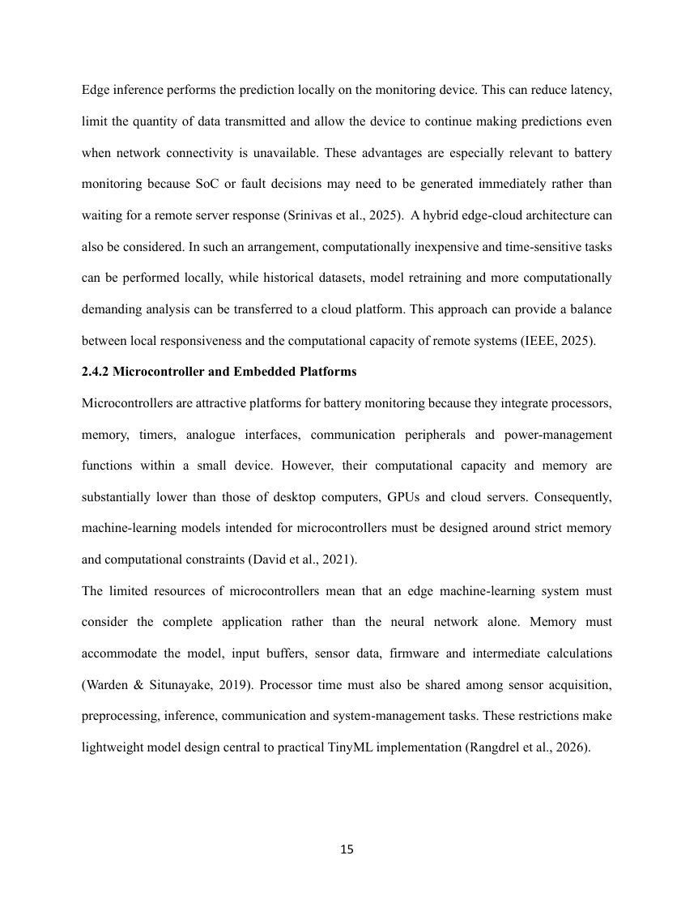

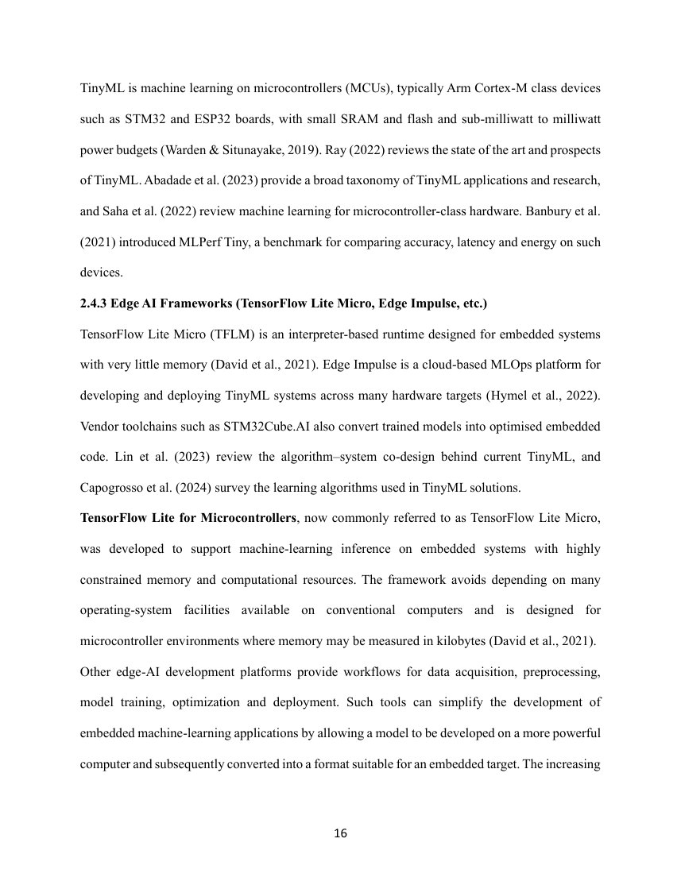

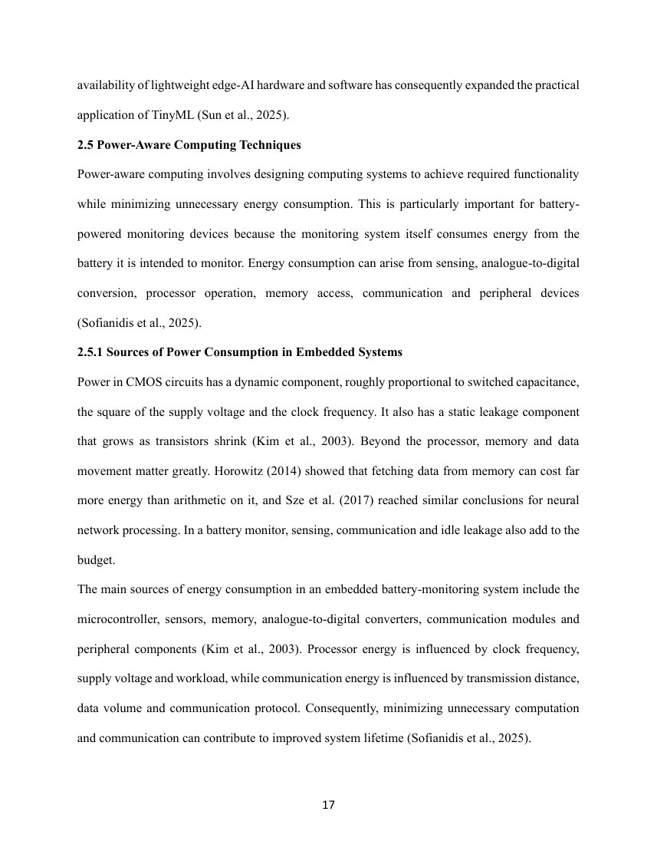



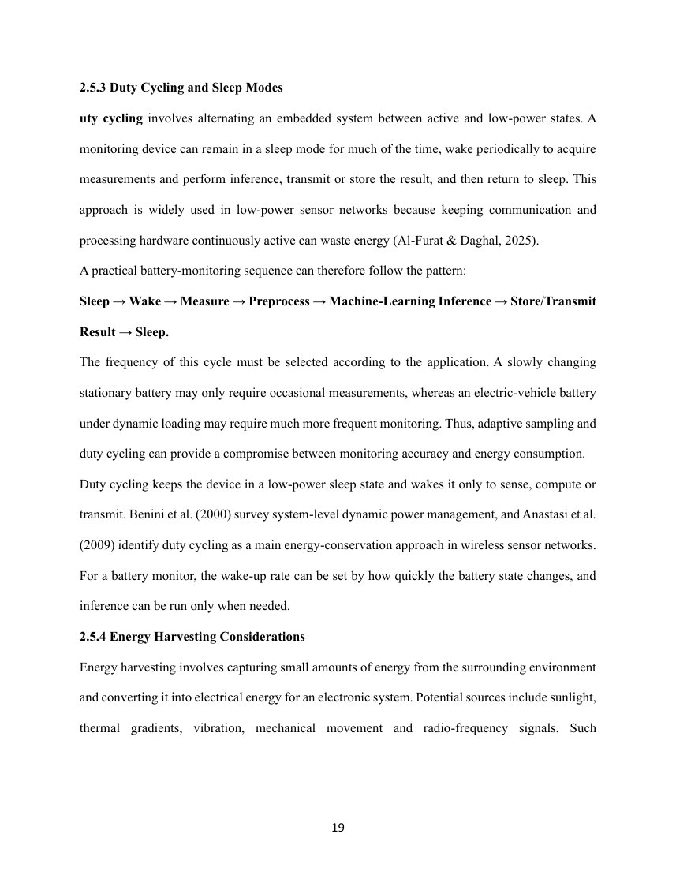

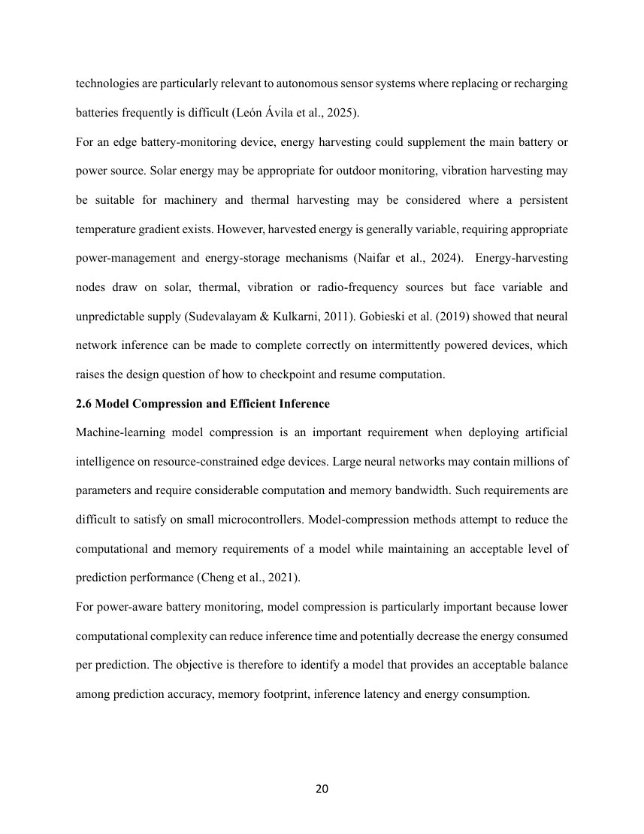







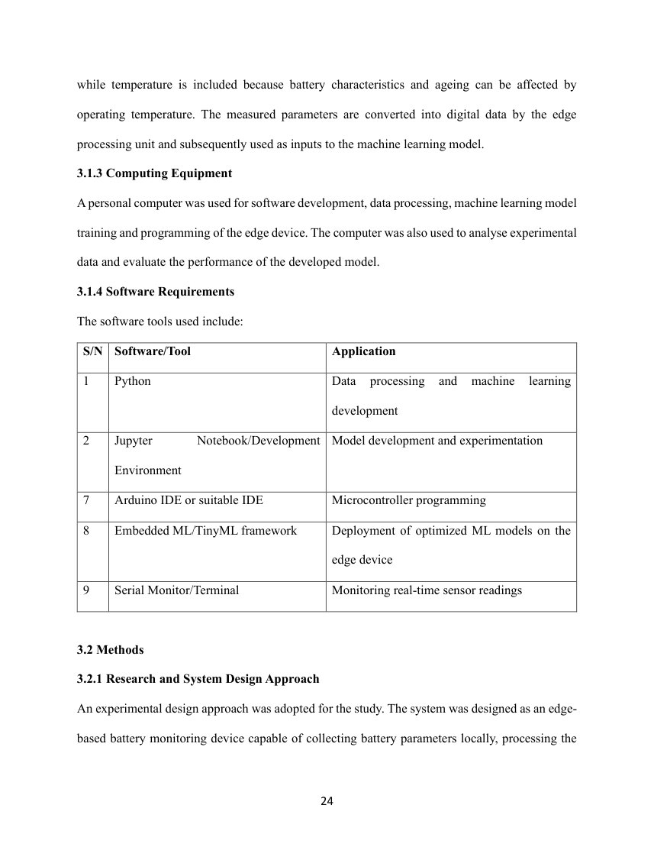



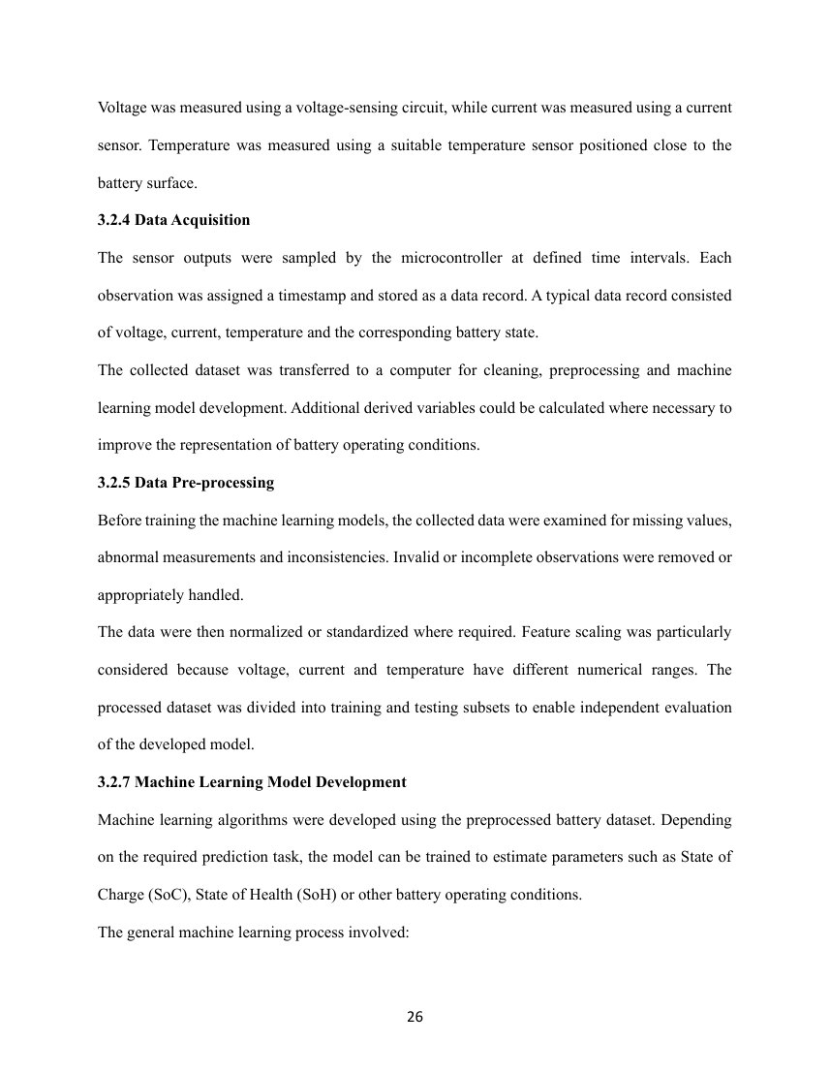

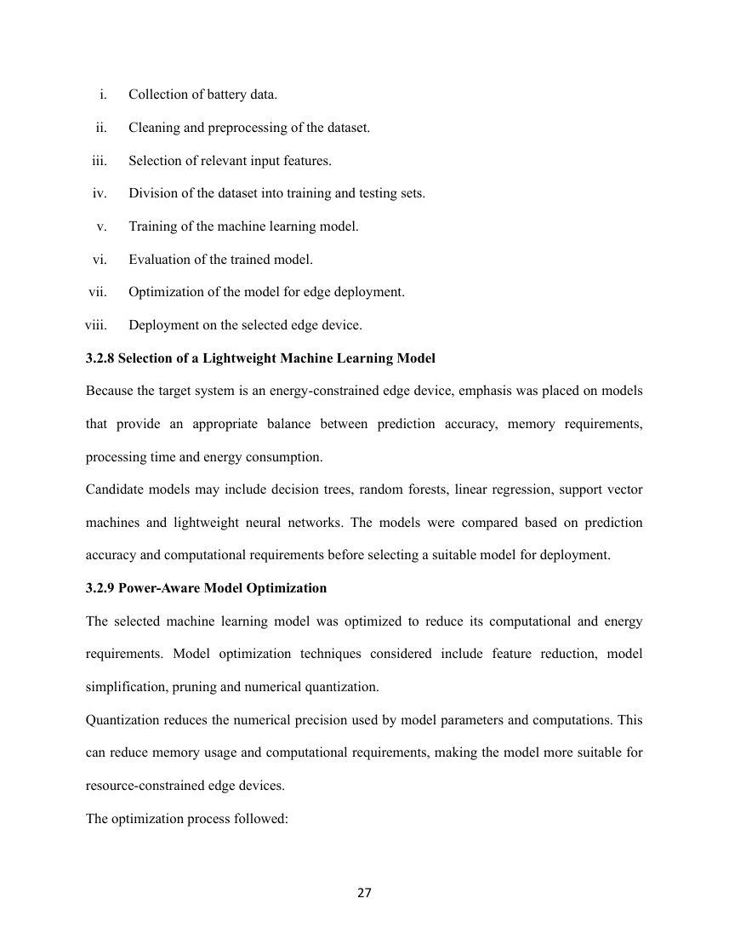



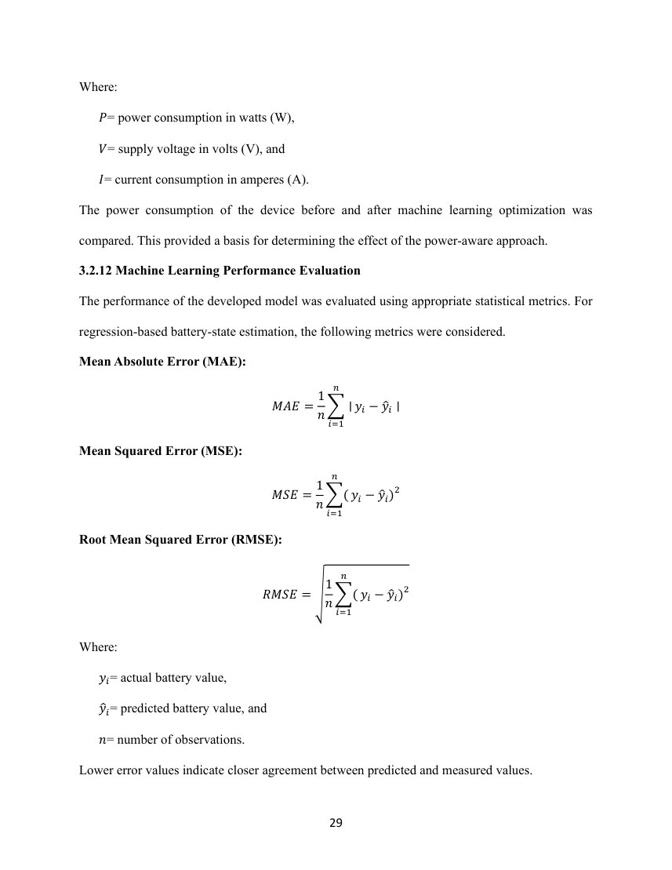

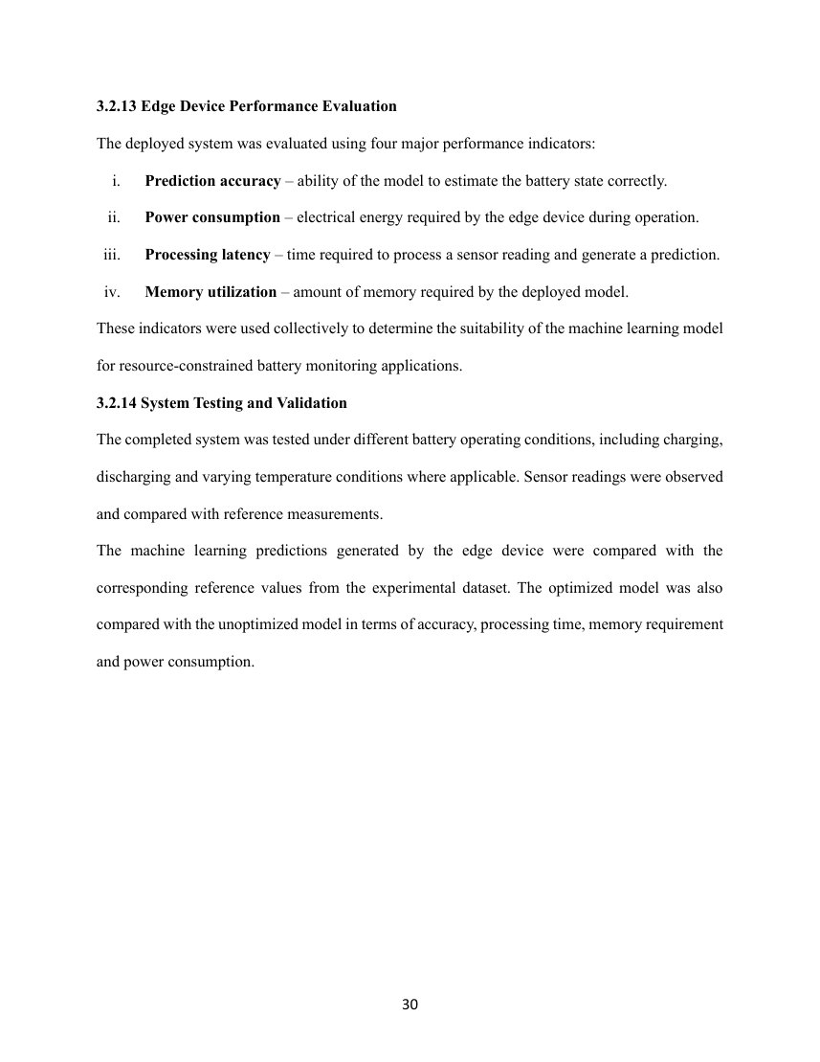

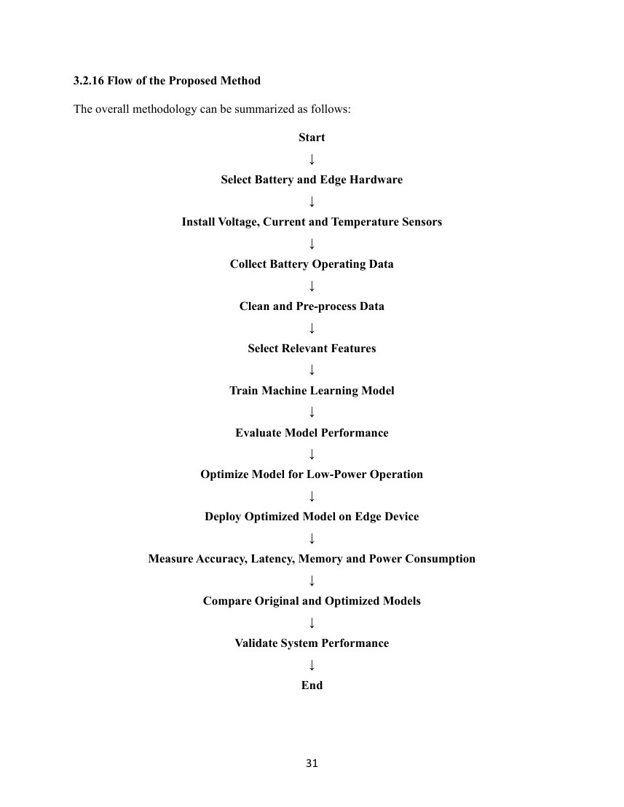

CHAPTER FOUR: IMPLEMENTATION AND DOCUMENTATION

4.1 Introduction
This chapter documents the system that is actually present in the project repository, distinguishes it from the hardware-based workflow proposed in Chapter Three, and reports the saved test and benchmark results. The implemented product is an offline Python research pipeline with a Streamlit dashboard, trained scikit-learn models, standalone C99 inference headers, and a host-side C simulator. It is not connected to a physical battery, sensor board, or microcontroller. All predictive scores describe agreement with an approximate capacity-referenced SoC proxy, not accuracy against independently measured SoC. The underlying dataset contains one Panasonic 18650PF cell and the experiments in this report use ten separate 25 °C drive cycles (Kollmeyer, 2018).

4.2 Implementation

4.2.1 Implemented Components and Data Flow
The repository separates data inspection, target auditing, proxy preparation, preprocessing, model training and evaluation, optimization, resource measurement, C export, and the dashboard. The workflow diagram shows the implemented sequence. The dashboard reads existing local artifacts; it does not retrain a model or acquire live measurements. The software stack recorded with the experiments was Python 3.10.20, NumPy 2.2.5, pandas 2.3.3, SciPy 1.15.3, scikit-learn 1.7.2, joblib 1.5.3, and Streamlit 1.61.1. The C simulator and export validation used the system C compiler with C99 warning and optimization flags.
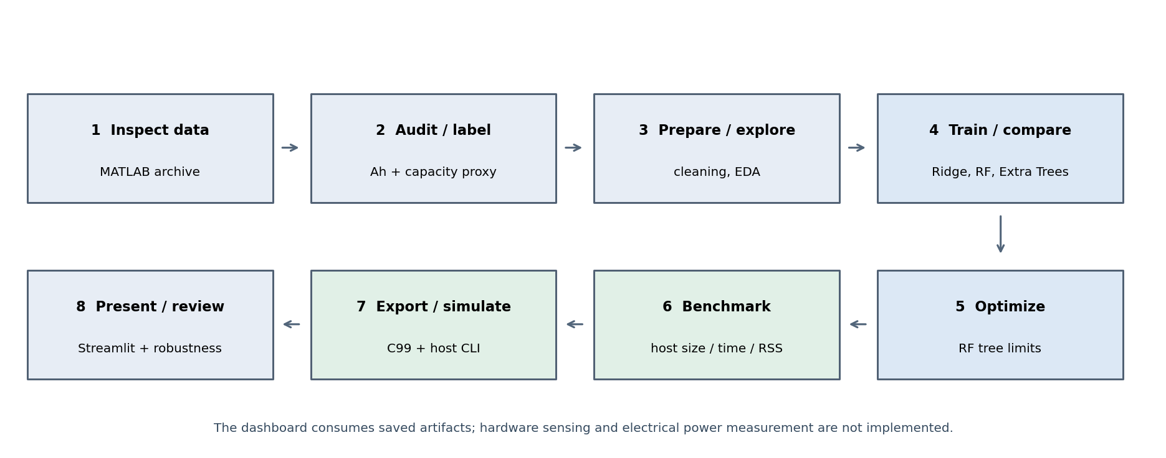
Figure 4.1. Implemented offline software workflow and evidence boundaries.
The processing flow begins with MATLAB archive inspection and Ah/current consistency checks. Ten separate 25 °C drive-cycle files are then transformed into a one-second target table, model inputs are validated, regressors are compared using complete-cycle holdout, and the selected Random Forest is optimized and benchmarked. The exported forests are compiled and checked against their Python estimators. The final UI exposes dataset replay, manual proxy inference, result review, and edge-export status; it displays an offline-simulation notice.

4.2.2 Dataset, Proxy Target, and Preprocessing
The archive inspection identified 198 MATLAB files and a summed 8,532,692 file-row observations across the archive. This archive-wide total is not a count of unique samples because the dataset documentation identifies duplicated contiguous and split drive-cycle records. The model dataset uses ten separate drive-cycle files at 25 °C, containing 1,126,083 source observations; one logged observation was selected near each regular one-second target, yielding 112,701 prepared rows. Sampling is selection from logged data, not interpolation to an exact one-hertz grid.
The dataset does not supply validated per-row SoC ground truth for this task. The code constructs the target as 100 × [1 + (Ah_sample − Ah_first)/Q_reference], where Q_reference = 2.77493 Ah is the arithmetic mean of two measured start-of-tests 1C discharge throughputs (2.79826 Ah and 2.75160 Ah). Each cycle is assumed to begin near full charge. Recorded Ah is used to construct this label and is excluded from model inputs. A target audit found that Ah change and integrated current agreed within 0.004041 Ah across the ten source cycle files; this checks internal charge accounting but does not validate initial SoC or the fixed capacity denominator. The proxy sensitivity and out-of-range records remain explicit.
Required columns and numeric values are checked for finiteness; elapsed time must not run backward within a cycle, and duplicate cycle/time keys are rejected. The cleaning log reports 112,701 rows read and written, no rows silently removed, no duplicate keys, and 506 prepared proxy values outside [0,100] retained without clipping. A StandardScaler artifact is fitted only on a training subset for the separate preprocessing output; the final tree models use raw features, while Ridge uses scaling inside its training-only pipeline. The four model inputs, in order, are voltage (V), current (A), battery-case temperature (°C), and elapsed time (s).
Table 4.1. Verified dataset and proxy-preparation summary.
Item | Observed implementation evidence
Raw archive inspection | 198 MATLAB files; 8,532,692 summed file-row observations, not a unique count.
Modeling subset | 10 separate Panasonic 18650PF drive cycles at 25 °C; 1,126,083 original observations.
Prepared dataset | 112,701 one-second-selected rows; 0 removed; 506 prepared proxy values outside [0,100] retained.
Model inputs | Voltage (V), current (A), battery-case temperature (°C), elapsed time (s); recorded Ah excluded.
Proxy definition | 100 × [1 + (Ah_sample − Ah_first)/2.77493 Ah]; initial full-charge state and shared capacity are assumptions.
Proxy range | −0.8375% to 100%; negative values are preserved rather than clipped.
Consistency audit | Maximum absolute Ah-change/current-integration difference: 0.004041 Ah; this is not a physical SoC validation.

4.2.3 Model Training, Selection, and Supplementary Evaluation
Ridge Regression, RandomForestRegressor, and ExtraTreesRegressor were fit and evaluated on a shared fixed complete-cycle split. Seven cycles (75,375 rows) formed the training set and three cycles (Cycle 2, Cycle 4, and LA92; 37,326 rows) formed the holdout, using seed 42. This prevents rows from a single cycle appearing in both partitions. The selected Random Forest uses 100 trees, min_samples_leaf=2 and max_leaf_nodes=128. Random Forest was provisionally chosen because it had the lowest aggregate MAE and RMSE and highest R² among the candidates on this split; because the holdout was used for selection and later optimization, these results are exploratory rather than an independent final test.
A supplementary leave-one-complete-cycle-out analysis refit each model ten times so that every sample received an out-of-fold prediction. This provides evidence about variation across the ten available cycles, but it is not independent confirmation: the same cell/cycles had already informed model selection and optimization. The dataset covers one physical cell at a single ambient temperature; it cannot establish multi-cell or multi-temperature generalization.

4.2.4 Model Optimization and Resource Evaluation
The optimization experiment bounded Random Forest complexity by reducing tree count and/or maximum leaf nodes. The 50-tree, 128-leaf candidate was carried forward because it reduced the serialized model size by approximately half while increasing fixed-holdout proxy MAE by only 0.0366 percentage points. Other tested reductions produced larger error increases. This is a model-size/performance trade-off, not evidence of lower electrical power.
Resource measurements were made on an Intel Core i5-4210U host running Linux with Python and scientific-computing libraries. Prediction calls alone were timed after warm-up for batch sizes 1, 32, and 256. The model ran in a separate subprocess; VmRSS/VmHWM sampled from Linux procfs includes the interpreter, libraries, dataset, and runtime allocations. It is not model-only memory. Serialized size is the exact joblib file size. The single-row candidate median was slower than the baseline, while batch medians were lower at 32 and 256 rows; this host measurement is batch-dependent and does not imply microcontroller performance.

4.2.5 C99 Export and Host Simulator
The exporter serializes each decision forest as flat node arrays and iterative tree traversal in standalone C99 headers. Header inputs are four float values in the same feature order as Python; predictions are returned as double values in proxy percentage units. The export-validation command compiles a temporary C harness with −std=c99 −O2 −Wall −Wextra −Werror and compares the C results against the saved Python estimators on every fixed-holdout row. A separate C99 command-line simulator reads one CSV feature row per line, supports selected (100-tree) or candidate (50-tree) model selection, and emits sample index, model label, and proxy prediction. It strictly rejects malformed or non-finite rows. It has no serial-port driver, sensor interface, model initialization logic, physical SoC initialization, firmware, or power measurement.

4.2.6 Dashboard and User Interface
The Streamlit application has nine navigation views: Dashboard, Battery Monitoring, ML Prediction, Model Comparison, Model Optimization, Performance, Dataset, Edge Deployment, and System Information. It displays recorded dataset signals, plots, saved metrics, model artifacts, a manual four-feature input form, and recorded-sample replay. It keeps at most twenty predictions in session history. Its dataset and inference services check schemas, feature order, finite values, expected estimator type, and artifact availability. A permanent offline-simulation notice distinguishes recorded values and model outputs from live sensor readings. The dashboard does not acquire hardware data or perform new model training.

4.3 Result
This section reports the saved results without attributing them to physical SoC or edge hardware. Errors are stated in percentage points of the derived proxy. The results are obtained from the JSON and CSV artifacts in the repository.

4.3.1 Test Case 1: Dataset and Preprocessing
The preparation pipeline returned 112,701 rows from ten drive cycles and passed its recorded schema, finite-value, monotonic-time, and duplicate-key checks. No sample was removed. A small set of proxy values below zero was retained. The capacity reference and target remain assumptions, despite the good agreement between Ah changes and integrated current.
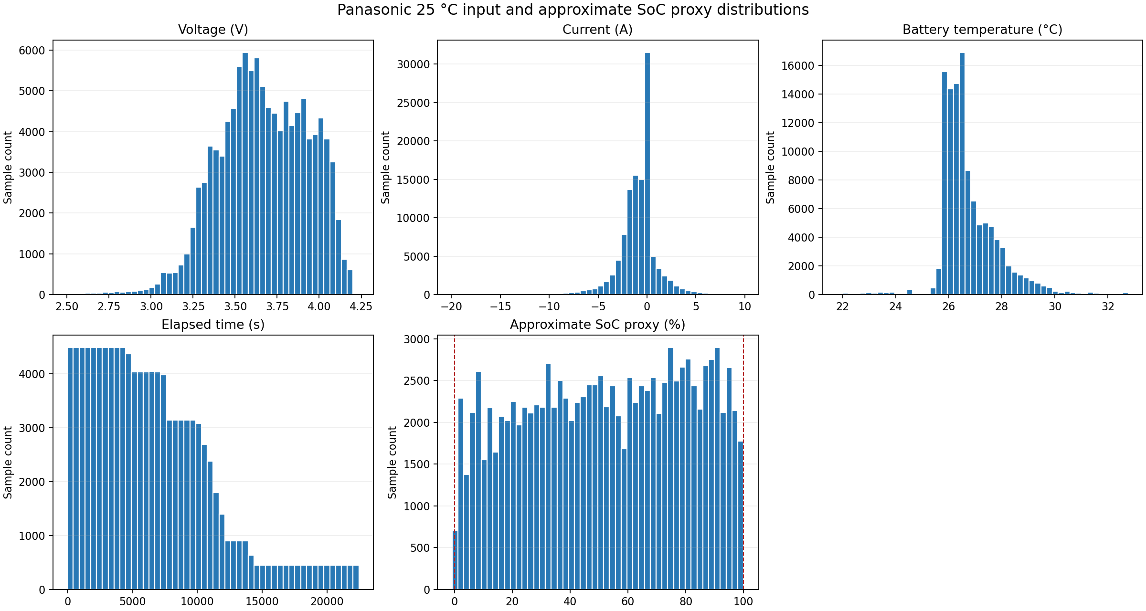
Figure 4.2. Distributions of measured model inputs and the approximate proxy in the prepared ten-cycle subset.
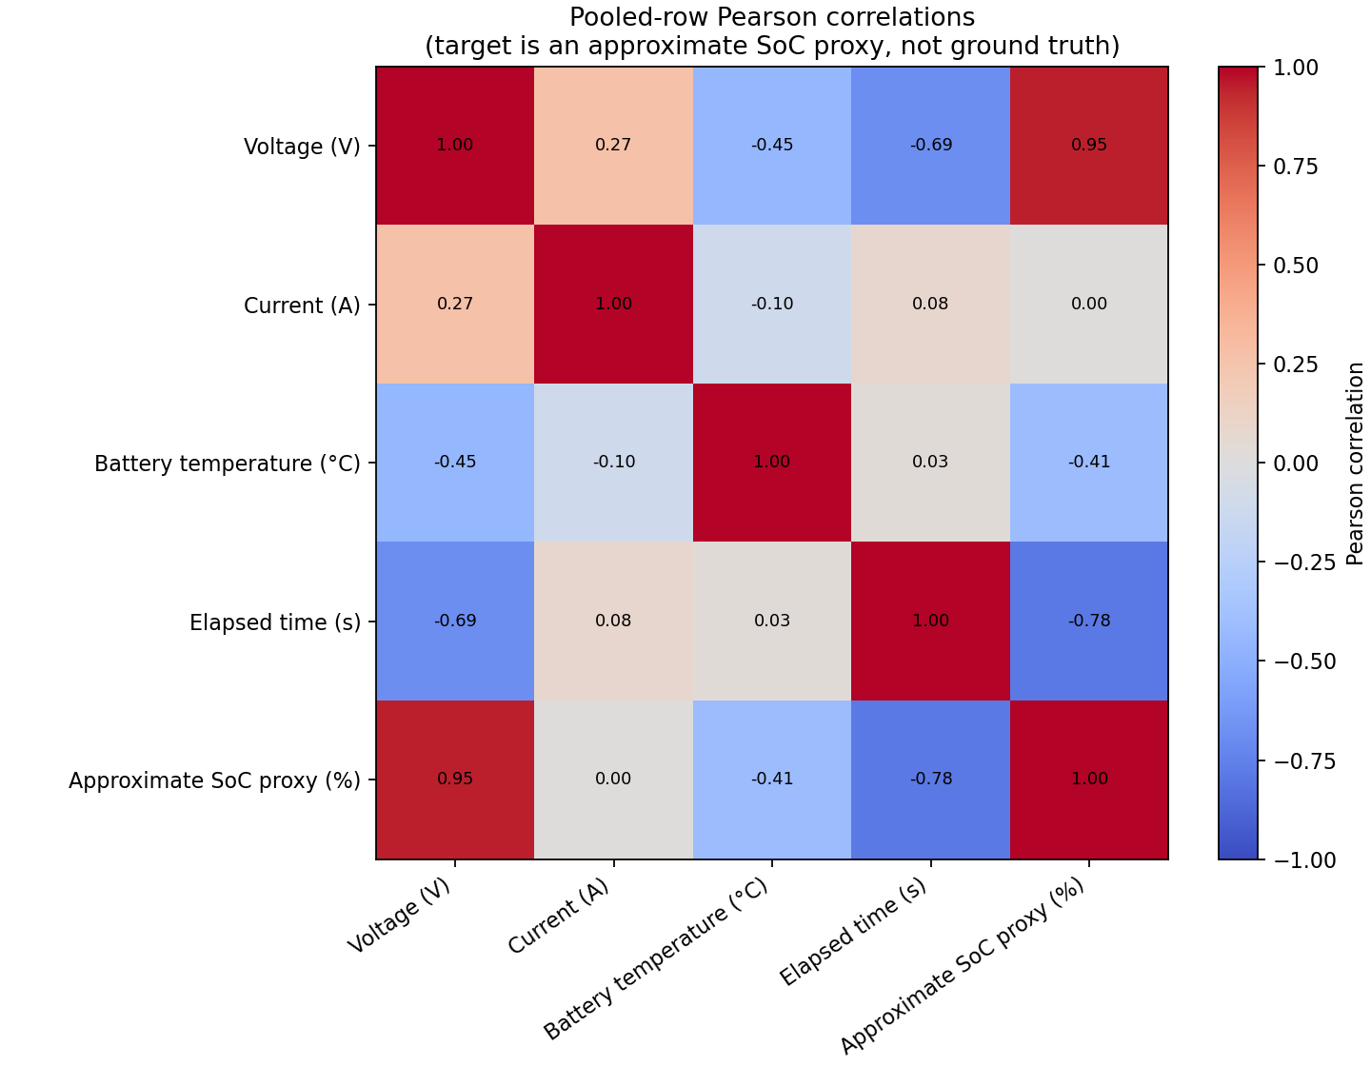
Figure 4.3. Descriptive pooled-row feature correlations with the approximate proxy.
The saved EDA metadata reports pooled-row Pearson correlations of 0.9482 for voltage, −0.7814 for elapsed time, −0.4073 for battery temperature, and 0.0017 for current with the proxy. These are descriptive correlations over serially correlated rows with unequal cycle sizes; they do not show causality or independent-sample significance.

4.3.2 Test Case 2: Model Comparison and Cycle Robustness
Table 4.2. Fixed complete-cycle holdout comparison (7 cycles train; 3 cycles test).
Model | Proxy MAE (pp) | Proxy RMSE (pp) | R²
RidgeRegression | 3.126 | 5.075 | 0.9700
RandomForestRegressor | 2.258 | 3.070 | 0.9890
ExtraTreesRegressor | 3.222 | 4.309 | 0.9784

Random Forest achieved the lowest holdout MAE and RMSE and the highest R² among the three compared regressors. Its MAE was lowest on each of the three held-out cycles. It was selected provisionally for the optimization stage; the observed performance measures proxy agreement only.
Table 4.3. Supplementary leave-one-cycle-out pooled out-of-fold comparison.
Model | Pooled MAE (pp) | Pooled RMSE (pp) | R² | Worst cycle by MAE
RidgeRegression | 4.008 | 5.870 | 0.9570 | 03-21-17_00.29 25degC_UDDS_Pan18650PF
RandomForestRegressor | 3.111 | 4.680 | 0.9727 | 03-21-17_00.29 25degC_UDDS_Pan18650PF
ExtraTreesRegressor | 4.523 | 6.873 | 0.9410 | 03-20-17_01.43 25degC_US06_Pan18650PF

The 100-tree Random Forest pooled leave-one-cycle-out proxy MAE was 3.111 percentage points, higher than its fixed-holdout result of 2.258 points. The worst held-out cycle by MAE was UDDS. These results are consistent with meaningful cycle-to-cycle difficulty differences; they should not be treated as a separately locked validation set.

4.3.3 Test Case 3: Optimization, Resource Measurements, and C Export
Table 4.4. Random Forest complexity variants on the shared holdout.
Variant | Trees | Max leaves | Proxy MAE (pp) | Joblib bytes | Size reduction
selected_baseline | 100 | 128 | 2.258 | 1,868,529 | 0.0%
rf_50_trees | 50 | 128 | 2.295 | 934,929 | 50.0%
rf_100_64_leaves | 100 | 64 | 2.681 | 946,929 | 49.3%
rf_50_64 | 50 | 64 | 2.719 | 474,129 | 74.6%
rf_25_32 | 25 | 32 | 3.470 | 122,529 | 93.4%

Table 4.5. Host-side model size, median/p95 latency (ms per batch), and process VmHWM.
Model | Joblib bytes | Batch 1 med/p95 | Batch 32 med/p95 | Batch 256 med/p95 | Peak RSS MB
Selected baseline · 100 trees | 1,868,529 | 39.01 / 65.80 | 38.69 / 63.08 | 47.72 / 63.09 | 300.9
Candidate · 50 trees | 934,929 | 43.05 / 82.76 | 24.91 / 36.71 | 25.34 / 40.03 | 301.1

Table 4.6. Compiled C99 versus Python prediction parity on every fixed-holdout row.
Export | Trees | Nodes | Header bytes | Rows | Max abs diff | Tolerance | Pass
provisional_selected_baseline | 100 | 25,500 | 1,210,081 | 37,326 | 4.26e-14 | 1e-09 | True
size_optimized_candidate_not_selected | 50 | 12,750 | 606,478 | 37,326 | 4.26e-14 | 1e-09 | True

Both forest headers compiled with the stated warning-as-error flags. C predictions passed the 10⁻⁹ absolute tolerance on 37,326 holdout rows per model; the maximum absolute difference recorded for either model was 4.263 × 10⁻¹⁴ proxy percentage points. This verifies translation parity with the source models, not correctness of the proxy target or physical SoC accuracy.

4.4 Discussion of Result
The results show that the software pipeline, saved estimators, dashboards, C99 headers, and host simulator work together on prepared dataset inputs. On the selected fixed split, Random Forest agreed with the approximate target more closely than Ridge or Extra Trees. The cycle-level holdout strategy is more appropriate than randomly mixing adjacent time-series rows because entire cycles were excluded from training. The worse pooled leave-one-cycle-out result and its UDDS error show that evaluation difficulty depends on the held-out profile. Since no independent cell or truly untouched cycle set was available, the observed metrics are exploratory.
The 50-tree candidate makes a useful software-size trade-off: its serialized joblib file is 49.96% smaller, its C header is approximately 49.9% smaller, and its fixed-holdout MAE increases by only 0.0366 points. However, the host single-row median latency increased from about 39.01 ms to 43.05 ms. The candidate was faster for the measured batch sizes 32 and 256, but host timing is batch- and runtime-dependent. Process high-water RSS was approximately 301 MB for both models and includes Python, scientific libraries, and the dataset, so it cannot be read as the forest’s memory requirement. Neither model’s measured file size, software latency, nor RSS is a measurement of electrical energy or power.
The principal limitation is the target. A shared capacity-referenced coulomb-counting proxy assumes a near-full starting condition and a fixed capacity across cycles. Agreement between Ah and current integration is internal consistency only. The single Panasonic cell, 25 °C subset, selected holdout reuse, and proxy construction limit claims about physical batteries. The code export establishes faithful reproduction of the trained estimator, while no cell, sensor, microcontroller, firmware, or electrical load was connected.
The actual implementation therefore partially fulfils the Chapter Three proposal: it realizes the data processing, model comparison, measured software resource evaluation, user-facing offline dashboard, and portable C inference format. It does not realize live sensor acquisition, microcontroller deployment, validated SoC/SoH output, multi-temperature testing, or device-level power measurement. The prototype is an engineering demonstrator and reproducible software study, not an operational battery management system.

4.5 System Testing
The project test suite was executed with the configured Python 3.10.20 environment. All 46 unit tests passed. Tests cover target/proxy validation, preprocessing, model comparison and selection, optimization, resource benchmark helpers, C99 export parity, host simulator inputs, and dashboard data/inference services. C-specific tests compile with a C99 compiler when available.
Table 4.7. System test activities and recorded outcomes.
Test case | Test activity | Test result
Dataset schema and numeric checks | Reject missing/non-numeric/non-finite inputs; verify required columns. | Passed in tests; the recorded dataset pipeline removed no rows.
Time/group integrity | Reject backwards elapsed time and duplicate (cycle,time) keys. | Passed.
Grouped training/test isolation | Check held-out cycle IDs do not overlap training. | Passed; 7 train cycles and 3 test cycles.
Proxy/model output validity | Check finite inputs and finite prediction shapes. | Passed in model, preprocessing, and dashboard service tests.
Optimization and benchmark checks | Compare candidates, sizes, batch latency, and process RSS output formats. | Passed; metrics stored in JSON/CSV.
C header export | Compile C99 harness and compare both forests on test rows. | Passed; full saved parity set 37,326 rows per model, max difference 4.263e-14.
C simulator input errors | Reject malformed row width, non-finite values, unknown model, and compare valid modes. | Passed.
Dashboard services | Validate feature order, missing features, non-finite values, and dataset schema. | Passed; 46 tests overall.
Physical device and power | Connect sensors/microcontroller and measure electrical power. | Not performed; no hardware available in this implementation.

4.6 Conversion
No existing operational battery-monitoring system was replaced, so direct, parallel, pilot, and phase-in conversion of a legacy system did not apply. The completed conversion is a model-format conversion: saved scikit-learn forests were exported to C99 arrays and checked against the Python models. The host CLI demonstrates use of those headers through text input. A future physical conversion must first specify the target board, sensor circuits, sampling/control behavior, safe initial SoC handling, memory limits, build toolchain, and rollback procedure. It must then be pilot-tested under supervised conditions before operational use. This study did not perform those steps.

4.7 Documentation
The README documents the environment, dataset workflow, reproducible experiment commands, export command, simulator build/run commands, and dashboard launch. The dataset investigation report describes candidate selection and target limitations. Each major experiment stores machine-readable CSV/JSON outputs. The user instructions below apply only when the expected local dataset, models, and result files are present.

4.7.1 Starting the Dashboard
From the repository root:
conda activate ml_env
python -m streamlit run src/ui/app.py
The application starts in Offline Simulation mode. Select a page in the sidebar. On the prediction page, either replay an existing prepared sample or enter voltage, current, battery temperature, and elapsed time. The output is a proxy prediction. A reference difference is shown only for dataset replay; manual measurements have no reference target and no accuracy score is generated.

4.7.2 Running the Host C Simulator
Compile and submit one four-value CSV row per line:
mkdir -p build
cc -std=c99 -O2 -Wall -Wextra -Werror \
edge/simulation/panasonic_edge_simulator.c -lm -o build/panasonic_edge_simulator
printf '4.1703,-2.638,25.63,0\n3.9,-0.5,25.3,120\n' \
| build/panasonic_edge_simulator --model selected
Field order is voltage (V), current (A), battery temperature (°C), elapsed time (s). The default selected model is the 100-tree forest; --model candidate selects the 50-tree candidate. Invalid row width, non-numeric or non-finite values, and unsupported model names return a nonzero exit status with an error on standard error. This is a local host interface and is not a hardware serial connection.
Output reproduced from the compiled simulator:
sample_index,model,soc_proxy_percent
0,selected_baseline,98.603052143925211
1,selected_baseline,98.603052143925211
Appendix C records this real host output. Appendix D contains an actual browser capture of the running dashboard; it shows recorded sample data and the offline-simulation disclaimer. No hardware image is included because no physical device was tested.

4.8 System Maintenance
Reproducible maintenance requires keeping raw source data separate from derived tables; recording data source, license, target assumptions, split IDs, features, seeds, and tool versions; and preserving saved metrics. Changes to target construction require a new proxy audit and model evaluation. Any estimator change requires retraining, optimization comparison, artifact provenance update, C-header regeneration, and C/Python parity validation. The host benchmarks should be repeated on the intended target rather than interpreted as transferable to it. A physical deployment enhancement would additionally require sensor and firmware tests, independent reference measurements, electrical power instrumentation, and safety review.

CHAPTER FIVE: SUMMARY, CONCLUSION AND RECOMMENDATIONS

5.1 Summary
The project developed an offline machine-learning software prototype from Panasonic 18650PF data. The implementation prepared 112,701 samples from ten 25 °C drive cycles, constructed an explicitly approximate capacity-referenced SoC proxy, compared Ridge Regression, Random Forest, and Extra Trees with complete-cycle holdout, selected Random Forest provisionally, and evaluated smaller variants. The 50-tree candidate reduced serialized model size by 49.96% with a 0.0366-point increase in holdout proxy MAE. Host latency, file size, and process RSS were measured and clearly separated from physical power. The trained forests were exported as C99 headers, matched their Python outputs to within 4.263 × 10⁻¹⁴ on 37,326 test rows, and were exercised through a host C simulator. A Streamlit dashboard exposed recorded-data exploration and manual or replayed predictions. The complete software suite passed 46 tests.

5.2 Conclusion
The stated software-development aim was partially achieved. A reproducible offline pipeline, model comparison and optimization, dashboard, compiled C99 export, and host-side inference simulation were implemented and tested. The fixed-holdout Random Forest MAE of 2.258 percentage points and the supplementary leave-one-cycle-out MAE of 3.111 percentage points quantify agreement with the derived proxy only. They do not demonstrate physical SoC accuracy. The C parity check confirms that the exported code reproduces the source estimator; it does not validate the target or an embedded deployment. Because no microcontroller, battery sensor circuit, independent SoC reference, or power measurement was used, the project cannot conclude that an edge device was physically deployed or that electrical energy was saved.

5.3 Recommendations
- Obtain an independently validated SoC reference or establish and validate a per-cycle capacity and initial-state protocol before describing model output as SoC accuracy.
- Evaluate on independent cells, drive profiles, and temperatures. Lock a final test group that is not reused for model selection or optimization, and report per-cell and per-cycle results.
- Integrate the C model with a named microcontroller and actual voltage, current, and temperature sensing hardware. Specify sampling, calibration, initialization, diagnostics, and fail-safe behavior before deployment.
- Measure target-board inference latency, model and runtime memory, and electrical energy/power with documented instruments and experimental conditions. Do not infer power from artifact size or desktop RSS.
- Assess quantization, input reduction, and inference scheduling as separate controlled experiments; retain model variants only when the trade-off is measured on the target system.
- Personalize the cover, approval, declaration, dedication, and acknowledgement pages; verify all reference details; and update Word’s table/list fields before submission.

REFERENCES
[ADD THE ORIGINAL REFERENCES CITED IN CHAPTERS ONE–THREE HERE. Verify APA formatting and cross-check every in-text citation before submission.]
Kollmeyer, P. (2018). Panasonic 18650PF Li-ion battery data [Data set]. Mendeley Data. https://doi.org/10.17632/wykht8y7tg.1
Pedregosa, F., Varoquaux, G., Gramfort, A., Michel, V., Thirion, B., Grisel, O., Blondel, M., Prettenhofer, P., Weiss, R., Dubourg, V., Vanderplas, J., Passos, A., Cournapeau, D., Brucher, M., Perrot, M., & Duchesnay, É. (2011). Scikit-learn: Machine learning in Python. Journal of Machine Learning Research, 12, 2825–2830.

APPENDIX A: PROJECT STRUCTURE AND REPRODUCIBILITY
The structure below lists the main implementation and evidence paths used in this report. Raw data and prepared CSV artifacts are local and excluded from Git; recreate or restore them using the README instructions.
Selected project paths:
src/data/ Dataset loading, auditing, proxy construction, and EDA
src/preprocessing/ Validation, training-only scaler, and cleaning log
src/models/ Training, comparison, selection, and optimization
src/evaluation/ Benchmarks, cycle robustness, C export/parity
src/ui/ Streamlit application, data loaders, prediction service
edge/exported/ Two standalone Random Forest C99 headers
edge/simulation/ Host-side C99 CSV simulator
results/metrics/ JSON provenance and experiment summaries
results/comparisons/ Model, optimization, resource, and cycle CSVs
tests/ Unit and compiled C integration tests
reports/ Dataset report, this document, and screenshots
Reproduce the full test run from the project root with: python -m unittest discover -s tests -v. The verified run for this report executed 46 tests and ended with OK.

APPENDIX B: VERIFIED SOURCE-CODE EXCERPTS
The following excerpts are extracted from the checked-in source files named above. They document the proxy formula, model feature ordering, and runtime prediction validation; they are not replacements for the complete source code.
src/data/prepare_panasonic_soc_proxy.py — derived proxy formula:
def derive_soc_proxy(
ah_values: np.ndarray,
*,
reference_capacity_ah: float,
) -> np.ndarray:
"""Estimate relative SoC from full-charge start and measured Ah throughput."""
ah = np.asarray(ah_values, dtype=float)
if ah.ndim != 1 or ah.size == 0:
raise ValueError("Ah values must be a non-empty one-dimensional array")
if not np.isfinite(ah).all():
raise ValueError("Ah values must be finite")
if not np.isfinite(reference_capacity_ah) or reference_capacity_ah <= 0:
raise ValueError("Reference capacity must be finite and greater than zero")
discharged_ah = ah - ah[0]
return 100.0 * (1.0 + discharged_ah / reference_capacity_ah)
src/data/prepare_panasonic_soc_proxy.py — model feature order:
MODEL_FEATURES = (
'voltage_v',
'current_a',
'battery_temp_c',
'elapsed_time_s',
)
src/ui/service.py — input ordering and one-row prediction validation:
def predict_soc_proxy(model: Predictor, features: Mapping[str, float]) -> float:
"""Predict one proxy percentage with explicit feature ordering and checks."""
try:
ordered = [float(features[column]) for column in FEATURE_COLUMNS]
except KeyError as error:
raise ValueError(f"Missing model input feature: {error.args[0]}") from error
except (TypeError, ValueError) as error:
raise ValueError("All model inputs must be numeric") from error
values = np.asarray(ordered, dtype=np.float32)
if not np.isfinite(values).all():
raise ValueError("All model inputs must be finite")
if model.n_features_in_ != len(FEATURE_COLUMNS):
raise ValueError(
f"Expected a {len(FEATURE_COLUMNS)}-feature model, "
f"found {model.n_features_in_}"
)
prediction = np.asarray(model.predict(values.reshape(1, -1)), dtype=float)
if prediction.shape != (1,) or not np.isfinite(prediction[0]):
raise ValueError("Model must return exactly one finite proxy prediction")
return float(prediction[0])
edge/simulation/panasonic_edge_simulator.c — strict CSV feature parser:
static int parse_features(char *line, float features[4])
{
char *cursor = line;
for (int index = 0; index < 4; ++index) {
while (*cursor == ' ' || *cursor == '\t' || *cursor == '\r' ||
*cursor == '\n') {
++cursor;
}
if (*cursor == '\0') {
return 0;
}
errno = 0;
char *end = NULL;
const double value = strtod(cursor, &end);
if (end == cursor || errno == ERANGE || !isfinite(value) ||
value > FLT_MAX || value < -FLT_MAX) {
return 0;
}
features[index] = (float)value;
if (!isfinite((double)features[index])) {
return 0;
}
cursor = end;
while (*cursor == ' ' || *cursor == '\t' || *cursor == '\r' ||
*cursor == '\n') {
++cursor;
}
if (index < 3) {
if (*cursor != ',') {
return 0;
}
++cursor;
} else if (*cursor != '\0') {
return 0;
}
}
return 1;
}
The C99 exporter implementation is in src/evaluation/export_panasonic_forest_c.py; the complete, generated model arrays are in edge/exported/. The project tests compile those headers and compare predictions to scikit-learn rather than reproducing the large generated arrays in this printed excerpt.

APPENDIX C: HOST C99 SIMULATOR EXAMPLE
The following command-line sample was compiled and run using the project’s actual C source and exported headers. The first line of output is the simulator’s CSV header; the remaining lines are model predictions for the two displayed input rows.
Input rows (voltage,current,temperature,elapsed time):
4.1703,-2.638,25.63,0
3.9,-0.5,25.3,120
Captured simulator standard output:
sample_index,model,soc_proxy_percent
0,selected_baseline,98.603052143925211
1,selected_baseline,98.603052143925211
This is host execution evidence only. It is not a physical serial connection, sensor reading, or battery-control demonstration.

APPENDIX D: ACTUAL DASHBOARD SCREENSHOT
Figure D.1 is a browser screenshot captured from the running Streamlit application. It displays a recorded Panasonic sample and the explicit Offline Simulation notice; no live sensor or physical edge device is connected.
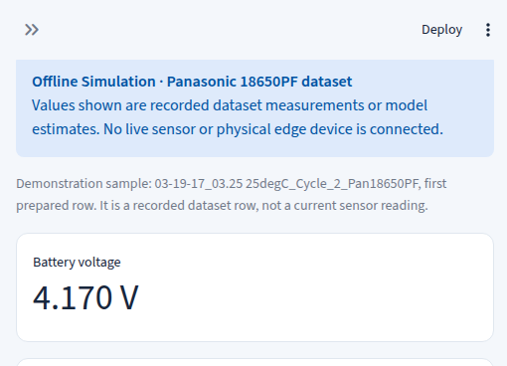
Figure D.1. Running Streamlit dashboard showing dataset replay and offline-simulation notice.

APPENDIX E: AUTOMATED TEST EVIDENCE
Verified command and terminal summary:
$ python -m unittest discover -s tests -v
Ran 46 tests in 30.513s
OK
The run included UI service/data checks and C-compiler integration tests. It did not test hardware, real-time sensor acquisition, electrical power, or an independently validated SoC reference.

APPENDIX F: EXTENDED RESULTS AND EVIDENCE LIMITATIONS

F.1 Fixed-Holdout Per-Cycle Proxy Results
Held-out cycle | Rows | MAE (pp) | RMSE (pp) | R²
03-19-17_03.25 25degC_Cycle_2_Pan18650PF | 11137 | 2.320 | 3.109 | 0.9885
03-19-17_14.31 25degC_Cycle_4_Pan18650PF | 12095 | 2.254 | 3.030 | 0.9908
03-21-17_09.38 25degC_LA92_Pan18650PF | 14094 | 2.213 | 3.073 | 0.9873

F.2 Interpretation Guardrails
- All model metrics are proxy-agreement measures, not validated physical SoC accuracy.
- The 50-tree model is an optimization candidate; the 100-tree Random Forest remains the provisionally selected baseline.
- The fixed holdout informed model choice and optimization, so reported model and resource results are exploratory.
- RSS includes the Python process, libraries, dataset, and runtime. It is not model-only memory.
- No physical battery/sensor/microcontroller deployment or electrical power measurement was performed.

