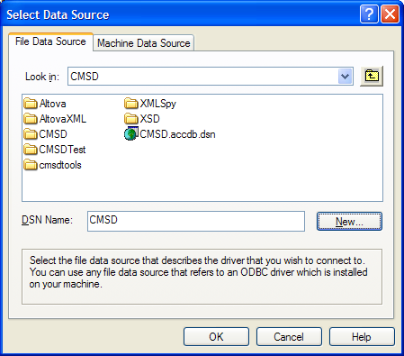ARENA WISH LIST

How to use options to select something without IF statements, e.g., Different Part cycle times. Use type match \* value and add to non-matching types.

(Entity.Type == Bracket) \* 22 + (Entity.Type == Shim) \* 36 + (Entity.Type == BodyJoint) \* 12

