MTConnect Dboard

MTConnect Dboard is a simple MTConnect client that archives program performance metrics and machine faults, and also provides a visual summary for each MTConnect monitored machine. The status query and archiving part of MTConnect Dboard is a windows service that runs continuously. The dashboard GUI part of the Dboard is a windows “Tray Icon” application that only runs when a user is logged into windows interactively.

## Dboard GUI

When the program is running a green, red or blue (possible flashing) lighting bolt is displayed in the Tray Icon area of windows – usually the lower right hand side of the user screen, as shown below:



By double clicking on the lighting bolt icon  a GUI window will pop up and display the current status of the monitored machine via MTConnect:

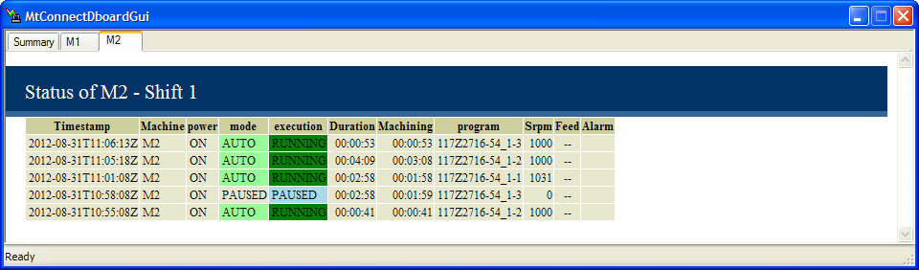

The GUI is a Tabbed view of each machine plus a summary window. Each machine (in example: M1 and M2) displays a (configurable, discussed later) table containing a trace of the machine status. The status adds a new table row based upon a transition event. In general, the finishing of a program is the event that is triggers a new row. The status table updates the timestamp, duration timers, color coding of the mode and execution and MTConnect sample, condition, and event data item status. In the GUI, the MTConnect events power, mode, execution, program; the MTConnect samples Srpm, Feed and a summary of the MTConnect conditions in the Alarm field. Whenever all the monitored MTConnect conditions are either a Warning or Fault, the Alarm field will display the Condition, Warning/Fault, Message in the alarm field. At this time only one alarm is displayed at a time

The summary tab view provides a table containing a brief overview of the status of each machine: machine name, power, mode, execution status, program, duration of current program and a horizontal bar graph showing the execution history for the last

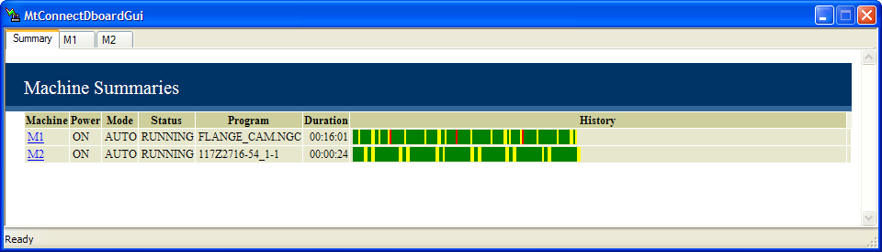

The bar graph history has green for running, yellow for paused, and red for stopped/off. By clicking on the Machine name (M1 or M2) the current MTConnect Agent XML is displayed in a new Internet Explorer window.

Tip: By clicking on the _ in the window upper right hand corner, the window will minimize to the tray icon area.

If enabled, there is a Faults History Tab that gives the alarms

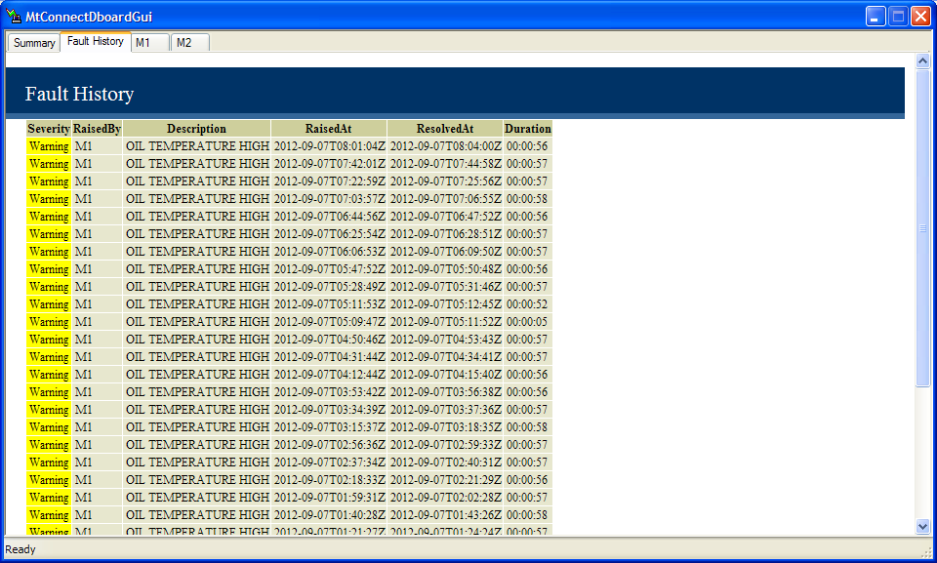

## Dboard Archiving

The DBoard does multiple MTConnect machine monitoring with archiving of data fro each shift. The shifts are configurable. At the end of each shift, archiving is done for a Comma separated value (CSV) file and updating to a Jet database update.

For the archival log file M1Log12_08_17Shift2.csv, the filename meaning is Machine M1, 2012/08/17, shift 2 archive is contained in this file. The shift summary is stored in a csv format with a header line followed by series of data lines:

There is also an archiving of all shift and machine data to a Jet data base, that if Microsoft Access is installed, is easily viewable and allows queries. The file MachinePerformanceLogCurrent.mdb contains all the table MachineState which contains data base rows of data corresponding to the summary archiving. 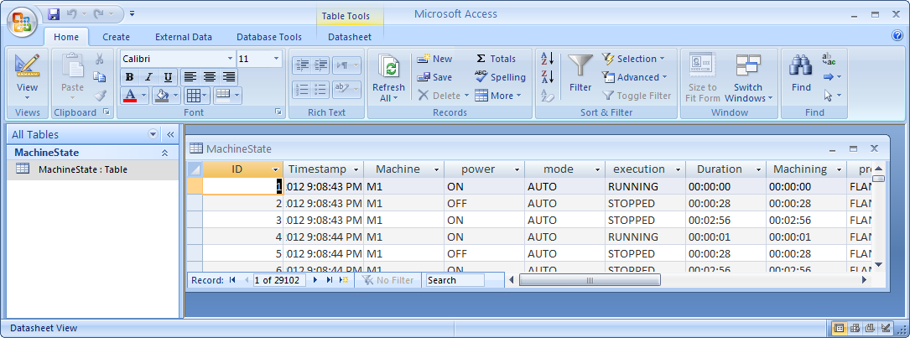

The location of the archival folder is configurable, but the default folder is C:\DailyLogs.

## Dboard Installation

The Dboard application comes with a windows installer script. Make sure you are administrator when you install the program, as it installs and starts a windows service and this can fail with inadequate authentication leve.

If you double click the Install.msi:



It will popup an install script that requires some configuration in order for the DBoard to work. The welcome screen pops up:

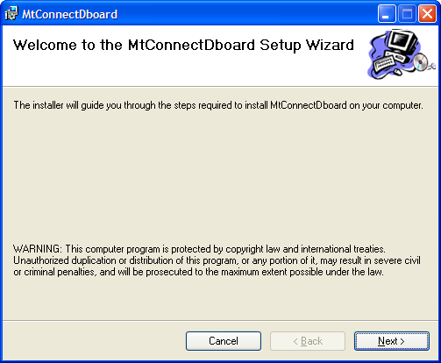

And by clicking Next, the Installation Folder tab is presented. The default installation folder is C:\Program Files\MTConnect \Dboard

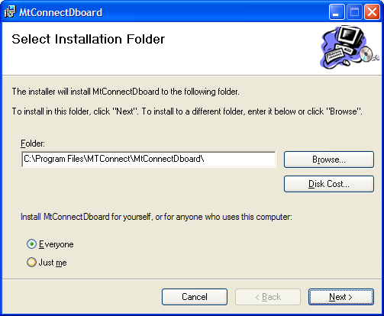

It is best to just click Next. Then the minimal configuration Tab is popped up to configure agents URL, and corresponding machine names.

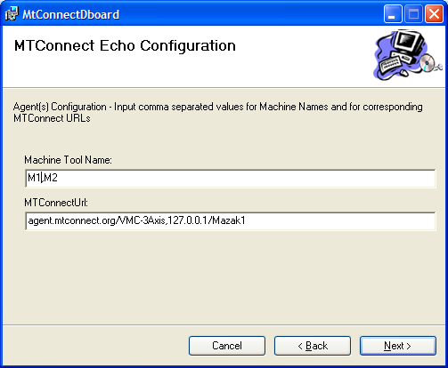

Each text field supports comma separated values for configuration of multiple ips and machines. Machines and MTConnect agent device names do not have to match.

In the example, two machines M1 & M2 are entered as M1,M2. Spaces will be removed. The MTConnect URL can be agent.mtconnect.org which will be mapped into a default ip as in http:// agent.mtconnect.org/current or by device http:// agent.mtconnect.org/VMC-3Axis/current. In the second URL, 127.0.0.1/Mazak1 says use MTConnect device name Mazak1 at IP 127.0.0.1.

Note, Mazak1 and M2 are different. M2 is just a display and archiving name, while the Mazak1 is an MTConnect device and **MUST BE CORRECT**.

Then click Next to start the installation:

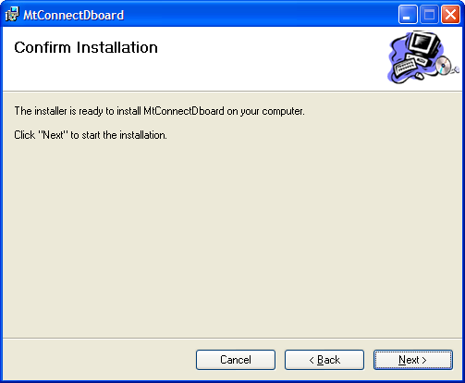

The installation will automatically install the windows service, the Dboard COM server to display the status, and will start the service. After a while, you should  in the Tray Icon area. If no lighting bolt is present, there must be an error, and will require opening the Installation folder (default: C:\Program Files\MTConnect\Dboard) and opening the debug.txt file to view error messages. If no error message is available, there is a possibility that the MTConnect Dboard service either did not install properly due to permissions problems or did not start due to some configuration problem.

## Dboard Configuration

The file MtConnectDboard.ini in the installation folder contains the configuration information to drive the archiving and display. It is in “ini”format, with a section of configuration information that is started with bracketed section name, i.e. [SECTIONNAME], followed by assignments, in the form name=value pairs; There are multiple. The [DEVICES] section contains the configuration derived from the installation wizard. You can change this to reflect different machine names and MTConnect URL (the key IP) as entered as comma separated values.

[DEVICES]

IP=agent.mtconnect.org,129.6.72.44/M1

Machine=M1,M2

The primary configuration is done in the [CONFIG] section. It contains the keys for defining the service name used in the Windows Service Control Manager, debug level(Debug) timestamping(Timestamp), Events to trigger on(Events), MTConnect query delay time (DELAY),

[CONFIG]

|  |  |
| --- | --- |
| ServiceName=MtConnectDboard | service name used in the Windows Service Control Manager |
| Path= |  |
|  |  |
| Debug=5 | Debug level used to log execution activity into the debug.txt file |
| Timestamp=1 | Flag to allow timestamping of data, 1=yes |
| Events=program,power,PartCountAct |  |
| DELAY=1000 |  |
| ## Data after renaming |  |
| Data =power,mode,execution,program,Feed,Sload,Srpm,Cloadc,Xloadc,Yloadc,Zloadc,PartCountAct,HydraulicLevel,HydraulicPressure,HydraulicTemp,CoolantLow,LogicProgram | The MTConnect data items, including samples, events and conditions, that will be collected and stored from the agent. Tag names in the list would contain aliases (renames) of raw MTConnect tag names. |
| Fields =Timestamp,Machine,power,mode,execution,Duration,Machining,program,Srpm,Feed,Alarm | Fields contains the display and archiving tags to display in the GUI and to save to file/database. Duration and Machining are two internally generated tag names. |
| ARCHIVEPATH=C:\DailyLogs\ | This is folder where archive logs are stored. |
| Archive=Timestamp,Machine,program,Duration,Machining,RpmTotal | Describes the tags to save to the data base archive. Tags such as RPM or feed would only report the last sample, so this would not be useful in a stored data base. |
| KPI=RpmTotal | List of the computed KPI from the MTConnect status queries. In this example, RpmTotal contains the total RPM for the spindle. |
| Fault = HydraulicLevel,HydraulicPressure,HydraulicTemp,CoolantLow,LogicProgram,Cloadc,Xloadc,Yloadc,Zloadc | List of the conditions that are mapped into faults for archiving and display. |
|  |  |
| Numbers=Srpm,Feed,SpindleLoad,RpmTotal | List of numeric (double) types in the potential list of tagged items |
| DateTime=Duration,Machining | List of timed data types in the potential list of tagged items. So, items update in seconds, but display in hr:min:sec |

Shifts are also part of the CONFIG section. Since shifts are the fundamental archival unit, the days of the week and shifts each day must be outlined to allow for accurate logging of MTConnect queries.

NUMSHIFTS=3

SHIFTCHANGES = 07:00, 15:00, 23:00

#SHIFTCHANGES = 09:25, 9:45, 23:00

WORKWEEK=Mon,Tue,Wed,Thu,Fri,Sat

The [ALIASES] sections provides for renames of MTConnect name or dataItemId so that they can either have a common name or a more readable name. Below is an example of the alias renames done by default:

[ALIASES]

controllermode=mode

path_feedratefrt=Feed

Sload=SpindleLoad

Sspeed=Srpm

Frt=Feed

hlow=HydraulicLevel

hpre=HydraulicPressure

htemp=HydraulicTemp

clow=CoolantLow

clp=LogicProgram

The VALUEREMAPPING section provides a way to remap into different values. This is useful to handle MTConnect 0.9 versus 1.0 version naming strategies and for changing states into a single state. Below is an example of the mappings done by default:

[VALUEREMAPPING]

execution.READY=IDLE

execution.ACTIVE=RUNNING

mode.AUTOMATIC=AUTO

execution.EXECUTING=RUNNING

The COLORCODING section provides a way to colorize cells in the display table for different tag.value mappings. The key values are included in the matching cells as HTML Table <TD> styles. Colors are based on HTML color naming scheme. Below is the default mapping done by default:

[COLORCODING]

execution.IDLE=style='background-color:lightblue;'

execution.RUNNING=style='background-color:MediumSeaGreen;'

execution.MACHINING=style='background-color:MediumSeaGreen;'

execution.STOPPED=style='background-color:yellow;'

execution.PAUSED=style='background-color:yellow;'

mode.AUTO=style='background-color:palegreen;'

mode.MANUAL=style='background-color:blue;'

The FORMATS section provides a way to format numeric values for display.

[FORMATS]

Srpm=%6.0f

Feed=%6.2f

SpindleLoad=%3.0f%%

The COSTFCNS section provides a way to calculate KPI after each MTConnect agent query. KPI are computed in an interpreter that contains all the Tag names and values, and then does the calculations based on these values and the variables Elapsed, Timestamp. In the sample below, RpmTotal is calculated each cycle based on the Spindle RPM reading (Srpm) times the Elapsed time (in seconds) divided by 60 seconds in a minutes. This value is saved between COSTFCNS calculations and can be archived. It is important to declare KPI COSTFCNS variables in the CONFIG section under the key KPI.

[COSTFCNS]

RpmTotal=RpmTotal+Srpm*Elapsed/60.0