MTConnect Dboard

MTConnect Dboard is a simple MTConnect client that archives program performance metrics and machine faults, and also provides a visual summary for each MTConnect monitored machine. The status query and archiving part of MTConnect Dboard is a windows service that runs continuously. The dashboard GUI part of the Dboard is a windows “Tray Icon” application that only runs when a user is logged into windows interactively.

## Dboard Internals

**Dboard**

**Tray**

**Icon**

**Parser**

**Csv**

**Archiver**

**Windows**

**Service**

**MTConnect**

**Agent**

Current

Snapshot

Via COM

pWebBrowser

**COM  
Server**

**Shift**

**Data**



**Jet DB**

**Archiver**

**Fault**

**Archiver**

## What different between vsdrpCOM and vsdrpCOMSelfReg

Selfreg causes the ocx to be called at install time to register, requiring

dependent Dlls to be present. The code runs. The plain "COM" setting runs

the registration at build time and puts the data in the MSI file. At install

time, the file gets copied and Windows writes the registry entries, making

this almost always the better way because you're depending on registration

code to work at install/uninstall time, just at build time.

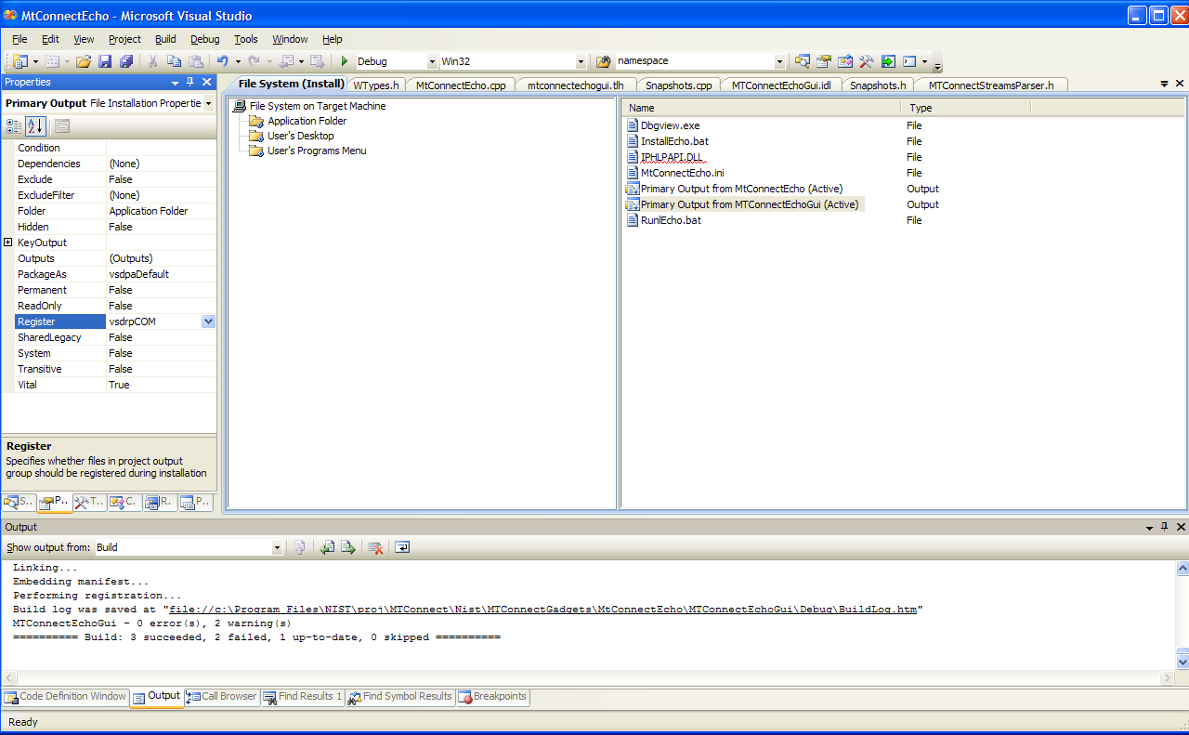

Scroll down here:

http://www.simple-talk.com/2005/04/25/getting-started-with-setup-projects/

the difference between vsdrfCOM and vsdrpCOM is that p is used for

project/primary output, f for just browsing to the file itself.

--

Phil Wilson

[Microsoft MVP-Windows Installer]

Definitive Guide to Windows Installer

http://apress.com/book/bookDisplay.html?bID=280

Hi all,

Could you please tell me what different between vsdrpCOM and

vsdrpCOMSelfReg.

I have two ActiveX controls, all two are register with vsdrpCOMSelfReg, but

when Un-Install, one ActiveX control cannot be Un-Register, but other are

OK. So does the ActiveX need to export some function need for the Installer

to Un-Register?