On the main screen select New and then a Shdr Configuration dialog pops up, where you configure the SHDR connections you want to interact with:

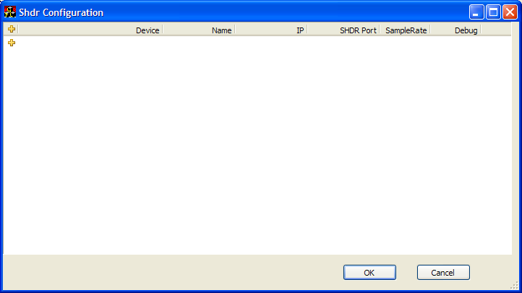

Click on the Plus sign to add a new SHDR interface and a new row will be added. Next Click on Device Column entry, and select from Menu the type of Device you want created (Command, Generic status, etc):

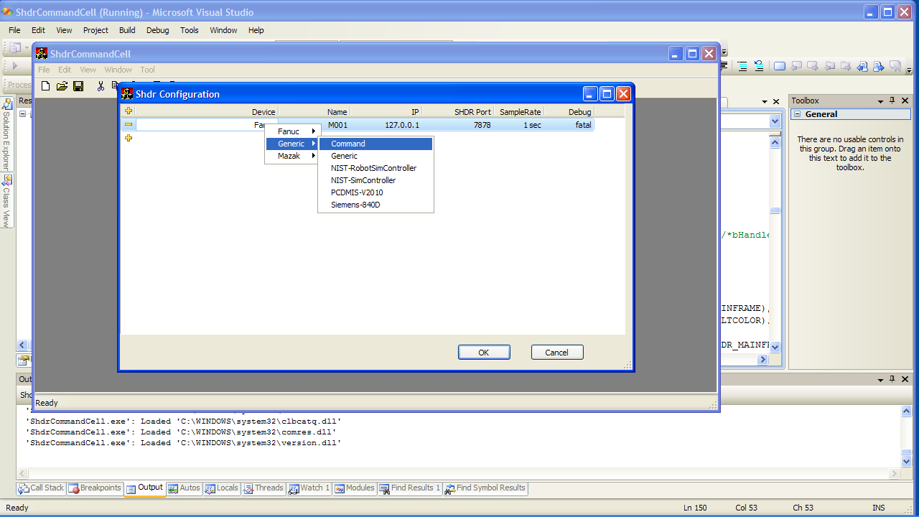

Add as many SHDR devices as you need and click OK.

Here is the setup for the simple Arena demo:

