**SMART User Guide**

**Version 1.0**

**Last Updated: SEPtember 4th, 2020**

**TABLE OF CONTENTS**

**What Is SMART? – A Overview** 2

**How do I access SMART? – Link to Access** 3

**Who Can Use SMART? – User Types** 4

What are the HQ SMART Site Owners Available Actions? 4

What are the HQ Study Administrators Available Actions? 4

What are the CO Study Administrators Available Actions? 5

What are the DGHP SMART Users Available Actions? 5

**How do I Add a New Study?** 6

**What is the Set-Up Profile?** 7

How do I Complete a Set-Up Profile? 7

How do I Edit a Study Set-Up Profile? 14

**What is the Detailed Profile?** 17

How Do I Complete a Detailed Profile? 17

**How Do I Upload Study Documents?** 25

**How Do I Search the SMART repository?** 29

**How Do I Run a Report?** 32

**Helpful Quick Links** 36

## **What Is SMART? – A Overview New Name for Tool -**Project Activity Management Systems (P.A.M.S)

**CDC Sponsor: DGHP**

**Business Need:** Numerous studies and projects are implemented across DGHP. Documents and datasets from these activities are generated and shared by partners, country offices and headquarters’ personnel. All study and project related materials (e.g. documents and datasets) are stored in multiple locations and a high number of staff at all levels shift and change roles, making it difficult to find and share up-to-date information as well as retain all records. In addition, it is challenging to monitor the progress of multiple activities across countries.

**Proposed Solution:** Develop an IT solution to become a:

* **Centralized *Reference Repository*** containing:
  + All study-related documentation such as protocols, revisions, data collection instruments, reports, other regulatory documents, reports for various stakeholders, publications, etc.
  + POCs/contact details and information
  + Deidentified datasets for studies implemented in countries used to produce scientific products
* **Tool to *Monitor*** **project progress**:
  + Automatically generate a monitoring report to show high-level study progress
  + *Automated Status Monitoring Report* may include: Study name, Topic of study, Study Description, Time Period, Country(s), Partner(s), Number of Sites, Number Enrolled, etc.

**Project Phases:**

**PHASE** **1** of Development:

* SMART will accept study documents and datasets uploaded by CDC HQ and Country Office (CO)
  + CDC HQ will assign roles and access levels for CDC HQ POCs in SharePoint and specify POCs and other study details in the *Set-Up Profile*
  + CDC CO will be able to specify regional information, context and POCs around each study and study activity in SMART *Detailed Profile*
* SMART will generate a monitoring report to show high level study progress for CDC HQ and CO
  + Example monitoring elements are:
  + Number of active studies or activities in region/country by time period
  + Number of participants enrolled per study or activity/country/partner in a time period

**PHASE** **2** of Development:

* SMART will accept study documents/datasets uploaded by partner POCs
* Partner is only able to upload documents including de-identified datasets to SMART
* SMART may have a metadata driven method that ensures data files are complete and/or contain all required elements according to protocols
* SMART may have ability to produce canned reports from dataset uploads for a variable subset

# **How do I access SMART? – Link to Access**

<https://cdc.sharepoint.com/teams/CGH-DGHP-SMART>

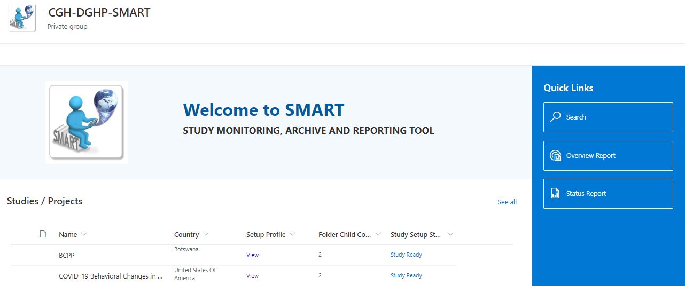

You may also access SMART from the GELSB SharePoint site <https://cdc.sharepoint.com/teams/CGH-DGHP-GELSB>

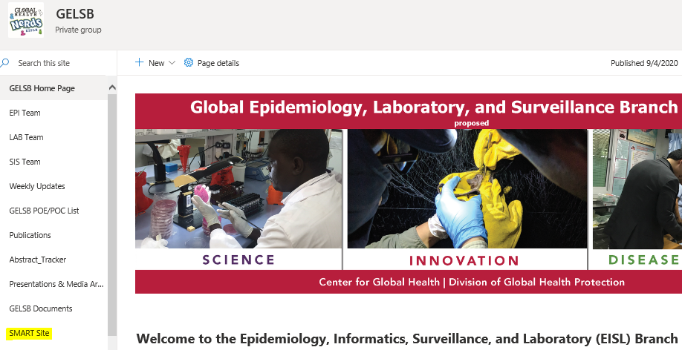

# **Who Can Use SMART? – User Types**

There are four active User types who will use SMART including Headquarters (HQ) SMART Site Owners, HQ Study Administrators, Country Office (CO) Study Administrators, and DGHP SMART Users.

1. **HQ Site Owner(s)**
   * *Creates new Projects/Studies*
   * Grants access to HQ and CO Study Administrators
   * Monitors system
   * Runs study activity reports
2. **HQ Project Administrators** (edit privileges)
   * *Creates, Edits & Maintains Study Set-Up Profile*
   * Grants access to study-specific users
   * Uploads documents into study
   * Runs study activity reports
3. **Field Project Administrators** (edit privileges for Field staff)

* *Edits & Maintains Country Detailed Profile*
* Grants access to study-specific users in country
* Uploads country-specific documents into study
* Runs study activity reports

1. **General Users** (*View only privileges*)

* Searches for documents
* Downloads documents

## What are the HQ SMART Site Owners Available Actions?

The HQ SMART Site Owners can create new studies (initiating workflows automatically) in the SMART SharePoint tool and maintain all artifacts on the site.

They create new projects or studies in SMART by completing the *Set-up Profile*. In addition, they grant access to HQ and CO study administrators to be able to use SMART. They can also search for specific documents that have been uploaded to SMART, either view or download them for further manipulation and analysis, and they can run study or project activity reports. Site Owners monitor the overall SMART system.

## What are the HQ Study Administrators Available Actions?

HQ Study Administrators play a key role in leading and supporting public health projects and research studies occurring globally. They create, edit and maintain the study Set-Up profile and grant permissions to other study-specific users for access to SMART as needed. They may also upload, search and view or download study documents. HQ Study Administrators may also view and edit details of a study or project in the Detailed Profile and run study activity reports.

## What are the CO Study Administrators Available Actions?

The CO Study Administrators are in the CDC country offices around the world and play a key role in leading and supporting public health projects and studies within that country. Each country office has access to the projects and studies occurring in that country.

CO Study Administrators complete, edit and maintain the Detailed Profile for each study/project in the country and update the study progress on a regular basis.

CO Study Administrators will also grant access to other study-specific users in the country. They may upload, search, and view and download study documents. They may also run study activity reports from SMART.

## What are the DGHP SMART Users Available Actions?

DGHP SMART Users will have “view only” privileges to SMART. They may search for documents, view documents, or download documents.

# **How do I Add a New Study?**

To add a new study, click “See all” on the SMART homepage to go to the list of current studies in the Library.

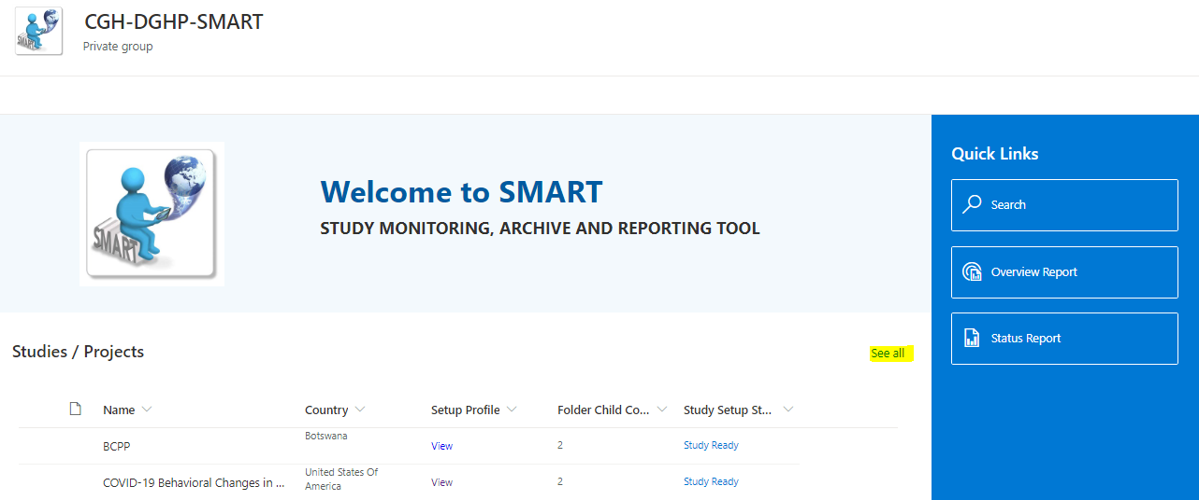

Select “**New**” and choose “**Study**” to add a new study. You will then be prompted to complete a **Set-Up Profile** for your study.

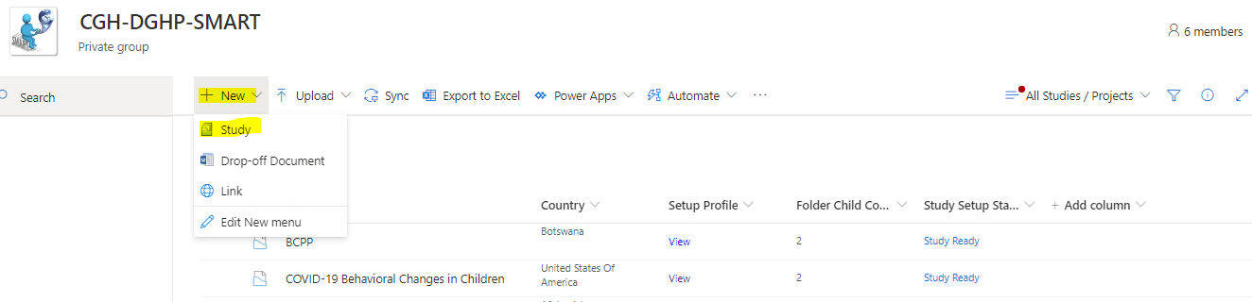

# **What is the Set-Up Profile?**

The Set-up profile summarizes the study/project by describing the study subject, locations, timing, funding and identification of study leads and points of contact.

## How do I Complete a Set-Up Profile?

Enter the **Abbreviated Project/Coag Name** anda more detailed full **Project/CoagName** then click **“Next” If we do our regular NOFO naming convention: the system should create “Capacity Building and it should have a folder to list the “36” folders on the same start date, then the funding page should be attached to the overarching project but also within the country folders.**

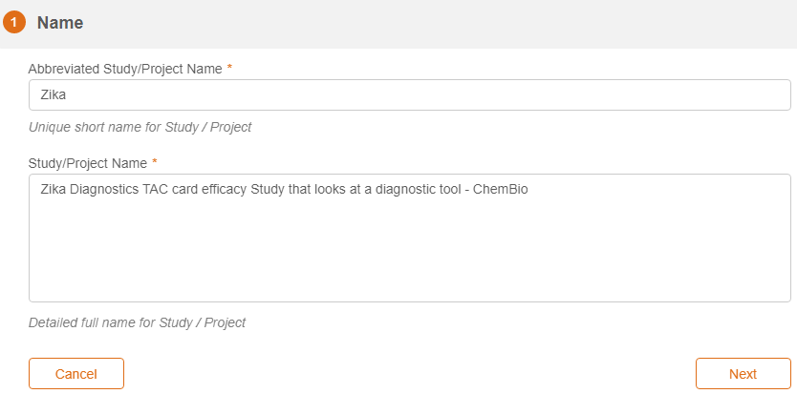Complete the Study/Project **Description** and click “**Next**”

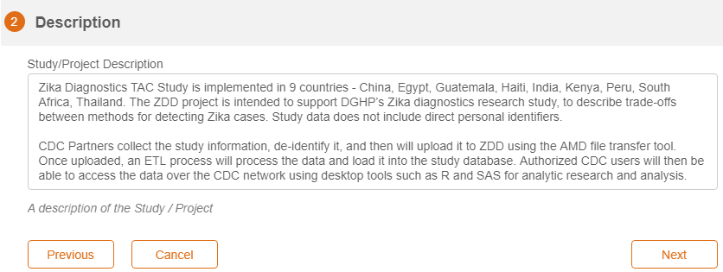

Enter study **Details** including ***Approved Protocol Number (if applicable)***, ***Date of Last Approved Protocol***, ***Primary Public Health Topic*** (choose all that apply from dropdown menus), ***Area of Focus*** (choose one from dropdown menu), ***Country(s)*** (choose all that apply from dropdown menu), ***Region*** (choose all that apply from dropdown menu), type of ***Subjects*** (choose one from dropdown menu), and ***Expected number of Participants***. Then click “**Next.**”

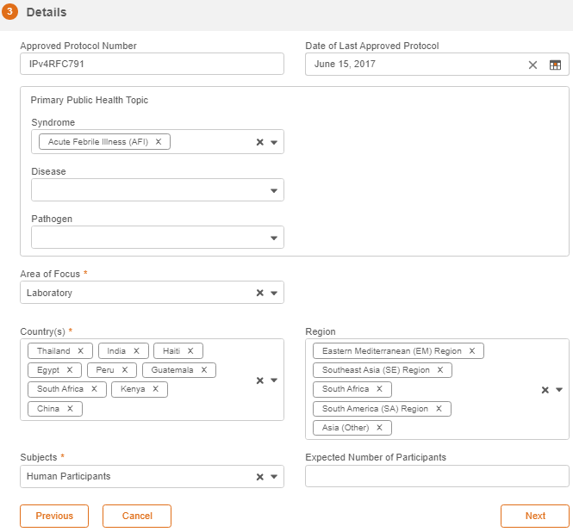

Note that “**Date of Last Approved Protocol**” (and for any subsequent date that needs to be entered in the tool), you may easily scroll to your desired date by clicking on the month or the year then selecting the month and year.

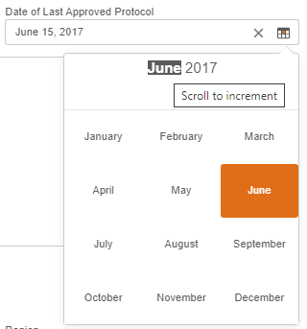 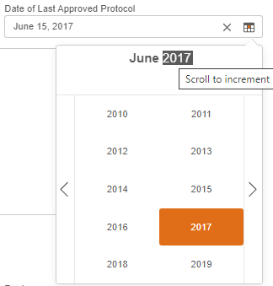

Enter ***Funding Source(s)***, Funding ***Start*** and ***End*** dates, and the ***amount*** of funding for ***each*** ***year*** the study is funded. Click **Add New Year** for each year the study is funded. Then click “**Next.**”

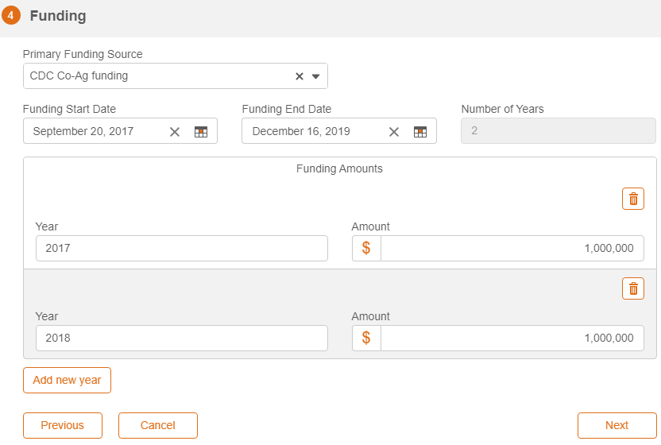

Select CDC Headquarters (HQ) **Primary** and **Secondary** Point of Contacts (POCs)then click**“Next”.**

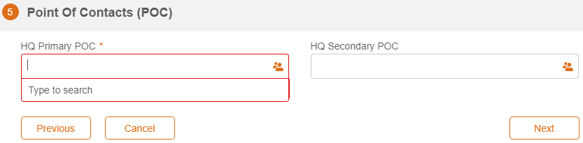

Enter ***Requested Frequency of Study/Project Update*** from the CDC country office (choose one from the dropdown menu – Daily, Weekly, Monthly, Quarterly, Annually), the anticipated ***Start Date for Updates***, and click “**Submit**”.

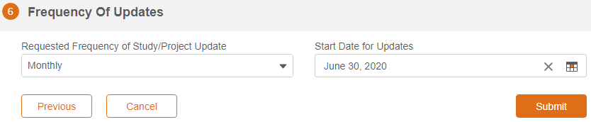

**Note that clicking “Submit” will save the information you entered in the Set-Up Profile.**

After clicking “**Submit**” and saving the data entered in the Set-Up Profile, a study workflow will be initiated so that the study will now show up in the Library list of studies. HQ users may now click “**View**” under the **Setup Profile** column to further edit/update the study’s profile (See “How do I Edit a Study Set-Up Profile” section).

The workflow will also create a “cross study share” folder and individual country folders for each country associated with that study (countries specified in the Set-Up Profile “*Details*” section). Each country office may then complete their country’s study Detailed Profile.

## How do I Edit a Study Set-Up Profile?

HQ Study Administrators can edit or update a study’s Set-Up Profile as needed.

Click on “See all” on the SMART homepage to see all studies.

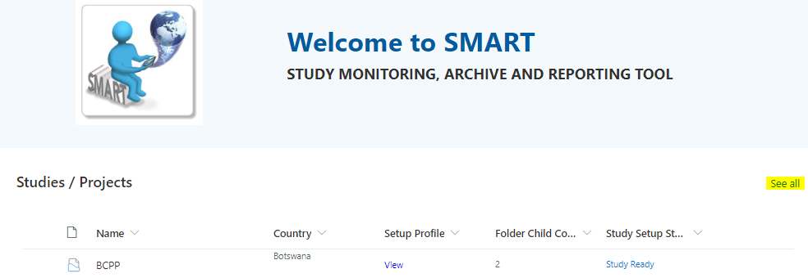

Click Setup Profile “**View**” to edit the Set-Up profile.

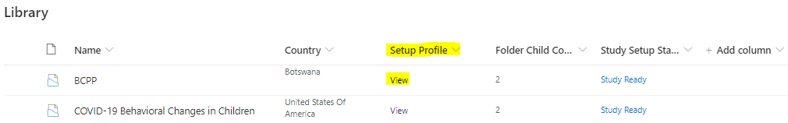

Click “**Edit**” to update or edit all sections of the study Set-up profile

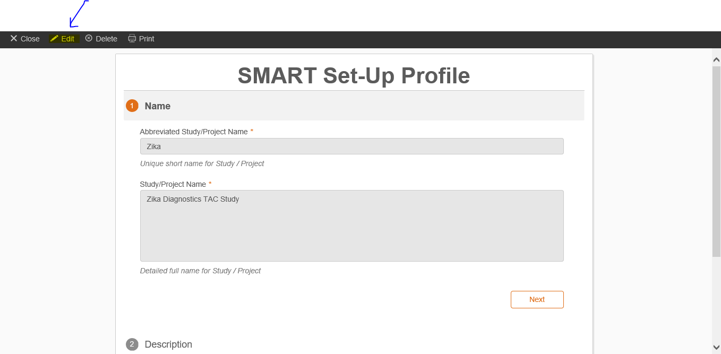

**What is the Detailed Profile?**

The Detailed Profile summarizes country-specific information about a study/project. Details include partner information and points of contact as well as progress updates and enrollment numbers.

CO Study Administrators will complete one Detailed Profile for each study implemented in their country and provide updates in the Detailed profile as requested in the Set-Up Profile.

Several fields are set to “read only” and auto populated from the Set-Up Profile.

## How Do I Complete a Detailed Profile?

Click “**See all**” on the SMART homepage to see all studies.



Click on the study name for which you want to complete the Detailed Profile (e.g., Zika) 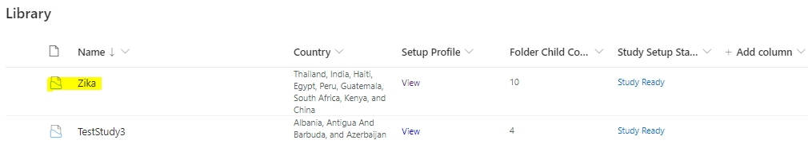

After you click the study name, you will see all the study folders (a cross study shared folder, to which all countries have view-only access and a country study folder for each associated country).

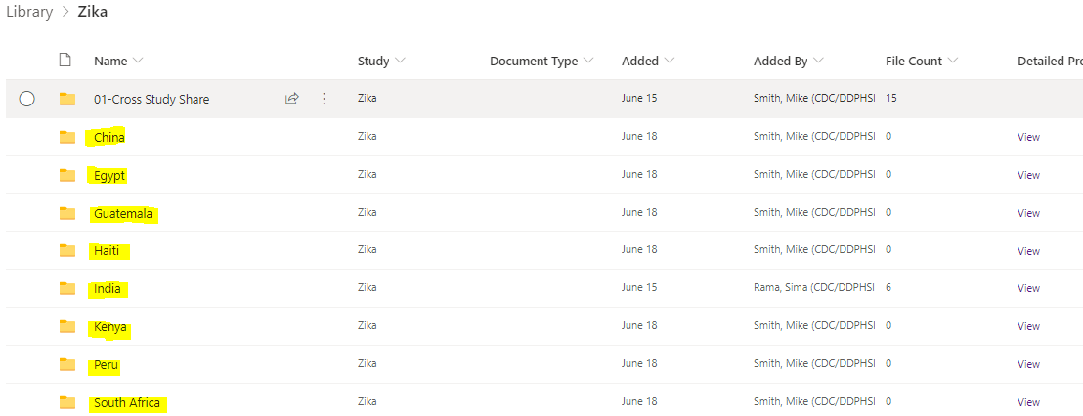

Under the **Detailed Profile** column, click “**View**” for each associated country to complete the Detailed Profile for that country (e.g., China)

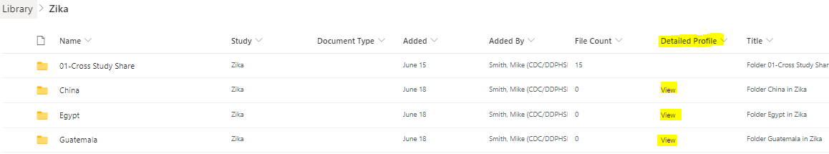

Click “**Edit**” to be able to enter information in the Detailed Profile form 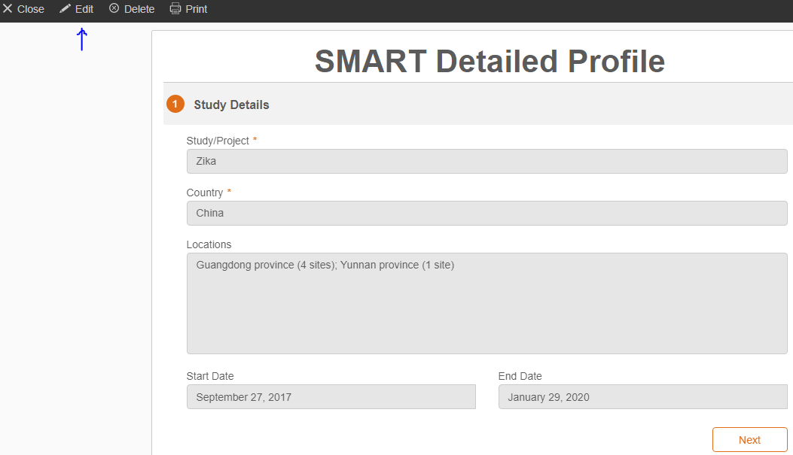

Add locations (separate each location with a semicolon), then enter study start and end dates (calendar dropdown) and click “**Next**” to go to the next section. 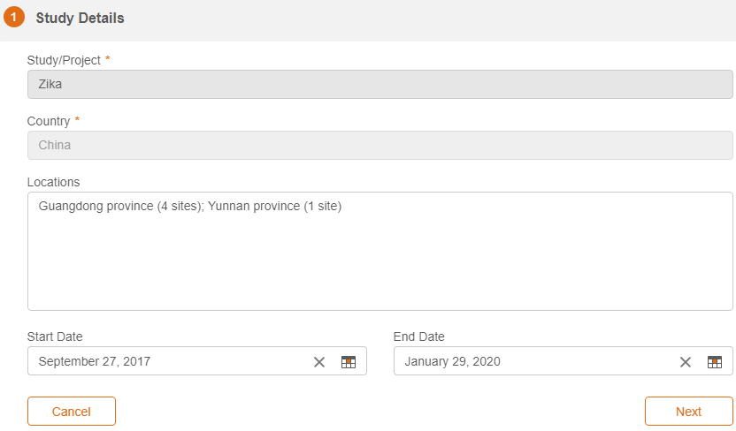

Add CDC Country Office (CO) Principal Investigator and CDC CO Secondary POC, then click “**Next**” 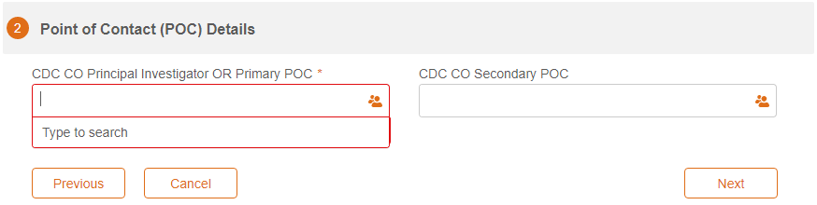

Add Partner **Organization Name**, and Point of Contact **Name**, **Email**, and **Phone**.

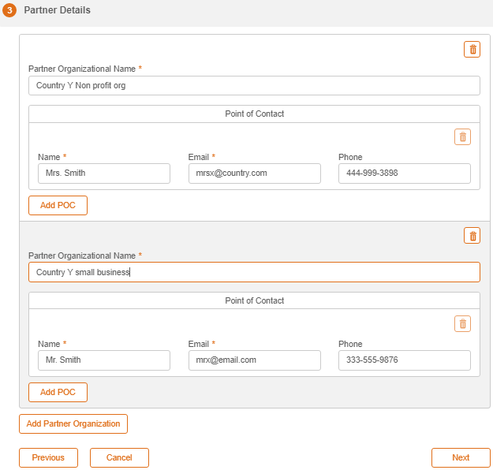

Click “**Add POC**” to add multiple POCs for a specific Partner Organization. You may click the trash icon to delete a POC.

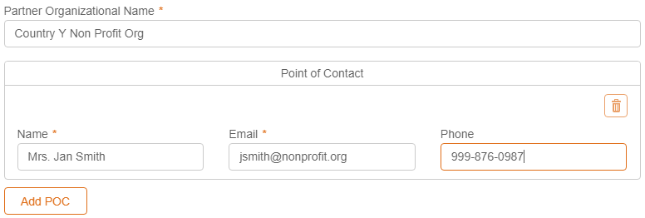

Click “**Add Partner Organization**” to add multiple partner organizations and POCs for each organization, then click “**Next.**” You may click the trash icon to delete a Partner Organization.

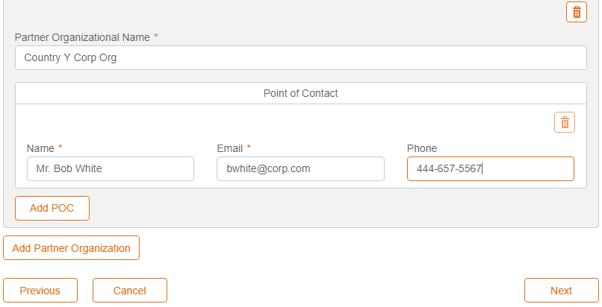

Complete “**Status Updates**” to provide ongoing progress reports on each project/study. Indicate status date, overall status (choose one from dropdown menu – not started, on track, delayed, completed), total subjects enrolled to date (or NA if data only), number of males and females, number pregnant, number of new subjects enrolled since last reported, summary findings, and other comments.

Then click “**Submit.**”

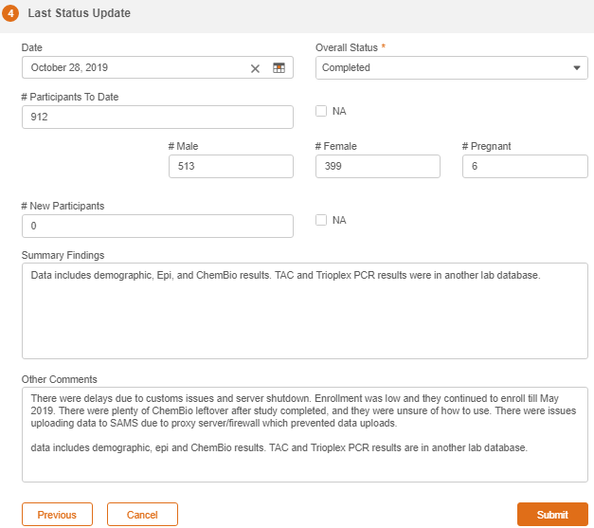

Once you click “**Submit**,” you will go back to the study’s main page with all the study countries’ folders and the cross study shared folder. 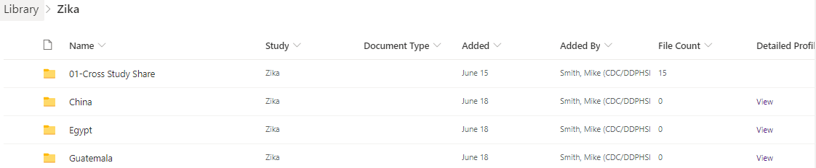

# **How Do I Upload Study Documents?**

On the Library page, click on the study name to go to the study folders. Choose the appropriate folder for the document. Select the “Cross Study Share” folder if the file is pertinent to the entire study or select an individual country folder if the file is pertinent to one country only.

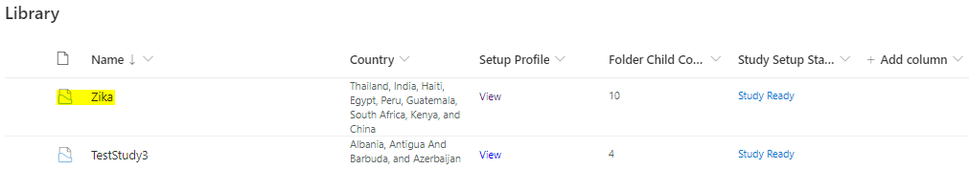

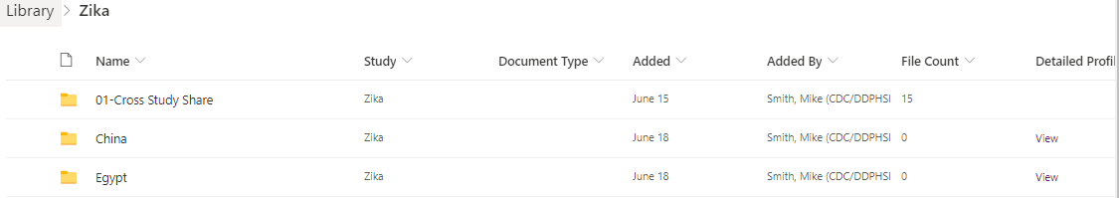

Click “Upload” to add a document to a folder.

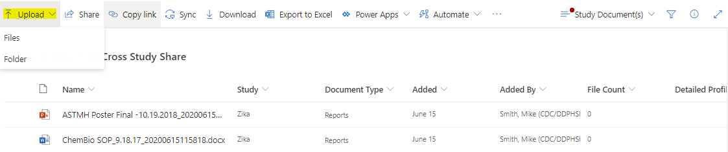

You can also drag and drop your file to the study folder you wish to add documents. 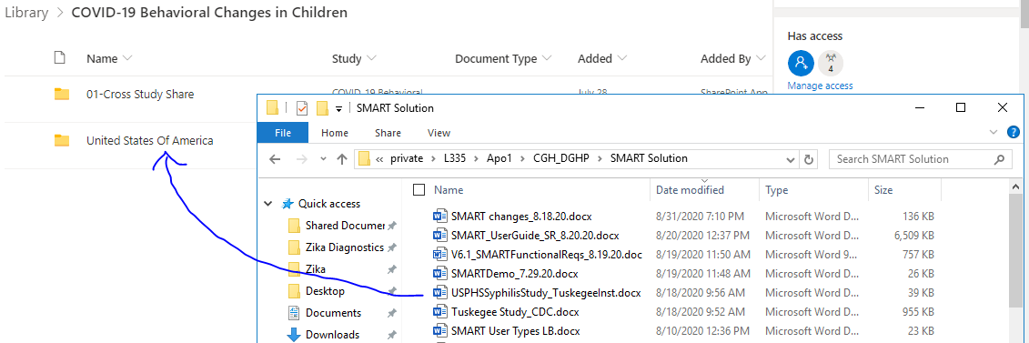

After the document uploads, you need to update the **Document Type** (which is “**Required Info**”). To add the Document Type to the file, open the Info panel, by clicking the “**i**” on the right side of the page (the pane may open automatically). Click “**Edit all**” and then “**Select an option**” under “**Document Type**.” Click “**Save**” after selection has been chosen.

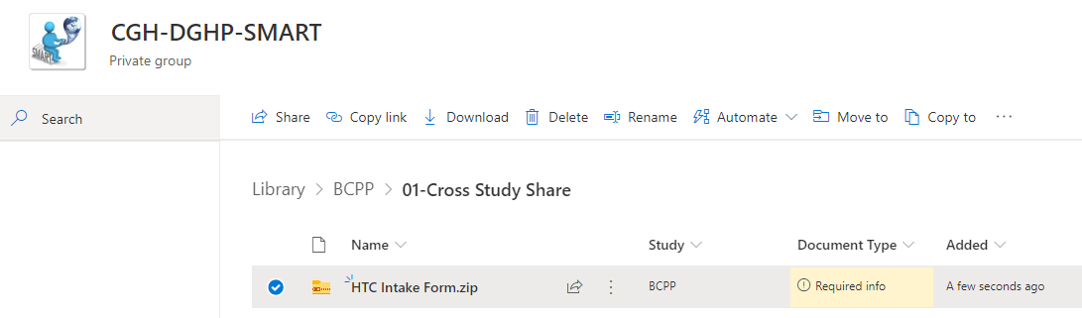

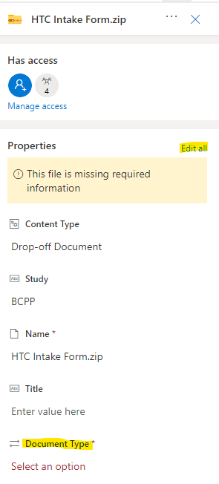

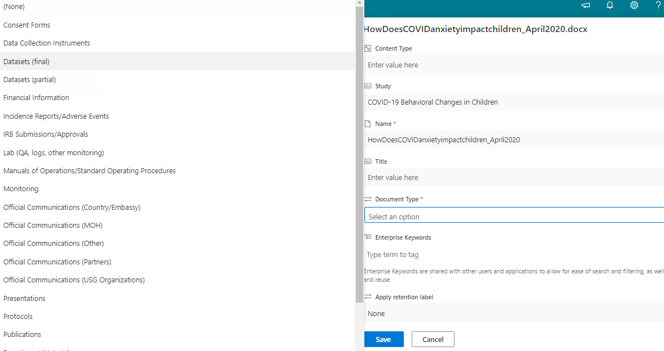

# **How Do I Manage SMART User Access?**

To give a user access to a specific study, go to the study folder, select the study, click “**i**” to the right of the page, then click “**Manage access**.”

Then you may “**Share**” or click on the **+** sign to grant *Direct* *access* for users to be able to edit the study Set-Up Profile and upload files to study folders.

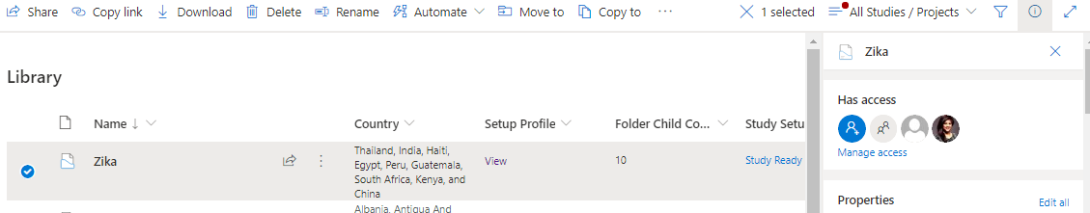

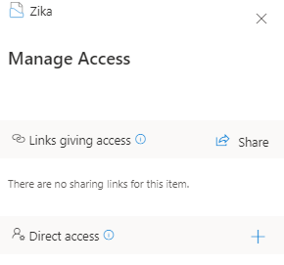

To grant access for CO users to be able to manage a specific country’s study Detailed Profile, click on the study, select the country folder, click “**i**” to the right side of the page, then click “**Manage access**.”

Then you may “**Share**” or click on the **+** sign to grant *Direct* *access* for users to be able to edit the country’s study Detailed Profile and be able to upload files to their country’s study folder.

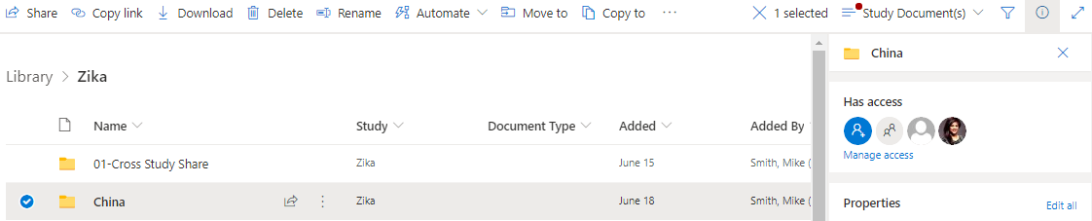

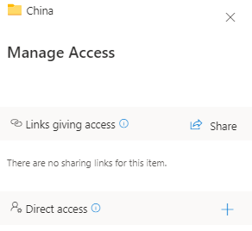

# **How Do I Search the SMART repository?**

On the SMART homepage, click “**Search**”.

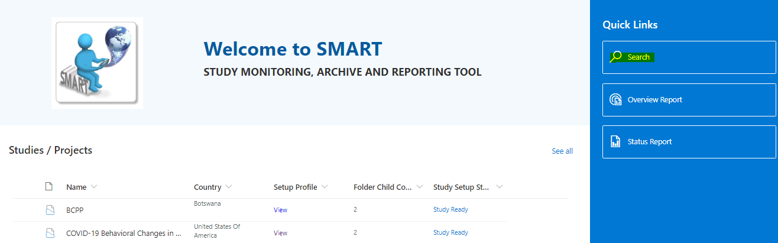

Type a key word or phrase in the search box to view files in the SMART repository.

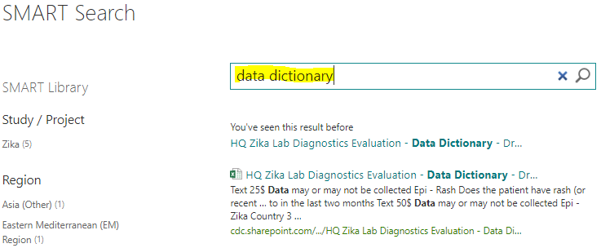

Click filters on the left side of the page to view specific files by study/project, region, country, document type, area of focus, primary health topic, type of subjects, funding source, file type, author, or date created.

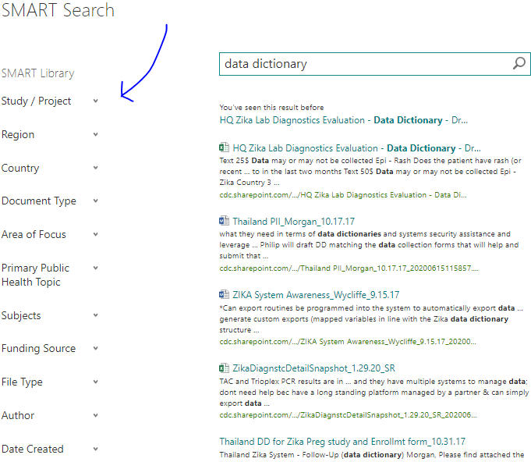

Access any file by clicking on the file link or by clicking on any of the functions (**Edit**, **Send**, **View Library**) in the box which appears when you hover over the file link.

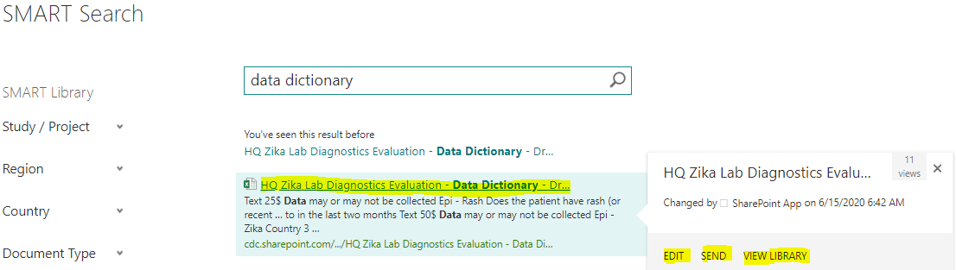

Click “**Edit**” to open and save a copy of the file to your local drive and edit as desired.

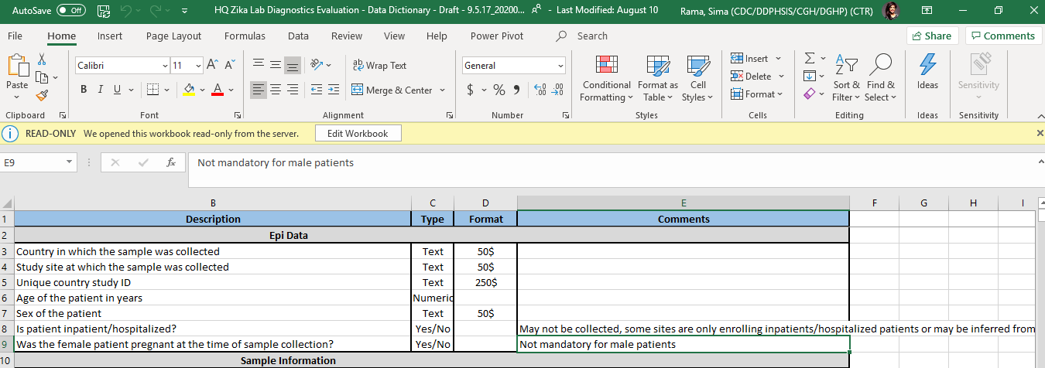

Click “**Send**” to add the link to an email.

Click “**View Library**” to see the study (and country’s) library containing the uploaded file.

# **How Do I Run a Report?**

There are two types of reports that a user can select in SMART – the Overview Report and the Status Report.

To view the Overview Report, select “**Overview Report**” on the main page [<https://cdc.sharepoint.com/teams/CGH-DGHP-SMART>]. This report highlights all DGHP studies and projects entered into SMART and indicates countries and regions where they are implemented, the primary public health topic and area of focus, and funding start/end dates for each study.

To view the Status Report, select “**Status Report**” on the main page [<https://cdc.sharepoint.com/teams/CGH-DGHP-SMART>]. This report is similar to the Overview Report but also includes details on the current status of the study or project such as the latest enrollment numbers.

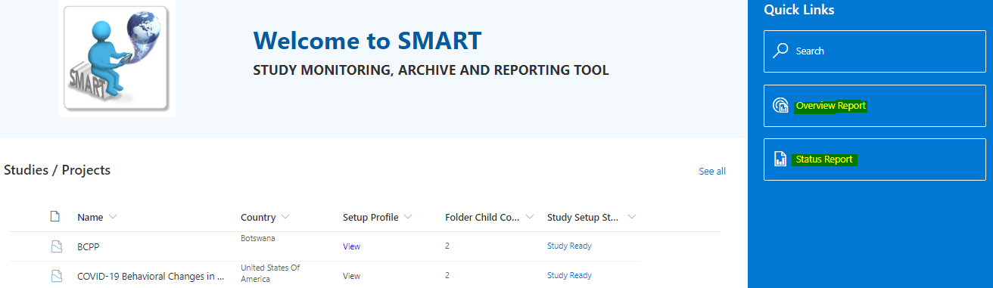

The blue tiles show the number of studies entered into SMART (Study/Project Count), the number of participating countries, study names, a map showing where the studies are implemented, and a list of the participating countries.

Filter by selecting a **Study/Project** and/or **Country** to view select studies within particular countries. To select multiple studies or countries, use the Ctrl key when making your selections. Clear the filters by refreshing the page or double click on the study list.

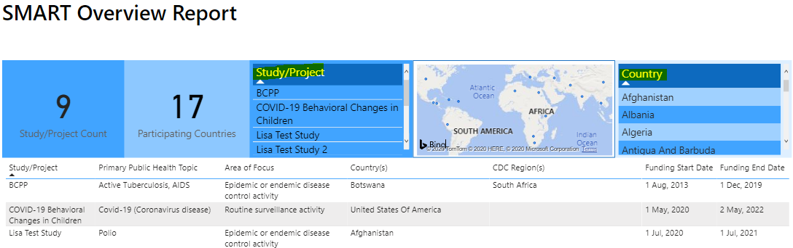

You may send the SMART Overview Report by email by clicking “**Send by email**” at the top of page.

To export the data, select the 3 dots on the far-right side of the table heading. “More options” will display allowing you to select “**Export Data**.” 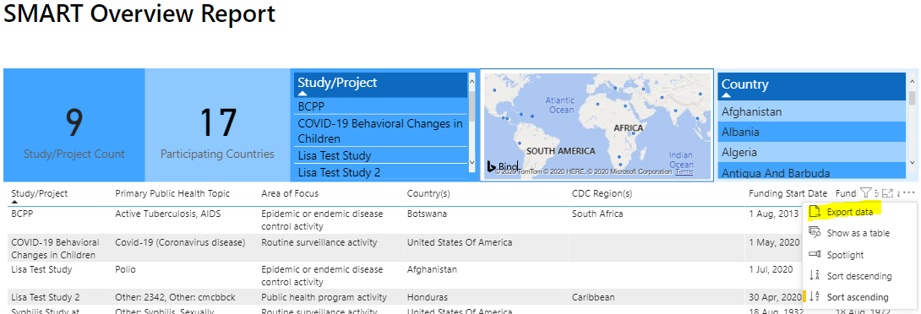

Click “**Export data**” and then select the file format from a dropdown menu – *xlsx with a maximum of 150,000 rows* or *csv with a maximum of 30,000 rows*. Then click “**Export**.” Would need to be mindful on raw datasets are being export.

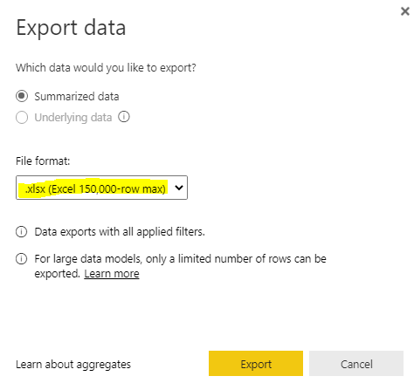

# **Helpful Quick Links**

1. Master Studies List – <https://cdc.sharepoint.com/teams/CGH-DGHP-SMART/Lists/master/Group%20By%20Study.aspx>
2. Country Look Up List – <https://cdc.sharepoint.com/teams/CGH-DGHP-SMART/Lists/Country/AllItems.aspx>
3. Document Type Look Up List – <https://cdc.sharepoint.com/teams/CGH-DGHP-SMART/Lists/dt/AllItems.aspx>
4. SMART Repository – <https://cdc.sharepoint.com/teams/CGH-DGHP-SMART/repository/Forms/AllItems.aspx>
5. Solution Artifacts – <https://cdc.sharepoint.com/teams/CGH-DGHP-SMART/sa/Forms/AllItems.aspx>
6. Search Center – [https://cdc.sharepoint.com/teams/CGH-DGHP-SMART/sc/](https://cdc.sharepoint.com/teams/CGH-DGHP-SMART/sc)
7. Search Page on Top Level – <https://cdc.sharepoint.com/teams/CGH-DGHP-SMART/Pages/docsearch.aspx>
8. To return to the SMART homepage, click on the SMART icon at the top of the page

