Office 365 Proposal Creation Add-in

User Guide

Version 1.0

Contents

Overview 1

Home 1

Documents 1

Call Reports 1

## Overview

When you are preparing a formal proposal document to present to a potential customer, Microsoft's Proposal Creation Word add-in is your ally. It connects to Proposal Manager and lets you manage tasks, related documents and notes, all without leaving Word.

With the Proposal Creation add-in, you can keep track of who's working on what section of the formal proposal document, and what task they are doing, be it developing content for the section, or reviewing and approving it.

In the blink of an eye, you can also see what internal documents are related to the formal proposal, so you can quickly navigate to them to trace how the information of the document is being worked on inside of the company.

Finally, with just one click you get to see all notes the team made about this specific sales opportunity in Proposal Manager, which enables you to take the notes into consideration when working on the formal proposal document.

Put it simply, if you are looking to score a sale with a proposal document, this is the tool you are looking for.

## Home

This section allows you to manage the section’s tasks.

Assigning a Task to a section:

1. Choose the Section and click on the Edit button:

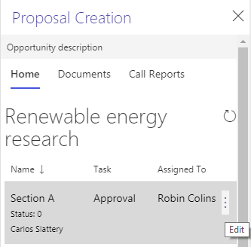

1. Select a Task from the list of Tasks (Note: currently this list is hard-coded but will be maintainable by the Organization in the next release).  
   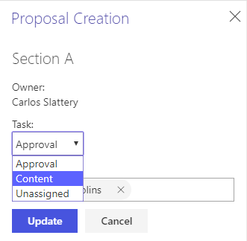
2. Select the user assigned to the task and finally click on the Update button.  
   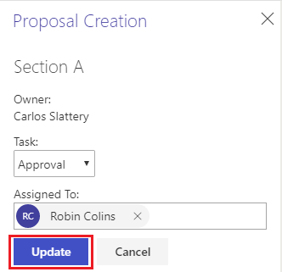

## Documents

This section allows you to browse all the documents related to the Opportunity. You can click on the name of the document for downloading it.

## Call Reports

This section allows you to visualize all the notes attached to the Opportunity. You can open the note by clicking on the Open button as shown below:

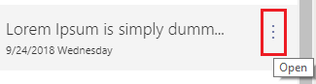

Note details:

