Office 365 Proposal Manager

Functional Overview

Version 1.0

Contents

1 Overview 1

2 User Experience Overview 1

2.1 User Personas 1

2.2 User Interfaces 2

2.3 Entities 2

2.4 User Permissions 3

3 Proposal Management Process 4

3.1 High Level Workflow 4

3.2 Data Flow 4

3.3 User Interaction Flow 5

# Overview

The purpose of this document is to provide an overview of the core features and capabilities of the Proposal Manager solution.

# Commercial Lending

Commercial Lending is a complex process involving a diverse team of experts and a deep need for smooth and continuous collaboration to facilitate creation of a proposal. Current system involves a series of steps handled manually with different members of the team working in silos and a designated loan officer having to follow up individually with all to put together different inputs to create a proposal which will then go through multiple iterations handled by the Relationship Manager with the customer.

Proposal Manager is aimed to streamline and automate this disjointed process:

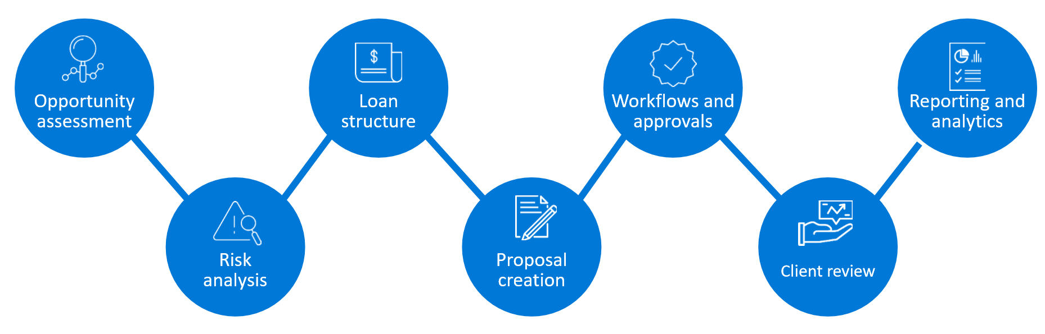

Proposal Manager enables a relationship manager and loan officer to work with other team members to prepare a commercial lending proposal for a prospective client.

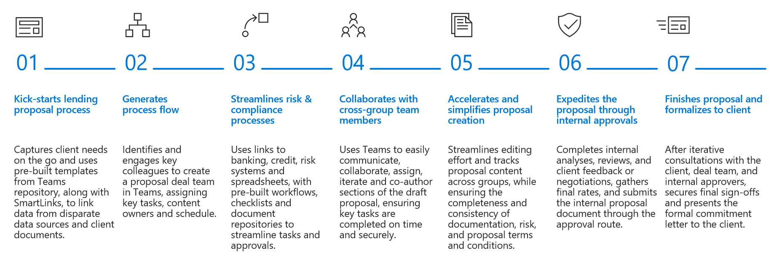

# User Experience Overview

This section details at a high level, how different personas interact with the solution.

This section details the different user personas interacting with the Proposal Management solution, their experience across different interfaces and end-to-end Proposal Management process for Corporate Lending, facilitated by the solution.

# User Personas

Solution considers 3 key personas as part of the team handling the opportunity, along with addition team members as defined in the user role mapping at the tenant level:

|  |  |
| --- | --- |
| Persona | Description |
| Relationship Manager | Owner of the opportunity, who identifies the opportunity, enters it into the system and drives it to a conclusion. Takes care of providing relevant documents to the participants involved in the proposal process, and acts as the point of contact with the customer |
| Loan Officer | Owns the proposal preparation process and forms the team handling the opportunity, based on decision taken on loan type and specific process to be followed for arriving at a proposal for the same |
| Credit Analyst | Example roles - Part of the opportunity team, selected by the loan officer. There could be one or more people associated with each role based on the process type, taking into consideration factors such as industry, geographic region and opportunity size. The solution is flexible to adapt to more personas to be part of the team. |
| Legal Counsel |
| Risk Officer |
| Proposal Manager Administrator | Dedicated administrator(s) in the tenant authorized to handle the administration and configuration of Proposal Manager. For each opportunity that is created, the Admin has to add the add-in for the team to be able to use the solution. |

**Note**: **Whenever we add a new persona (AAD Group) into Azure Active Directory, we need to restart the Web App, so that the new group will get added into application cache, other wise new group will get only added after the application cache expiration time (Which we specify in the application setup page).**

# User Interfaces

Different members of the opportunity team can interact with the solution using two different interfaces:

|  |  |
| --- | --- |
| Team Type | Description |
| Proposal Manager Team | Root team for Proposal Manager where the administrator can perform the administration and configuration of the solution and add the add-in for each opportunity. Relationship Manager has the ability to create an opportunity and Loan Officer can add or remove team members, choose deal type and upload the Proposal Document template used for the opportunity from this team |
| Opportunity Team | A team is formed in MS Teams for each opportunity, and all members of the opportunity team are automatically added to the same. Each Team consists of different channels to facilitate collaboration, and the Proposal Manager add-in enables specific process steps across all personas on each of the channels |

# Entities

The Proposal Management process is built around three main entities – the Opportunity that gets processed by an internal team, the specific process/workflow identified to validate and move the opportunity forward, and the associated Proposal that is prepared as an outcome of the process.

**Opportunity**

An Opportunity is a potential deal identified by the Relationship Manager for one of his/her own clients based on knowledge gathered from customer discussions and market analysis. He then uses the Proposal Manager application to convert the opportunity, by means of well-defined corporate lending processes and a hand-picked team of experts brought together to execute the process, to a proposal document that can then be presented to the customer, offering a loan or line of credit that they can use in line with the terms and conditions.

Opportunity consists of the following key details:

* Client Information
* Relevant notes and documents
* Specific info for lending process

Opportunity is considered as Complete when a decision has been taken on the proposal by the customer.

**Workflow**

Specific process to be followed for an opportunity is based on the type of loan determined to be the optimal fit as per the loan officer, who takes the decision based on different considerations such as deal size, past history with the client and other details. The solution supports different types of work flows that can be created from the Deal Types section in the Configuration channel in the Proposal Manager team.

**Proposal Document**

Proposal document, to be presented to the customer by the Relationship Manager, for the customer’s review and decision is the final deliverable from the Proposal Management process for each opportunity. Each loan type and process can be associated with a template chosen by the loan officer at the beginning of the process.

A proposal document is composed of clearly defined sections, each with a specific purpose and expected set of details to be updated based on inputs gathered from documents or information obtained from different steps of the process. Owners are identified for each section based on which step of the process is associated with the same. Loan Officer owns the end-to-end process for preparation of a formal document, that is then handed off to the Relationship Manager.

# User Permissions

Different types of users with associated permissions are as follows:

* Regular user
  + profile, User.ReadBasic.All, mail.send
* App Admin user (user that adds the add-in for each opportunity)
  + profile, User.Read.All, mail.send, Sites.ReadWrite.All, Files.ReadWrite.All, Group.ReadWrite.All
    - The above permissions needs to be granted by a tenant admin (via admin consent)
* App context
  + Email, profile, User.Read.All, Mail.Send, Sites.ReadWrite.All, Files.ReadWrite.All, Group.ReadWrite.All, Directory.ReadWrite.All
    - The above permissions needs to be granted by a tenant admin (via admin consent)
* Tenant admin
  + Grants the permissions as noted above and config/deploy the system
  + Authorize the app in Azure and initial SharePoint site (details in deployment guide)

# Proposal Management Process

This section details the end-to-end process and defines how each team member interacts with the solution as part of the process.

# High Level Workflow

At a high level, the process starts with identification of an opportunity and ends with the customer taking a decision on a proposal document prepared during the course of the process.

1. Relationship Manager identifies a corporate lending opportunity for one of his/her clients and creates a new opportunity using the Proposal Manager application
2. Opportunity is assigned to a loan officer who identifies the process to be followed and forms a team
3. Team members collaborate and perform their assigned responsibilities at different stages of the process to prepare a Proposal document
4. Relationship Manager presents the proposal document to the client for review and decision
5. Client conveys his decision on if the proposal has been Accepted or Rejected

# Data Flow

Shared below is a high level data flow showcasing the different components and how they interact with each other:

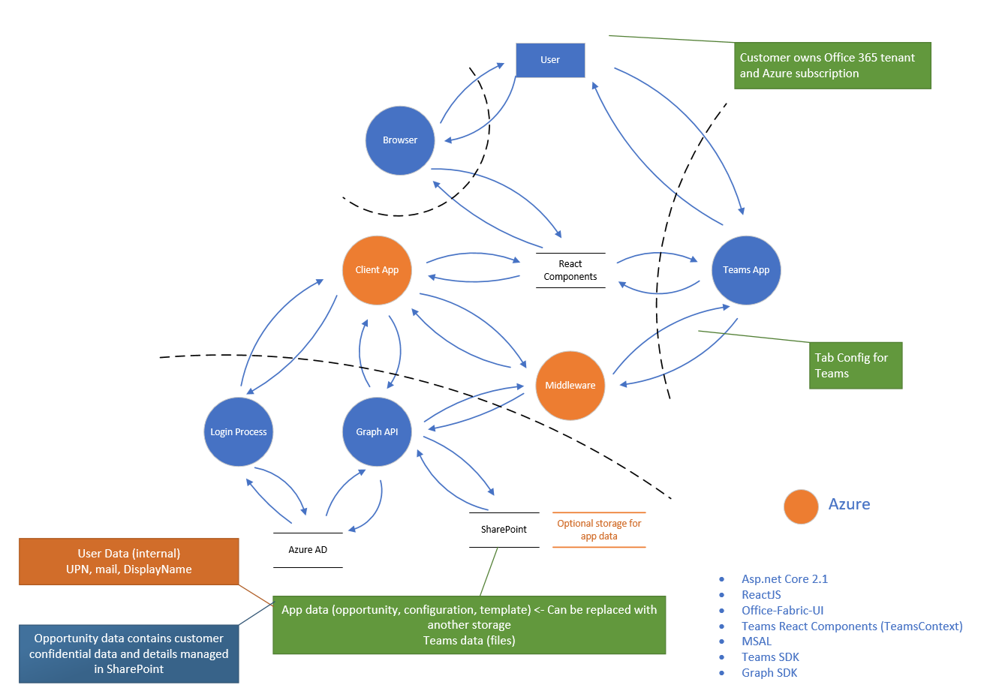

# User Interaction Flow

This section details the interaction experience for each persona.

### Proposal Manager Team Experience

**Relationship Manager**

Relationship Manager owns the opportunity, from creation to closure.

1. Relationship Manager identifies an opportunity and creates it in the system
   1. Documents can be uploaded as part of the opportunity creation process, which gets copied to the General channel in corresponding Team once created
   2. Metadata defined during the opportunity creation process cannot be updated later
2. Sees a list of all opportunities associated with the user in the Opportunities list
3. Select an opportunity to see a summary view of the opportunity, with all relevant information and quick access to team members
4. For each opportunity:
   1. Review process workflow at a high level
   2. Add/update notes about the opportunity, visible only to the Relationship Manager
   3. Assign loan officer if not assigned, or Change loan officer

**Loan Officer**

Loan Officer owns the Proposal Document, from identification to formalization.

1. Sees a list of all opportunities associated with the user in the Opportunities list
2. Select an opportunity to see a summary view of the opportunity, with all relevant information and quick access to team members
3. For each opportunity:
   1. Choose the deal type, which triggers the following steps:
      1. Create a Team with same name as opportunity
      2. Create pre-defined channels in each team, based on the process steps in the deal type, each with a specific purpose
      3. Copy documents uploaded at the time of opportunity creation to the Files tab in the General channel
   2. Select team members for each role and finalize the team working on the opportunity
   3. Review process workflow at a high level
   4. Edit team by adding or removing specific team members

**Proposal Manager Administrator**

Administrator is a designated admin on the tenant who is authorized to manage the administration of the solution and add the add-in for teams associated with new opportunities

1. Access Administration page from the Administration channel in the Proposal Manager
2. For opportunities listed in ‘Requires Action’ tab, review opportunities with status ‘Creating’, and click on the Action button, which automatically adds the Proposal Manager add-in to the Team corresponding to the selected opportunity

**Other Personas**

All other personas are not currently supported by default in the Proposal Manager Team.

### Opportunity Team Experience

A Team is formed in MS Teams for each opportunity, with everyone working on the opportunity added as members.

A custom add-in, Proposal Manager, facilitates the process within Teams. The add-in can be loaded automatically for each Team associated for an opportunity by following the configuration steps here. This add-in needs to be shared with the team members by the administrator and should be added to all the channels manually by Relationship Manager or Loan Officer. Every channel in Teams have Conversation and Files tabs by default, which facilitates the collaborative experience.

The Team for an opportunity, consists of the following channels by default, each with a tab for Proposal Manager add-in, which in turn consists of one or more sections.

|  |  |  |
| --- | --- | --- |
| Channel | Section | Description |
| General | Workflow | * Overview of the process workflow with the owner and status for each step |
| Team Updates | * Team overview, with quick access links, and status |
| Channel for each process step in the deal type | Checklist | Example channels in line with the three personas listed as examples in User Personas   * Checklist for each process step * Ability to upload documents or download uploaded documents for each checklist item * Mark status as Completed, In Progress or Blocked at the process level |
| Formal Proposal | Proposal Status | * Overview of the status of different sections of the proposal document, updated by the loan officer |
| Customer Decision | Customer Decision | * Decision by the customer on the final proposal and the details of loan disbursement, if applicable |