Office 365 Proposal Manager

Getting Started Guide

Version 3.0

Contents

1 Overview 1

2 Setup Azure App Service 1

2.1 Azure App Registration 1

2.2 Application Insights 3

3 Register Proposal Manager App 3

2.2.1 Register App 3

2.2.2 Configure Application Registration 4

2.2.3 Create a bot for Microsoft Teams 8

3 Setup Office 365 Groups 9

4 SharePoint Configuration 10

4.1 Configure SharePoint 10

4.2 Note Site ID 11

4.3 Create temporary folder for opportunity documents 12

4.4 SharePoint Layout 12

4.5 Create SharePoint lists 12

5 Adding Custom Tile to App Launcher 16

5.1 Creating Custom Tile 16

5.2 Promote the tile to the Home Tab 17

6 Deploy Solution 18

6.1 Update App Settings 18

6.2 Update Client App Settings 20

6.3 Local Test and Debug 21

6.4 Publish to Azure 21

6.5 Accept Application Consent as Admin 23

7 Teams add-in for Proposal Manager 24

7.1 Enable side-loading of add-ins 25

7.2 Create custom add-in for Teams 25

7.3 Load Proposal Manager add-in 26

7.4 Enabling Automatic add-in loading 30

8 Office add-in for Proposal Creation 31

8.1 Deploying Office add-in 31

8.2 Configure SharePoint Document ID Service 31

9 User Experience Overview 32

9.1 User Personas 32

9.2 User Interfaces 33

9.3 Key Entities 34

9.4 User Permissions 35

9.5 Proposal Management Process 35

9.5.1 High Level Workflow 35

9.5.2 Data Flow 36

9.5.3 User Interaction Flow - Portal 36

9.5.4 Teams Experience 37

10 API Guidance 38

11 Extensibility 38

12 Maintenance 39

12.1 Update AD users and groups 39

12.2 Clear SharePoint site 40

12.3 Settings Update UI 41

13 Security Considerations 42

14 Troubleshooting 42

15 Known Issues 43

# Overview

The purpose of this document is to provide guidance on setup and deployment to an ISV partner who is familiar with Office 365, Microsoft Azure and web application implementation. This document is part of the Final Release RC1 of the solution - Office 365 Proposal Manager.

**Prerequisites**

To setup the solution, make sure that you have:

* Office 365 Tenant (Business or Enterprise SKU)
* Microsoft Azure subscription
* Visual Studio 2017 (Enterprise, recommended), version 15.7.4 and above recommended
* Asp.Net Core 2.1
* Node.js

Note that the following access permissions are required to be able to deploy the solution:

* Ensure that you have global admin access on the Office 365 tenant where the solution is being deployed and proceed as follows.
* You need to have Contributor or Owner access on the Microsoft Azure subscription where the web application is planned to be deployed and made available to the users.

# Setup Azure App Service

Make sure that you have owner access on the Microsoft Azure subscription where the web application is planned to be deployed and made available to the users.

## Azure App Registration

First step is to create the web application where users can access the Proposal Manager application. Make sure that you have Owner access on the Azure subscription before proceeding.

Sign into [Microsoft Azure portal](https://portal.azure.com/).

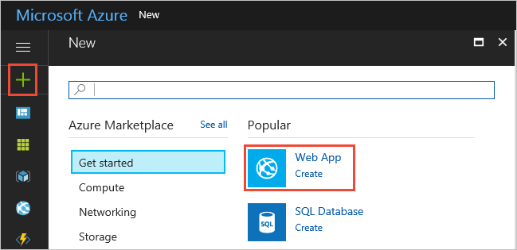

Choose the **+** icon in the left navigation bar, then choose **Web App**.



If you don't see **Web App** in the list, use the search box to find it.

At the bottom of the introduction page, choose **Create**.

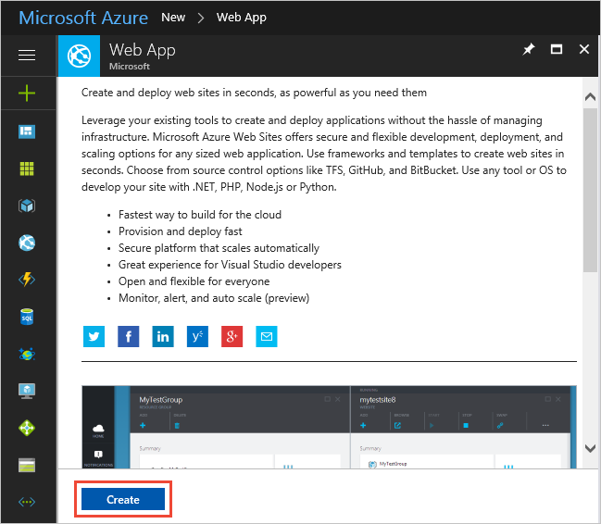

Enter a name for the new web app. You'll see a green checkmark when the name is unique. Then choose **Create**.

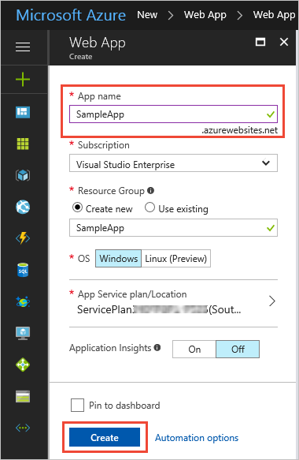

## Application Insights

In case you would like to monitor the live web application, at least initially, it is a good idea to leverage Azure Application Insights. This can be configured from the Azure Portal, Application Insights tab. Take care to note the Instrumentation ID.

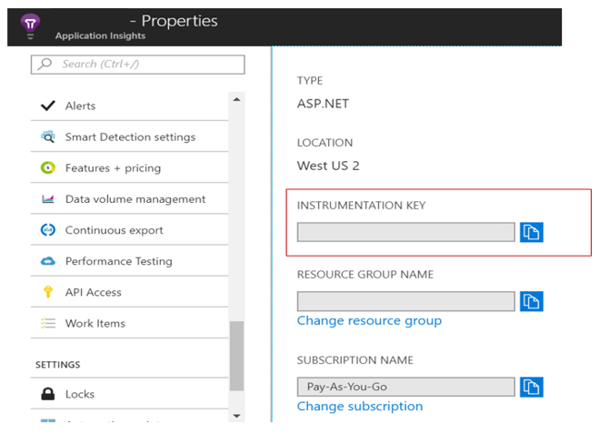

# Register Proposal Manager App

## Register App

First, we need to register the “Proposal Manager” app to enable users in the organization to access the solution and to facilitate communication between the dashboard and the solution implementation.

1. To access the Application Registration Portal, go to https://apps.dev.microsoft.com and login using your admin account
2. Click on **Add an app**

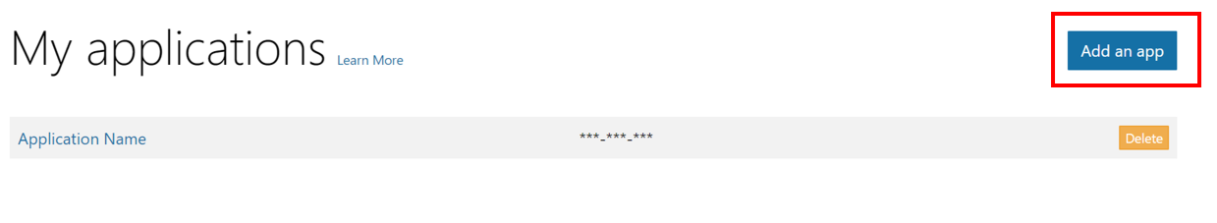

1. Give an appropriate name, say **‘Proposal Manager’** and Click **Create**. **Note the Application Id**

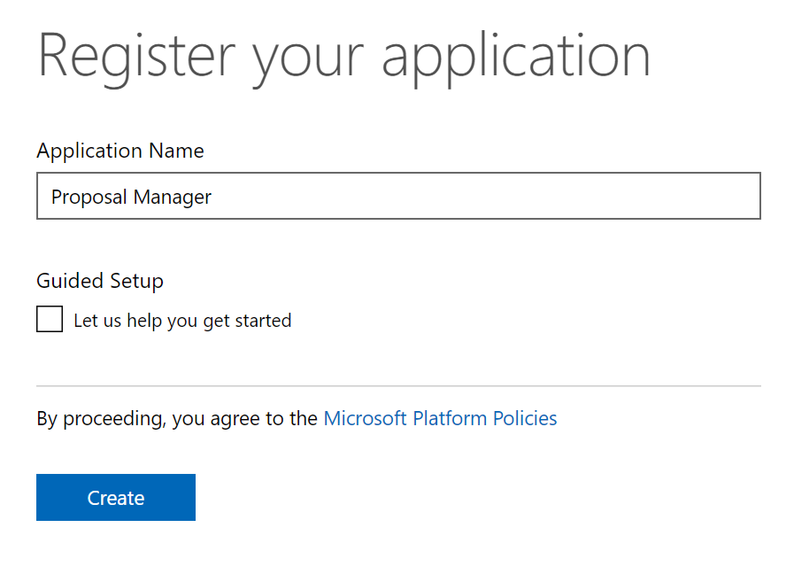

1. Once is registered you will see it listed as shown below.

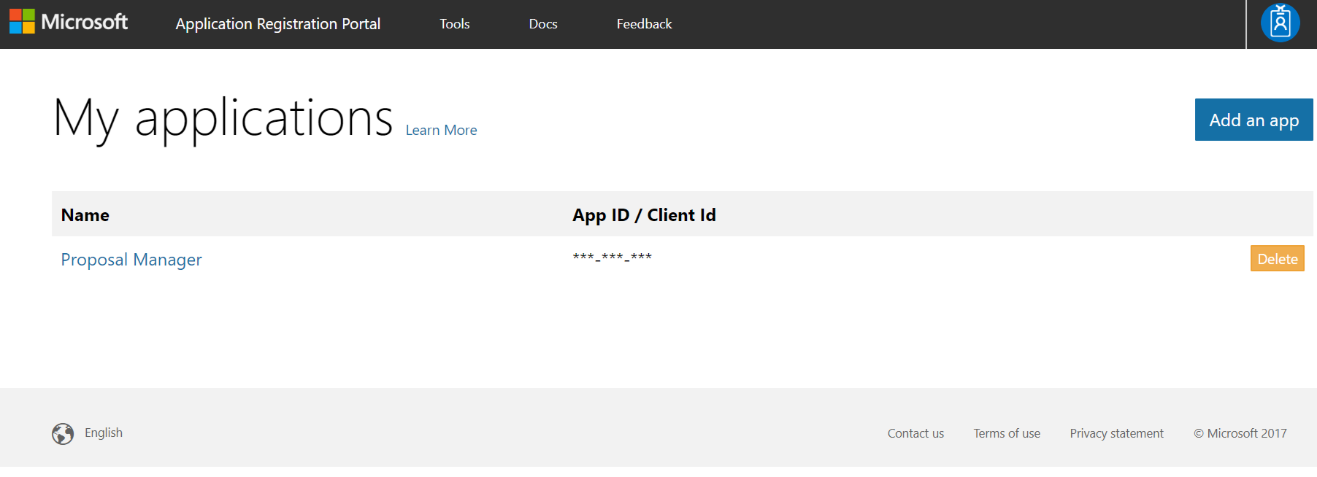

## Configure Application Registration

Now let’s configure the Proposal Manager Azure Registration using the following details below:

1. Property Name: Enter the name of your application if needed
2. Application ID: Validate that the right application ID is shown
3. Application Secret: Generate a new application secrete that will be use and ensure you capture it for use later. Example:

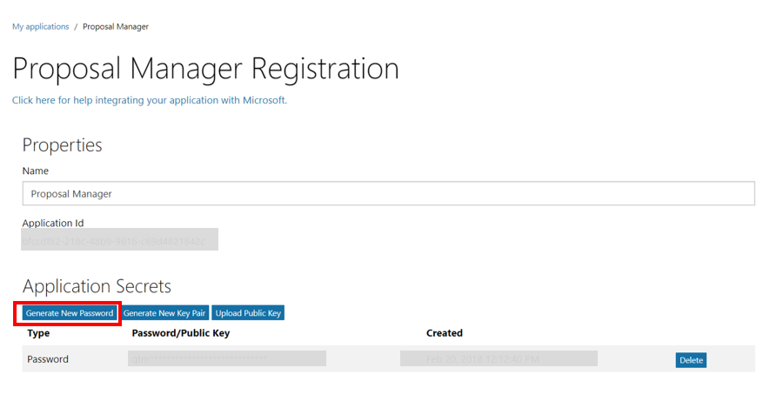

Ensure you note the Password\Public Key which will be needed. If this is lost, another key will need to be generated to configure the application.

1. Platform: In the Platform section select Web Platform option and continue with its configuration
2. Identify the web URLS that will be needed as shown below example:

Check 'Allow Implicit Flow'. In the Redirect URLs section, add the URLs that are indicated as allowed for the Proposal Manager web application, once deployed

For example, if the Azure web site is created as https://proposalmanager.azurewebsites.net, take care to add the following:

* + - https://proposalmanager.azurewebsites.net
    - https://proposalmanager.azurewebsites.net/tab
    - https://proposalmanager.azurewebsites.net/tab/config

Screen will look something like this:

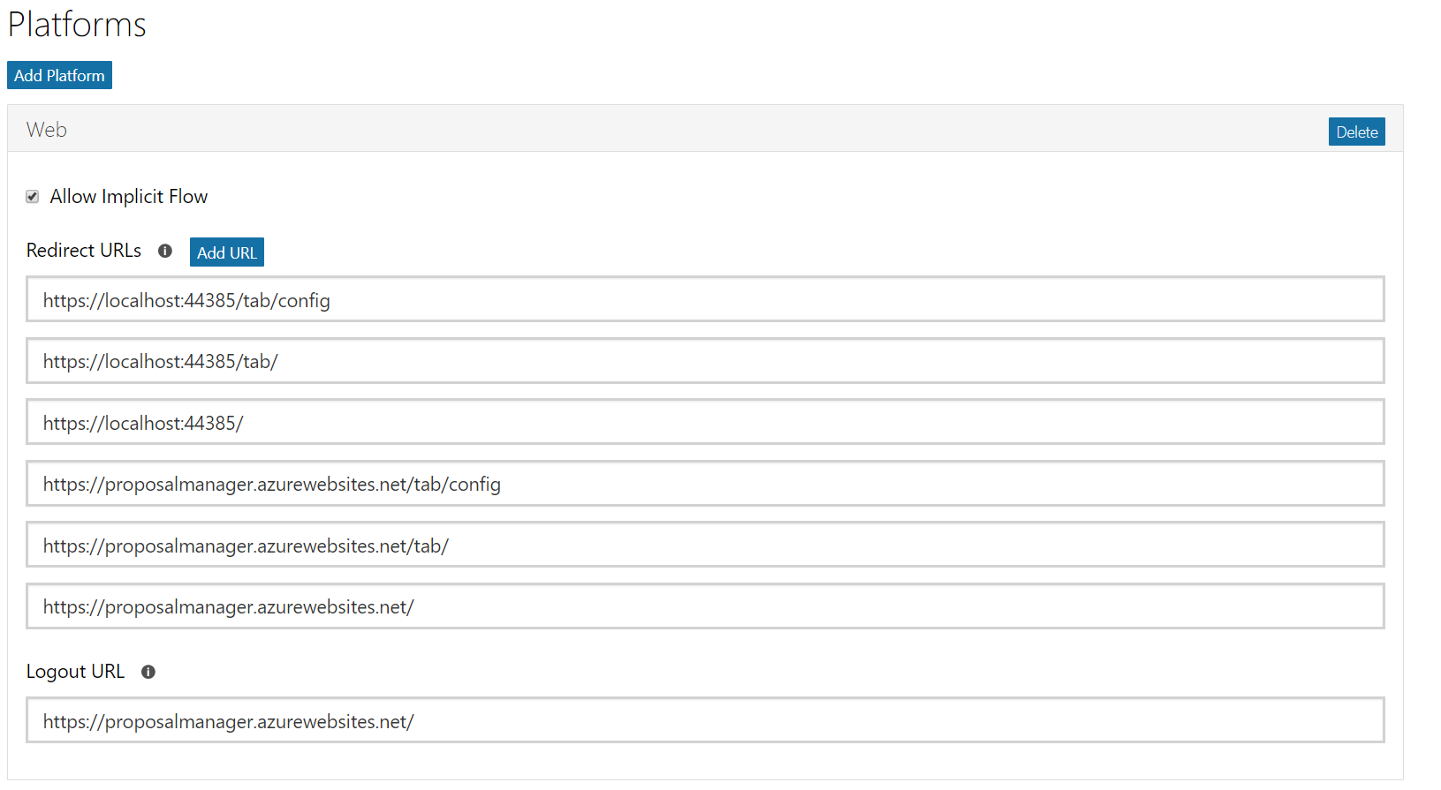

1. Click on ‘Add Platform’ and select ‘WebAPI’, a Web API section gets added with an APP ID URI and corresponding scope. Add a new scope to the WebAPI platform with the below details.

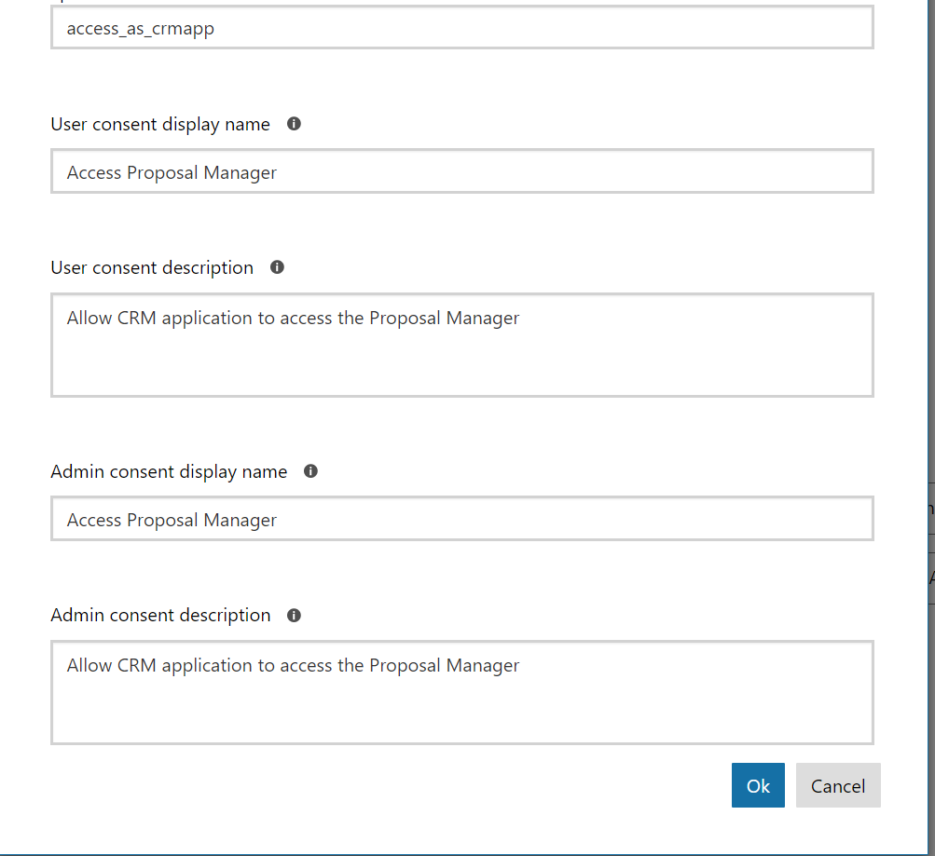

1. Click on ‘Add Application’ inside WebAPI section. Enter the applicationid value in textbox, and “Scope” dropdown select check value “app://<appid>/access_as_user” . Example below.

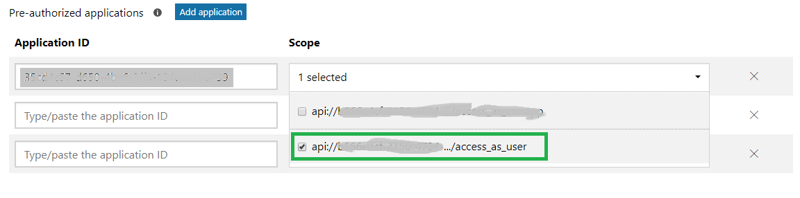

1. Identify your Owners: Example below

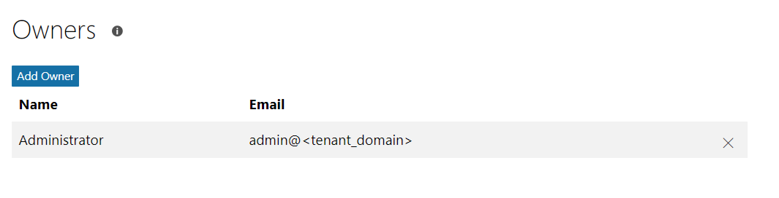

1. Identify Microsoft Graph Permissions as shown below:

Note: Before applying the below permissions please ensure the admin user(account) being used to register the application has the required graph permissions.

You can go the [Graph API Explorer](https://developer.microsoft.com/en-us/graph/graph-explorer) , login in the left pane by using the button labelled ‘Sign In with Microsoft’. Once signed in click on ‘modify permissions’ link in the left pane which pops-up a window to Modify Permissions. This is required for the admin consent later.

Note: In the Microsoft Graph Permissions, set appropriate **Delegated Permissions** and **Application Permissions** by Clicking **Add** and then selecting **permission**.

*See* ***Delegated Permissions*** *and* ***Application Permissions*** *for list of minimum permissions to delegate.*

Example of how what settings we have validated that should be set.

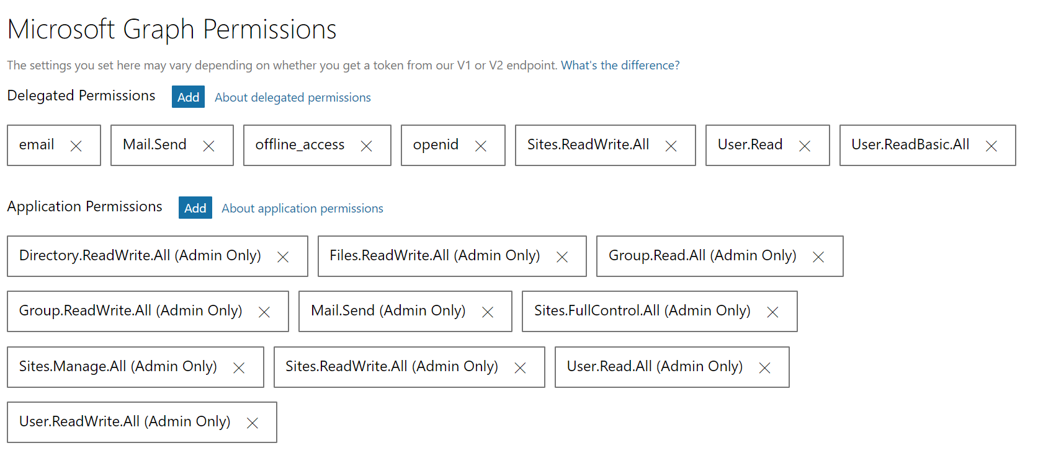

1. Identify your Home Page URL, Terms of Service URL and Privacy URL as needed
2. In the Platform section, add Web API Platform and leave the default values
3. In the Profile selection, choose the logo that you would like to use and specify the home page URL as the web application URL that you plan to deploy the time tracker solution to

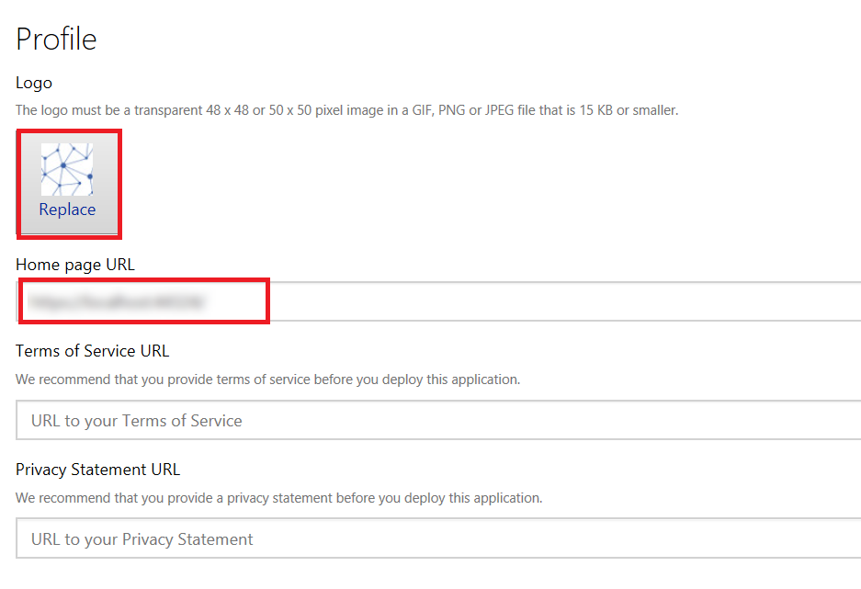

1. Save Settings and you’re done.

## Create a bot for Microsoft Teams

A bot is used to relay event notifications in the form of cards that get displayed in the General channel of the team created for an opportunity. Team name and Opportunity Name have a one to one mapping.

The following events are currently notified via a card in the general channel:

* Opportunity creation – This is applicable only in the rare scenario of a team (with the same name as the opportunity) already being present.
* Opportunity status changes – Any action in the application that changes the state of the opportunity.
* Update of status in Checklist related channels
* Assigning of a proposal document section to an owner

Sample card generated to notify the checklist event:

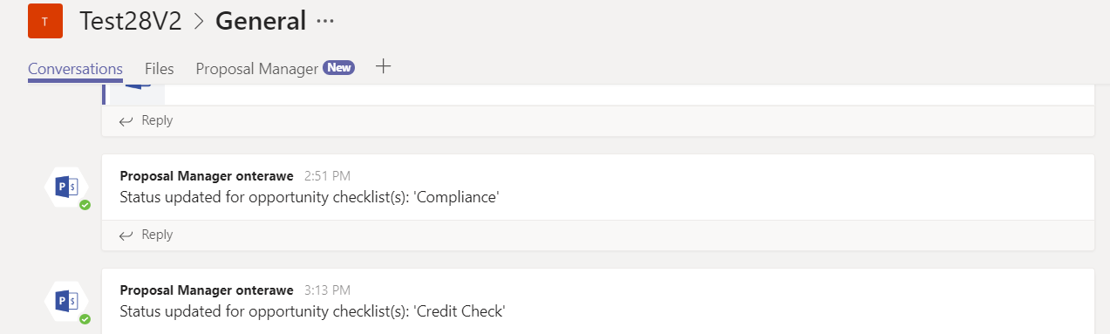

The registered bot has to be mentioned in the manifest file in the below section along with the given scopes.

|  |
| --- |
| "bots": [  {  "botId": {Bot id},  "scopes": [  "personal",  "team"  ]  }  ] |

The bot details should also be added in appsettings.json as below in the section ProposalManagement:

"BotServiceUrl": "https://smba.trafficmanager.net/amer-client-ss.msg/",

"BotName": {Bot Name},

"BotId": "{Bot Id}"

Refer [here](https://docs.microsoft.com/en-us/microsoftteams/platform/concepts/bots/bots-create) to learn more about implementing and integrating bots.

# Setup Office 365 Groups

Proposal Manager requires the users to be added to role-specific groups to facilitate access with required permissions.

Note that the group names given below are indicative examples. Any group name can be used based or organizational mapping. This can be mapped to roles defined in the application at the time of deployment.

|  |  |
| --- | --- |
| Example Group Name | Purpose |
| Relationship Managers | Relationship Managers, who are authorized to create opportunities |
| Loan Officers | Loan Officers, who manage assigned opportunities, including selecting proposal document template |
| Legal Counsel | Legal Counsel for an opportunity who take care of compliance review |
| Senior Risk Officers | Risk Officers for an opportunity who take care of risk assessment |
| Credit Analysts | Credit Analysts for an opportunity who take care of credit check |
| Proposal Management Administrators | Administrators who are authorized to create Microsoft Teams and associated channels for an opportunity. Note that members of this group should have ‘Global Administrator’ role in the Office 365 tenant |

To create Office 365 groups:

* Go to https://portal.azure.com
* Select Azure Active Directory tab from the left navigation menu (or choose from the 'All services' list)
* Choose Groups and click on 'New group'

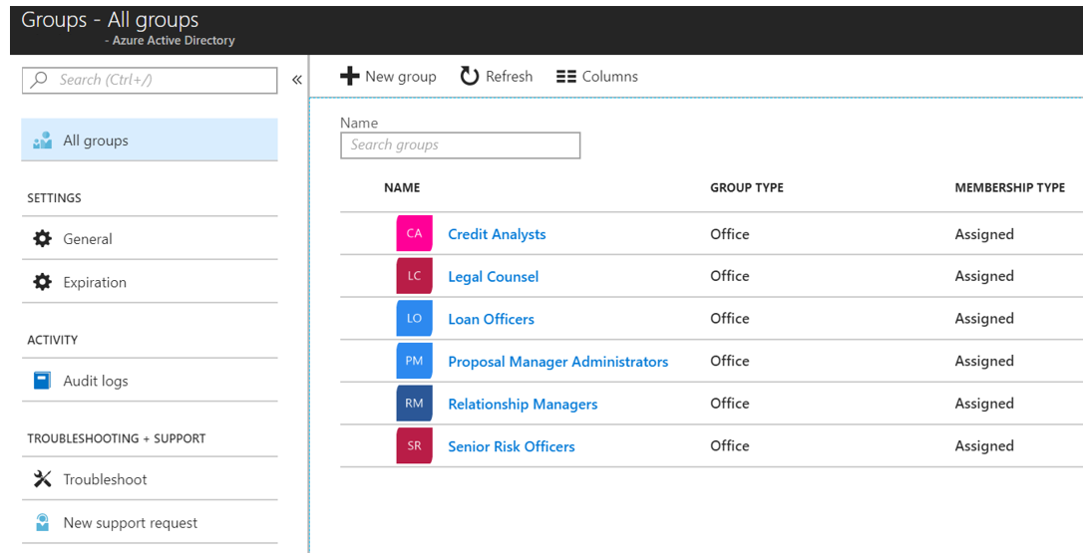

Ensure that users who require access to the solution are added to the relevant groups.

# SharePoint Configuration

In this section we will go over how to setup and configure SharePoint to be used as a repository to store information on opportunities.

## Configure SharePoint

Access SharePoint Management portal at https://<tenant>-admin.sharepoint.com

Create a new site, say, Proposal Manager

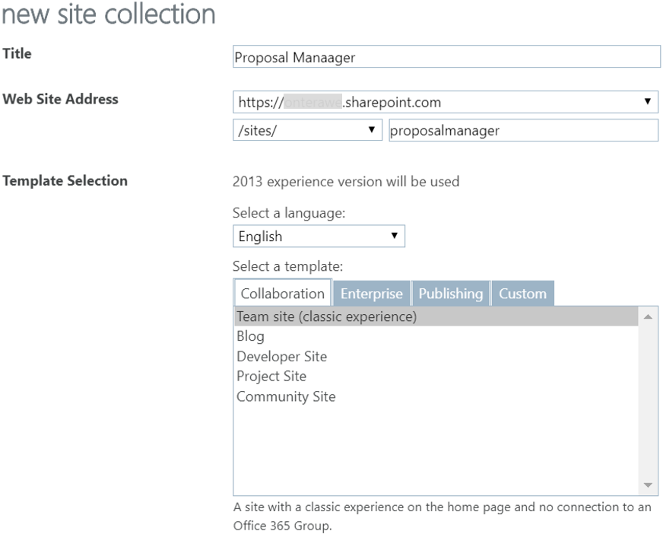

Add the Admin user as an owner on the site:

https://<tenant>.sharepoint.com/sites/ProposalManager/_layouts/15/people.aspx?MembershipGroupId=3

Example:

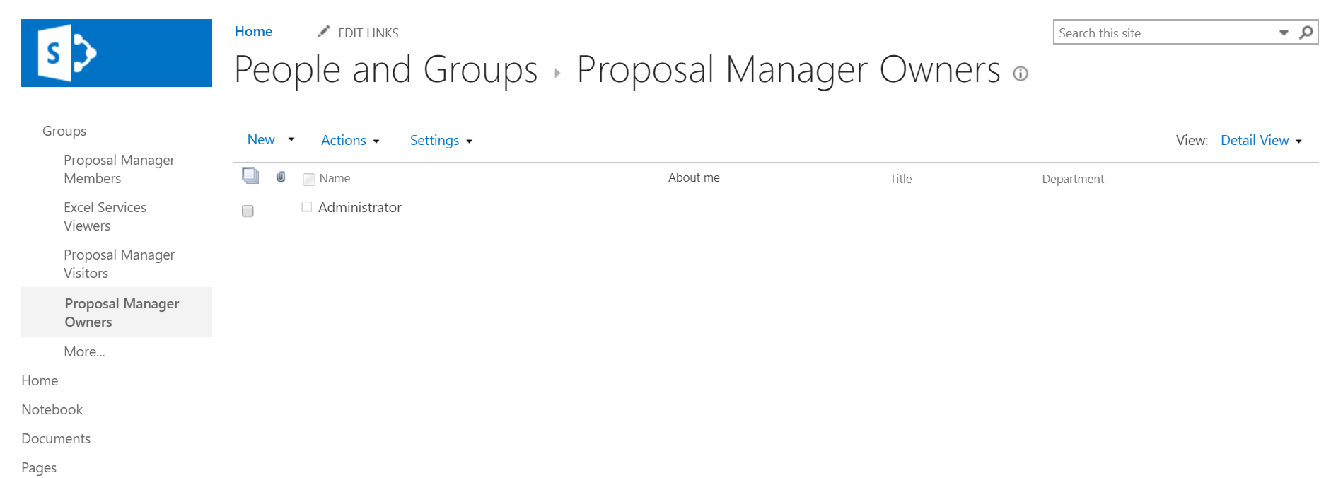

The user who created the site will automatically be added to this group.

## Note Site ID

Application configuration requires the site id to be updated. Use the following request query below to get the site ID:

https://graph.microsoft.com/v1.0/sites/<tenant>.sharepoint.com:/sites/ProposalManager?$select=id

The response will be in the format: {hostname},{spsite.id},{spweb.id}

## Create temporary folder for opportunity documents

We need to create a temporary folder which will be used to save the documents uploaded at the time of creating an opportunity, until the Team has been setup for the opportunity in Microsoft Teams after which the documents are then copied to the Files tab in the General channel of that team.

To set this up, proceed as follows:

* Go to the default document library of the site at https://<tenant_name>.sharepoint.com/sites/proposalmanager/Shared%20Documents
* Click on New from the top right bar above the list, choose Folder from the drop-down and give the name ‘TempFolder’

## SharePoint Layout

The application uses multiple SharePoint site to store different information as indicated below:

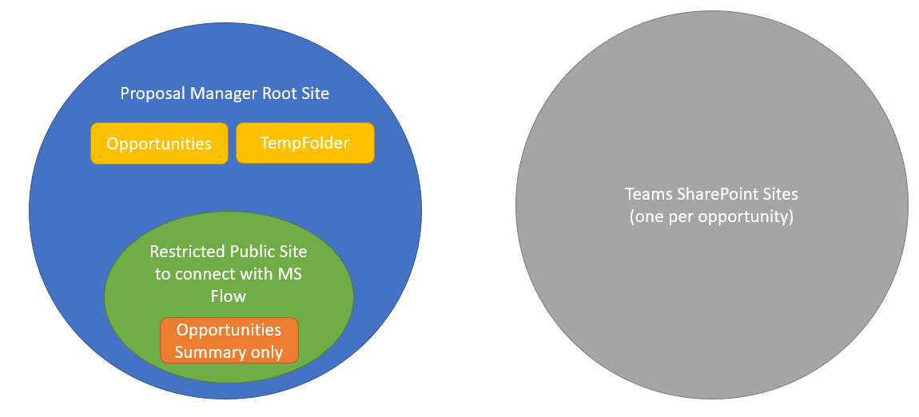

## Create SharePoint lists

To configure access and different options used in the Proposal Manager application, we need to create the following SharePoint lists (note that the names of all lists are configurable from the application settings)

**Categories**

The values defined here determines the categories that are available when uploading files as part of creating the opportunity.

|  |  |  |
| --- | --- | --- |
| Column | Type | Required |
| Title | Single line of text | x |
| Name | Single line of text |  |
| Modified | Date and Time |  |
| Created | Date and Time |  |
| Created By | Person or Group |  |
| Modified By | Person or Group |  |

Add records based on what you would like to make available as categories for files for an opportunity that gets copied to the General channel in Teams.

Example records:

|  |  |
| --- | --- |
| Title | Name |
| 1 | Marketing |
| 2 | Analysis |
| 3 | Call Memo |
| 4 | Other |

**Industry**

The values defined here determines the options that are available for Industry field when creating the opportunity.

|  |  |  |
| --- | --- | --- |
| Column | Type | Required |
| Title | Single line of text | x |
| Name | Single line of text |  |
| Modified | Date and Time |  |
| Created | Date and Time |  |
| Created By | Person or Group |  |
| Modified By | Person or Group |  |

Add records based on what you would like to make available as options for the Industry field.

Example records:

|  |  |
| --- | --- |
| Title | Name |
| 1 | Retail |
| 2 | Education |
| 3 | Manufacturing |

**Opportunities**

This list is used to save information on opportunities created from the dashboard and managed from dashboard and Microsoft Teams.

|  |  |  |
| --- | --- | --- |
| Column | Type | Required |
| Title | Single line of text | x |
| OpportunityId | Single line of text |  |
| Name | Single line of text |  |
| OpportunityState | Single line of text |  |
| OpportunityObject | Multiple lines of text |  |
| LoanOfficer | Single line of text |  |
| RelationshipManager | Single line of text |  |
| Reference | Single line of text |  |
| Modified | Date and Time |  |
| Created | Date and Time |  |
| Created By | Person or Group |  |
| Modified By | Person or Group |  |

**Note:** For the OpportunityObject column, take care to specify 'Plain text' for type of text to allow

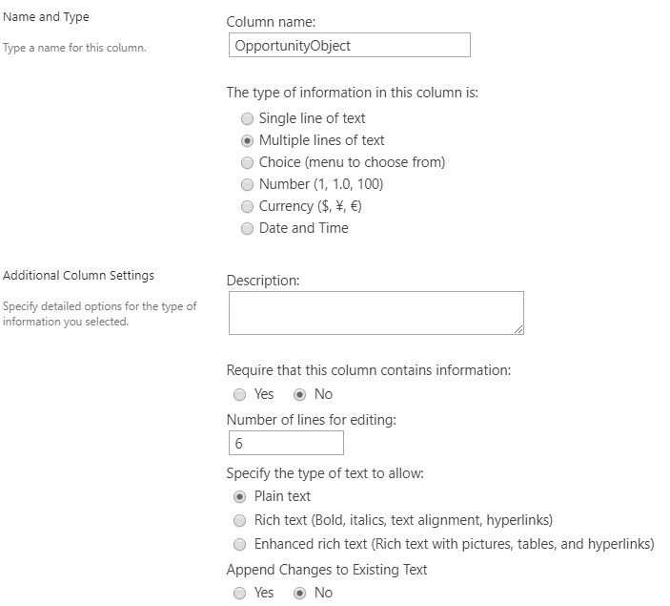

Next, index the following columns, add 5 simple indexes, as detailed [here](https://support.office.com/en-us/article/add-an-index-to-a-sharepoint-column-f3f00554-b7dc-44d1-a2ed-d477eac463b0):

* LoanOfficer
* Name
* OpportunityId
* Reference
* RelationshipManager

Records get added here automatically when a Relationship Manager creates opportunities in the dashboard.

**Regions**

The values defined here determines the options that are available for Region field when creating the opportunity.

|  |  |  |
| --- | --- | --- |
| Column | Type | Required |
| Title | Single line of text | x |
| Name | Single line of text |  |
| Modified | Date and Time |  |
| Created | Date and Time |  |
| Created By | Person or Group |  |
| Modified By | Person or Group |  |

Add records based on what you would like to make available as options for the Industry field.

Example records:

|  |  |
| --- | --- |
| Title | Name |
| 1 | North |
| 2 | East |
| 3 | South |
| 4 | West |

**ProcessMappings**

This list is used to define roles available in the application.

|  |  |  |
| --- | --- | --- |
| Column | Type | Required |
| Title | Single line of text | x |
| AdGroupName | Single line of text |  |
| RoleName | Single line of text |  |
| RoleValue | Single line of text |  |
| AdGroupId | Single line of text |  |
| ProcessStep | Single line of text |  |
| Channel | Single line of text |  |
| ProcessType | Single line of text |  |

Next, add 3 simple indexes (or create separate indices) for the following columns, as detailed [here](https://support.office.com/en-us/article/add-an-index-to-a-sharepoint-column-f3f00554-b7dc-44d1-a2ed-d477eac463b0):

* AdGroupName
* RoleName
* RoleValue

**NOTE:** AdGroupName refers to the Group Name in AD – take care to ensure that this matches the Office 365 group names setup in AAD for each role exactly or the application will not work correctly.

Display name of the role is based on the title.

For ProcessType, the acceptable values are Base, CheckListTab, proposalStatusTab, customerDecisionTab and Administration. Currently, any process step other than those associated with the three default channels (General, Formal Proposal and Customer Decision) are set to have type, CheckListTab.

RoleNames LoanOffice, RelationshipManager and Administrator are a fixed set of values and should match the values shown below exactly. The other 3 role names shown below viz. Credit Analyst, Legal Counsel and Senior Risk Officer are editable can be used as is or replaced by role names that are more appropriate for the given scenario.

ADGroupName values in the example can be modified and need not be the same as given below.

Example records:

|  |  |  |  |  |  |
| --- | --- | --- | --- | --- | --- |
| Title | AdGroupName | RoleName | ProcessStep | ProcessType | Channel |
| 1 | Loan Officers | LoanOfficer | Start Process | Base | None |
| 2 | Relationship Managers | RelationshipManager | New Opportunity | Base | None |
| 3 | Proposal Manager Administrators | Administrator | None | Administration | None |
| 4 | Credit Analysts | CreditAnalyst | Credit Check | CheckListTab | Credit Check |
| 5 | Legal Counsels | LegalCounsel | Compliance Review | CheckListTab | Compliance Review |
| 6 | Senior Risk Officers | SeniorRiskOfficer | Risk Assessment | CheckListTab | Risk Assessment |
| 7 | Loan Officers | LoanOfficer | None | ProposalStatusTab | Formal Proposal |
| 8 | Loan Officers | LoanOfficer | Draft Proposal | CustomerDecisionTab | Customer Decision |

# Adding Custom Tile to App Launcher

To enable users to quickly access the Proposal Manager, you can add a custom tile to the Office 365 App Launcher, that can then be pinned as need to the top navigation bar or to the Home tab.

## Creating Custom Tile

To enable users to quickly access the Proposal Manager, you can add a custom tile to the Office 365 App Launcher, that can then be pinned as need to the top navigation bar or to the Home tab.

[Sign in to Office 365](https://support.office.com/en-us/article/sign-in-to-office-365-e9eb7d51-5430-4929-91ab-6157c5a050b4) with your work or school account. Select the app launcher icon and choose **Admin**.

In the Office 365 admin center, search for **tiles** or use the left navigation pane by choosing **Settings** > **Organization profile** > **Add custom tiles for your organization**.

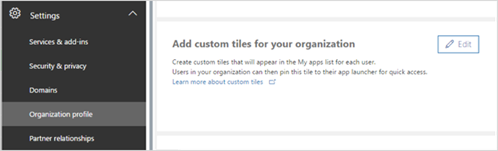

**Note:** If you don't see the Custom tiles link, verify you have an Exchange Online mailbox assigned to you and you've successfully signed into your mailbox. Both are required for this feature.

Choose **Add a custom tile**. Enter a **Tile name, URL, Description, Image URL and** choose **Save** to create the custom tile.

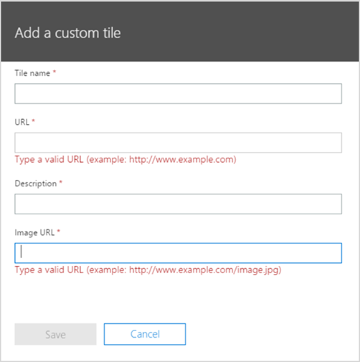

**Tip:** The image should be 60x60 pixels and be available to everyone in your organization. You can, for example, put it in a library on a SharePoint site and generate an [anonymous guest link](https://support.office.com/en-us/article/anonymous-guest-link-80e49744-e30f-44db-8d51-16661b1d4232#__toc371328495) to use as the URL. You may need to first [enable external sharing](https://support.office.com/en-us/article/enable-external-sharing-c8a462eb-0723-4b0b-8d0a-70feafe4be85).

Your custom tile now appears in the app launcher on the **All** tab for you and your users.

## Promote the tile to the Home Tab

Select the app launcher icon and select the **Home** tab. Locate the new tile for your app, select the ellipsis, and choose **Pin to home**.

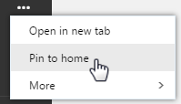

**Note:** If you don't see the custom tile created in the previous steps, make sure you have an Exchange Online mailbox assigned to you and you've signed into your mailbox at least once. These steps are required for custom tiles in Office 365.

**Important:** Both you and your users need to perform these steps to promote custom tiles from the My apps page to the app launcher.

# Deploy Solution

Get a local copy of the latest version of the source code and open the solution in Visual Studio.

## Update App Settings

Open appsettings.json located at .\WebReact and update as follows

|  |  |  |
| --- | --- | --- |
| Property | Description | Example Value |
| **AzureAd** |
| AppId | App ID from the Application ID URI section under Web API at apps.dev.microsoft.com | "<app_id>" |
| ClientId | This is the unique ID of the service principal object associated with the application, which is the Object ID the app properties in AAD at portal.azure.com. | "<client_id>" |
| ClientSecret | Client secret for the app registered in tenant | <Noted from the Application Registration portal - apps.dev.microsoft.com> |
| Instance | Public Instance name for AAD | "https://login.microsoftonline.com/" |
|  |  |  |
| Domain | Domain name of the tenant | “<tenant_domain>” |
| TenantId | ID of the tenant where the solution is deployed | "<tenant_id>" |
| CallbackPath | Landing page for the app after authentication | "/signin-oidc" |
| BaseUrl | Return URL for the app after authentication, this should match one of the reply-to URLs specified in the app manifest | "https://<app_url>.azurewebsites.net" |
| Scopes | Application scope | “openid email profile offline_access User.Read.All Mail.Send Sites.ReadWrite.All Files.ReadWrite.All Group.ReadWrite.All Directory.ReadWrite.All“ |
| GraphResourceId | Public end-point for Graph API | "https://graph.microsoft.com/" |
| GraphScopes | Scope required by the application for accessing Microsoft Graph | “User.Read.All Mail.Send Sites.ReadWrite.All Files.ReadWrite.All Group.ReadWrite.All Directory.ReadWrite.All” |
| **ProposalManager** |
| SharePointHostName | SharePoint site where the application is hosted | “<tenant>.sharepoint.com” |
| ProposalManagementRootSiteId | SharePoint site where the application configuration information and opportunities are stored | "tenant.sharepoint.com,<site.id>, <site.web.id>" |
|  |  |  |
| CategoriesListId | List name used for the different options for Category field | “Categories” |
| IndustryListId | List name used for the different options for Industry field | “Industry” |
| RegionsListId | List name used for the different options for Region field | “Regions” |
| NotificationsListId | List name used for Notifications | “Notifications” |
|  |  |  |
| RolesListId | List used to map user roles | “ProcessMappings” |
| OpportunitiesListId | List used to save Opportunities info for dashboard | “Opportunities” |
|  |  |  |
| SharePointLisPrefix | Prefix used to identify application specific lists in SharePoint | “pm_” |
| GraphRequestUrl | Graph REST API end-point for GET calls | "https://graph.microsoft.com/v1.0/" |
| GraphBetaRequestUrl | End-point for Graph API Beta | "https://graph.microsoft.com/beta/" |
| ServiceEmail | Email used for service notifications | “proposals@tenantname.com” |
| UserProfileCacheExpiration | Cache time in minutes for the user profile which determines how often the information is refreshed in the UI | “30” |
| TeamsBotName | Bot name in Teams | “Proposal Manager” |
| MicrosoftAppId | App ID for the Bot | “<bot_app_id>” |
| MicrosoftAppPassword | App Secret for the Bot app | “<bot_app_secret>” |
| AllowedTenants | ID of tenants allowed to interact with the app | “<tenant id list>” |
| BotServiceUrl | Service URL set for the bot | "https://smba.trafficmanager.net/amer-client-ss.msg/” |
| BotName | Bot name | “Proposal Manager” |
| BotId | ID for the bot | “<bot_id>” |
| TeamsAppInstanceId | App ID for the Proposal Manager add-in in Teams | “<teams_app_id>” |
| **Logging** |
| LogLevel | Logging level for the application | “Default: Warning” |

## Update Client App Settings

Open appsettings.js located at .\WebReact\ClientApp\src\helpers and update the fields indicated below. Take care to retain the scopes as indicated:

|  |
| --- |
| // General settings  export const appUri = ‘<to be updated>’;  // Authentication settings  export const clientId = '<to be updated>';  export const redirectUri = appUri + "/";  export const instanceId = 'https://login.microsoftonline.com/';  export const graphScopes = ["offline_access", "profile", "User.ReadBasic.All", "mail.send"];  export const graphScopesAdmin = ["offline_access", "profile", "User.Read.All", "mail.send", "Sites.ReadWrite.All", "Files.ReadWrite.All", "Group.ReadWrite.All"];  export const webApiScopes = ["<to be updated>"]; // From app registration  export const clientSecret = '<to be updated>';  export const authority = null; // Null for login as common  export const teamsAppInstanceId = '<to be updated>'; |

**WebApiScopes** value should be look like below.

Format: export const webApiScopes = ["api://<appID>/access_as_user"];

## Local Test and Debug

To test the solution locally against the application setup in the tenant, update the appsettings.json appropriately as indicated above, and then set the BaseUrl to a local value such as https://localhost:44385/ Make sure that this is added as a valid reply-to URL in the application as detailed here

Before building the solution for the first time, take care to navigate to .\WebReact\ClientApp from the command line, and run npm install to install all dependencies

Now run the application in Debug mode from Visual Studio by using the debug controls.

[Debugging in Visual Studio](https://docs.microsoft.com/en-us/visualstudio/debugger/index)

## Publish to Azure

Choose Build 🡪 Publish Solution to build and deploy the solution to Azure from the Publish UI.

* Select the New Publish profile option and choose Azure App

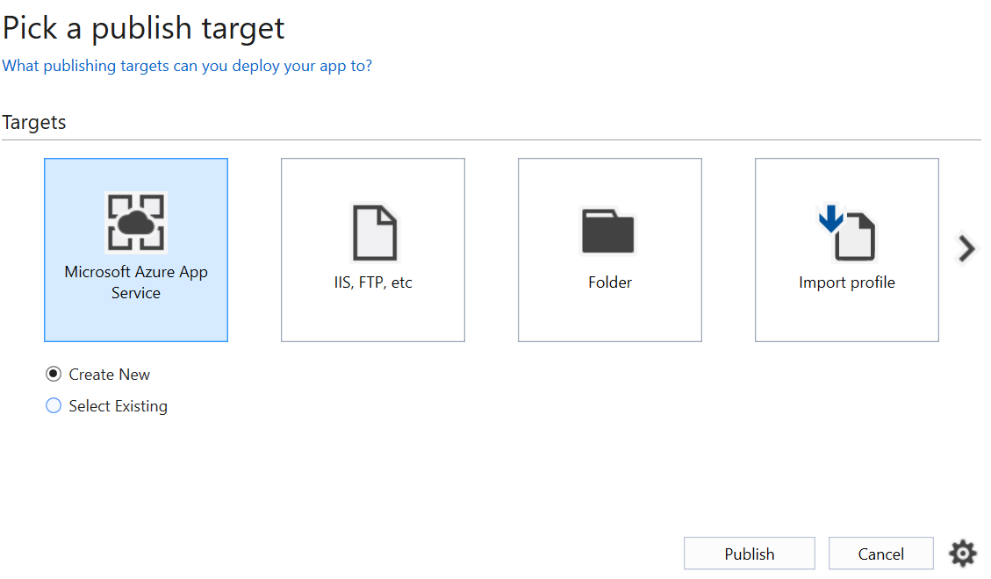

* Logon using the Azure account that you used to setup the application
* Select the Resource Group where the application is setup and expand, then choose the application

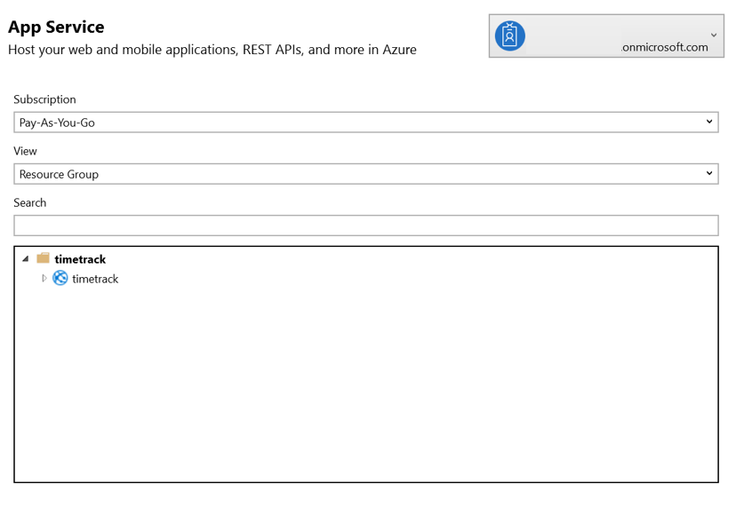

* Click on Publish to deploy the application to the Azure app service

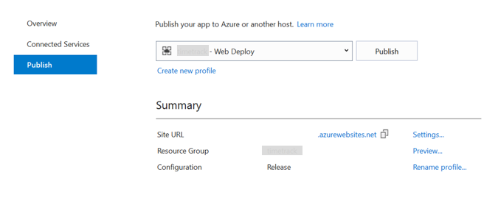

Once publish is completed, the web application is automatically launched on the default browser.

**Set Deployment Scope**

To deploy the Proposal Manager solution to a select set of users in the organization, prior to a global rollout, restrictions can be set in the Azure app as follows:

Navigate to the app settings in Azure Portal at Azure Active Directory --> All applications --> Enterprise applications. Select the application configured to be used for the Proposal Manager solution

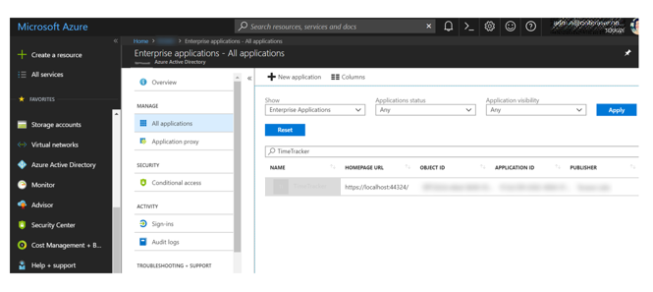

Go to Users and Groups

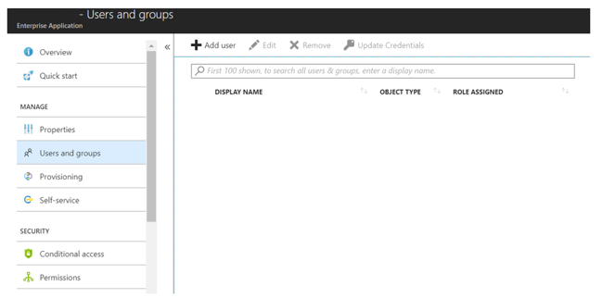

Click on Add User to add Users/Groups who should be given access to the solution. One can also send an invitation to users from this screen.

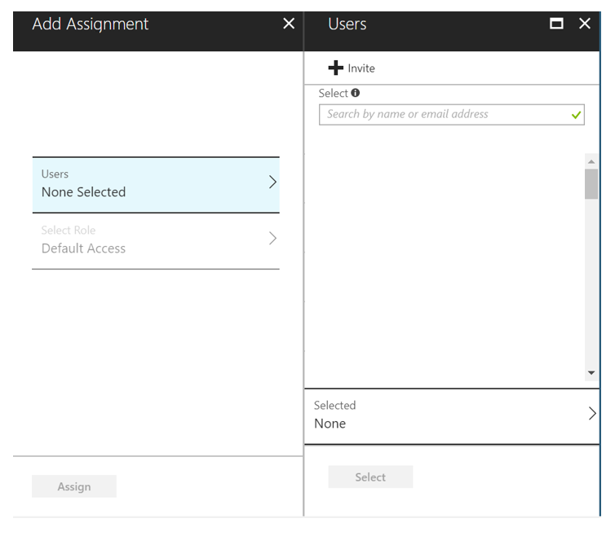

Following the above steps enables the administrator to do a limited deployment of the Proposal Manager solution, whereby only a select set of users in the organization can access the solution.

When ready, the administrator can remove the restriction by removing access restrictions for the app, which enables all users in the tenant to be able to access the Enterprise application.

## Accept Application Consent as Admin

Once the application is deployed, logon as the admin user at:

https://login.microsoftonline.com/common/adminconsent?client_id="<client_id>"&state=12345&redirect_uri="<external_uri>"

Click Accept on the list of permissions that show up.

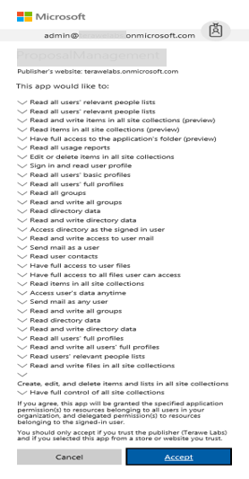

This enables the administrator to set consent on the application context. Once this step is completed, sign in to the portal, and sign out – do not use the application yet.

Next step is give admin consent to users:

Login as admin and navigate to:

https://<external_uri>/Administration?adminconsent=true}

After granting consent and sign-in to app, sign-out & close browser

This sets application permissions across all users in the tenant, and at this point any user can login and use the app.

# Teams add-in for Proposal Manager

To facilitate managing the end-to-end process of handling opportunities involving multiple team members using the rich collaboration capabilities of Microsoft Teams, we have extended Microsoft Teams by adding a team for each opportunity with channels and corresponding content to address different parts of the process.

# Enable side-loading of add-ins

To manage admin settings for apps in Teams, go to the Office 365 admin center and open Settings > Services & add-ins, then choose Microsoft Teams. As an admin, you can directly get to this section with the following link: <https://portal.office.com/adminportal/home#/Settings/ServicesAndAddIns>

Sideloading is how you add an app to Teams by uploading a zip file directly to a team. Only team owners, or members who are granted permissions, can sideload apps into Teams.

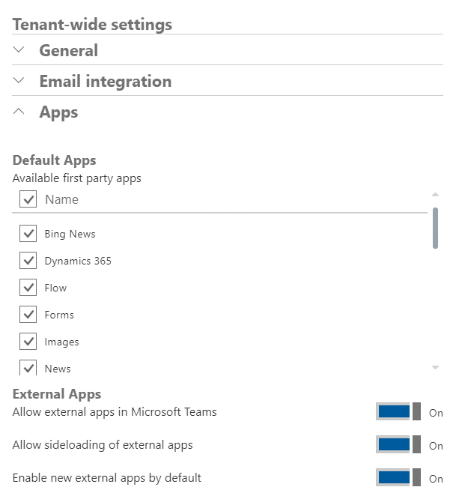

Ensure that sideloading of external apps is enabled at the tenant level.

# Create custom add-in for Teams

To share with Relationship Managers and Loan Officers who need to add this to the channels in the teams to access the capabilities of Proposal Manager, the app needs to be packaged as detailed [here](https://docs.microsoft.com/en-us/microsoftteams/platform/concepts/apps/apps-package).

A Teams app package is a .zip file containing the following:

* A manifest file named "manifest.json", which specifies attributes of your app and points to required resources for your experience, such the location of its tab configuration page or the Microsoft app ID for its bot.
* A transparent "outline" icon and a full "color" icon.

Define the manifest schema for the custom add-in, as detailed [here](https://docs.microsoft.com/en-us/microsoftteams/platform/resources/schema/manifest-schema).

It is recommended to use [App Studio](https://docs.microsoft.com/en-us/microsoftteams/platform/get-started/get-started-app-studio) for creating the Team Addin package along with the manifest file. The given link has information for installation of App Studio inside Microsoft Teams desktop application.

An example manifest for Proposal Manager solution is shared below (take care to replace <app_name> appropriately based on the URL for accessing the solution.

|  |
| --- |
| {    "$schema": "https://statics.teams.microsoft.com/sdk/v1.2/manifest/MicrosoftTeams.schema.json",    "manifestVersion": "1.2",    "version": "1.0.0",    "id": "<id>",    "packageName": "com.teams.porpmgmt",    "developer": {      "name": "GoLocal Solutions",      "websiteUrl": "https://<app_name>.azurewebsites.net/",      "privacyUrl": "https://<app_name>.azurewebsites.net/tab/privacy",      "termsOfUseUrl": "https://<app_name>.azurewebsites.net/tab/termsofuse"    },    "icons": {      "color": "color.png",      "outline": "outline.png"    },  "name": {  "short": "Proposal Manager",  "full": "Proposal Manager Add-in for Microsoft Teams"  },  "description": {  "short": "Proposal Manager GoLocal Solution",  "full": "Proposal Manager GoLocal Solution"  },    "accentColor": "#FFFFFF",    "configurableTabs": [      {        "configurationUrl": "https://<app_name>.azurewebsites.net/tab/config?channelName={channelName}&teamName={teamName}&groupId={groupId}&channelId={channelId}&upn={upn}",        "canUpdateConfiguration": true,        "scopes": [          "team"        ]      }    ],      "permissions": [      "identity",      "messageTeamMembers"    ],    "validDomains": [      "<url>.azurewebsites.net",      "login.microsoftonline.com"    ]  } |

# Load Proposal Manager add-in

Once the Proposal Manager Administrator has created the Team and associated channels for an opportunity initiated by the Relationship Manager, the Relationship Manager and the Loan Officer will now see the opportunity as ‘In Progress’ in the dashboard.

Relationship Manager or Loan Officer can now open Teams app in Web or Desktop to add the Proposal Manager add-in on the channels for the specific opportunity. This step is not supported in the mobile version of the Microsoft Teams app.

**Note:** Take care to use the most recent Teams add-in package for Proposal Manager shared by the administrator.

Open Teams application in Web or Desktop and navigate to the Team, whose name corresponds to the name of the opportunity

Select more options (Click on '...') next to the Team Name and choose 'Manage team'

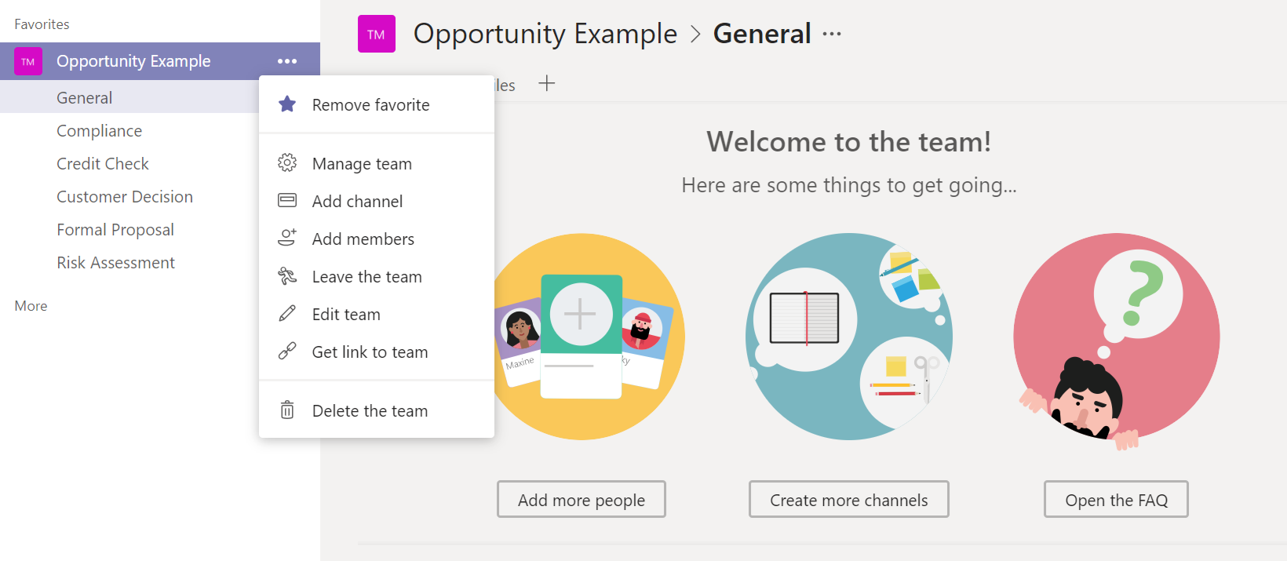

Choose the Apps tab and click on ‘Upload a custom app’

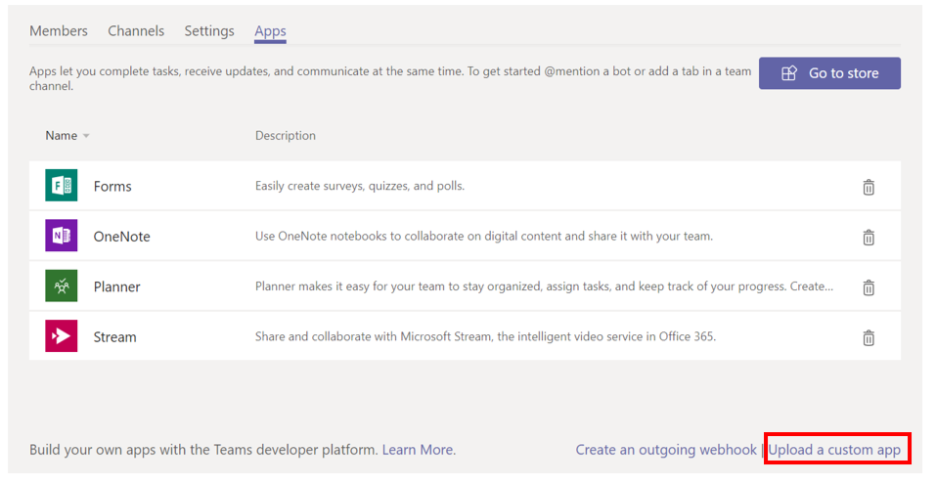

Upload the Proposal Manager add-in package shared by the administrator – Proposal Manager will now show up as a new app in the list

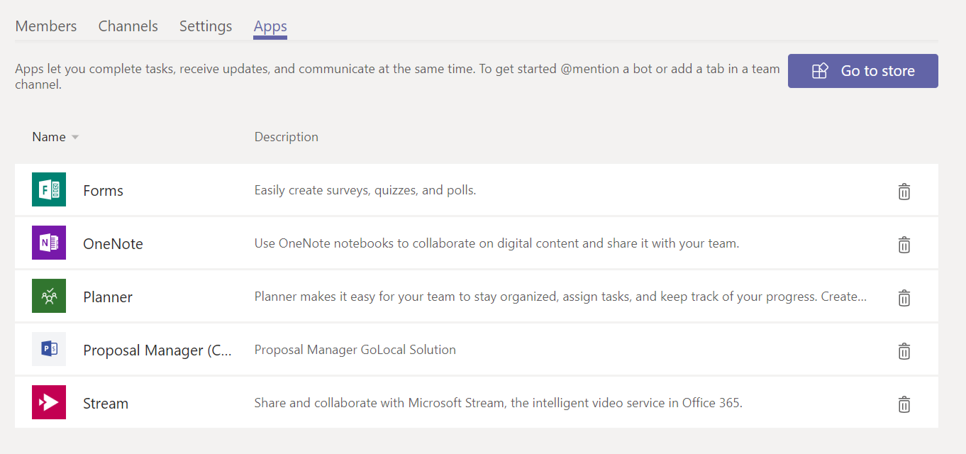

On each of the 6 channels, add the Proposal Manager add-in by clicking on the + sign next to the Files tab and choosing Proposal Manager

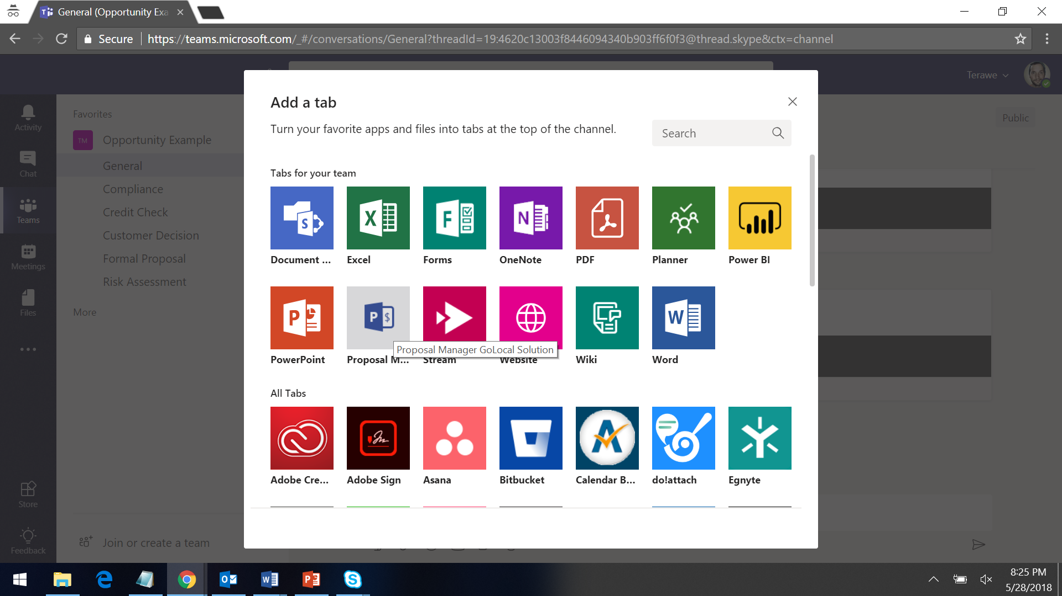

Proposal Manager settings page will load, click on Save to add the new tab.

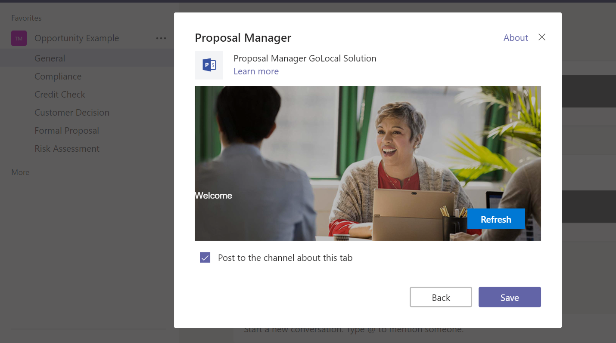

The contents of the tab will be different based on the channel where you have added it.

For example, the tab in the General channel will have the following sections:

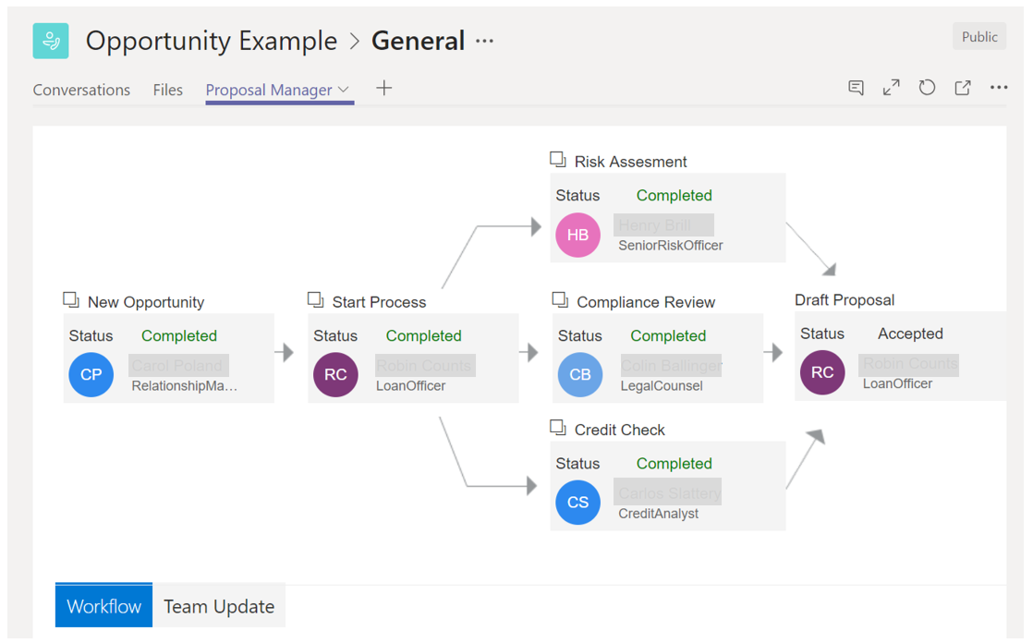

Each of the 6 channels have specific purpose facilitated by the add-in experience.

# Enabling Automatic add-in loading

Proposal Manager solution provides the capability whereby an admin can configure the Proposal Manager Teams add-in to be automatically added to the Team when the team and channels are created for an opportunity.

To enable this, proceed as follows:

1. Login to Microsoft Teams as admin and manually create a new team, say, ‘Proposal Manager Team’
2. Side-load the application add-in to that team (no need to add the tab to any channels)
3. Go to Office Graph API Explorer and login with the same admin credentials

Run this command: <https://graph.microsoft.com/beta/me/joinedTeams>

and locate the team(in this case ‘Proposal Manager Team’) created in step 2. An example response is given below as reference:

|  |
| --- |
| {    "id": "<id>",    "deletedDateTime": null,    "classification": null,    "createdDateTime": "<date>",    "description": "This team is used as a template for loading the app in new teams/ channels",    "displayName": "Proposal Manager Team",    "groupTypes": [      "Unified"    ],    "mail": "<email>",    "mailEnabled": true,    "mailNickname": "ProposalManagerTeam",    "membershipRule": null,    "membershipRuleProcessingState": null,    "onPremisesLastSyncDateTime": null,    "onPremisesSecurityIdentifier": null,    "onPremisesSyncEnabled": null,    "preferredDataLocation": null,    "preferredLanguage": null,    "proxyAddresses": [      "SMTP:<email>"    ],    "renewedDateTime": "<date>",    "resourceBehaviorOptions": [      "HideGroupInOutlook",      "WelcomeEmailDisabled",      "SubscribeMembersToCalendarEventsDisabled"    ],    "resourceProvisioningOptions": [],    "securityEnabled": false,    "theme": null,    "visibility": "Private",    "onPremisesProvisioningErrors": []  } |

1. Run this command to get the Teams App ID:

GET [https://graph.microsoft.com/beta/teams/<id>/apps](https://graph.microsoft.com/beta/teams/%3cid%3e/apps)

Extract the app id and add it to the app settings (see sample response below)

|  |
| --- |
| {    "id": "<app_id>", <- This is the ID that needs to be updated as value for TeamsAppInstanceId in appsettings.json & appsettings.js    "name": "Proposal Manager",    "version": "1.0.0",    "isBlocked": false,    "installedState": "installed",    "context": "sideloaded"  } |

# Office add-in for Proposal Creation

The Word add-in for Proposal Creation facilitates collaborative finalization of the Proposal document, with support for advanced features such as assignment of owners for sections and creation of tasks associated with specific sections. This is integrated with the Proposal Manager solution and activities are published as cards in the General channel.

# Deploying Office add-in

Please refer to the Proposal Creation add-in documentation for details on deploying the add-in on a new tenant.

# Configure SharePoint Document ID Service

The Proposal Creation add-in relies on a unique Document ID to map the Proposal Document to an opportunity. For this, it is required enable the Document ID feature for each new opportunity. Note that you must be a site collection administrator to perform the following steps.

1. Go to the created Opportunity SharePoint site, say, https://<tenant>.sharepoint.com/sites/<opportunity_name>
2. Click **Site Contents** and then click **Site Settings**.
3. Under Site Collection Administration, click **Site collection features**.
4. Next to Document ID Service click **Activate**.

cid:image002.jpg@01D410BC.49A4CC20

1. Go back to site settings page.
2. Under Site Collection Administration, click **Document ID settings**.
3. On the Document ID settings page:
   1. Check the **Assign Document IDs** check box
   2. Input the prefix characters (Such as PROPMGT) in **Begin IDs with the following characters** text box
   3. Check **Reset all Document IDs in this Site Collection to begin with these characters** check box
   4. Select All Sites in **Use this search scope for ID lookup** dropdown.

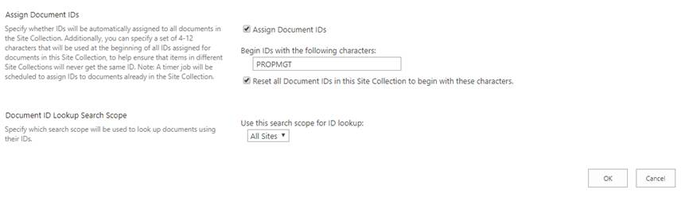

1. Click **OK.**

# User Experience Overview

This section details at a high level, how different personas interact with the solution.

This section details the different user personas interacting with the Proposal Management solution, their experience across different interfaces and end-to-end Proposal Management process for Corporate Lending, facilitated by the solution.

The guide for using the API is present at $/APIGuide. To view the API documentation,

please right click on the solution, select ‘Open Folder in File Explorer’ , inside the root

directory the folder named APIGuide holds the API documentation.

# User Personas

Solution considers 3 key personas as part of the team handling the opportunity, along with addition team members as defined in the user role mapping at the tenant level:

|  |  |
| --- | --- |
| Persona | Description |
| Relationship Manager | Owner of the opportunity, who identifies the opportunity, enters it into the system and drives it to a conclusion. Takes care of providing relevant documents to the participants involved in the proposal process, and acts as the point of contact with the customer |
| Loan Officer | Owns the proposal preparation process and forms the team handling the opportunity, based on decision taken on loan type and specific process to be followed for arriving at a proposal for the same |
| Credit Analyst | Example roles - Part of the opportunity team, selected by the loan officer. There could be one or more people associated with each role based on the process type, taking into consideration factors such as industry, geographic region and opportunity size. The solution is flexible to adapt to more personas to be part of the team. It is mandatory that such personas are linked to Process type CheckListTab in the Settings -> Role Mapping(by an administrator) so any change in status in the checklist gets reflects on the workflow screens. |
| Legal Counsel |
| Risk Officer |
| Administrator | Dedicated global administrator in the tenant authorized to create Team and associated channels in Microsoft Teams once an opportunity has been created  **NOTE:** This role will no longer be required once app context is supported by Teams API. At this time, programmatically creating Teams require admin consent necessitating the need for a specific admin persona |

# User Interfaces

Different members of the opportunity team can interact with the solution using two different interfaces:

|  |  |
| --- | --- |
| User Interface | Description |
| Dashboard | Primary entry point for users (Relationship Managers and Loan Officers), where they can login, see a list of opportunities associated with them and access details of a specific one. Relationship Manager has the ability to create an opportunity and Loan Officer can add or remove team members and update template used for the opportunity from this UI |
| Teams Add-in | A team is formed in MS Teams for each opportunity, and all members of the opportunity team are automatically added to the same. Each Team consists of different channels to facilitate collaboration, and the Proposal Manager add-in enables specific process steps across all personas on each of the channels |

# Key Entities

The Proposal Management process is built around three main entities – the Opportunity that gets processed by an internal team, the specific process/workflow identified to validate and move the opportunity forward, and the associated Proposal that is prepared as an outcome of the process.

**Opportunity**

An Opportunity is a potential deal identified by the Relationship Manager for one of his/her own clients based on knowledge gathered from customer discussions and market analysis. He then uses the Proposal Manager application to convert the opportunity, by means of well-defined corporate lending processes and a hand-picked team of experts brought together to execute the process, to a proposal document that can then be presented to the customer, offering a loan or line of credit that they can use in line with the terms and conditions.

Opportunity consists of the following key details:

* Client Information
* Relevant notes and documents
* Specific info for lending process

Opportunity is considered as Complete when a decision has been taken on the proposal by the customer.

**Workflow**

Specific process to be followed for an opportunity is based on the type of loan determined to be the optimal fit as per the loan officer, who takes the decision based on different considerations such as deal size, past history with the client and other details. In the current version, the solution supports a single loan type and an associated, fixed workflow.

**Proposal Document**

Proposal document, to be presented to the customer by the Relationship Manager, for the customer’s review and decision is the final deliverable from the Proposal Management process for each opportunity. Each loan type and process can be associated with a template chosen by the loan officer at the beginning of the process.

A proposal document is composed of clearly defined sections, each with a specific purpose and expected set of details to be updated based on inputs gathered from documents or information obtained from different steps of the process. Owners are identified for each section based on which step of the process is associated with the same. Loan Officer owns the end-to-end process for preparation of a formal document, that is then handed off to the Relationship Manager.

# User Permissions

Different types of users with associated permissions are as follows:

* Regular user
  + profile, User.ReadBasic.All, mail.send
* App Admin user (user that creates the team & channels)
  + profile, User.Read.All, mail.send, Sites.ReadWrite.All, Files.ReadWrite.All, Group.ReadWrite.All
    - The above permissions needs to be granted by a tenant admin (via admin consent)
* App context
  + Email, profile, User.Read.All, Mail.Send, Sites.ReadWrite.All, Files.ReadWrite.All, Group.ReadWrite.All, Directory.ReadWrite.All
    - The above permissions needs to be granted by a tenant admin (via admin consent)
* Tenant admin
  + Grants the permissions as noted above and config/deploy the system
  + Authorize the app in Azure and initial SharePoint site (details in deployment guide)

# Proposal Management Process

This section details the end-to-end process and defines how each team member interacts with the solution as part of the process.

# High Level Workflow

At a high level, the process starts with identification of an opportunity and ends with the customer taking a decision on a proposal document prepared during the course of the process.

1. Relationship Manager identifies a corporate lending opportunity for one of his/her clients and creates a new opportunity using the Proposal Manager application
2. Opportunity is assigned to a loan officer who identifies the process to be followed and forms a team
3. Team members collaborate and perform their assigned responsibilities at different stages of the process to prepare a Proposal document
4. Relationship Manager presents the proposal document to the client for review and decision
5. Client conveys his decision on if the proposal has been Accepted or Rejected

# Data Flow

Shared below is a high level data flow showcasing the different components and how they interact with each other:

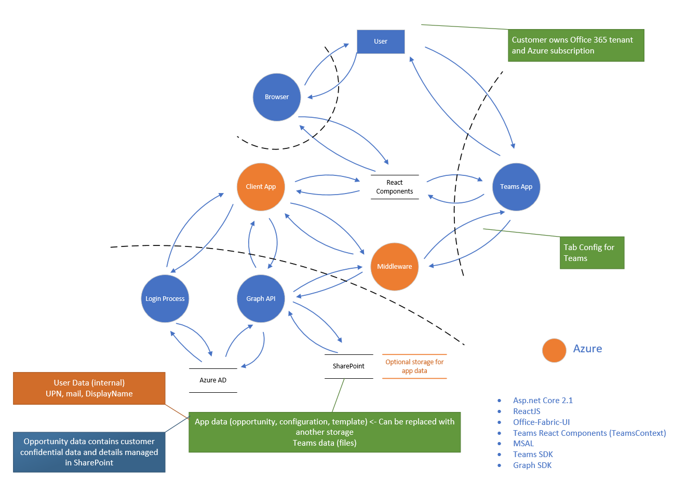

# User Interaction Flow - Portal

This section details the interaction experience for each persona.

**Relationship Manager**

Relationship Manager owns the opportunity, from creation to closure.

1. Relationship Manager identifies an opportunity and creates it in the system
   1. Documents can be uploaded as part of the opportunity creation process, which gets copied to the General channel in corresponding Team once created
2. Sees a list of all opportunities associated with the user in the dashboard
3. Select an opportunity to see a summary view of the opportunity, with all relevant information, quick access to team members and link to launch MS Teams
4. For each opportunity:
   1. Review process workflow at a high level
   2. Add/update notes about the opportunity, visible only to the Relationship Manager
   3. Assign loan officer if not assigned, or Change loan officer

**Loan Officer**

Loan Officer owns the Proposal Document, from identification to formalization.

1. Sees a list of all opportunities associated with the user in the dashboard
2. Select an opportunity to see a summary view of the opportunity, with all relevant information, quick access to team members a link to launch MS Teams
3. For each opportunity:
   1. Select team members for each role and finalize the team working on the opportunity
   2. Review process workflow at a high level
   3. Edit team by adding or removing specific team members

**Note:** In the current version, Edit Team is supported only when the opportunity has three additional roles with names “Legal Counsel”, “Credit Analyst” and “Senior Risk Officer”. No other roles are supported in the web dashboard, and has to be managed using the API.

**Administrator**

Administrator is a global admin on the tenant who is authorized to create Teams for new opportunities

1. Access Administration page from the dashboard menu
2. For opportunities in status ‘Creating’, initiate creation of Teams, which triggers the following steps:
   1. Create a Team with same name as opportunity
   2. Create 6 pre-defined channels in each team, each with a specific purpose
   3. Copy documents uploaded at the time of opportunity creation to the Files tab in the General channel

**Other Personas**

All other personas are not currently supported by default in the Dashboard.

# Teams Experience

A Team is formed in MS Teams for each opportunity, with everyone working on the opportunity added as members.

A custom add-in, Proposal Manager, facilitates the process within Teams. The add-in can be loaded automatically for each Team associated for an opportunity by following the configuration steps here. This add-in needs to be shared with the team members by the administrator and should be added to all the channels manually by Relationship Manager or Loan Officer. Every channel in Teams have Conversation and Files tabs by default, which facilitates the collaborative experience.

The Team for an opportunity, consists of the following channels by default, each with a tab for Proposal Manager add-in, which in turn consists of one or more sections.

|  |  |  |
| --- | --- | --- |
| Channel | Section | Description |
| General | Workflow | * Overview of the process workflow with the owner and status for each step |
| Team Updates | * Team overview, with quick access links, and status |
| Risk Assessment | Checklist | Example channels in line with the three personas listed as examples in User Personas   * Checklist for each process step * Ability to upload documents or download uploaded documents for each checklist item * Mark status as Completed, In Progress or Blocked at the process level |
| Credit Check |
| Compliance Review |
| Formal Proposal | Proposal Status | * Overview of the status of different sections of the proposal document, updated by the loan officer |
| Customer Decision | Customer Decision | * Decision by the customer on the final proposal and the details of loan disbursement, if applicable |

# API Guidance

Developers can use the Proposal Manager API to directly create or update Opportunities and associated artifacts from another solution or interface. API Documentation is available as part of the solution code in *.\APIGuide*

**TIP:** When adding, updating or removing team members, that section should be submitted to the API as a whole, otherwise any team member not in the section will be removed. For example, if we add a new team member and we only submit that changed section to the update API, all other team members will be deleted

# Extensibility

Proposal Manager is designed to be extensible to support potential new requirements for partners and customers across multiple industry verticals and regions.

# Maintenance

This section details some of the common maintenance scenarios.

# Update AD users and groups

Managing users and their roles are a key administrator responsibility.

The activities in this regard can all be performed from the Office 365 Admin portal at https://portal.office.com/adminportal

|  |  |
| --- | --- |
| Add a new user | On the admin portal, click on Add a user under the Active Users section, provide required details and click on Add    Navigate to the Groups list at https://portal.office.com/adminportal#/groups and add the newly added user to the group corresponding to their role |
| Update user role | Navigate to the Groups list at https://portal.office.com/adminportal#/groups and add or remove users from the groups corresponding to their role |
| Remove user | On the admin portal, click on Delete a user under the Active Users section |

# Clear SharePoint site

It may sometimes be necessary for the administrator to clear the list of opportunities from the system, such as for archiving reasons or to reset a test or prototype environment.

To delete all opportunities from the application, so as to have a clear dashboard for all users, proceed as follows:

* Navigate to the SharePoint site setup for Proposal Manager, and select the list for Opportunities
* Choose Select All from the top left of the list, and then click Delete.

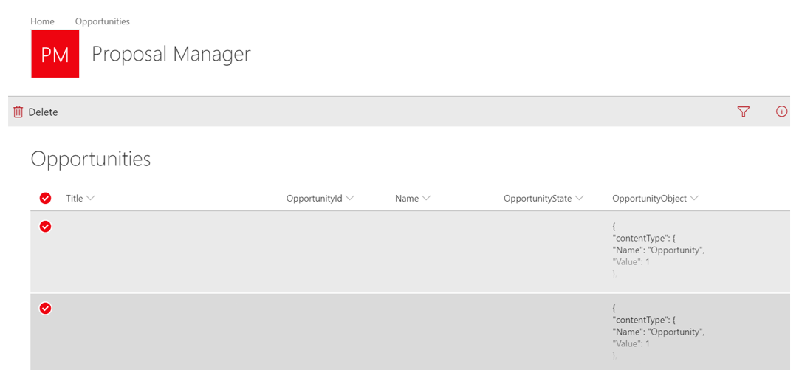

Note that when cleaning up the Opportunities list, it is recommended to also delete the corresponding Teams manually by logging into Microsoft Teams.

# Settings Update UI

An admin can maintain master data stored in SharePoint lists via the Settings page accessible from the Settings link in the left menu of the Web UI. 4 key lists can be updated from the UI as illustrated below. Note that the screenshots show sample data.

**Category**

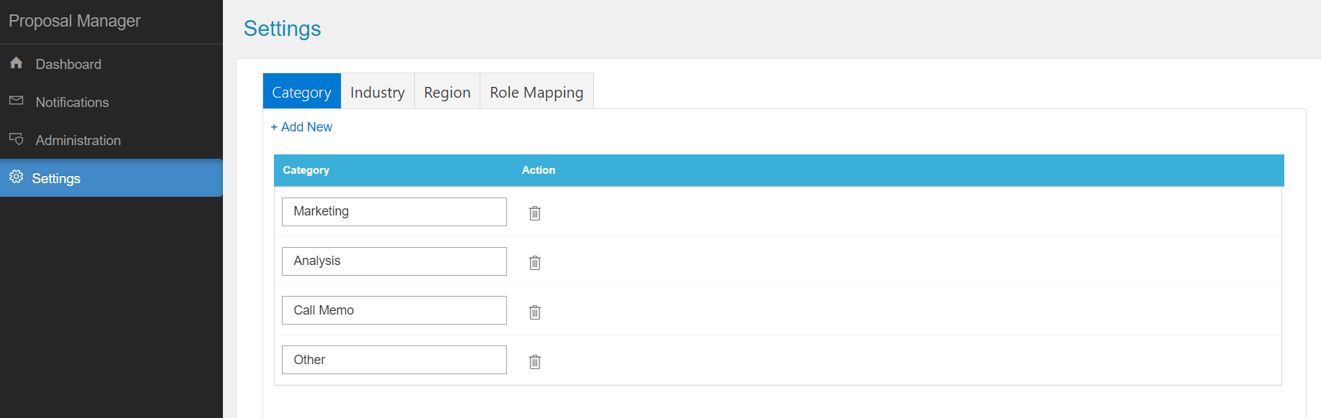

**Industry**

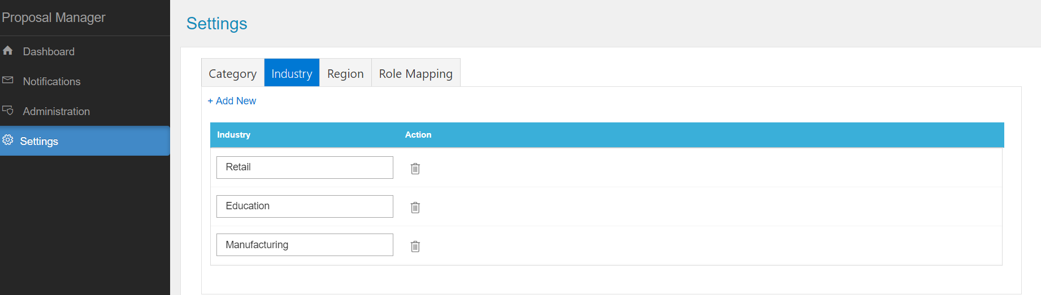

**Region**

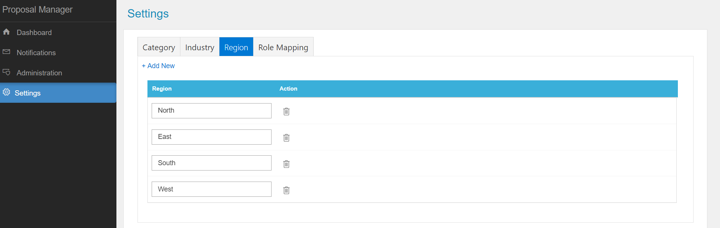

**Role Mapping**

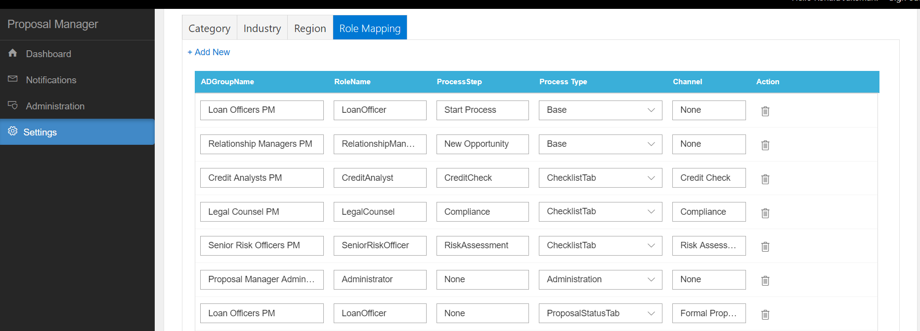

# Security Considerations

After app has been deployed and tested ad before go live, the following steps are recommended for the production environment:

* Lockdown SharePoint site: Remove all users from members list
* Replace app secret with certificates as detailed in Azure AD [guidelines](https://docs.microsoft.com/en-us/azure/active-directory/develop/active-directory-protocols-oauth-service-to-service)

# Troubleshooting

|  |  |
| --- | --- |
| **Error** | **Recommended Solution** |
| If the exact SSL port is not set in Visual Studio, same as the one used for App registration. | In Visual Studio, solution explorer, at the top search window, type ‘launchsettings’. The search result should display launchsettings.json. Open this file and in the section ‘iisSettings’, inside ‘iisExpress’ please ensure that the correct sslPort is set, eg:  "sslPort": 44385 |
| “Reply-to address does not match one defined for the application” | Confirm that the reply-to URLs specified for the application in the Application Registration Portal exactly matches the reply-to address specified in the error message |
| Dashboard shows 500 error after first time successful load on Azure | Scale up the web app to add more memory to see if it resolves the issue |
| Landing page gets stuck at “Loading your experience” | Make sure that pop-ups are enabled on the site to facilitate opening the sign-in window |
| If the login is not happening, check the browser console and look for an error while calling the userprofile. | Try to restart the application in Azure app service. |
| Clicking on the Proposal Manager add-in link from a channel in Teams Mobile app opens a page stuck in “Loading” | Logon to the account in another window on the default browser in the phone on some other site as http://portal.microsoftonline.com before clicking on the add-in link in Teams. |
| A particular user is unable to login | Ensure that the user has a valid O365 license.  Also check for the user being the member of the right Azure AD group as per the documentation. |

# Known Issues

This section lists some of the key known issues:

* Direct link to Team
  + Connect with Team link in Opportunity Summary launches Microsoft Teams but not the specific team for the opportunity
    - Getting the deep link for a team is not supported at this time by the Teams API without admin access
* File selection and upload does not work on mobile devices
* Proposal Manager has been validated only on Microsoft Edge and Google Chrome on Desktop and on the default browser on iOS and Android phones
* In the project ‘WebReact’, the folder named ‘Images’, inside ‘components-teams; folder should be renamed to ‘images’ with a small ‘i’ , as it is case sensitive. This is a one-time change.