CPE301 – SPRING 2019

Design Assignment 1

Student Name: Cody Jones

Student #: 5002863328

Student Email: Jonesc30@unlv.nevada.edu

Primary Github address: https://github.com/Jonesc30/Submission

Directory: Submission

Submit the following for all Labs:

1. In the document, for each task submit the modified or included code (only) with highlights and justifications of the modifications. Also, include the comments.
2. Use the previously create a Github repository with a random name (no CPE/301, Lastname, Firstname). Place all labs under the root folder ESD301/DA, sub-folder named LABXX, with one document and one video link file for each lab, place modified asm/c files named as LabXX-TYY.asm/c.
3. If multiple asm/c files or other libraries are used, create a folder LabXX-TYY and place these files inside the folder.
4. The folder should have a) Word document (see template), b) source code file(s) and other include files, c) text file with youtube video links (see template).

1. **COMPONENTS LIST AND CONNECTION BLOCK DIAGRAM w/ PINS**

List of Components used

Block diagram with pins used in the Atmega328P

1. **INITIAL/MODIFIED/DEVELOPED CODE OF TASK 1/A**

.org 0

sbi DDRB, 2 ; set PORTB.2 as output

sbi PORTB, 2 ; set LED off

; generate waveform with 40% DC and .625 sec period

BEGIN:

cbi PORTB, 2 ; set LED on

; Delay 4 000 000 cycles

; 250ms at 16.0 MHz

ldi r18, 21

ldi r19, 75

ldi r20, 191

L1: dec r20

brne L1

dec r19

brne L1

dec r18

brne L1

nop

sbi PORTB, 2 ; set LED off

; Delay 6 000 000 cycles

; 375ms at 16.0 MHz

ldi r18, 31

ldi r19, 113

ldi r20, 31

L1: dec r20

brne L1

dec r19

brne L1

dec r18

brne L1

nop

jmp BEGIN

#define *F_CPU* 16000000UL

#include <avr/io.h>

#include <util/delay.h>

int main(void)

{

DDRB |= (1<<2); // set PORTB.2 for output

while (1)

{

*_delay_ms*(250); // delay for 40% DC

PORTB &= ~(1<<2); // set LED on

*_delay_ms*(375); // delay for remaining 60%

PORTB |= (1<<2); // set LED off

}

}

1. **DEVELOPED MODIFIED CODE OF TASK 2/A from TASK 1/A**

.org 0

cbi DDRC, 2 ; set PORTC.2 as input

sbi PORTC, 2 ; enable pull up

sbi DDRB, 2 ; set PORTB.2 as output

sbi PORTB, 2 ; set LED off

WHILE:

sbic PINC, 2 ; skip next instr if PINC is low

jmp SKIP ; jump when PINC is high

cbi PORTB, 2 ; set LED on

; Delay 21 328 000 cycles

; 1s 333ms at 16.0 MHz

ldi r18, 109

ldi r19, 51

ldi r20, 106

L1: dec r20

brne L1

dec r19

brne L1

dec r18

brne L1

jmp WHILE

SKIP:

sbi PORTB, 2 ; set LED off

jmp WHILE

#define *F_CPU* 16000000UL

#include <avr/io.h>

#include <util/delay.h>

int main(void)

{

DDRC &= (0<<2); // connect PORTC.2 to switch as input

PORTC |= (1<<2); // enable pull-up

DDRB |= (1<<2); // set PORTB.2 for output (LED)

while(1){

if(!(PINC & (1<<PINC2))){ // check if pin is low

PORTB &= ~(1<<2); // set LED on

*_delay_ms*(1333); // set delay of 1.333 sec

}

else{ // otherwise (pin is high)

PORTB |= (1<<2); // set LED off

}

}

return 0;

}

1. **SCHEMATICS**

Use fritzing.org

1. **SCREENSHOTS OF EACH TASK OUTPUT (ATMEL STUDIO OUTPUT)**

Task 1 ASM:

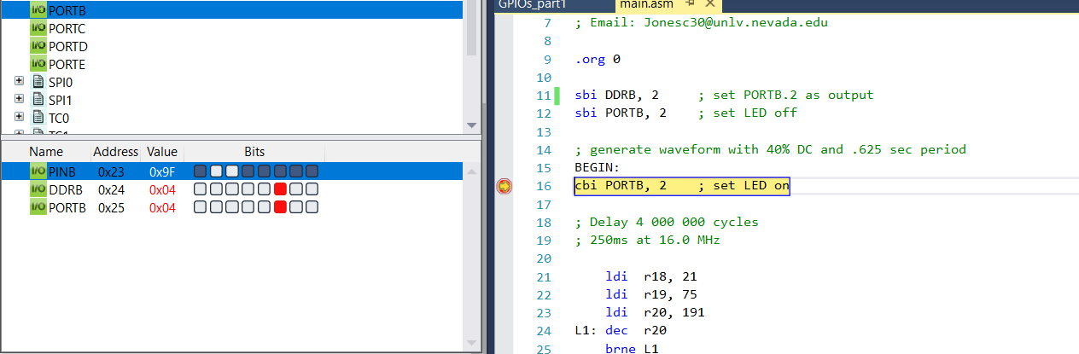

Task 1 C:

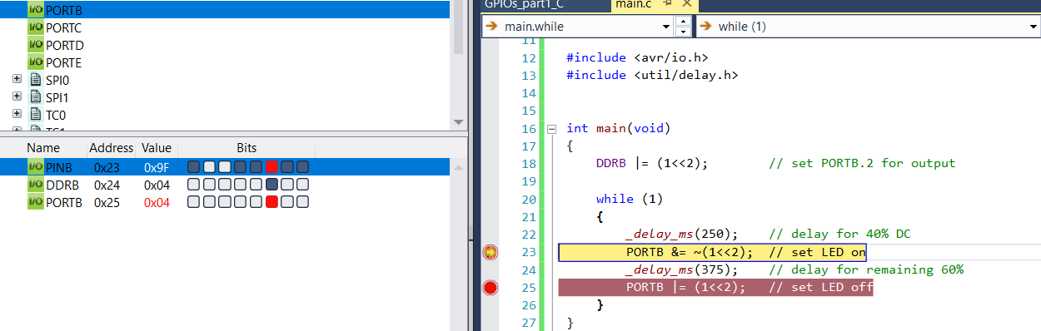

Task 2 ASM:

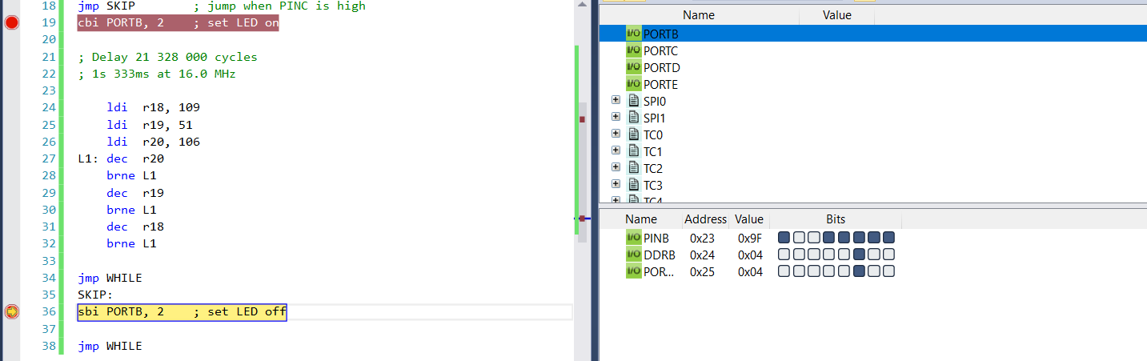

Task 2 C:

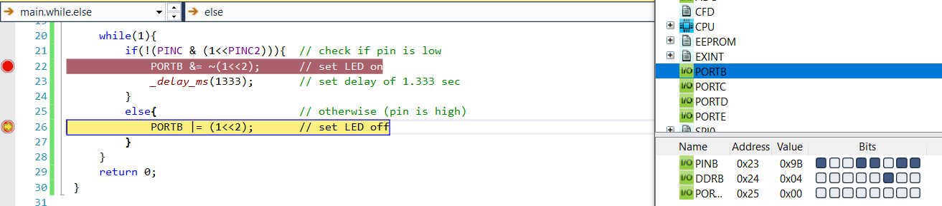

1. **SCREENSHOT OF EACH DEMO (BOARD SETUP)**
2. **VIDEO LINKS OF EACH DEMO**

Task 1: <https://www.youtube.com/watch?v=_rZsjGkK3Cc>

Task 2: <https://www.youtube.com/watch?v=pVCrSVZ6zBQ>

1. **GITHUB LINK OF THIS DA**

<https://github.com/Jonesc30/Submission/tree/master/DesignAssignments>

**Student Academic Misconduct Policy**

<http://studentconduct.unlv.edu/misconduct/policy.html>

“This assignment submission is my own, original work”.

NAME OF THE STUDENT