**Automation in Warehouses Using Raspberry Pi**

Kodidety Solomon Jones

*Abstract*— This is a research paper of Automation in Warehouses. Automation has become a notable topic in the field of factories for Warehouses. In this paper, we look at the Automation in warehouses using Raspberry Pi. We will first define what we mean by this term and what is so significant about it. We will delve a bit into the History of Raspberry pi. Then we will see about the Automation in warehouse using Raspberry Pi with sensors and components for Automation.

Keywords:Automation,Warehouse, Raspberry pi, Sensors.

Introduction

Automation in warehouse is the process where the minimal or reduced human effort is used in the warehouses so as to decrease the stress on the human and to increase the efficiency. The Raspberry Pi is the mini size CPU where we can do electronic projects. It was created in February 2012 by the Raspberry Pi Foundation. The Raspberry Pi Foundation is a charity founded in 2009. It enables people of all ages to explore computing, and to program in simple language like Python. It is free and open source. We can connect many sensors like Temperature sensor, Moisture sensor, Infrared sensor, Ultrasonic sensor, float sensor, LDR sensors, etc…

**A. *Automation***

Automation is the process where the minimal or reduced human effort is used so as to decrease the stress on the human and to increase the efficiency. The Automation automates the machines according to the situation and controls the systems with less human intervention. The Automation uses the feedback system to know the status so that the actuators will work according to that. Here we use the Raspberry Pi as the controller and program it accordingly so that it controls the machines.

**B. Wa*rehouses***

Warehouse is the storage place where the storage of the stock or the goods is done. There are different types of material handling equipment’s are used to move the goods from one place to another place. The warehouses are generally the large plane buildings where they often have the cranes, forklifts, pallets , Automated Guided Vehicles, etc..

s

**C. Raspberry Pi**

Raspberry is the mini size CPU which acts as the controller for the whole process in this Automation of warehouse. It has some General purpose input and output pins so the sensors and the actuators can be controlled by this input and output pins. We use the sensors as the inputs when the sensor senses the value then the controller accordingly controls the outputs or it notifies the operator about the situation.

Here in the Automation of warehouses using Raspberry Pi we use many sensors to Automate the process.  
  
1. Temperature and Moisture Sensor:

Here we use the sensor of DHT11 module. It is used to measure the both temperature and the moisture parallelly. In the fig.1. We can see the humidity sensor where there are two parallel electrodes and the moisture holding substrate is placed in between .The resistance of the plates changes based on the moisture on the substrate so the humidity is calculated in this process. Whereas the temperature sensor works on the Seebeck effect. Where the temperature difference between the two dissimilar electrical conductors or semiconductors produces a voltage difference. So this voltage differences are manipulated into the temperature readings.

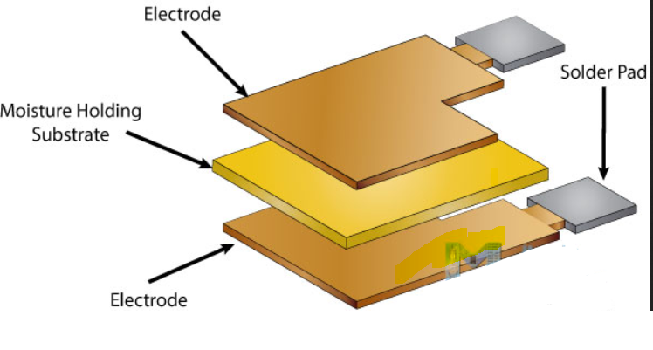

Fig .1

The specification of the DHT11 module is shown below.

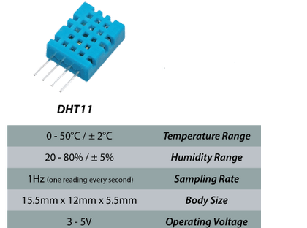

Fig 2

**Application of Temperature and moisture sensor in the Automation of Warehouses:**

The temperature and the moisture sensors plays one of the major role in the warehouse automation. Sometimes the irregular temperatures in the warehouse for certain goods will damage the goods and it will cause great loss in the warehouses. So by using the temperature sensors we can control the temperature in the warehouse so the goods can be safely stored. Similarly the moisture also effects the goods so this measures the moisture content in the air and takes its preventive measures to safeguard the goods in the warehouse. This controlling of the machines is done by the Raspberry Pi by taking the inputs from the sensors.

2. Infrared sensor:

The Infrared Sensor is the sensor which is used to detect the objects using the infrared light.The infrared light is the light which is in the wavelength of 700nm to 1400 nm. This wavelength is not visible to our naked eye as its wavelength is smaller than the visible wavelength. Here in this process the infrared light is continuously emitted as shown in the fig.3

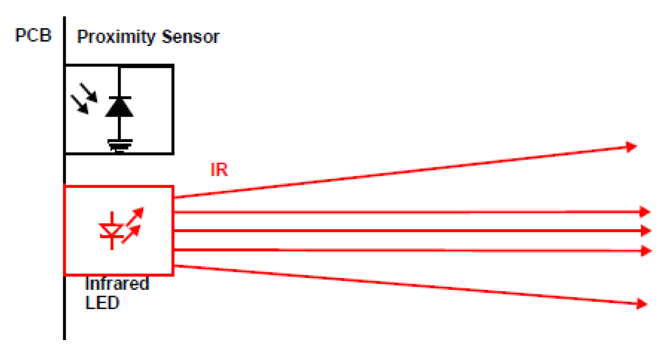

Fig .3

When the object comes in front of it then this infrared light hits the object and reflects back .So some of them hits the proximity sensor as in fig 4. When the proximity sensor receives the signal then it sends the input to the controller that some object has detected.

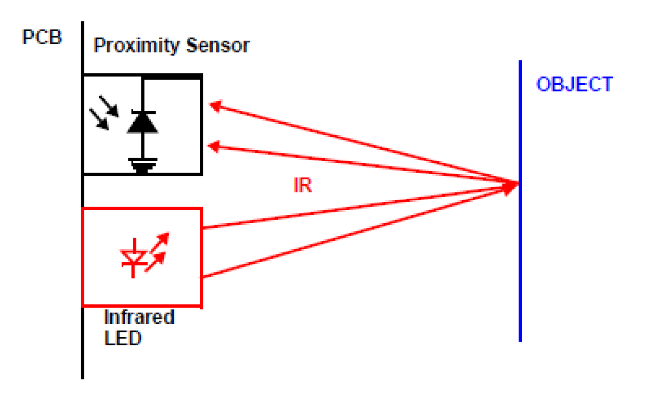

Fig. 4

**Application of Infrared sensor in the Automation of Warehouses:**

When the infrared sensor is connected to the Raspberry Pi it notifies the Raspberry Pi that some object is detected. So that the Raspberry Pi which acts as the controller takes the action according to that. Generally this can be used in the AGV’s so as to detect the objects in front of it and take the immediate action according to that situation.

Now a days this sensors are used for line following robots. So this makes the AGV’s to follow the line and move in its own path . This process works as the lines are coated with black color so the black color has the property of absorbing as shown in fig 5.This robots have three IR sensors which will

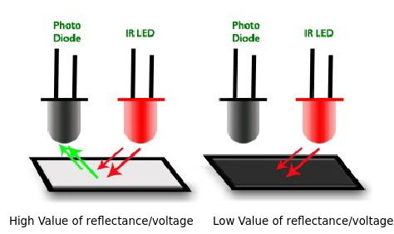

Fig .5

place on robot which moves along the line as show in the fig 6.

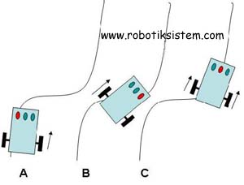

Fig. 6

When the left sensor gets activated it means the robot is moving right so the controllers adjusts it by making right motor move faster and make it to follow the line similarly when right sensor gets activated it means robot is moving left so left motor moves faster make it to follow the line. When the middle sensor gets activated it means the robot is following the line. In this way this infrared sensors are used in Automation of ware houses.

3. Ultrasonic sensor:

The ultrasonic sensor is the type of sensor which is used to find the distance of the detected object. In Ultrasonic the term Ultra means very small and Sonic means sound wave .So the ultrasonic sensor uses the sound waves to measure the distance.

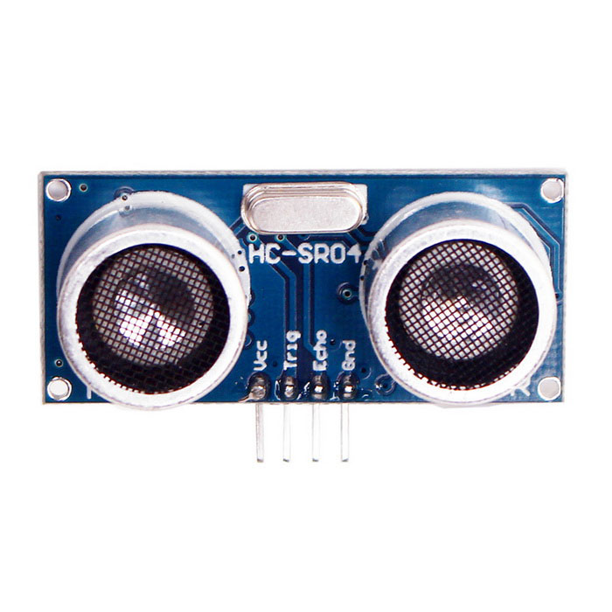  
Fig. 7

Here the sensor has Trigger and is Echo as shown in the fig 7. The trigger sends the sound wave for certain time and waits for the reflection to be received by the Echo. This works on the speed formula where,

Speed =Distance Travelled/Time taken

Here we are using the sound waves so the speed of sound in air is (Speed)=341 m/s

We consider the time as the difference between the start time and end time i.e. trigger start time and echo receiving end time=Time taken

Then we use the below formula to measure the distance.

Distance in meters =341/Time taken

In this way the distance can be calculated using ultrasonic sensor using the Raspberry pi.

**Application of Ultrasonic sensor in the Automation of Warehouses:**

When the ultrasonic sensor is connected to the Raspberry Pi it notifies the Raspberry Pi that some object is detected at certain distance and takes the action so that the task can be achieved perfectly. Generally this ultrasonic sensors are used in AGV’s so that they can estimate the distance of the wall and they can move accordingly in the warehouses so that they can work automatically in the warehouses.

4. Float sensor:

The float sensor is the sensor which is used to measure the level of fluid in the tank .This float sensor has the reed switch internally which works according to the magnet placed in the float as shown in the fig 8.

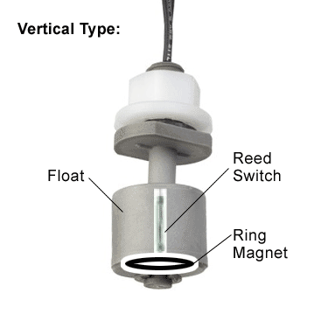

Fig. 8

The reed switch activates when the magnet is near to it. So in this way the level of the fluid in the tanks can be found using the float sensor.

**Application of Float sensor in the Automation of Warehouses:**

The float sensors can be used in the fuel tanks so that the fuel level can be known. So automatically the fuel notification will can be sent to the operator or make it to fill the fuel automatically with less human interference. This can also be used at the lubrication tanks and engine oil tanks to check the levels.

5. LDR sensor:

The LDR sensor is the sensor which is used to measure the light intensity. The resistance of the LDR changes depending on the light so it is called as the Light Dependent Resistor. The changing of the resistange is manipulated to the values so as to turn ON/OFF the lights. The figure of the LDR is shown in the fig .9.

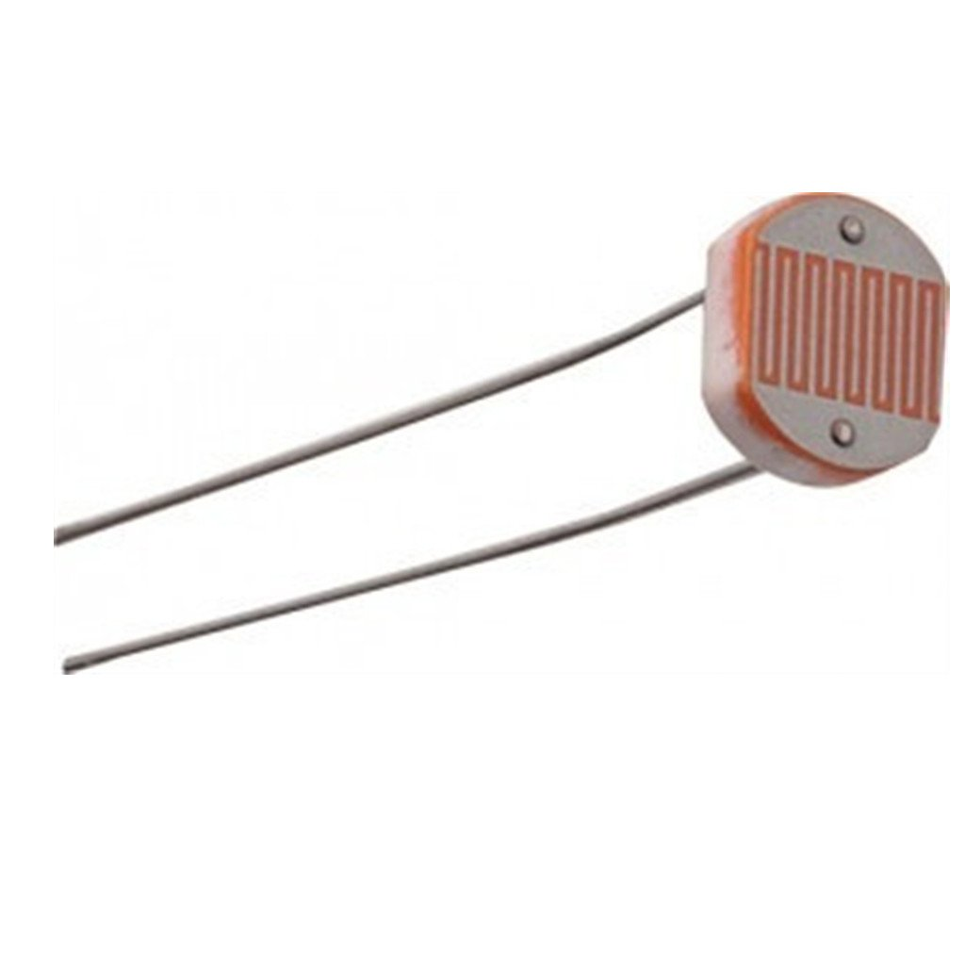

Fig.9

**Application of LDR sensor in the Automation of Warehouses:**

The LDR sensors can be used in the warehouses so that the lights can be turned ON/OFF automatically. Here the LDR sensor is connected to the Raspberry Pi so that it take the decision based on the situation weather it may be too dark , slightly dark or some other so that it turns the lights ON or OFF so as to save the power consumption in the Ware houses.

***Abbreviations and Acronyms***

LDR means Light Dependent Resistor  
AGV’s means Automated Guided Vehicles  
m/s = meters per second (in SI system)

**D. *Conclusion***

The Automation in Warehouses using the Raspberry pi is the future Technology for the automation in the Warehouses where we can connect many number of the sensors parallely and we can monitor them using IoT from any part of the world. Not only these sensors we can also connect different Sensors for the automation in the warehouse according to the necessity and we can automate them at very less price.

***References***

1. <https://en.wikipedia.org/wiki/Automation>

2. <https://en.wikipedia.org/wiki/Warehouse>

3. <http://raspberrypi.org/>

4. <https://www.wh1.com/store/>

5. <http://www.thomasnet.com/articles/materials-handling/material-handling-equipment>

6. <https://core.ac.uk/download/pdf/138555.pdf>

7.<https://www.google.co.in/search?q=ir+sensor&ie=utf-8&oe=utf-8&client=firefox-b-ab&gfe_rd=cr&ei=Wk9bWbyUDY3y8Ae_pLT4Cg>

8.<http://www.robotev.com/product_info.php?products_id=161%22>

9.<https://cdn-learn.adafruit.com/downloads/pdf/dht.pdf>

10.<http://howtomechatronics.com/tutorials/arduino/dht11-dht22-sensors-temperature-and-humidity-tutorial-using-arduino/>

11.<https://diyhacking.com/make-line-follower-robot/>

12. <http://argebilisim.trakya.edu.tr/pages/cizgi-robot>

13.<http://www.mtechlog.com/2015/09/using-ultrasonic-sensor-with-arduino.html>

14.<https://www.cynergy3.com/blog/how-select-correct-float-switch>

15.<http://howtomechatronics.com/tutorials/arduino/dht11-dht22-sensors-temperature-and-humidity-tutorial-using-arduino/>

16. <https://www.raspberrypi.org/learning/physical-computing-with-python/ldr/>  
17.<https://github.com/Joneskys/Journal>