Entrega 2 Semana 5: Implementacion de Jenkins en SkillCert
John Edisson Vanegas Cuervo
Politecnico Grancolombiano
Enfasis Profesional I - Integracion Continua
Fecha: 6 de junio de 2026

Resumen
Esta entrega implementa Jenkins como gestor de operaciones de integracion continua para SkillCert. El pipeline valida el repositorio con checkout desde GitHub, instalacion de dependencias, pruebas backend, build frontend, validacion de Docker Compose y construccion de contenedores.

Objetivo
Aplicar integracion continua mediante Jenkins y demostrar con evidencias visuales que el pipeline se ejecuto correctamente.

Repositorio
https://github.com/Jonevan369/skillcert-integracion-continua

Caracteristicas requeridas para Jenkins
Caracteristica | Implementacion
Jenkins | Jenkins LTS 2.541.3 ejecutado en contenedor temporal.
Node.js | NodeJS-20 configurado en Jenkins; consola evidencia v20.20.2.
Docker | Docker Desktop activo y socket Docker montado en el agente Jenkins.
Build tools | build-essential instalado para compilar dependencias nativas como better-sqlite3.
Plugins | Pipeline, Git, GitHub Branch Source, Pipeline Stage View, NodeJS, Docker Workflow y Timestamper.
Repositorio | GitHub: https://github.com/Jonevan369/skillcert-integracion-continua

Pipeline ejecutado
Checkout, Install Dependencies, Backend Tests, Frontend Build, Validate Docker Compose, Build Containers y Post Actions terminaron en SUCCESS.

Evidencias visuales
Captura 1. Dashboard Jenkins con job skillcert-ci y ultimo exito
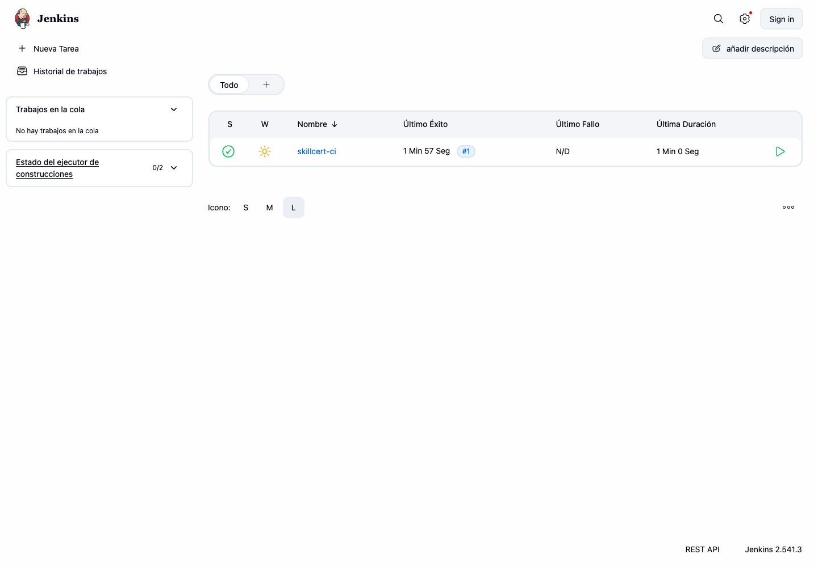
Captura 2. Build Jenkins exitoso con repositorio y duracion
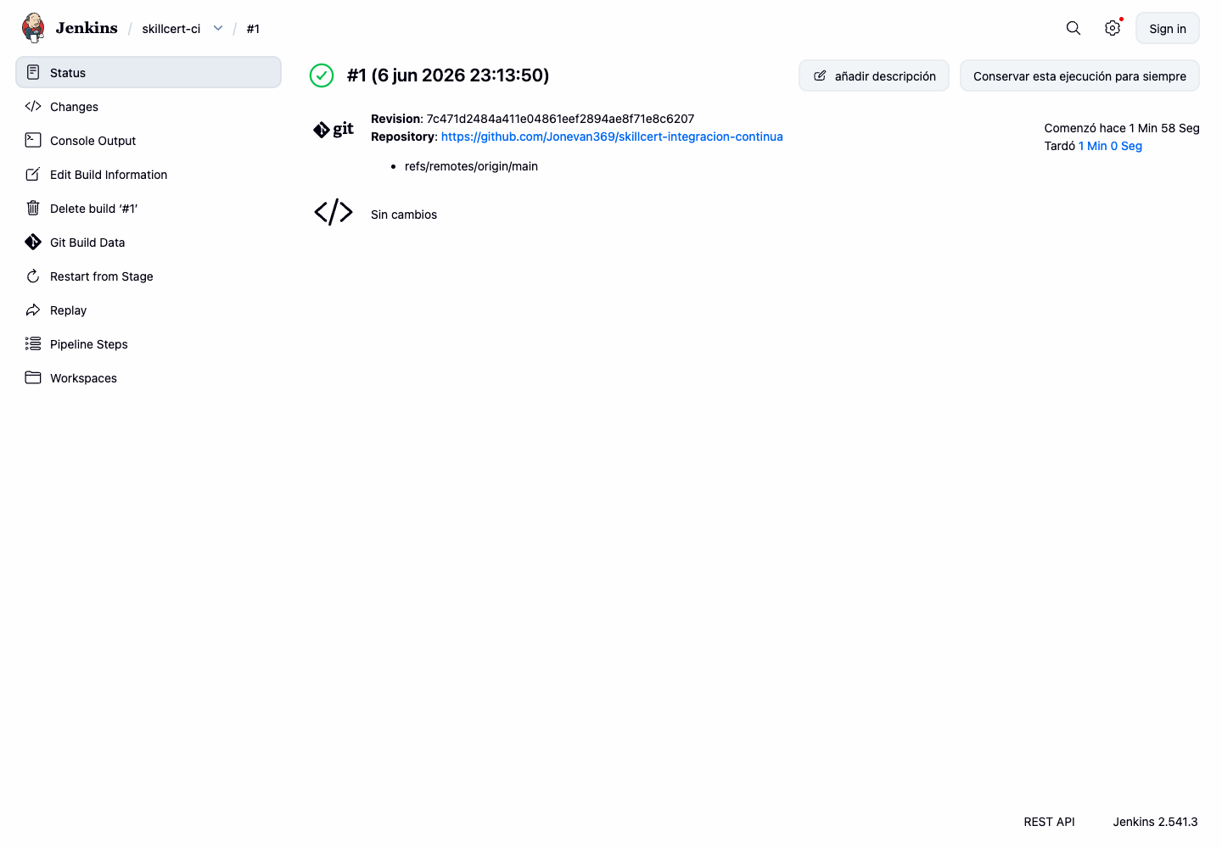
Captura 3. Etapas del pipeline en SUCCESS desde Jenkins wfapi
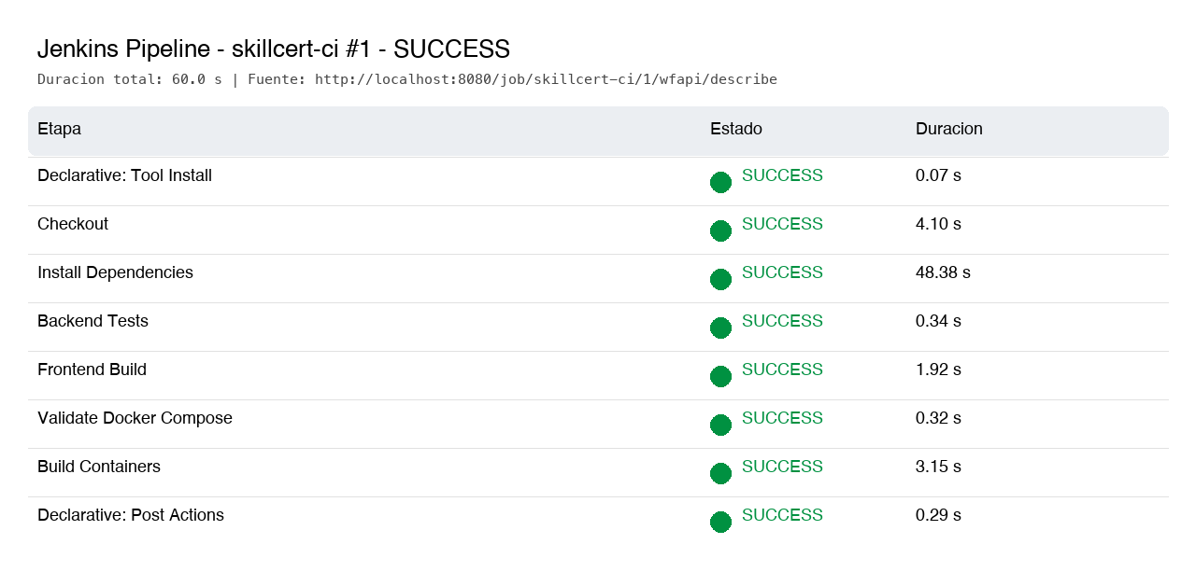
Captura 4. Consola Jenkins: npm test -w server y pass 3
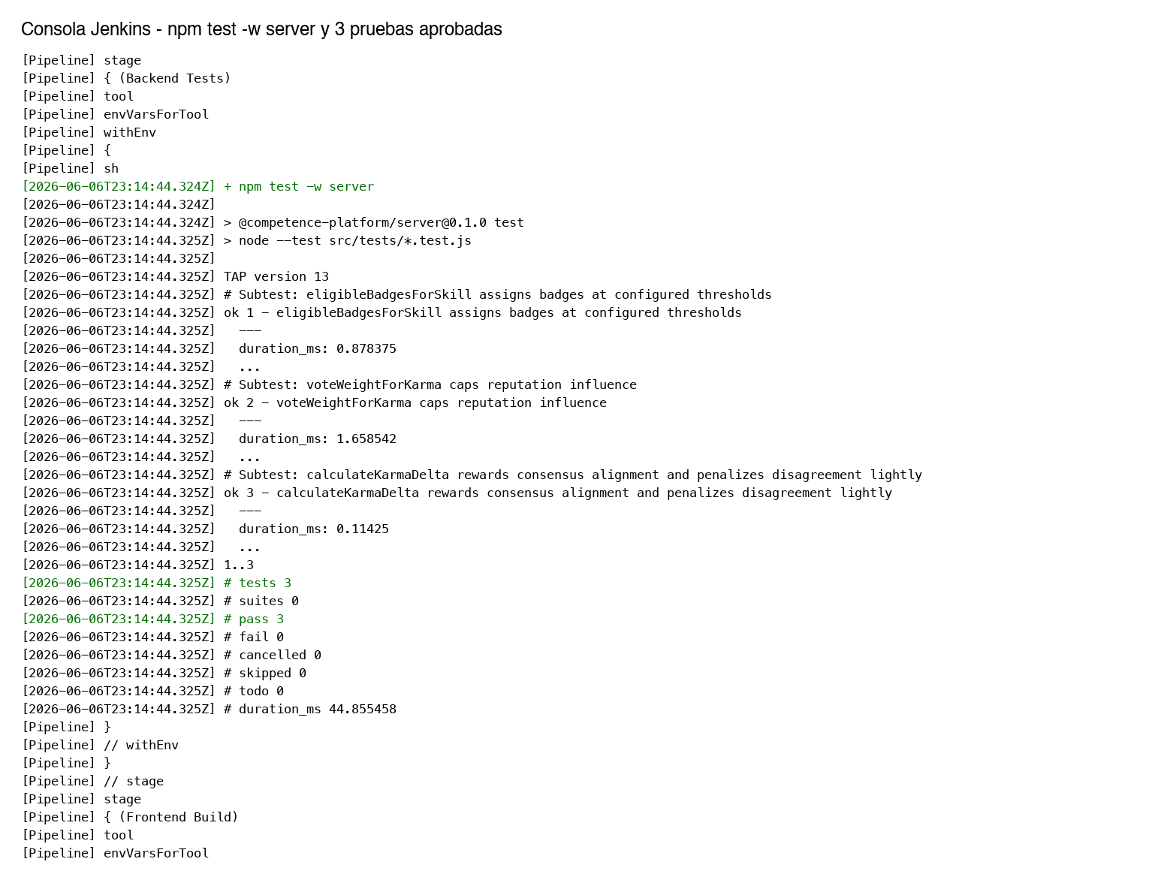
Captura 5. Consola Jenkins: docker ps, docker compose build e imagenes Built
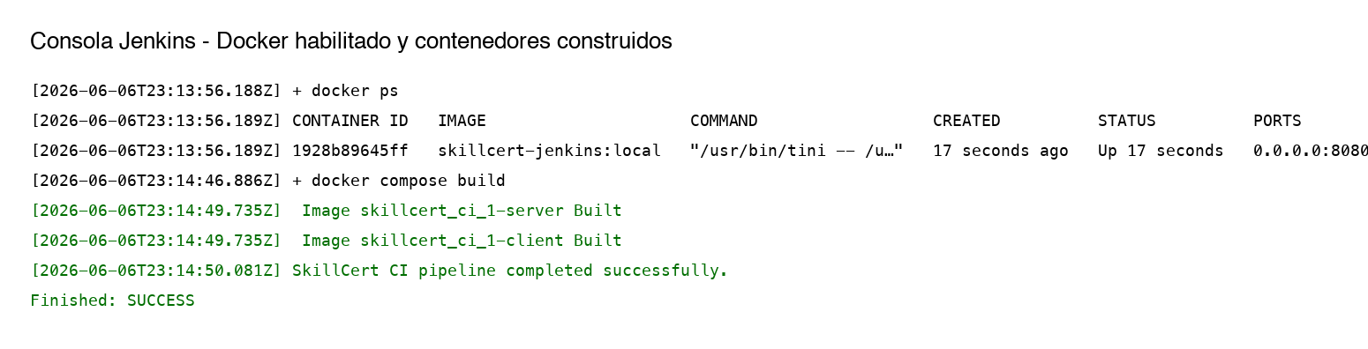
Captura 6. Jenkinsfile publicado en GitHub
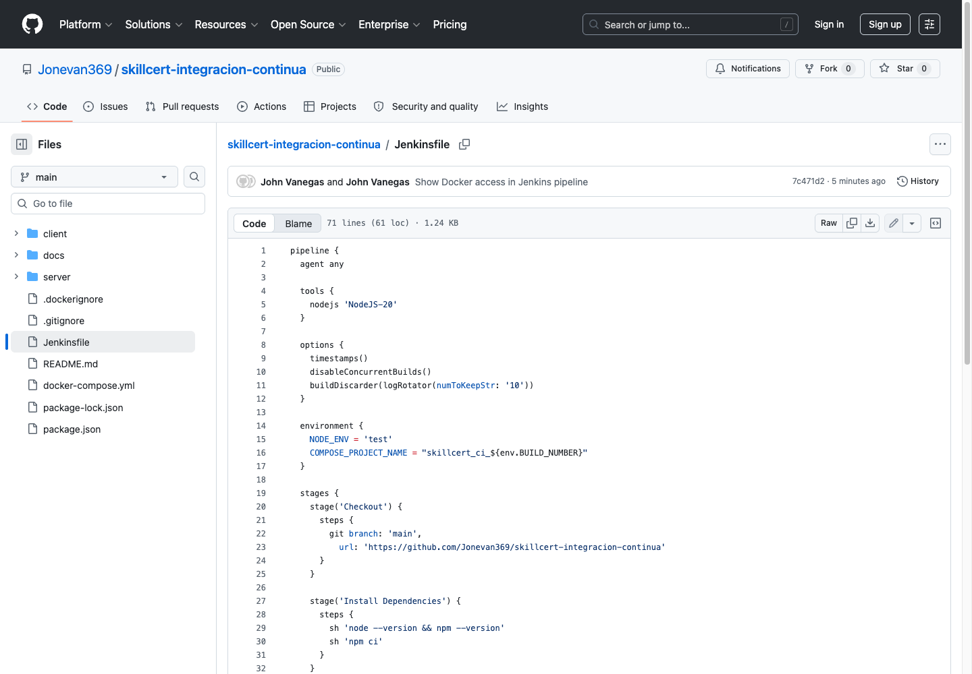

Solucion del error de Docker
El error de permisos al Docker local se resolvio dando al agente Jenkins acceso al daemon Docker. En esta evidencia se uso Jenkins en contenedor con el socket Docker montado y usuario root:
docker run -u root -v /Users/johnvanegas/.docker/run/docker.sock:/var/run/docker.sock skillcert-jenkins:local
En un agente Linux tradicional, la solucion equivalente es: sudo usermod -aG docker jenkins && sudo systemctl restart jenkins.

Webhook GitHub
La URL requerida para GitHub es http://SERVIDOR_JENKINS/github-webhook/. La captura real del webhook no se pudo completar desde este entorno porque GitHub solicito sesion/permisos de administrador al abrir Settings > Webhooks. No se incluye una captura falsa; debe completarse desde la cuenta propietaria del repositorio.

Anexo 1: Jenkinsfile completo
pipeline {
agent any

tools {
nodejs 'NodeJS-20'
}

options {
timestamps()
disableConcurrentBuilds()
buildDiscarder(logRotator(numToKeepStr: '10'))
}

environment {
NODE_ENV = 'test'
COMPOSE_PROJECT_NAME = "skillcert_ci_${env.BUILD_NUMBER}"
}

stages {
stage('Checkout') {
steps {
git branch: 'main',
url: 'https://github.com/Jonevan369/skillcert-integracion-continua'
}
}

stage('Install Dependencies') {
steps {
sh 'node --version && npm --version'
sh 'npm ci'
}
}

stage('Backend Tests') {
steps {
sh 'npm test -w server'
}
}

stage('Frontend Build') {
steps {
sh 'npm run build'
}
}

stage('Validate Docker Compose') {
steps {
sh 'docker ps'
sh 'docker compose config'
}
}

stage('Build containers') {
steps {
sh 'docker compose build'
}
}
}

post {
always {
sh 'docker compose down --volumes --remove-orphans || true'
}
success {
echo 'SkillCert CI pipeline completed successfully.'
}
failure {
echo 'SkillCert CI pipeline failed. Review the failing stage logs in Jenkins.'
}
}
}

Anexo 2: Extracto de consola Jenkins
[Pipeline] envVarsForTool
[Pipeline] withEnv
[Pipeline] {
[Pipeline] sh
[2026-06-06T23:14:44.324Z] + npm test -w server
[2026-06-06T23:14:44.324Z]
[2026-06-06T23:14:44.324Z] > @competence-platform/server@0.1.0 test
[2026-06-06T23:14:44.325Z] > node --test src/tests/*.test.js
[2026-06-06T23:14:44.325Z]
[2026-06-06T23:14:44.325Z] TAP version 13
[2026-06-06T23:14:44.325Z] # Subtest: eligibleBadgesForSkill assigns badges at configured thresholds
[2026-06-06T23:14:44.325Z] ok 1 - eligibleBadgesForSkill assigns badges at configured thresholds
[2026-06-06T23:14:44.325Z] ---
[2026-06-06T23:14:44.325Z] duration_ms: 0.878375
[2026-06-06T23:14:44.325Z] ...
[2026-06-06T23:14:44.325Z] # Subtest: voteWeightForKarma caps reputation influence
[2026-06-06T23:14:44.325Z] ok 2 - voteWeightForKarma caps reputation influence
[2026-06-06T23:14:44.325Z] ---
[2026-06-06T23:14:44.325Z] duration_ms: 1.658542
[2026-06-06T23:14:44.325Z] ...
[2026-06-06T23:14:44.325Z] # Subtest: calculateKarmaDelta rewards consensus alignment and penalizes disagreement lightly
[2026-06-06T23:14:44.325Z] ok 3 - calculateKarmaDelta rewards consensus alignment and penalizes disagreement lightly
[2026-06-06T23:14:44.325Z] ---
[2026-06-06T23:14:44.325Z] duration_ms: 0.11425
[2026-06-06T23:14:44.325Z] ...
[2026-06-06T23:14:44.325Z] 1..3
[2026-06-06T23:14:44.325Z] # tests 3
[2026-06-06T23:14:44.325Z] # suites 0
[2026-06-06T23:14:44.325Z] # pass 3
[2026-06-06T23:14:44.325Z] # fail 0
[2026-06-06T23:14:44.325Z] # cancelled 0
[2026-06-06T23:14:44.325Z] # skipped 0
[2026-06-06T23:14:44.325Z] # todo 0
[2026-06-06T23:14:44.325Z] # duration_ms 44.855458
[Pipeline] }

Conclusiones
La integracion continua quedo aplicada y demostrada con Jenkins: el job clono el repositorio, instalo dependencias, ejecuto pruebas, compilo el frontend, valido Docker Compose y construyo los contenedores. La ejecucion final termino en SUCCESS y quedo soportada con capturas y consola exportada.

