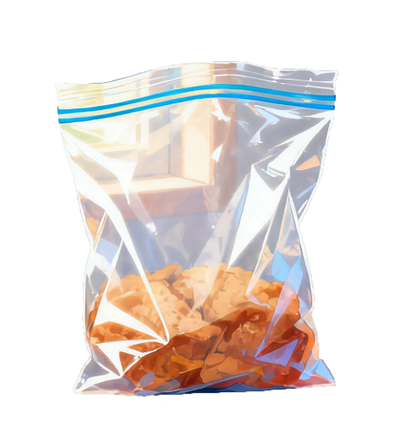

<https://static.igem.wiki/teams/5847/home/01.webp>

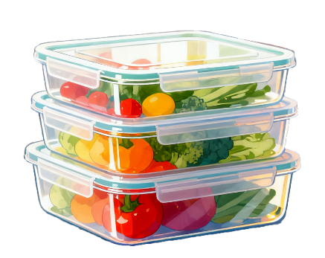

<https://static.igem.wiki/teams/5847/home/02.webp>



<https://static.igem.wiki/teams/5847/home/03.webp>



<https://static.igem.wiki/teams/5847/home/04.webp>



<https://static.igem.wiki/teams/5847/home/05.webp>

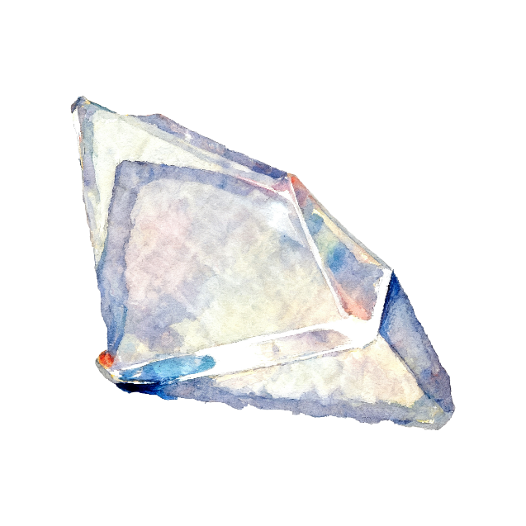

<https://static.igem.wiki/teams/5847/home/06.webp>

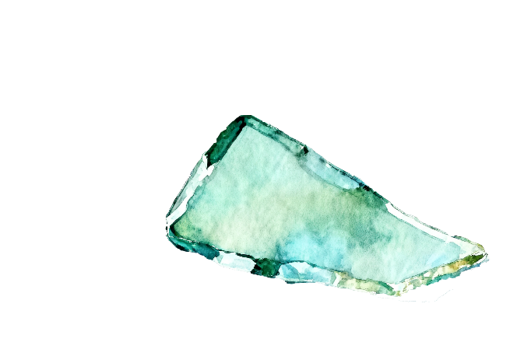

<https://static.igem.wiki/teams/5847/home/07.webp>

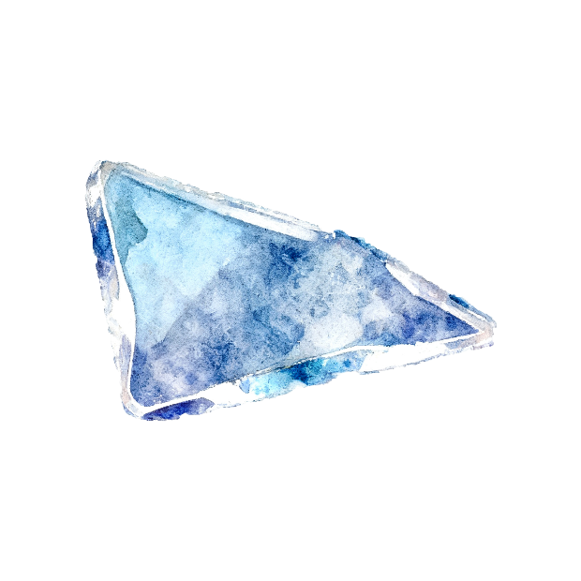

<https://static.igem.wiki/teams/5847/home/08.webp>

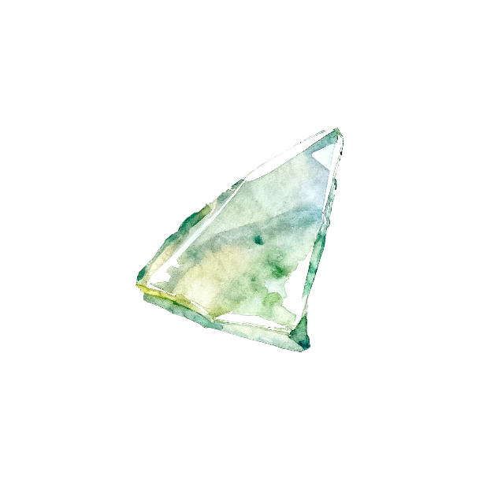

<https://static.igem.wiki/teams/5847/home/09.webp>



<https://static.igem.wiki/teams/5847/home/10.webp>



<https://static.igem.wiki/teams/5847/home/11.webp>



<https://static.igem.wiki/teams/5847/home/12.webp>



<https://static.igem.wiki/teams/5847/home/13.webp>

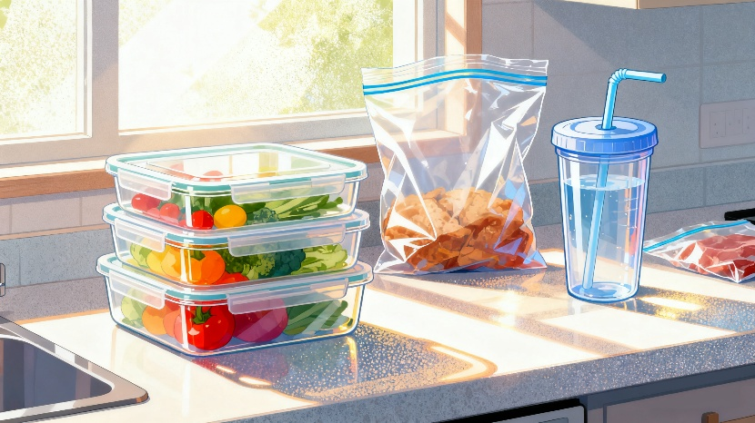

<https://static.igem.wiki/teams/5847/home/14.webp>



<https://static.igem.wiki/teams/5847/home/15.webp>