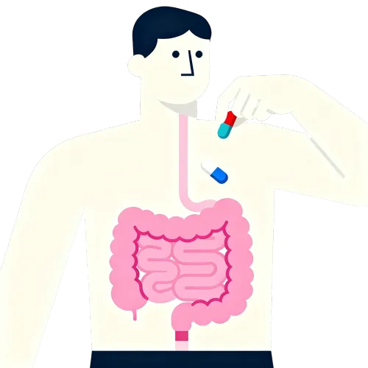

<https://static.igem.wiki/teams/5847/web/01.webp>

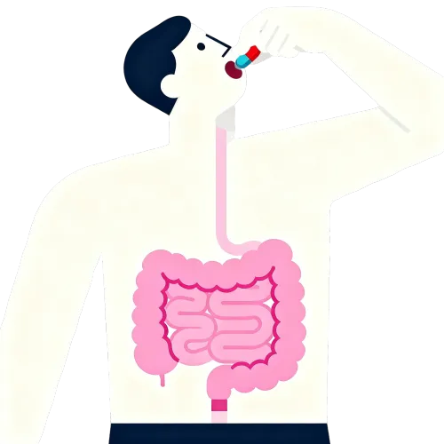

<https://static.igem.wiki/teams/5847/web/02.webp>

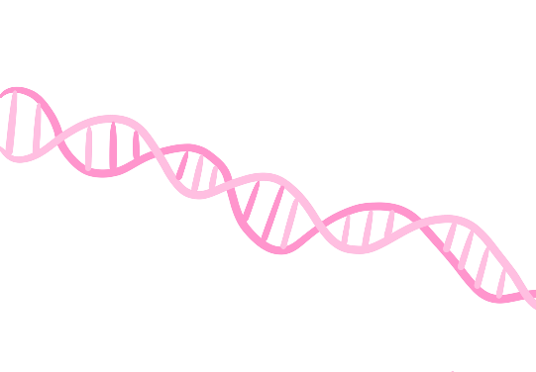

<https://static.igem.wiki/teams/5847/web/03.webp>



<https://static.igem.wiki/teams/5847/web/04.webp>

<https://static.igem.wiki/teams/5847/web/05.webp>

<https://static.igem.wiki/teams/5847/web/06.webp>

<https://static.igem.wiki/teams/5847/web/07.webp>



<https://static.igem.wiki/teams/5847/web/08.webp>

 <https://static.igem.wiki/teams/5847/web/09.webp>

 <https://static.igem.wiki/teams/5847/web/10.webp>

<https://static.igem.wiki/teams/5847/web/11.webp>

<https://static.igem.wiki/teams/5847/web/12.webp>

<https://static.igem.wiki/teams/5847/web/13.webp>

<https://static.igem.wiki/teams/5847/web/14.webp>

<https://static.igem.wiki/teams/5847/web/15.webp>

←这里有张图片<https://static.igem.wiki/teams/5847/web/16.webp>

<https://static.igem.wiki/teams/5847/web/17.webp>

<https://static.igem.wiki/teams/5847/web/18.webp>

<https://static.igem.wiki/teams/5847/web/19.webp>

<https://static.igem.wiki/teams/5847/web/20.webp>

<https://static.igem.wiki/teams/5847/web/21.webp>

<https://static.igem.wiki/teams/5847/web/22.webp>

<https://static.igem.wiki/teams/5847/web/23.webp>

<https://static.igem.wiki/teams/5847/web/24.webp>



<https://static.igem.wiki/teams/5847/web/25.webp>