<https://cs.senecac.on.ca/~bci433/>

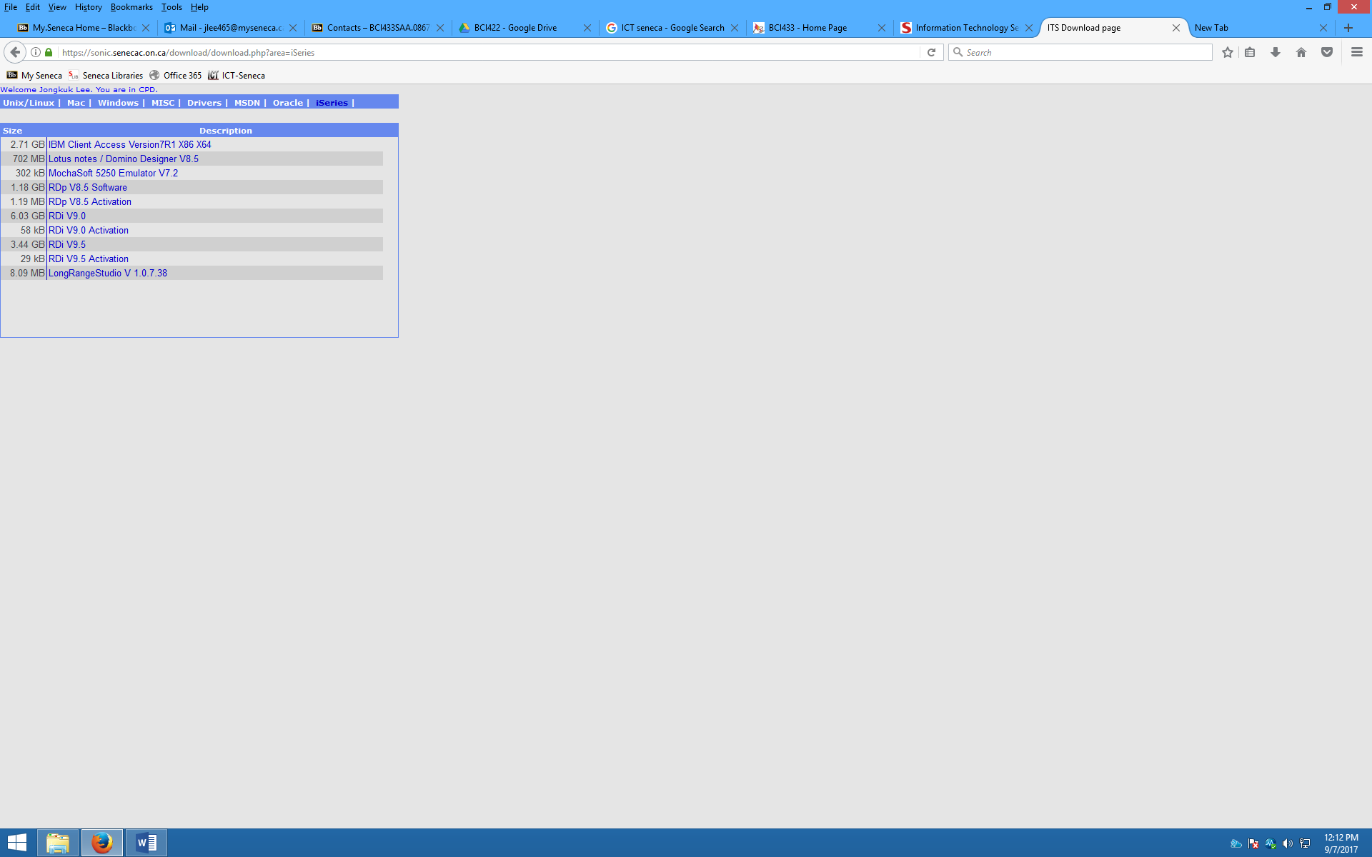

Seneca TUG award

RESET – LEFT CTRL

LOGIN THE SYSTEM

WRKMBRPCM BCI433RUSS/HANDOURS /🡪 library name/ file name

Press enter

CALL BCI433LIB/INTROLAB

ENTER

FIELD EXIT - + ON NUMERIC (KEYPAD)

CLRL + F 🡪 move to next field

FILED ‘-‘ (NEGATIVE) – ON NUMERIC KEYPAD

SHIFT ESC

F4 – PROMPT

F1 - HELP

Tutorial: YouTube

<https://www.youtube.com/watch?v=7980eoVjz08&list=PLaM_KQsEt0UYkaiBaWmq8HWri4piW6hlx>

RDi

Client Access (PDM)

what is the program?

ZEUS.SENECA.ON.CA

ZEUS.SENECACOLLEGE.CA

BCI433

IFS 🡪 Root File System 🡪 BCI433 Notes 🡪 BCI433~~.ppt🡪 copy and paste to local PC

DSPLIBL 🡪 library list

System value

book

Who Knew You Could Do That with RPG IV? A Sorcerer's Guide to System Access and More