BCI433 Notes - User Profiles

The user profile describes the user to the system. Information on the following is stored in the user profile:

User’s password – to sign on,

Initial Program – a program that will run when the user signs on to the system.

Initial Menu – a specific menu to show the user when first signed on to the system.

The Current Library – Determines the one unique user’s personal library on a library list. Everyone gets the same system and user libraries from QSYSLIBL and QUSRLIBL system values when they sign on. (assuming no initial program changes the library list)

The current library is also used when a user creates an object and does not state specifically what library it is to be stored in.

==> CrtOutQ Test (this command does not mention a library)

Object TEST type *OUTQ created in library DY433D40

(The current library was used to store Test)

If the user profile does not indicate a current library then QGPL is used to store the objects.

The **user class** or **special authorities** the user has determines the level of access to system resources.

The user class has default special authorities. This is enforced when system wide security (QSECURITY) is set to level 30 or above

CHGUSRPRF 🡪 USER CLASS 🡪 F1

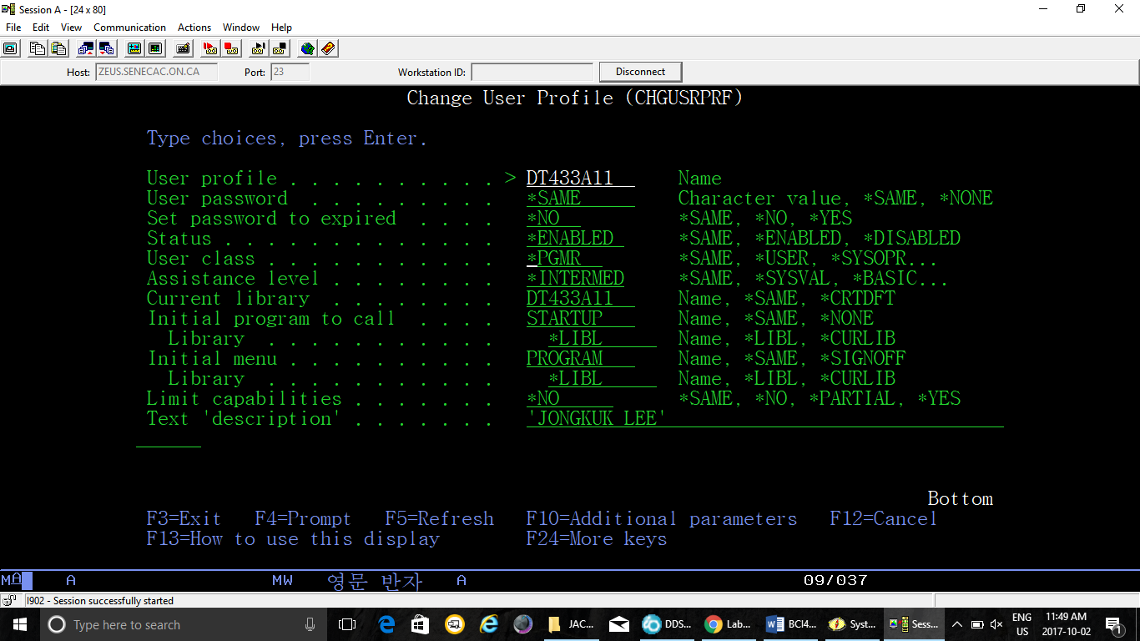

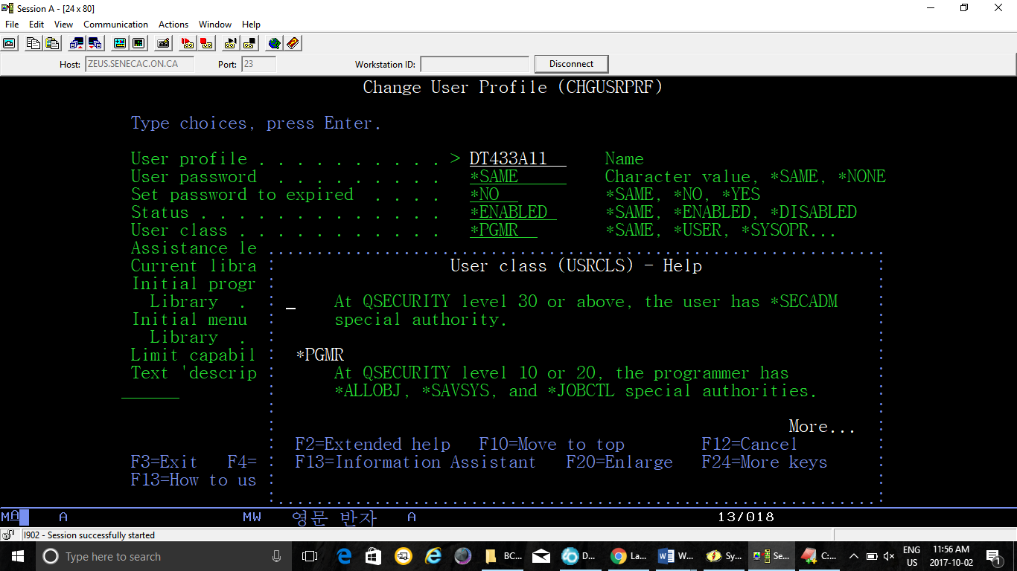

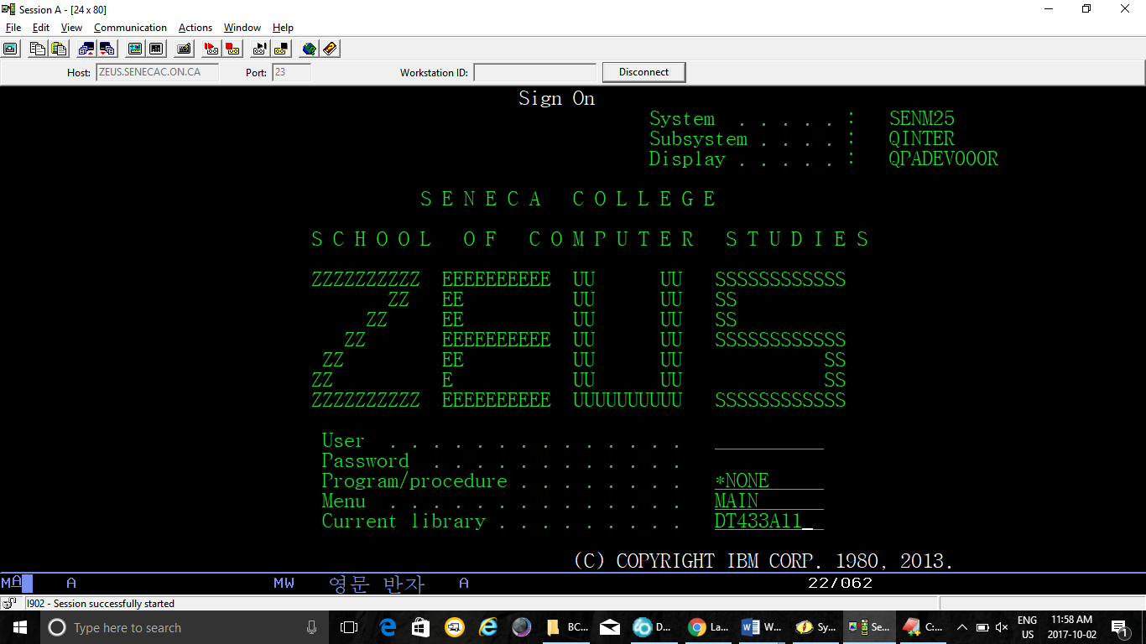

USER CLASS and Special Authorities that go with them

*SECOFR

*ALLOBJ *SAVSYS *JOBCTL *SERVICE

*SPLCTL *SECADM *AUDIT *IOSYSCFG

*SECADM

*SECADM

*SYSOPR

*SAVSYS *JOBCTL

*PGMR

*USER

**It is possible to have a user class that does not match its default special authorities**

==> CRTUSRPRF USRPRF(TEST02) USRCLS(*PGMR)

==> CHGUSRPRF USRPRF(TEST02) USRCLS(*PGMR) SPCAUT(*SECADM)

User class and special authorities do not match system supplied values.

Special authority (SPCAUT)

This specifies the special authorities given to a user. Special authorities are required to perform certain functions on the system. Special authorities cannot be removed from many of the system-supplied user profiles, including QSECOFR and QSYS.

The following special authorities are available to be given:

*ALLOBJ All object authority is given to the user. The user can access any system resource with or without private user authorizations.

*SECADM Security administrator authority is given to the user. The user can create, change, or delete user profiles if authorized to the Create User Profile (CRTUSRPRF), Change User Profile (CHGUSRPRF), or Delete User Profile (DLTUSRPRF) commands and is authorized to the user profile.

This authority does not allow giving special authorities that this user profile does not have. To give *SECADM special authority to another user, a user must have both *ALLOBJ and *SECADM special authorities.

*SAVSYS Save system authority is given to the user profile. This user has the authority to save, restore, and free storage for all objects on the system, with or without object management authority.

*IOSYSCFG Input/output (I/O) system configuration authority is given to the user. The user has authority to change system I/O configurations.

(*JOBCTL) Job control special authority is given to the user. The user is given the authority to change, display, hold, release, cancel, and clear all jobs that are running on the system or that are on a job queue or output queue that has OPRCTL (*YES) specified. The user also has the authority to load the system, to start writers, and to stop active subsystems.

*AUDIT Audit authority is granted to this user. The user is given the authority to perform auditing functions. Auditing functions include turning auditing on or off for the system and controlling the level of auditing on an object or user.

(*SERVICE) Service special authority to users who need to perform service functions.

(*SPLCTL) Spool control special authority to users who need to perform all spool-related functions.

Maximum Allowed Storage – The number of Kilobytes of storage allotted to the user.

A person who is a Security Administrator or has the *SECADM special authority can run the following command for a user profile if they have authority to that profile:

Change User Profile (CHGUSRPRF)

Type choices, press Enter.

User profile . . . . . . . . . . > DY433D40 Name

User password . . . . . . . . . *SAME Character value, *SAME, *NONE

Set password to expired . . . . > *NO *SAME, *NO, *YES

Status . . . . . . . . . . . . . *ENABLED *SAME, *ENABLED, *DISABLED

User class . . . . . . . . . . . *PGMR *SAME, *USER, *SYSOPR...

Assistance level . . . . . . . . *INTERMED *SAME, *SYSVAL, *BASIC...

Current library . . . . . . . . DY433D40 Name, *SAME, *CRTDFT

Initial program to call . . . . STARTUP Name, *SAME, *NONE

Library . . . . . . . . . . . *LIBL Name, *LIBL, *CURLIB

Initial menu . . . . . . . . . . PROGRAM Name, *SAME, *SIGNOFF

Library . . . . . . . . . . . *LIBL Name, *LIBL, *CURLIB

Limit capabilities . . . . . . . *NO *SAME, *NO, *PARTIAL, *YES

Text 'description' . . . . . . . 'RUSSELL PANGBORN'

Additional Parameters

Special authority . . . . . . . *USRCLS *SAME, *USRCLS, *NONE...

+ for more values

Special environment . . . . . . *SYSVAL *SAME, *SYSVAL, *NONE, *S36

**Display sign-on information . . *SYSVAL *SAME, *NO, *YES, *SYSVAL**

Password expiration interval . . *SYSVAL 1-366, *SAME, *SYSVAL, *NOMAX

Block password change . . . . . *SYSVAL 1-99, *SAME, *SYSVAL, *NONE

Local password management . . . *YES *SAME, *YES, *NO

Limit device sessions . . . . . *SYSVAL *SAME, *SYSVAL, *YES, *NO...

Keyboard buffering . . . . . . . *SYSVAL *SAME, *SYSVAL, *NO...

Maximum allowed storage . . . . 200000 Kilobytes, *SAME, *NOMAX

Highest schedule priority . . . 4 0-9, *SAME

Job description . . . . . . . . QDFTJOBD Name, *SAME

Library . . . . . . . . . . . QGPL Name, *LIBL, *CURLIB

Group profile . . . . . . . . . *NONE Name, *SAME, *NONE

Owner . . . . . . . . . . . . . *USRPRF *SAME, *USRPRF, *GRPPRF

Group authority . . . . . . . . *NONE *SAME, *NONE, *ALL...

Group authority type . . . . . . *PRIVATE *PRIVATE, *PGP, *SAME

Supplemental groups . . . . . . *NONE Name, *SAME, *NONE

+ for more values

Accounting code . . . . . . . . *BLANK

Document password . . . . . . . *SAME Name, *SAME, *NONE

Message queue . . . . . . . . . DY433D40 Name, *SAME, *USRPRF

Library . . . . . . . . . . . QUSRSYS Name, *LIBL, *CURLIB (continued on next page)

Delivery . . . . . . . . . . . . *NOTIFY *SAME, *NOTIFY, *BREAK...

Severity code filter . . . . . . 0 0-99, *SAME

Print device . . . . . . . . . . *WRKSTN Name, *SAME, *WRKSTN, *SYSVAL

Output queue . . . . . . . . . . DY433D40 Name, *SAME, *WRKSTN, *DEV

Library . . . . . . . . . . . DY433D40 Name, *LIBL, *CURLIB

Attention program . . . . . MARKSRPG Name, *SAME, *SYSVAL...

Library . . . . . . . . . . . *LIBL Name, *LIBL, *CURLIB

Sort sequence . . . . . . . . . *SYSVAL Name, *SAME, *SYSVAL, *HEX...

Library . . . . . . . . . . . Name, *LIBL, *CURLIB

Language ID . . . . . . . . . . *SYSVAL *SAME, *SYSVAL...

Country or region ID . . . . . . *SYSVAL *SAME, *SYSVAL...

Coded character set ID . . . . . *SYSVAL *SAME, *SYSVAL, *HEX...

Character identifier control . . *SYSVAL *SAME, *SYSVAL, *DEVD...

Locale job attributes . . . . . *SYSVAL *SAME, *SYSVAL, *NONE...

+ for more values

A system value determines if the Sign on screen shows when a user sign in.

Here is the sign on screen:

**Sign-on Information**

**System: SENM25**

**Previous sign-on . . . . . . . . . . . . . : 09/24/12 12:03:17**

**Press Enter to continue.**

**F3=Exit sign-on request F9=Change password**

**(C) COPYRIGHT IBM CORP. 1980, 2007**.

Here is the system value that determines if a sign on screen is displayed.

Display System Value

System value . . . . . : QDSPSGNINF

Description . . . . . : Sign-on display information control

Sign-on information . . . . : 1 0=Do not display

1=Display

The CHGPRF command is run by a user to manage their own user profile. All aspects of a user profile are not made available to this command. For example a user can not grant themselves special authority or change their user class.

**A user can run the CHGPRF command to:**

Change the output queue used for spooled files generated by a compile.

Change the message queue used to store messages sent to their user profile

Change the initial program run when signing on to the system. Note this action can be prevented if a person with object authority to a profile and *SECADM special authority sets the Limit Capabilities option on a profile to *YES.

Change Profile (CHGPRF)

Type choices, press Enter.

Assistance level . . . . . . . . *INTERMED *SAME, *SYSVAL, *BASIC...

Current library . . . . . . . . DY433D40 Name, *SAME, *CRTDFT

Initial program to call . . . . STARTUP Name, *SAME, *NONE

Library . . . . . . . . . . . *LIBL Name, *LIBL, *CURLIB

Initial menu . . . . . . . . . . PROGRAM Name, *SAME, *SIGNOFF

Library . . . . . . . . . . . *LIBL Name, *LIBL, *CURLIB

Text 'description' . . . . . . . 'RUSSELL PANGBORN'

Additional Parameters

Keyboard buffering . . . . . . . *SYSVAL *SAME, *SYSVAL, *NO...

Job description . . . . . . . . QDFTJOBD Name, *SAME

Library . . . . . . . . . . . QGPL Name, *LIBL, *CURLIB

Document password . . . . . . . *SAME Name, *SAME, *NONE

Message queue . . . . . . . . . DY433D40 Name, *SAME, *USRPRF

Library . . . . . . . . . . . QUSRSYS Name, *LIBL, *CURLIB

Delivery . . . . . . . . . . . . *NOTIFY *SAME, *NOTIFY, *BREAK...

Severity code filter . . . . . . 0 0-99, *SAME

Print device . . . . . . . . . . *WRKSTN Name, *SAME, *WRKSTN, *SYSVA

Output queue . . . . . . . . . . DY433D40 Name, *SAME, *WRKSTN, *DEV

Library . . . . . . . . . . . DY433D40 Name, *LIBL, *CURLIB

Attention program . . . . . . . MARKSRPG Name, *SAME, *NONE...

Library . . . . . . . . . . . *LIBL Name, *LIBL, *CURLIB

Sort sequence . . . . . . . . . *SYSVAL Name, *SAME, *SYSVAL, *HEX..

Library . . . . . . . . . . . Name, *LIBL, *CURLIB

Language ID . . . . . . . . . . *SYSVAL *SAME, *SYSVAL...

Country or region ID . . . . . . *SYSVAL *SAME, *SYSVAL...

Coded character set ID . . . . . *SYSVAL *SAME, *SYSVAL, *HEX...

Character identifier control . . *SYSVAL *SAME, *SYSVAL, *DEVD...