How ​ to​ ​ Register​ ​ for​ ​ Online​ ​ Tests​

|  |  |  |
| --- | --- | --- |
| It is very important to use | YOUR SENECA USER NAME | for the registration process |

​​​​​​ ​​​​​ ​​ ​​ ​​ ​​​​​​ ​​

1. Open​ ​a​ ​browser​ ​type​ ​the​ ​URL​ ​address:

https://online.ict.senecacollege.ca//

1. Click​ ​on​ ​“Register​ ​Now”​ ​on ​the​​ ​upper​ ​left​ ​corner

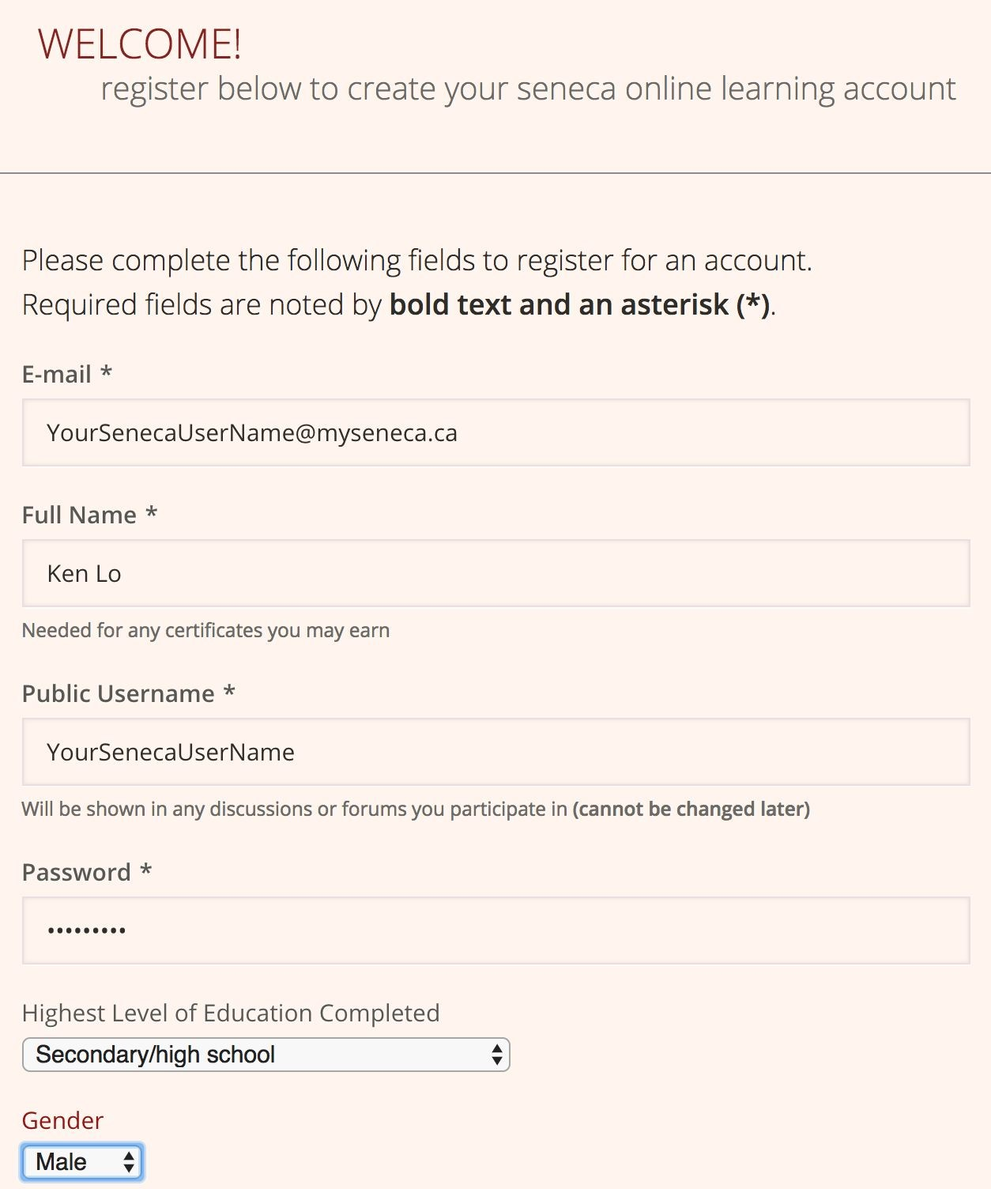

How ​ to​ ​ Register​ ​ for​ ​ Code​ ​ Online​

|  |  |  |
| --- | --- | --- |
| It is very important to use | YOUR SENECA USER | NAME for the registration process |

​​​​​​ ​​​​​ ​​ ​​ ​​ ​​​​​​ ​​

1. Open​ ​a​ ​browser​ ​type​ ​the​ ​URL​ ​address:

https://codeboard.io/

1. Click​ ​on​ ​“Sign​ ​up”​ ​on ​the​​ ​upper​ ​right​ ​corner

