Jongwoo Shim [260670012]

Comp 546 - Assignment 3

1. When using the square generating function as filter, and applying the noise function over them, for most thresholds you get a blurred image composed of the noise image. However at ~300 threshold you start to be able to see the original filter, but setting it to any other threshold would result in the original filter being invisible. This is due to the fact that the threshold is set too low then too much of the original noise is passed, however if the threshold is set too high then there are not sample for the original filter to show.

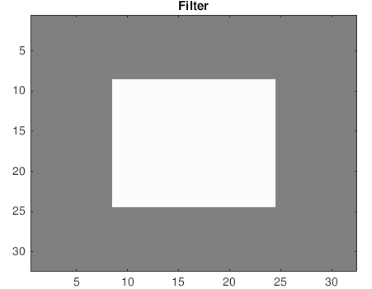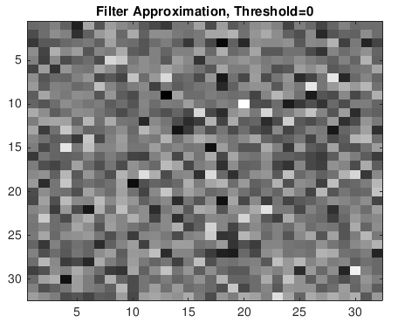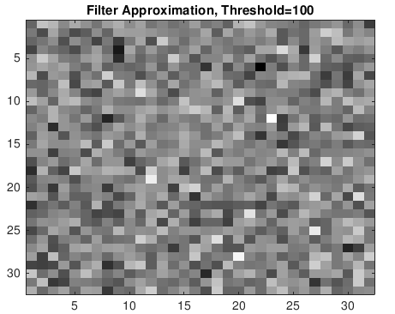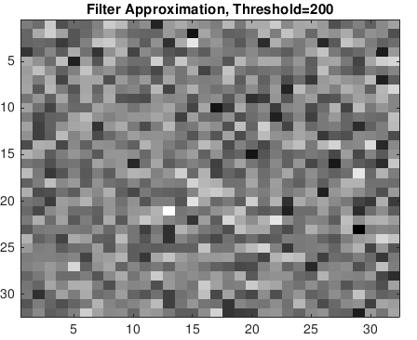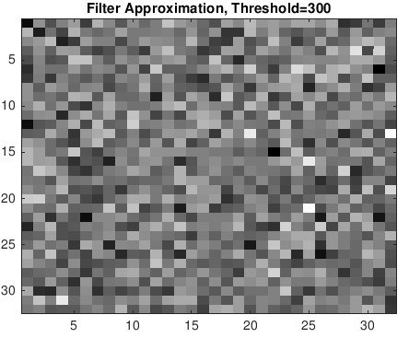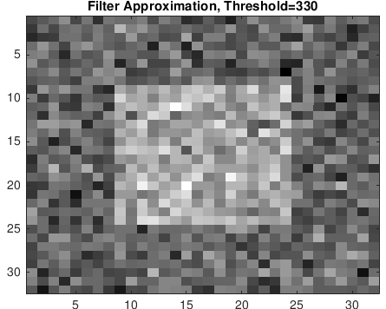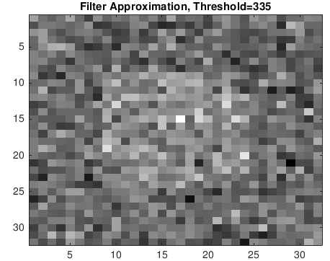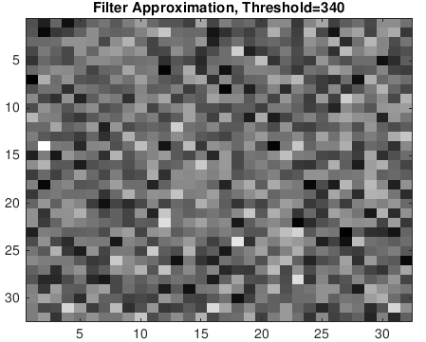

1. When sin waves are added to random signals, they result in spikes in the frequency domain. If we were to have a sin wave with a large amplitude, the max(abs(fft(I))) will always be larger then that of the mean(abs(fft(I))), regardless of the frequencies at which spikes actually occurred; resulting in a constant threshold throughout multiple frequencies, as seen with the ideal observer. Whereas the Gabor Observer's sensitivity spikes at the frequency of 20, matching the Gabor function that it is observing. This can be explained through the fact that Gabors produce the largest responses when cross-correlated with a signal of the same sign in the overlap region; meaning that the Gabors are most sensitive when the sin used matches the frequency of the signal.
2. \*\*\*The derivation will be attached on a pdf\*\*\*

Using matlab to generate the graphs demonstrate that they did match the lowpass/highpass functions, with the x-axis representing x values and the y-axis representing the y values. The first image being N = 8, to test the lowpass function and the 2nd/3rd images representing a non-ideal high pass function with N = 64.

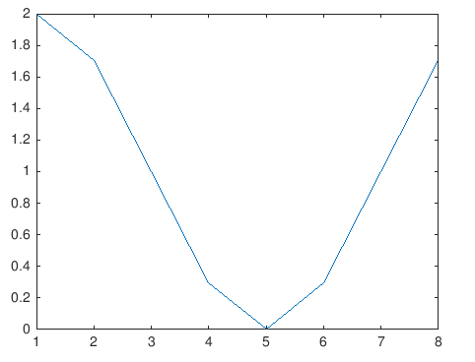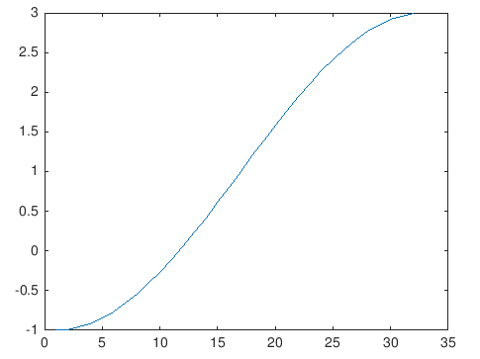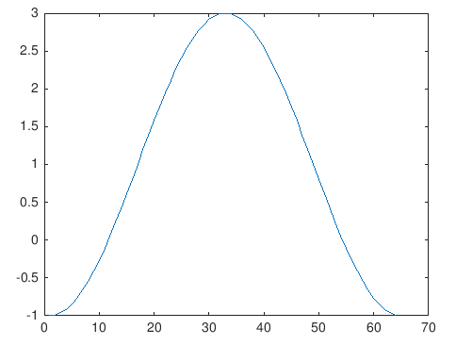

1. Setting the wavelengths of the sine signal to greater N, resulted in these graphs, which demonstrates the second convolution theorem, F{f•g} = F{f} \* F{g}. The graph of the sin function show two peaks when applied through the Fourier transformation, while the graph of the cos passed through the Fourier transformation demonstrates a negative amplification. And when passing the overlap of the cosine and the sine function over one another through the Fourier transformation you get a reduced absolute amplitude due to the negative amplification of the F(cos). The graph of the (Sin \* Cos) function demonstrating that the cos window reduces the artifact by removing the edges of the image boundaries. While in theory, due to the convolution theory of Fourier transformation theory, you should get the same result between the 5th graph and the 6th graph, the frequencies at which the peaks occur do not match, while the overall shapes remains the same. Which shows that although the theorem is not perfectly matched, the overall form of the Fourier transformation remains.

On the other end of the spectrum setting the values to be lower then N, demonstrates no removal of the artifacts as they do not exist in these images.

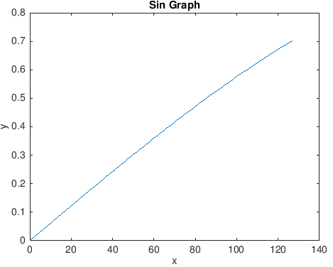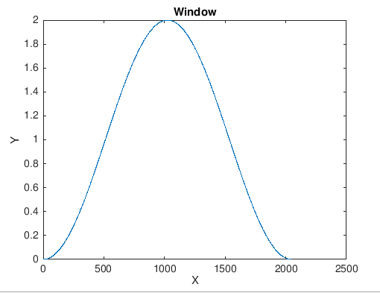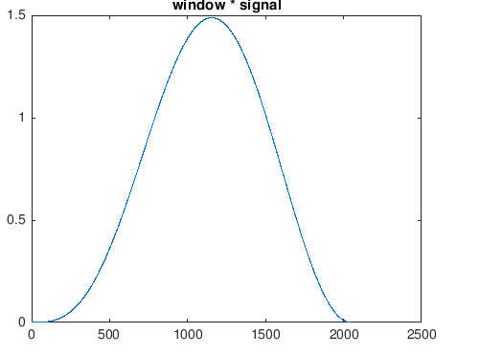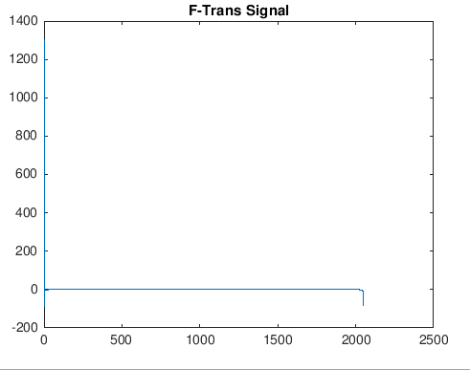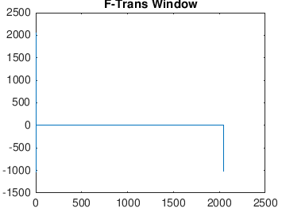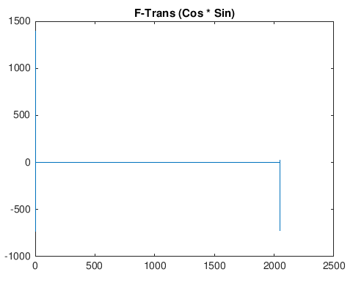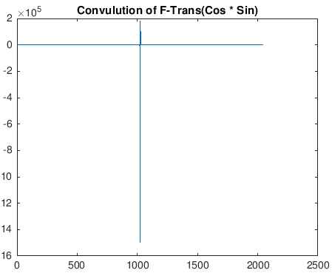

1. \*\*\*Proof will be attached on a pdf \*\*\*
2. For all 4 of the Fourier Transformation models of the sound files, experience an initial negative or neutral curve before rapidly increasing in amplitude. This is most likely due to the sound files having a slight break before starting to pick up the intended sounds, picking up either background noises or no sound at all. With the spectrograms of the images with the samplesPerBlock/freqPerBlock being set to 256, a very high temporal resolution and low spatial resolution can be observed. Which result in detection of frequencies but not the precise time periods in which they had occurred. When upping these variable values to 16348, we get the reverse effect of low temporal resolution and high spatial resolutions. Showing exactly where certain frequencies were detected but not where in the temporal domain they are.   
   The first 6 images, being the detection of vowels('a'/'e') demonstrate that only specific frequencies exists in these sound bites. While looking at the high frequency resolution spectrograms show the existence of horizontal bands/glottal pulses of vowels. While the last two demonstrate a much more results, having clusters of varying frequencies, which is also reflected in both versions of their respective spectographs.

