Code Smells Identified
Shotgun Surgery
In this package, the class /jabref/src/main/java/org/jabref/migrations/PreferancesMigrations.java has multiple strings with the same value. If there is a change of one string, it is inconvinient to search all the strings with the same value and change.
Possible Solution:
If possible, create constants, enumerators to store all the strings with the same value and/or functions to adapt the current solution.
Examples: Image 1 and 2.
Feature Envy
In the previous class has functions that focus on manipulating data of other classe rather than itself.
Possible Solution:
Reduce the amount of method calls by moving the current methods implementations pr creating new methods inside each class.
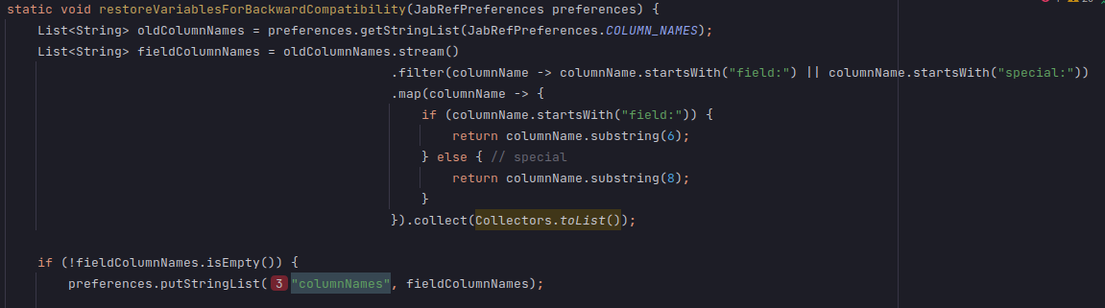
Examples:
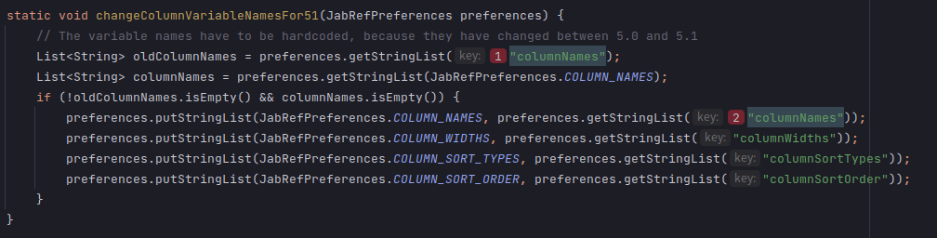

Innapropriate Intimacy
In the class /jabref/src/main/java/org/jabref/migrations/MergeReviewIntoCommentMigration.java has publics methods that calls and has access to private parts, such as variables and functions, of other classes.
Possible Solution:
Create new private functions that gets all the variables needed to the current method.
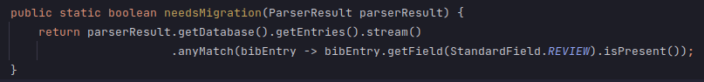
Example:

Cognitive Complexity
/**
* Determine whether there starts a special char at pos (e.g., oe, AE). Return it as string.
* If nothing found, return Optional.empty()
*
* <p>
* Also used by BibtexPurify
*
* @param c the current "String"
* @param pos the position
* @return the special LaTeX character or null
*/
public static Optional<String> findSpecialChar(char[] c, int pos) {
if ((pos + 1) < c.length) {
if ((c[pos] == 'o') && (c[pos + 1] == 'e')) {
return Optional.of("oe");
}
if ((c[pos] == 'O') && (c[pos + 1] == 'E')) {
return Optional.of("OE");
}
if ((c[pos] == 'a') && (c[pos + 1] == 'e')) {
return Optional.of("ae");
}
if ((c[pos] == 'A') && (c[pos + 1] == 'E')) {
return Optional.of("AE");
}
if ((c[pos] == 's') && (c[pos + 1] == 's')) {
return Optional.of("ss");
}
if ((c[pos] == 'A') && (c[pos + 1] == 'A')) {
return Optional.of("AA");
}
if ((c[pos] == 'a') && (c[pos + 1] == 'a')) {
return Optional.of("aa");
}
}
if ("ijoOlL".indexOf(c[pos]) >= 0) {
return Optional.of(String.valueOf(c[pos]));
}
return Optional.empty();
}
Located in jabref/src/main/java/org/jabref/logic/bst/BibtexCaseChanger.java
Problem: The cognitive complexity (Measurement of how hard to understand the control flow of a method is) present in this method is too high (value of 23 passing the default value of 15)
Refactor proposal:
Change type of c from “char[]” to “String[]”, which would represent all two character segments made from the “current string”, and use the String method “contains()” or “equalsIgnoreCase()” to check if each two character segment follows one of the mentioned patterns. If so, return that segment, otherwise return null if we reached the end of our string.

Excess Comments
// Comments from bibtex.web:
// sp_ptr := str_start[pop_lit1];
int i = 0;
// sp_end := str_start[pop_lit1+1];
int n = s.length();
// sp_brace_level := 0;
int braceLevel = 0;
// while (sp_ptr < sp_end) do begin
while (i < n) {
// incr(sp_ptr);
i++;
// if (str_pool[sp_ptr-1] = left_brace) then
// begin
if (c[i - 1] == '{') {
// incr(sp_brace_level);
braceLevel++;
// if ((sp_brace_level = 1) and (sp_ptr < sp_end)) then
if ((braceLevel == 1) && (i < n)) {
// if (str_pool[sp_ptr] = backslash) then
// begin
if (c[i] == '\\') {
// incr(sp_ptr); {skip over the |backslash|}
i++; // skip over backslash
// while ((sp_ptr < sp_end) and (sp_brace_level
// > 0)) do begin
while ((i < n) && (braceLevel > 0)) {
// if (str_pool[sp_ptr] = right_brace) then
if (c[i] == '}') {
// decr(sp_brace_level)
braceLevel--;
} else if (c[i] == '{') {
// incr(sp_brace_level);
braceLevel++;
}
// incr(sp_ptr);
i++;
// end;
}
// incr(num_text_chars);
result++;
// end;
}
// end
}
// else if (str_pool[sp_ptr-1] = right_brace) then
// begin
} else if (c[i - 1] == '}') {
// if (sp_brace_level > 0) then
if (braceLevel > 0) {
// decr(sp_brace_level);
braceLevel--;
// end
}
} else { // else
// incr(num_text_chars);
result++;
}
}
stack.push(result);
Located in jabref/src/main/java/org/jabref/logic/bst/VM.java
Problem: Multiple sections of code commented out, affecting the code’s readibility and understanding
Refactor proposal: Remove them from the source code and replace with comments that explain what logic is happening in this section. An overall comment explaining the first ever if and else should be enough to understand the code.

Long Parameter List
public CitationKeyPatternPreferences(boolean shouldAvoidOverwriteCiteKey,
boolean shouldWarnBeforeOverwriteCiteKey,
boolean shouldGenerateCiteKeysBeforeSaving,
KeySuffix keySuffix,
String keyPatternRegex,
String keyPatternReplacement,
String unwantedCharacters,
GlobalCitationKeyPattern keyPattern,
Character keywordDelimiter) {
this.shouldAvoidOverwriteCiteKey = shouldAvoidOverwriteCiteKey;
this.shouldWarnBeforeOverwriteCiteKey = shouldWarnBeforeOverwriteCiteKey;
this.shouldGenerateCiteKeysBeforeSaving = shouldGenerateCiteKeysBeforeSaving;
this.keySuffix = keySuffix;
this.keyPatternRegex = keyPatternRegex;
this.keyPatternReplacement = keyPatternReplacement;
this.unwantedCharacters = unwantedCharacters;
this.keyPattern = keyPattern;
this.keywordDelimiter = keywordDelimiter;
}
Located in jabref/src/main/java/org/jabref/logic/citationkeypattern/CitationKeyPatternPreferences.java

Problem: Constructor with too many parameters ( value of 9 parameters surpassing the default 7 allowed)

Refactor Proposal: Make a data class to either include all the booleans or all the Strings (or maybe both) to reduce the amount of global variables and parameters required for this method.
3 parameters for keySuffix, GlobalCitationKeyPattern and Character;
2 (5 parameters total with two data classes containing 3 variables each) if using a data class for all booleans and another for the Strings;
4 (7 parameters total with a data class containing 3 variables) if using only for booleans or strings;
1 (4 parameters total with a data class containing 6 variables) if using the data class for all booleans and strings.)

Long Class
java/org/jabref/gui/preview/CopyCitationAction.java: line 94-174

Problem: This class is doing more than it should. There should be an uniform way of formating citations to the various formats.

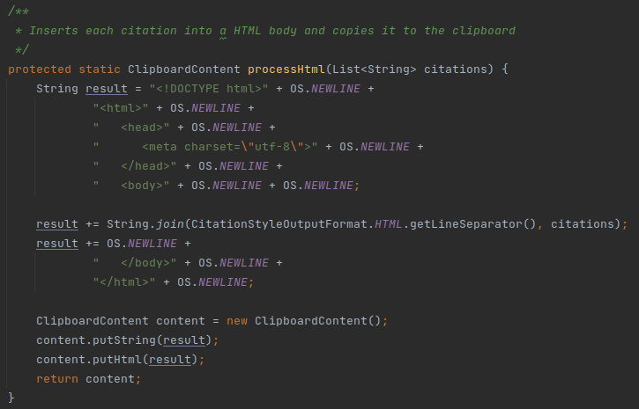
Refactoring Proposal: Extract the citation process methods on this class and place it in a suiting class the citationstyle package.

Switch Statement
java/org/jabref/gui/EntryTypeView.java: line 210-316
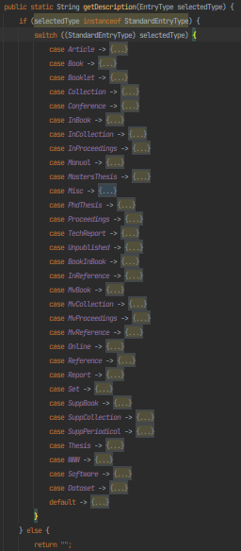
Problem: This switch statement iterates through all the values in the Enum. If we wanted to add a new type of entry, or remove one, we would need to refractor 2 classes.
Refractoring Proposal: Extract this method and add description as an instance variable in the StandardEntryType Enum.

Lack of constants
java/org/jabref/gui/fieldeditors/LinkedFileViewModel.java: lines 208, 226, 260, 312
Problem: The String “File not found” and “Could not find file ‘%0’.” can be found repeated throughout this class. This increases chances of creating inconsistencies.

Refractoring Proposal: Creating class constants for these Strings.

Long Parameter List

java/org/jabref/preferences/GuiPreferences.java: line 28-35
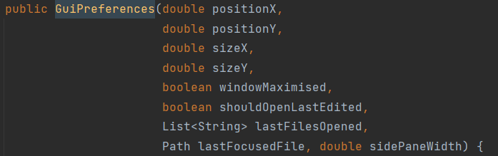
Problem: The constructor of this class has too many parameters (9 parameters, which is greater than the 7 authorized).

Refactoring Proposal: Create a new class which deals with the positionX, positionY, sizeX and sizeY and this code smell should be solved.

Inappropriate Naming
java/org/jabref/preferences/JabRefPreferences.java: line 146 and 413

Problem: Names should not differ only by capitalization.

Refractoring Proposal: change private Language language to private Language currLanguage.

Cognitive Complexity
java/org/jabref/preferences/JabRefPreferences.java: lines 747-789
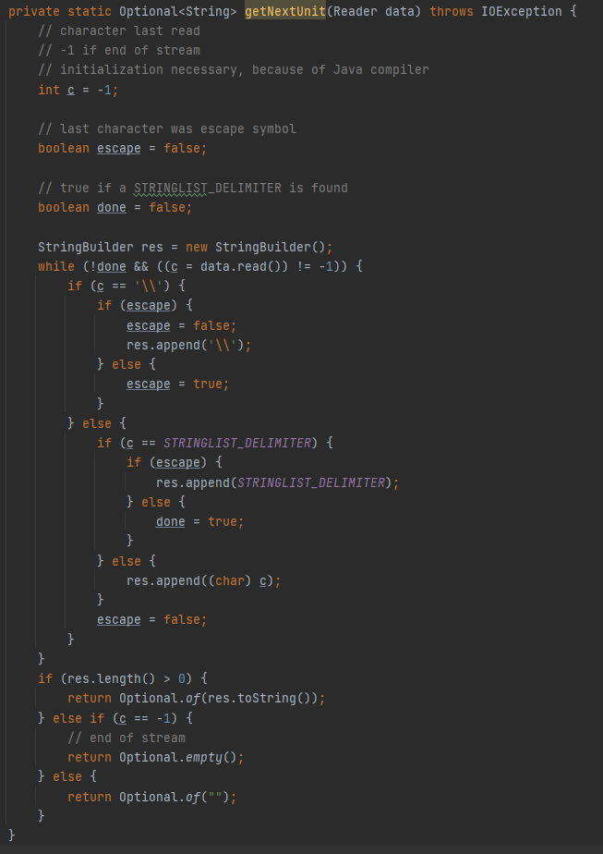
Problem: Method is too complex thus hard to maintain.

Refractoring Proposal: More comments should be added to better explain this method or it should be broken into smaller methods.

Long Method
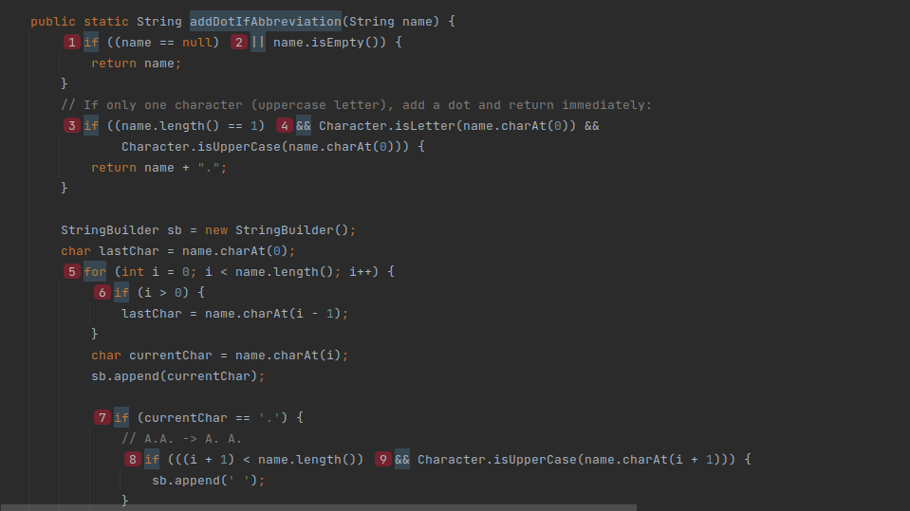
Located at src/java/org/jabref/model/author.java line 39 the method addDotIfAbbreviation
Problem: it’s 82 lines long and has a cognitive complexity of 41 (way above the default value of 15)
Refactor Proposal:
Split into several methods to reduce complexity and length. The inner code on the outer for (lines 52 to 117) could be moved to a new method that takes the input chars (currentChar and lastChar) and the String Builder. The same could then be done for the inner for loop (lines 99 to 116)

Long Class

Located at src/java/org/jabref/model/entry/BibEntry.java
Problem: Class spans over too many lines, over 1000, and provides too many methods
Refactor proposal:
Create a new class BibEntryFields that stores the fields for the BibEntry and provides all related functionality, allowing to remove responsibility and methods from BibEntry.java
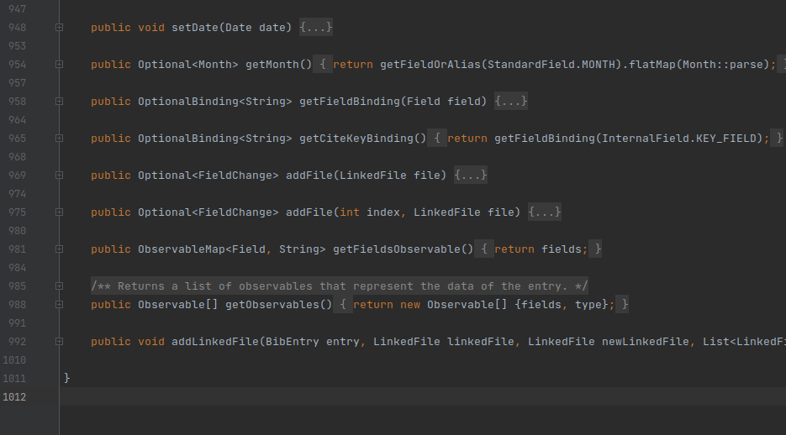

Duplicated Code
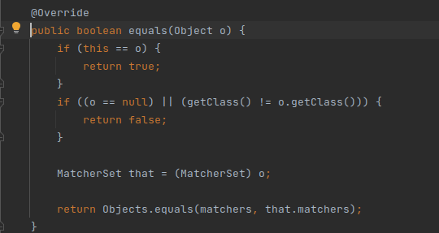
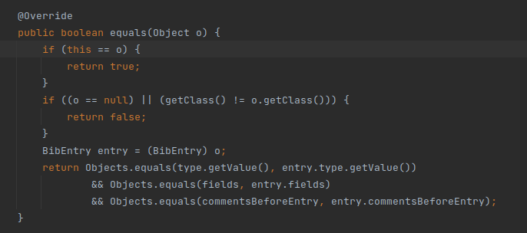
Location: src/main/java/org/jabref/model/search/matchers/MatcherSet.java, src/java/org/jabref/model/entry/BibEntry.java and several other places
Problem: This segment of the equals method has similar duplicates many times across the code. This could be an issue if another generic case needs to be considered which would alter the result or allow a faster matching.
Refactor Proposal:
Extract the common part of the method to a static method and pass the non common part of the verification as a lambda

Design Patterns Identified

These are some of the design patterns that can be identified throughout the project.

Factory

1. src/main/java/org/jabref/model/entry/field/FieldFactory.java

This class hides the logic of creating a Field or set of Fields by providing a single access point for their creation.

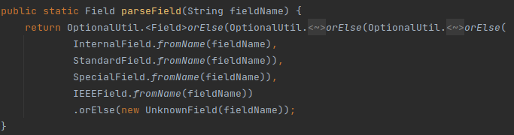Figure 1: Creating a single field from its name
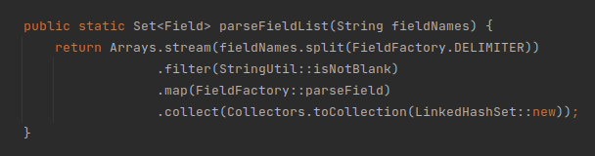Figure 2: Creating multiple fields from their name

2. src/main/java/org/jabref/model/entry/types/EntryTypeFactory.java

This class hides the logic of creating an EntryType by allowing the user to create one from a single String.
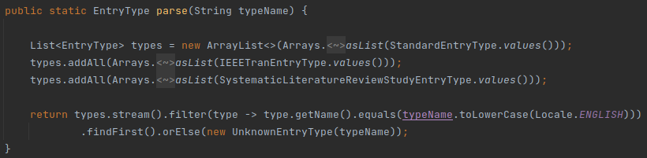Figure 3: Create a single EntryType from its type name
3. java/org/jabref/gui/actions/ActionFactory.java

This class allows the user to create various JavaFX components associated with actions without having to worry about the actual process of creation or association.
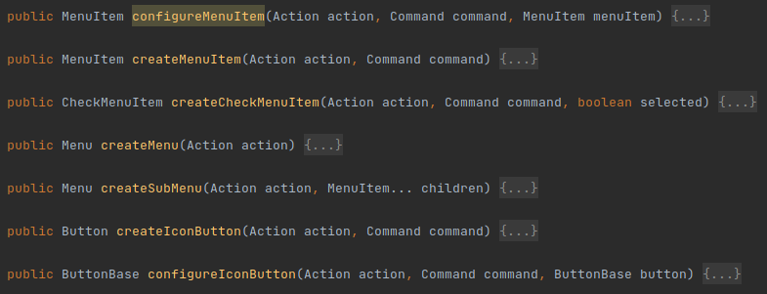Figure 4: Methods for creating different JavaFX components associated with actions
Strategy

1. src/main/java/org/jabref/gui/autocompleter

The AutoCompletionStrategy provides a template for solving an auto completion problem.
In this package we can also find problem solvers, like AppendWordsStrategy, AppendPersonNamesStrategy and ReplaceStrategy.
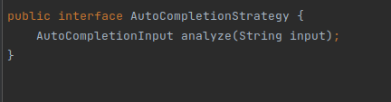Figure 5: Template for a problem solver algorithm
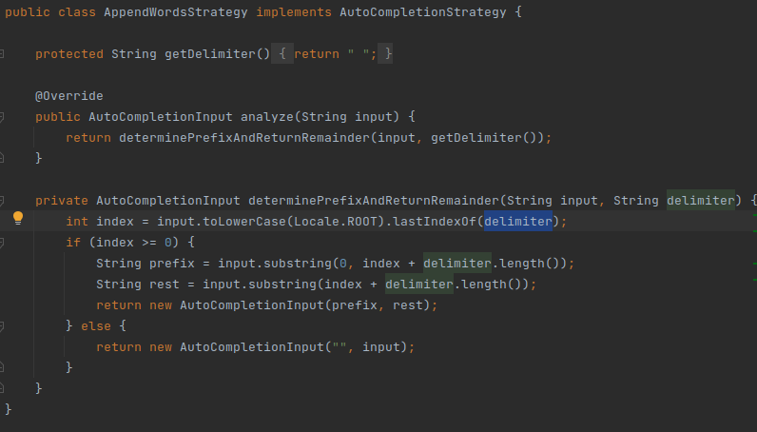Figure 6: AppendWordsStrategy, an algorithm to solve the problem
Proxy

1. java/org/jabref/logic/bst/PurifyFunction.java

This class only does error checking and the actual work is done by BibtexPurify. This is a protection proxy.
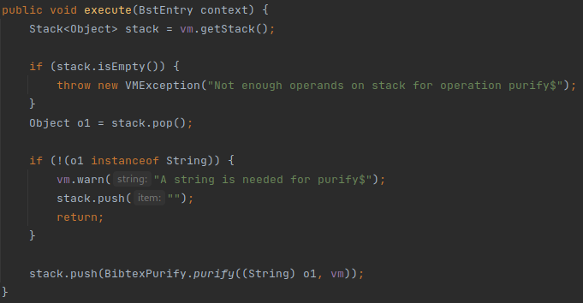Figure 7: Protecting BibtexPurify from receiving invalid arguments
2. java/org/jabref/logic/citationstyle/CitationStyleGenerator.java

This class provides a protection proxy to a CLS_ADAPTER by protecting the user from uncatched exceptions.
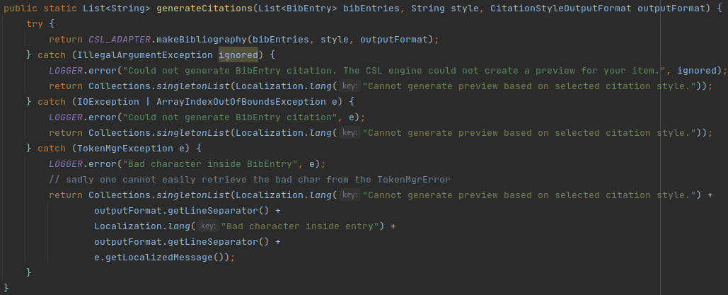Figure 8: Protecting the user from un-handled exceptions raised by the CLS

Singleton

1. java/org/jabref/logic/logging/LogMessages.java

This class provides a single access point, through the static method getInstance(), for the instance where error messages are stored.
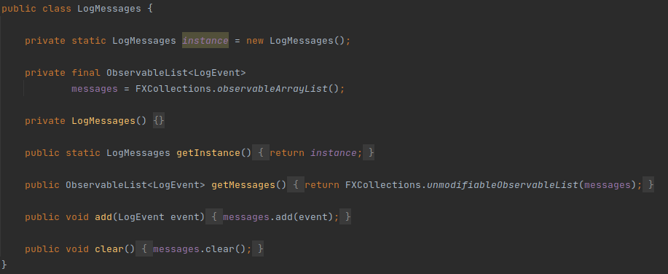Figure 9: LogMessages.java
2. java/org/jabref/preferences/JabRefPreferences.java

This class provides a global access point to a single instance, the constructor is private to ensure there is only one instance is created.
Figure 10: The only instance of JabRefPreferences

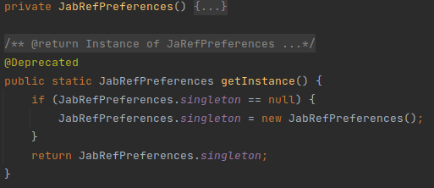Figure 11: Ensuring there only exists one instance

3. java/org/jabref/gui/externalfiletype/ExternalFileTypes.java

This class provides access to the available external file types.
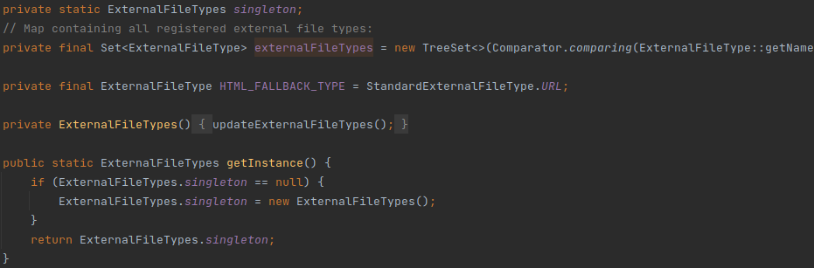Figure 12: ExternalFileTypes.java

Observer

1. java/org/jabref/model/model/database

The BibDatabase allows listeners to subscribe and unsubscribe from the eventBus, which acts like the Subject. In the same package KeyChangeListener represents the listener which gets notified of the events from the BibDatabase’s event bus and handles them accordingly.
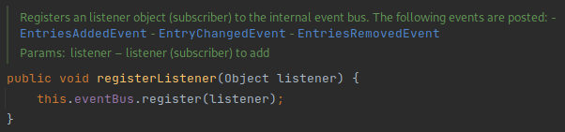Figure 13: BibDataBase.java registering listeners in the event bus
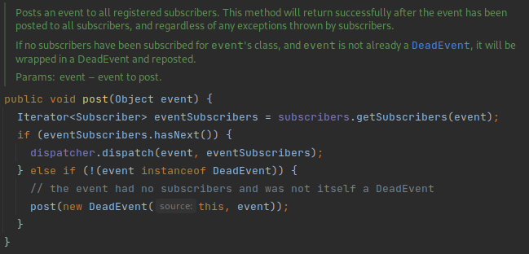Figure 15: EventBus.java forwarding the events to all the event subscribers
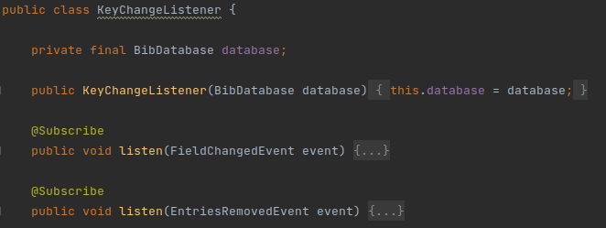Figure 14: KeyChangeListener.java listening for the events in the BibDatabase
2. src/main/java/org/jabref/model/util

The FileUpdateListener and FileUpdateMonitor match the observer and subject, respectively.
We can add and remove new observers by calling addListenerForFile(…) and removeListener(…) in the subject. The observer gets updated through the fileUpdated() method.
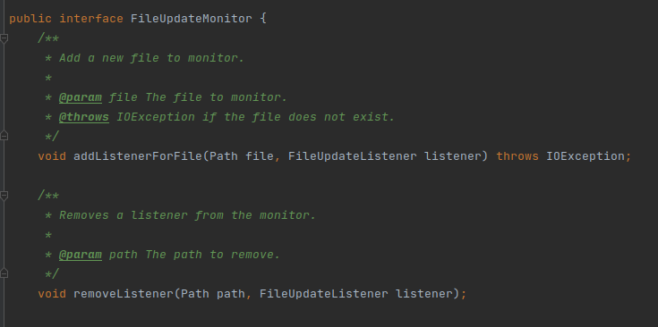Figure 16: FileUpdateMonitor.java registering listeners
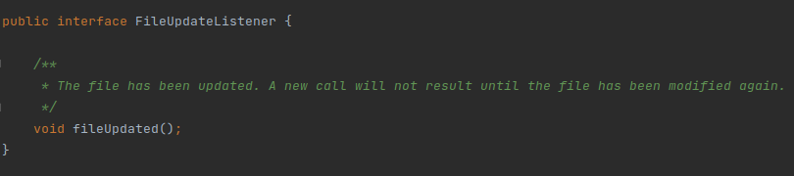Figure 17: FileUpdateListener

Builder

1. java/org/jabref/model/entry/BibEntryTypeBuilder.java
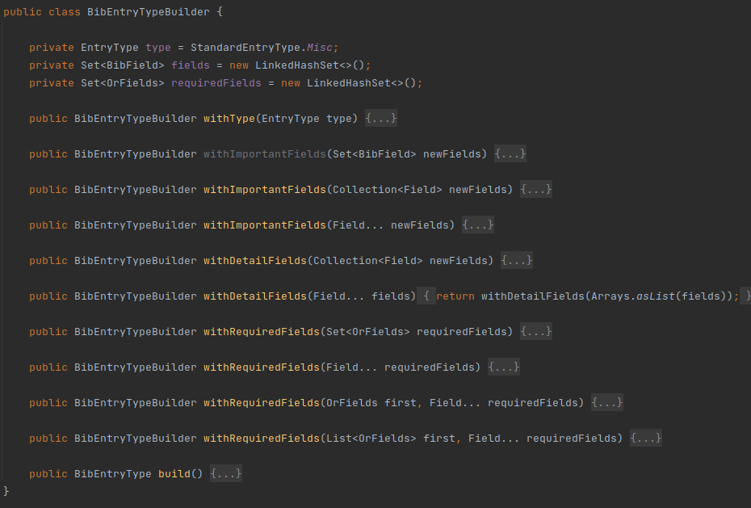Figure 18: BibEntryTypeBuilder.java
This class lets the user create a BibEntryType step-by-step, with all the required details.

2. java/org/jabref/preferences/PreviewPreferences.java

This class allows the user to build a PreviewPreferences class step-by-step.
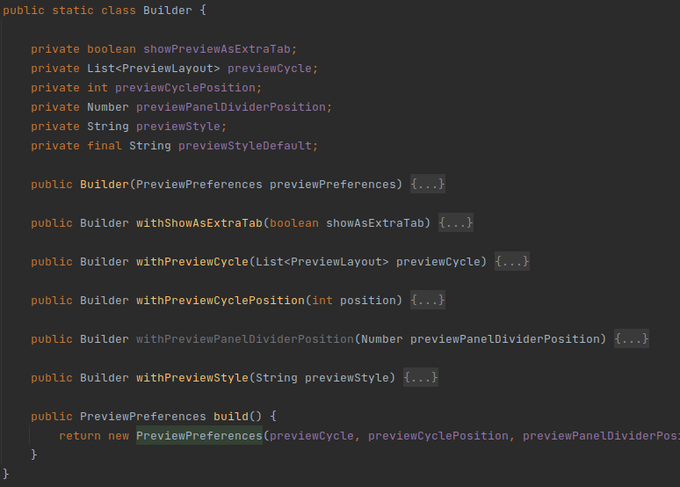Figure 19: PreviewPreferences.java

Facade

1. java/org/jabref/preferences/JabRefPreferences.java

Every preferece is stored inside JabRefPreferences which provides convenient access to a particular sub-preference. It knows where to direct the client’s request and how to operate.

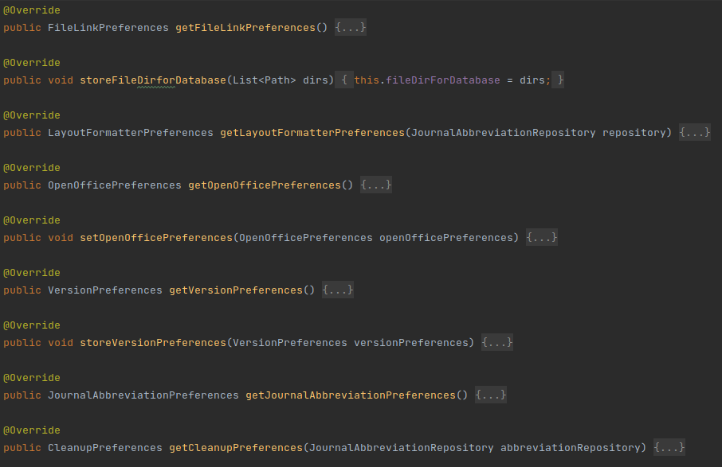Figure 20: Methods for acessing different preferences

Command

1. java/org/jabref/gui/actions/SimpleCommand.java

This class is an abstraction of a command that is executed by the actions of GUI elements, such as buttons. These actions provide normalized access to the Jabref low level functionalities.
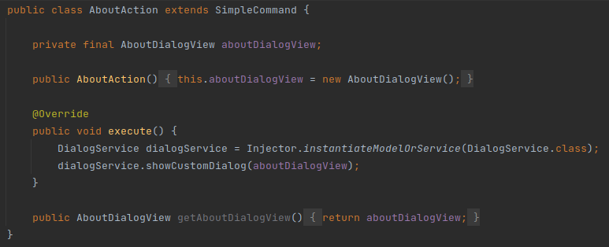
Figure 21: An action
Dependency Metrics
Before to analysis of the data collected of the dependency metric results, it is importante to understand the following keywords:
Cyclic: This metric is used to measure the number of dependency graphs that packages as nodes reach the same abstraction by following one or more paths forming a cycle.
Dcy: This metric is used to measure the number of abstract classes the current abstraction depends on.
Dcy*: This metric is used to measure the number of indirect dependency between class abstractions.
Dpt: this metric is used to measure the number of abstract classes that depends on the current class.
Dpt*: This metric is used to measure the number of abstract classes that depends indirectly on the current class.
PDcy: This metric is used to measure the number of packages that the current abstraction depends on.
PDpt: This metric is used to measure the number of packages that the current abstraction is used.

Troubleshooting possible cases
Most of the packages has a high Cyclic and Dcy* values (in this case, mosto f the classes has 784 value on Cyclic metric and 1337 value on Dcy* metric), meaning that most of the classes on this packages depends on each other and one change on one class, has the potencial to affect the other dependable classes, causing cascade of changes.
Some classes has high values on Dpt which means that this classes are used alot in many implementations of other classes.

Martin Package Metrics Report
I begin this report by first preseting the definitions of each parameter of the metrics to better explain what each thing represent in the project’s context then later show the possible troublesome spots in the project’s code due to the metrics results.
The definitions were gathered from

Definitions of the Parameters
Efferent Coupling (Ce) - This metric is used to measure interrelationships between classes. As defined, it is a number of classes in a given package, which depends on the classes in other packages. It enables us to measure the vulnerability of the package to changes in packages on which it depends.

The high value of the metric Ce> 20 indicates instability of a package, change in any of the numerous external classes can cause the need for changes to the package. Preferred values for the metric Ce are in the range of 0 to 20, higher values cause problems with care and development of code.

Afferent Coupling (Ca) - This metric is an addition to metric Ce and is used to measure another type of dependencies between packages, i.e. incoming dependencies. It enables us to measure the sensitivity of remaining packages to changes in the analysed package.
High values of metric Ca usually suggest high component stability. This is due to the fact that the class depends on many other classes. Therefore, it can’t be modified significantly because, in this case, the probability of spreading such changes increases.
Preferred values for the metric Ca are in the range of 0 to 500.
Abstractness (A) - This metric is used to measure the degree of abstraction of the package and is somewhat similar to the instability (later presented). Regarding the definition, abstractness is the number of abstract classes in the package to the number of all classes.

Instability(I) - This metric is used to measure the relative susceptibility of class to changes. According to the definition instability is the ration of outgoing dependencies to all package dependencies and it accepts value from 0 to 1.

According to Robert Martin, the optimal case would be that instability of the class is compensated by its abstractness, which satisfies the equation I + A = 1. Classes that were well designed should group themselves around this graph end points along the main sequence.

Normalized distance from Main Sequence (D) - This metric is used to measure the distance between stability and abstractness and is calculated using the formula
D = | A + I -1 |, where A is Abstractness and I is Instability.
This value should be as low as possible as it indicates it’s close to the main sequence. We should always avoid the two extreme situations which are:
A = 0 and I = 0, meaning that the package is extremely stable and concrete, meaning that it can’t be extended.
A = 1 and I = 1, most impossible as a completely abstract package must have some sort of connection to the outside, so that the instance that uses said functionalities of the package could be created.

Troubleshooting possible cases
The package “org.jabref.architecture” present values of 1 to both A and I parameters, meaning that it’s a completely abstract package with no connections to the outside.
The packages “org.jabref.logic.logging”, “org.jabref.logic.l10n” and many more present in the excel sheet present values of 0 to both A and I parameters, meaning that each package cannot be extended as it is very stable and concrete
Many of the packages present in the project dont satisfy the equation presented by Robert Martin (I + A = 1) for being an optimal package, for example the package “org.jabref.logic.preview”, with values of 1 for A and 0.02 for I, representing that the package may present unnecessary dependancy coupling.
7 of the jabref’s packages’ Ca values surpass the recommended maximum limit which is 500 (Them being “org.jabref.logic.cleanup”, “org.jabref.model.strings”, “org.jabref.model.openoffice.style”, “org.jabref.model.metadata”, “org.jabref.logic.layout”, “org.jabref.model.groups” and “org.jabref.gui.icon”), possible pointing out that the package is very dependant on many other classes so it can’t be modifed too significantly or it would cause the changes to spread towards other classes, more specific, a shotgun surgery code smell.
There’s way too many packages in the project that surpass the recommended maximum value of Ce (default value being 20), causing them to be instable as a change in other external classes that make use of the package may cause changes to said package, again, possible shotgun surgery, innapropriate intimacy and feature envy code smells may be present in these packages.
Many of the packages dont present a very low value of D, meaning that they are very far from the main sequence of code due to the lack of proportionality between the value A and I.

MOOD Metrics Report

The MOOD (Metrics for Object-Oriented Design) metrics are a set of metrics which includes:
Atribute Hiding Factor (AHF): The obscurity (contrary of visibility) of the attributes of a class. Public attributes are visible to all classes inside their class’s package and protected attributes are visible to all subclasses.
Attribute Inheritance Factor (AIF): How many of a class’s fields can be inherited.
Coupling Factor (CF): Dependencies per class (includes super classes).
Method Hiding Factor (MHF): The obscurity of the methods of a class. For public methods it’s assumed they are visible to all classes inside their class’s package and for protected it’s assumed they are visible to all subclasses.
Methond Inheritance Factor (MIF): How many of the non-overriden methods of a class are available from an inherited class.
Polymorphism Factor (PF): How much polymorphism is used. This is calculated by dividing the number of overriding methods by the number of potential overrides in the subclasses.

Analysis

With this information we can take closer look into the collected metrics and take some conclusions.
For the values in the architecture, CLI, migrations, preferences and stylestester packages it meets our expectations.
CLI is mostly a proxy package to other packages so the coupling factor will naturally be high, the same for migrations, preferences and styletester.
The packages we should be worried about are the gui, logic and model, as these are the areas of most intese traffic in our application and as such we want to make sure that there isn’t evidence of any code that could introduce bugs in the future. These packages are also the ones that reflect the most on the overall metrics for the project.

Trouble Spots

Unwanted Visibility: Usually for AHF we wan’t values close to 100%, but all around the project we can see that AHF is really low which could indicate a huge problem with visibility. With high visibility comes the possibility for tampering with instance variables which could alter the flow of the program in unexpected ways. If this does reveal to be a problem the first package we should look into is model, as it handles critical data and has one of the lowest AHF.

According to this metric set, there doesn’t seem to be any other trouble spots on the project, although, as mentioned previously, there are some packages with high coupling factor and it could be worth looking into a different way of implementing the functionalities of these packages without such high coupling.

Complexity Metrics
MetricsReloaded Plugin

Complexity metrics are measured based on cyclomatic complexity. The complexity of a module is the number of independent cycles in the flow graph (all the paths that can be traversed during a program execution). This metric correlates complexity with maintenance effort, meaning the more complex a module is the harder it is to maintain.

package | Average Cyclomatic Complexity | Total Cyclomatic Complexity
 | 2,01 | 595
  org.jabref.gui
 | 1,18 | 13
  org.jabref.logic
 | 2,56 | 100
  org.jabref.migrations
 | 1,96 | 106
  org.jabref.model
 | 1,44 | 511
  org.jabref.preferences

According to this table, on average every package has only 2 independent paths except for preferences and logic that have 1 path.

Cognitive Complexity
This complexity tells us how hard it is for a person to understand a method.
The package with the most cognitive complex methods is java/org/jabref/logic such as the one located in jabref/src/main/java/org/jabref/logic/bst/BibtexCaseChanger.java which the team has already pointed out in the code smells.

Essential Cyclomatic Complexity
This complexity shows how much complexity is left once we have removed the well structured complexity (i.e. a for loop which we know when it is going to finish). Methods with lower Essential complexity are easier to break into smaller methods, on the other hand methods with higher Essential complexity are more difficult to understand, maintain and test.
Gui and Logic are the packages with higher values of Essential Complexity. The method org.jabref.gui.fieldeditors.FieldNameLabel.getDescription(Field) has the highest Essential complexity because it has a big case with many returns in it.

Design Complexity
The Design Complexity is related to how interlinked a methods control flow is with calls to other methods.
The packages Gui and Logic have the most methods with the highest Design Complexity meaning it is harder to understand at once their interconnections. org.jabref.logic.importer.fileformat.RisImporter.importDatabase(BufferedReader) is the method with the worst design because it is long and calls many other methods, having many interconnections.

Cyclomatic Complexity
This complexity calculates how many independent paths there are in a method, thus how many tests are necessary.
Once again, Gui and Logic are the packages with the highest complexity. org.jabref.logic.layout.format.RTFChars.transformSpecialCharacter(long) is the method with the highest complexity due to the amount of ifs there are that increment the number of independent paths

In conclusion, the packages Gui and Logic are the ones with methods that have the highest complexities, therefore the ones we should focus on improvements.

Chidamber Metrics

For this analysis the metrics for System B on the NASA Study¹ will be used as reference values.
CBO – Coupling Between Object Classes
org.jabref.model.entry.BibEntry has the highest value of 616 for this metric which highly exceeds the reference maximum. The reason behind this is that BibEntry is a super class with over 1000 lines being the central object of the application. This class probably holds too much responsibility and should be split into smaller classes which handle certain aspects of a BibEntry. The overall average for this metric of 13.33 is still way above the reference value of 1.25, which indicates excess of class responsibilities is most likely common across the project.
DIT – Depth of the Inheritance Tree
org.jabref.gui.util.RadioButtonCell, org.jabref.gui.groups.GroupDialogView.IkonliCell and org.jabref.gui.commonfxcontrols.CitationKeyPatternPanel.HighlightTableRow all have the same highest DIT of 9, a little bit above our reference maximum of 4. However, these classes inherit classes on external libraries, therefore having little significance for the project’s quality.
LCOM – Lack of Cohesion of Methods
org.jabref.model.strings.StringUtil has the highest value of LCOM however being an util class with nothing but static methods that provide extended functionality over the Java String class this is to be expected and not necessarily an issue. However org.jabref.gui.util.NoSelectionModel has the second highest LCOM value of 15. This happens because the entire class is composed of empty methods, therefore there is no correlation between any methods. While this is not the type of issue this metric is meant to locate, a class which does not implement the methods of their super class signals that there may be a bad design, in this situation perhaps Disabling selection should be handled with the use of an optional variable rather than an empty class.
NOC – Number of Children
org.jabref.gui.actions.SimpleCommand has the highest NOC of 80, which is also way above our reference maximum of 21. This is because this class provides the basic functionality for a command and therefore has methods which gets reused often. However it may be possible that some subclasses could be grouped under other subclasses to reuse even more code. This would reduce the NOC for SimpleCommand.
RFC – Response for a class
org.jabref.preferences.JabRefPreferences has the highest RFC value of 543. This is however bellow the reference maximum of 827. The high value is due to the fact JabRefPreferences handles all the preferences classes, therefore interacting with those classes often.
WMC – Weighted Methods Per Class
org.jabref.preferences.JabRefPreferences also holds the highest WMC of 272, although this is also lower than the reference maximum of 381. As explained for the RFC, JabRefPreferences handles logic for all the preferences in the application, which results in a large number of methods.
References:
¹Laing, V. and C. Coleman. “Principal Components of Orthogonal Object-Oriented Metrics.” (2001).
Use Cases

These are the use cases we created for some generic uses of the JabRef tool.
Name | Search articles
ID | SEARCH_ARTICLES
Description | The user wants to search the web for articles on a topic.
Primary Actors | User
Secondary Actors | CCSB, MathSciNet, Crossref, Inspire, IEEEXplore, Springer, ACM, GVK, CiteSeerX, Medline, NASA ADS, DBLP, arXiv, JSTOR, DOAJ, Google Scholar, zbMATH Open
Pre-conditions | - The application must be running  - A library must be selected  - There must be an internet connection
Main Flow | 1. The use case begins when the user executes the Web Search action.  2. The use case ends when the article database replies with matching articles.
Post-conditions | The list of articles is presented to the user.

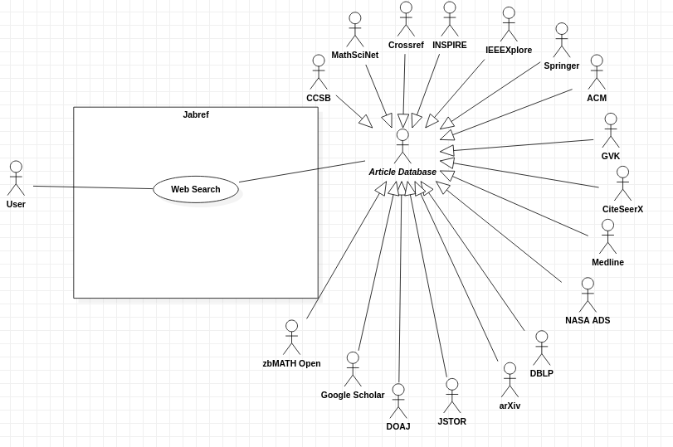
Search Article
Create a Library
Name | Create a new library
ID | CREATE_LIB
Description | The user wants to create a new library to store entries.
Actors | User
Pre-conditions | There are no pre-conditions associated with this use case, besides the application to be running
Main Flow | 1. The use case begins when the user executes the new library action.  2. The use case ends when a new database is created
Post-conditions | The library is added to the jabref frame and the user can add entries to it.
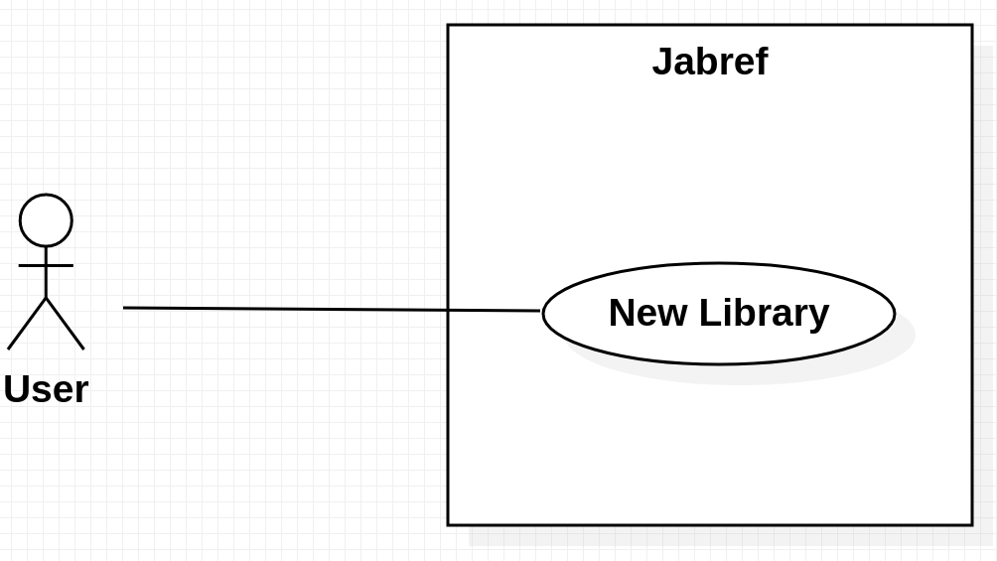

Insert an Article into a Library

Name | Insert an article into a library
ID | INSERT_ARTICLE
Description | The user wants to insert an article into a library.
Actors | User
Pre-conditions | The user must have selected a library.
Main Flow | 1. The use case begins when the user executes the new entry action.  2a. If the user wants to manually add an article, it goes to insert entry action.  2b. Use case ends when the user reaches the insert article action.  3. If the user wants to import a local file representing an article, it goes to import file to Library action and ends.  4. If the user wants to insert an article using text only, it goes to insert plain text action and ends.  5. If the user wants to import a file from the internet, it goes to import file from Web action then finishes when it reaches the web search action.
Post-conditions | The article has been created and inserted into the selected library.

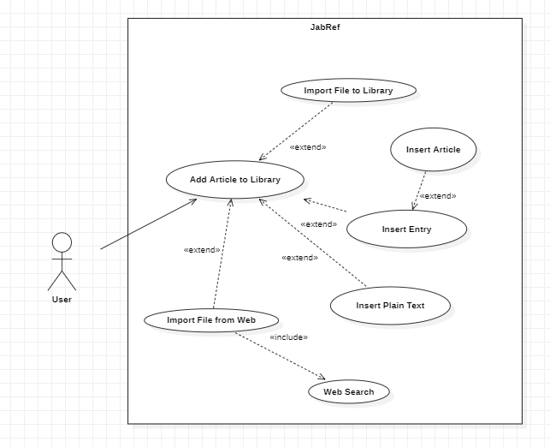
Remove an Article from a Library

Name | Remove an article from a library
ID | REMOVE_ARTICLE
Description | The user wants to remove an article from a library
Actors | User
Pre-conditions | User must have selected an article in a library.
Main Flow | 1. The use case begins when the user chooses an article from a library.  2. The user goes to Delete Entry action.  3. The use case ends when the user confirms the deletion of the selected entry or aborts the delete action and then finishes.
Post-conditions | The selected article has been removed from the library.
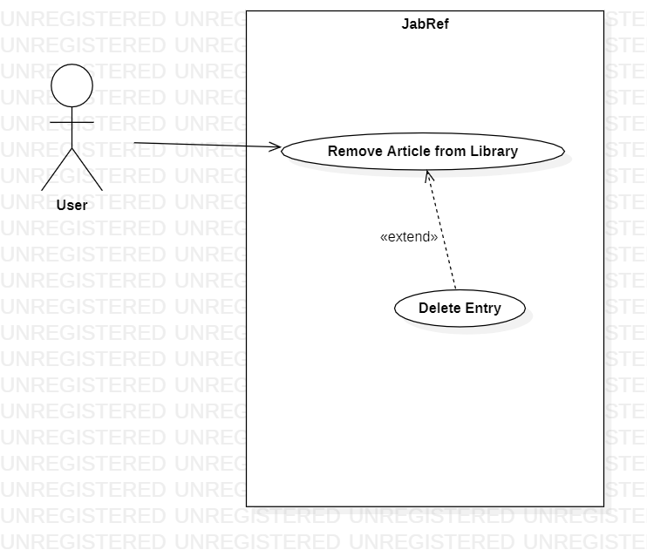

Export a Library to Tex

Name: | Export the library to Tex.
Id: | EXPORT_LIB_TO_TEX_0
Description: | The current user would want to export the current saved application file to LaTex file format.
Actors: | User
Pre-conditions: | User must have a file with atleast 1 entry
Main flow: | 1. The use case begins when the user creates a new application file or imports a existing one.  2. The user save the current file.  3. The system exports the application file located in a chosen path by the user.  4. The use case ends when the file is written.
Alternative flow: | None
Post-conditions: | A file with the result of the export was created in the path chosen by the user.
