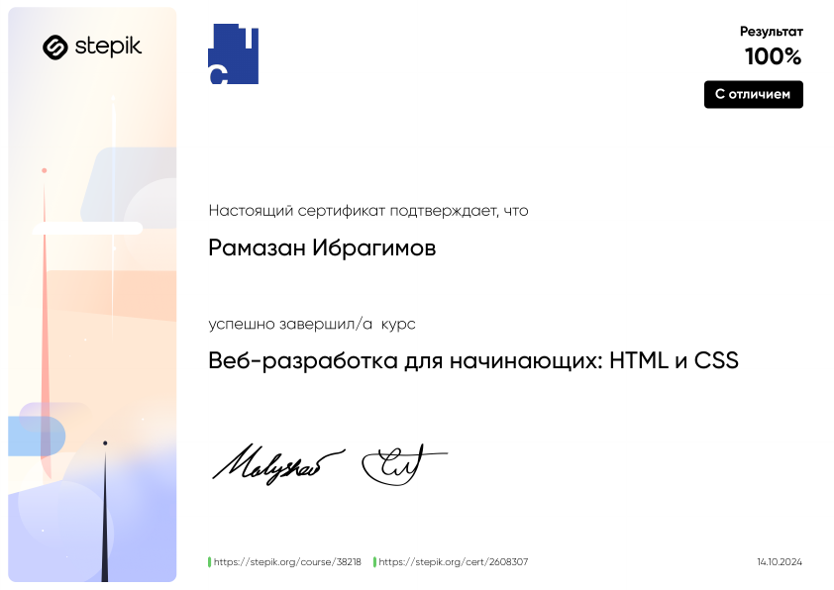

https://stepik.org/cert/2608307

