[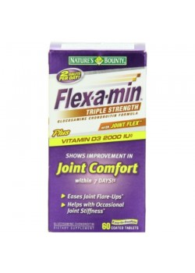](http://petocart.com/image/cache/data/27JAN/ABSB002DW907M-500x500.jpg)

**Nature's Bounty Flex-a-Min Triple Strength, 60 Tablets**

Brand: [Nature's Bounty](http://petocart.com/index.php?route=product/manufacturer/info&manufacturer_id=2531)  
SKU: ABSB002DW907M  
Only 5 Left In-stock.

Price: $12.87 + $3.95 shipping.

Qty: 

[Description](http://petocart.com/#tab-description)

|  |  |
| --- | --- |
| Nature's Bounty Logo | **Flex-a-min Triple Strength Joint Flex Formula with Univestin** 60 Tablets |
| border | |
| |  |  |  |  |  | | --- | --- | --- | --- | --- | | |  | | --- | | Nature's Bounty Flex-a-min Triple Strength Joint Flex Formula with Univestin (60 Tablets)**Flex-a-min Triple Strength** | | |  | | --- | | * Ingredients provide joint comfort by helping to support the joint matrix, build strong bones, and nourish cartilage and connective tissue.\* * Formula helps support the health of your immune system with 2000 IU of vitamin D3 per serving.\* * Individual results may vary. | | | At a Glance | |   Nature's Bounty Flex-a-min Triple Strength Glucosamine Chondroitin Formula with Joint Flex plus Vitamin D3 + MSM takes joint care science to the next level.\* This proprietary blend combines traditional ingredients with the joint-focused antioxidant power of Aflapin.  bullet**Flex-a-min**  Flex-a-min nourishes your joints and promotes healthy cartilage formation.\* Keeping your joints healthy is important--the joint support system is responsible for providing shock absorption and support for your internal structure. With the highest quality joint-care ingredients, including glucosamine HCl, Univestin, chondroitin, MSM, hyaluronic acid, vitamin D, and many more, Flex-a-min gives you the nutrients your joints need to move freely and comfortably.\* | |
| border | |
| Bone and Jointbullet**Bone and Joint**  All of us have probably experienced occasional joint stress or stiffness due to exercise, everyday activities and the natural aging process. Nature's Bounty bone and joint support supplements provide the nutrients responsible for joint mobility and flexibility and help to maintain bone strength and well-being.\* | |
| border | |
| bullet**Nature's Bounty: Quality You Can Count On**  Health-conscious people have trusted Nature's Bounty for decades. Our dedication to quality, consistency, and scientific research has resulted in vitamins and nutritional supplements of unrivaled excellence. By combining the latest breakthroughs in nutritional science with the finest ingredients, Nature's Bounty is proud to provide you with supplements of unsurpassed quality and value.  Nature's Bounty supplements are overseen by scientists, manufacturing specialists, and quality experts, each one dedicated to maintaining the highest quality standards. As part of a commitment to quality, Nature's Bounty only uses ingredients from suppliers that meet stringent Quality Assurance Standards, as well as GMP food quality standards. Every Nature's Bounty product is subjected to numerous quality tests and assays throughout the manufacturing process to verify purity and full potency. | |
| border | |
| bullet**What's in the Box**  Nature's Bounty Flex-a-min Triple Strength Joint Flex Formula with Univestin (60 Tablets). | |
| |  | | --- | | \*These statements have not been evaluated by the Food and Drug Administration. This product is not intended to diagnose, treat, cure, or prevent any disease. | | |

"  
**Features :** Easy to swallow coated tablets   
**Size : 60**  
**Product dimensions : 1.9x4.7x2.4 inches**  
**Product weight : 0.35 pounds**

# ove Free Joint Health Glucosamine Chondroitin Plus MSM & Vitamin D3, Tablets 80 ea

http://www.drugstore.com/img/spacer.gif[Schiff Move Free Joint Health Glucosamine Chondroitin Plus MSM & Vitamin D3, Tablets rates 4.5 out of 5 stars, from 5 customer reviews.(5)](http://www.drugstore.com/schiff-move-free-joint-health-glucosamine-chondroitin-plus-msm-and-vitamin-d3-tablets/qxp207668?tab=1#TblTabStrip)

[read reviews](http://www.drugstore.com/schiff-move-free-joint-health-glucosamine-chondroitin-plus-msm-and-vitamin-d3-tablets/qxp207668?tab=1#TblTabStrip) | [write a review](http://www.drugstore.com/products/writereview.asp?pid=207668&trx=29907)

[suggested:](http://www.drugstore.com/pricing.asp?catid=21620&trx=29364&trxp1=183281&trxp2=207668&trxp3=1) ~~$29.99~~

our price: $27.99$0.35 / ea

save 7% ($2.00)

in stock

Top of Form

special offers

[Click & Save: Buy 1 Schiff Move Free supplement & get the 2nd 50% off](http://www.drugstore.com/user/promo.asp?code=74D6BE6F&trx=29984&trxp1=180200&trxp2=4)

|  |  |
| --- | --- |
| /img/sites/0//autodelivery/pdetails-new-tag.gif | Auto-Reorder & Save: Get 10% off or more on all future shipments of this item. [learn more »](javascript:OpenOverlay('317752','overLay');) |

ship this item

Bottom of Form

Top of Form

quantity: 



[Save to your list™](http://www.drugstore.com/your-list/qxc10782?product=207668&catid=183281) »

Bottom of Form

|  |  |  |  |
| --- | --- | --- | --- |
| |  |  | | --- | --- | | Promos | product details-Tab | | |
| http://www.drugstore.com/img/spacer.gif | |  |  | | --- | --- | | ingredients | ingredients-Tab-Selected | | |

|  |  |  |  |
| --- | --- | --- | --- |
| http://www.drugstore.com/img/spacer.gif | |  |  | | --- | --- | | Reviews_Page_ | reviews-Tab | |

|  |  |  |  |
| --- | --- | --- | --- |
| http://www.drugstore.com/img/spacer.gif | |  |  | | --- | --- | | Directions | directions-Tab | |

|  |  |
| --- | --- |
| http://www.drugstore.com/img/spacer.gif |  |
| Facts: | |
| |  |  |  |  |  |  |  |  |  |  |  |  |  |  |  |  |  |  |  |  |  |  |  |  |  |  |  |  |  |  |  |  |  |  |  |  |  |  |  |  |  |  |  |  |  |  |  |  |  |  |  |  |  |  |  |  |  |  |  |  |  |  | | --- | --- | --- | --- | --- | --- | --- | --- | --- | --- | --- | --- | --- | --- | --- | --- | --- | --- | --- | --- | --- | --- | --- | --- | --- | --- | --- | --- | --- | --- | --- | --- | --- | --- | --- | --- | --- | --- | --- | --- | --- | --- | --- | --- | --- | --- | --- | --- | --- | --- | --- | --- | --- | --- | --- | --- | --- | --- | --- | --- | --- | --- | | |  |  |  | | --- | --- | --- | | **Supplement Facts** | | | | Serving Size: | 2 Tablets | | | Servings Per Container: | | 40 | |  | | | | **Amount per Serving** | | % Daily Value | |  | | | |  | | | | **Vitamin D** as Cholecalciferol | 2000 IU | 500 | |  | | |  |  |  |  | | --- | --- | --- | |  | | | | **Glucosamine Hydrochloride** | 1500 mg\* |  | |  | | | | **MSM** Methylsulfonylmethane | 750 mg\* |  | |  | | | | **Uniflex** FruiteX-B Calcium Fructoborate | 216 mg\* |  | |  | | | | **Chondroitin Sulfate** | 200 mg\* |  | |  | | | | **Joint Fluid** Hyaluronic Acid | 3.3 mg\* |  | |  | |  |   <td\* Daily Value not established.</td   |  | | --- | |  | | | |

|  |
| --- |
| Other Ingredients: Microcrystalline Cellulose, Hydroxypropyl Cellulose, Coating: Hydroxypropyl Methylcellulose, Modified Corn Starch, Titanium Dioxide, Polyethylene Glycol, Glycerin, Magnesium Trisilicate, Croscarmellose Sodium, Maltodextrin, Magnesium Stearate, Silicon Dioxide |

# From the Manufacturer|Powered by Webcollage

Is the information in this section helpful? [Yes](javascript:void(0)) / [No](javascript:void(0))

## Product Overview

* http://media.webcollage.net/rwvfp/wc/cp/13399766/module/movefree/_cp/products/1382123657765/tab-2dd5c44b-325c-426e-bce3-a38b09326c8d/f09eab27-31ab-4ae3-8095-bff491930089.jpg.w960.jpg
* 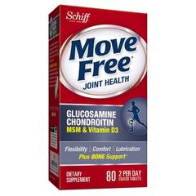

Move Free® Glucosamine Chondroitin Plus MSM & Vitamin D3 Joint Supplement formula contains premium-quality ingredients, including glucosamine, chondroitin, uniflex, hyaluronic acid, MSM and Vitamin D3 to promote the health of your bones and joints.† Move Free® Glucosamine Chondroitin Plus MSM & Vitamin D3 promotes joint flexibility, comfort and lubrication.†  
  
**Benefits of Move Free® Glucosamine Chondroitin Plus MSM & Vitamin D3**

* + Glucosamine and chondroitin comforts, protects, and lubricates joints†
  + Uniflex helps protect joint tissue and cartilage†
  + Hyaluronic acid is absorbed into joints for cushioning†
  + MSM comforts and soothes sore joints†
  + Vitamin D3 helps promote bone health and joint movement†
  + Comforts joints with just 2 tablets per day†

## How Does it Work?

* http://media.webcollage.net/rwvfp/wc/cp/13399766/module/movefree/_cp/products/1382123657765/tab-26f0f676-83bd-4b81-a5a8-a4379c84746e/e8b9f3a1-6839-43a9-ad5b-13cbc5de99d1.jpg.w960.jpg
* 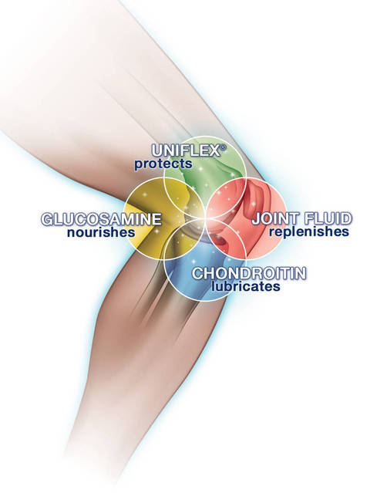[Enlarge Image](javascript:void(0);)

**Glucosamine and Chondroitin: Protect, Nourish, and Lubricate Joints†**  
  
Glucosamine and chondroitin work together in Move Free® Glucosamine Chondroitin Plus MSM & Vitamin D3 to protect and help lubricate your joints. Glucosamine is a natural component of cartilage, the connective tissue that protects the bones in your joints and allows them to slide easily over one another. Studies demonstrate that glucosamine, a key ingredient in Move Free® Glucosamine Chondroitin Plus MSM & Vitamin D3, supports joint health and flexibility.†  
  
Chondroitin is a naturally occurring complex carbohydrate found in connective tissue such as cartilage. By helping cartilage retain water, chondroitin assists or helps in lubricating and cushioning joints.  
  
**Uniflex: Delivers Protection and Comfort of Joint†**  
  
One key compound in Move Free® Glucosamine Chondroitin Plus MSM & Vitamin D3 is Uniflex (calcium fructoborate), a clinically tested mineral complex found naturally in fruits and vegetables that protects and comforts joints.†  
  
**Hyaluronic Acid: Cushions and Lubricates Joints†**  
  
Move Free® Glucosamine Chondroitin Plus MSM & Vitamin D3 contains hyaluronic acid (HA), a potent form of one of the main lubricating components found in your joints. As we get older, our HA tends to decrease, which can reduce joint cushioning. Since HA is naturally present in your body, you already have built-in pathways to absorb and use it. The HA in Joint Fluid is similar in molecular size to naturally occurring HA, and a clinical study shows that when taken orally, this form of HA is absorbed directly into the joints.1   
  
**MSM: Comforts and Soothes Sore Joints†**  
  
Move Free® Glucosamine Chondroitin Plus MSM & Vitamin D3 provides the added benefit of 1,500 milligrams of MSM (methylsulfonylmethane), a natural source of sulfur found in the body that is important in the formation of collagen in joints. When replenished, MSM can actually improve joint health. The amount of MSM found in Move Free® Glucosamine Chondroitin Plus MSM & Vitamin D3 has been shown to support joint comfort and soothe sore joints.†  
  
**Vitamin D3: Promotes Bone Health and Joint Movement†**  
  
Move Free® Glucosamine Chondroitin Plus MSM & Vitamin D3 provides 2,000 IU of joint-healthy Vitamin D3. As we age, our bones lose calcium, which can compromise overall bone health and joint movement. Vitamin D3 addresses this problem by helping bones absorb calcium better and helps bones retain the calcium already in them.

* http://media.webcollage.net/rwvfp/wc/cp/13399766/module/movefree/_cp/products/1382123657765/tab-26f0f676-83bd-4b81-a5a8-a4379c84746e/308d1f9e-0bc5-40a6-a34d-f394e4d615c5.jpg.w960.jpg

## Supplement Facts

* http://media.webcollage.net/rwvfp/wc/cp/13399766/module/movefree/_cp/products/1382123657765/tab-3ab03430-8caf-4e5e-9c58-1735907f547a/c0403ba9-0b47-4063-a934-c705831c58bb.jpg.w960.jpg
* 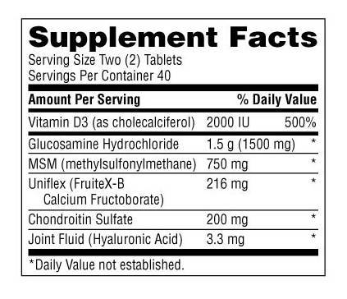[Enlarge Image](javascript:void(0);)

**Directions:**For best results, take two (2) tablets all at once with a meal, OR one (1) table twice daily with meals.  
  
**Other Ingredients:**  
Microcrystalline cellulose, hydroxypropyl cellulose, coating (hydroxypropyl methylcellulose, modified corn starch, titanium dioxide, polyethylene glycol, glycerin, magnesium trisilicate), croscarmellose sodium. Matodexterin, magnesium stearate, silicon dioxide. **Contains shellfish (shrimp, crab, lobster and crayfish).**Chrondroitin Sulfate is derived from bovine and porcine sources.

**No**Added Sugar (Sucrose, Fructose, Lactose), **No** Salt (Sodium Chloride), **No** Yeast, **No** Wheat, **No** Gluten or Milk. **No**Preservatives or Artificial Flavors.

*Note: If pregnant, lactating or on prescribed medication, consult your physician before using. KEEP OUT OF REACH OF CHILDREN. STORE IN A COOL, DRY PLACE WITH LID TIGHTLY CLOSED.*

## Move Free® Rewards

* http://media.webcollage.net/rwvfp/wc/cp/13399766/module/movefree/_cp/products/1382123657765/tab-74edf5bb-f6e0-4df7-83b7-9d85d24047de/e8b9f3a1-6839-43a9-ad5b-13cbc5de99d1.jpg.w960.jpg
* 

Join the Move Free® Rewards loyalty program today and start earning points that you can redeem for valuable rewards.

**How to Participate:**

**1) Join:** Sign up for Move Free® Rewards at www.movefreerewards.com. Registration is free.

**2) Purchase:** Every Move Free® and Schiff® Glucosamine supplement you purchase has a point value.

**3) Enter Rewards Codes:** Sign into your Move Free® Rewards account and enter the unique rewards code found on the product bottle to earn and save your points.

**4) Get Rewarded:** As you earn enough points, you can redeem them for valuable rewards, including coupons and valuable information to support your joint health.

## More Move Free® Products