**ADIDAS ANALYSIS**

A store that specializes in the sales of sport wares and materials, there are about six retail stores and purchase is made from any of the available stores. The retail stores offer different sales method which includes online, instore or outlets. The available data given covers sales from year 2020 to 2021

This analysis hopes to examine sales and profit with respect to region, Sales Method and finally best performing product.

The data was analyzed using Microsoft Excel.

**Data Cleaning:** I checked for blanks and found none, went further to confirm the integrity of the data by confirming each column content in relation to the header which was perfect and I proceeded into analysis.

**Findings:**

* **Regional Sales Performance**

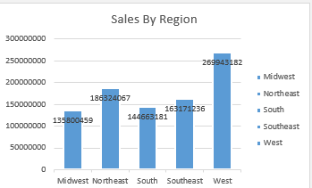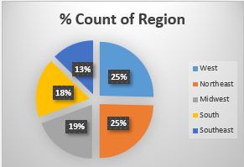The analysis reveals that the West region led in sales quantity, followed by the Northeast, Southeast, South, and Midwest regions. Initially, the West region's high count suggested potential sales and profit success, followed by the Northeast, Midwest, South, and Southeast. However, further investigation into sales quantity and profit revealed that the Midwest region underperformed despite its moderate count.

* **Retailer Profitability**

A closer examination of retailer performance showed that West Gear generated the highest quantity sold, followed by Footlocker, Sport Direct, Kohl's, Amazon, and Walmart.

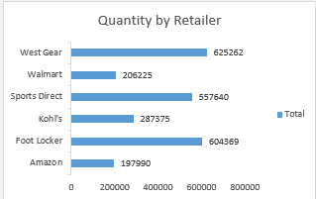

* **Top Profitable States**

To identify key profit drivers, we analyzed the top 10 profitable states. New York emerged as the leading state, followed by Florida, California, Texas, and South Carolina. This insight is crucial for-profit maximization, customer appreciation, and retention strategies.

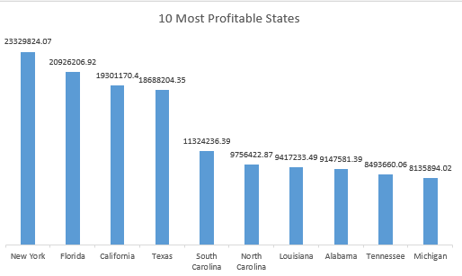

* **Sales Method Analysis**

The analysis of sales methods revealed that online sales dominated, likely due to the company's e-commerce presence. Outlet sales followed, and in-store sales trailed behind.

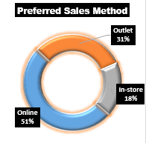

* **Product Sales Performance**

The product sales analysis showed that:

1. Men's street footwear led in sales quantity.

2. Men's athletic footwear followed closely.

3. Women's apparel secured third place.

4. Women's street footwear and athletic wear trailed behind.

5. Men's apparel recorded the lowest sales quantity.

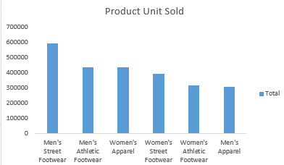

This comprehensive analysis provides actionable insights for regional sales optimization, retailer partnerships, and product offerings.