**COMP 3123 – Full Stack Development – Lab 1**

1. JavaScript Refresher Exercises

**Developer Note:**

1. Answer any 4 of the JavaScript exercises below
2. Try to solve the problems without using search engines or stack overflow for the solutions.

**Exercise 1:**

***Write a JavaScript program to capitalize the first letter of each word of a given string.***

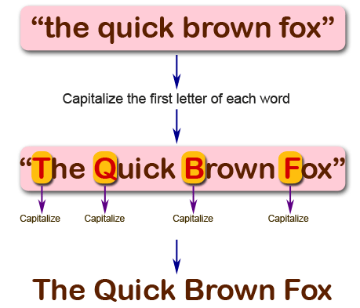

**Function capitalizeWords(str) {**

**Return str**

**.split(“ “)**

**.map(word => word.charAt(0).toUpperCase() + word.slice(1).toLowerCase**

**.join(“ “)**

**}**

**Exercise 2:**

***Write a JavaScript program to find the largest of three given integers.***

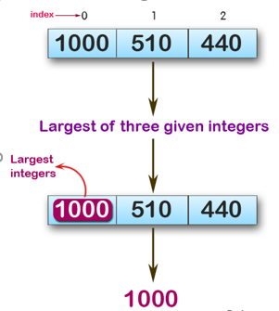

console.log(max (1,0,1));

console.log(max (0,-10,-20));

console.log(max (1000,510,440));

**Sample Output:**

1  
0  
1000

**function max(a, b, c) {**

**return Math.max(a, b, c);**

**}**

**console.log(max (1,0,1));**

**console.log(max (0,-10,-20));**

**console.log(max (1000,510,440));**

**Exercise 3:**

*Write a JavaScript program to move last three character to the start of a given string. The string length must be greater or equal to three****.***

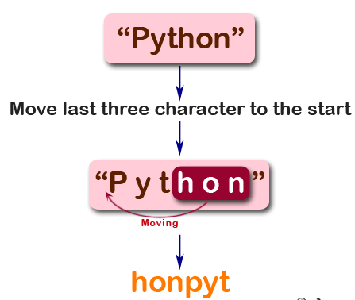

console.log(right("Python"));

console.log(right("JavaScript"));

console.log(right("Hi"));

**Sample Output:**

honPyt  
iptJavaScr  
Hi

**function characters(str){**

**if(str.length < 3){**

**return str;**

**}**

**const ending = str.slice(-3);**

**const word = str.slice(0, -3);**

**return ending + word;**

**}**

**console.log(characters("Python"))**

**console.log(characters("JavaScript"))**

**console.log(characters("Hi"))**

**Exercise 4:**

*Write a JavaScript program to find the types of a given angle.*

Types of angles:  
• Acute angle: An angle between 0 and 90 degrees.  
• Right angle: An 90 degree angle.  
• Obtuse angle: An angle between 90 and 180 degrees.  
• Straight angle: A 180 degree angle.

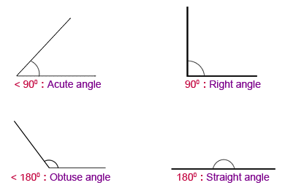

console.log(angle_Type(47))

console.log(angle_Type(90))

console.log(angle_Type(145))

console.log(angle_Type(180))

**Sample Output:**

Acute angle  
Right angle  
Obtuse angle  
Straight angle

**function isInRange(number, min, max){**

**return number > min && number < max;**

**}**

**function angle_Type(angle) {**

**if (isInRange(angle, 0, 90)) {**

**return("Acute angle");**

**}**

**else if (isInRange(angle, 90, 180)) {**

**return("Obtuse angle");**

**}**

**else if (angle === 90) {**

**return("Right angle");**

**}**

**else if (angle === 180) {**

**return("Straight angle");**

**}**

**}**

**console.log(angle_Type(47))**

**console.log(angle_Type(90))**

**console.log(angle_Type(145))**

**console.log(angle_Type(180))**

**Exercise 5:**

*Write a JavaScript program to find the maximum possible sum of some of its k consecutive numbers (numbers that follow each other in order.) of a given array of positive integers.*

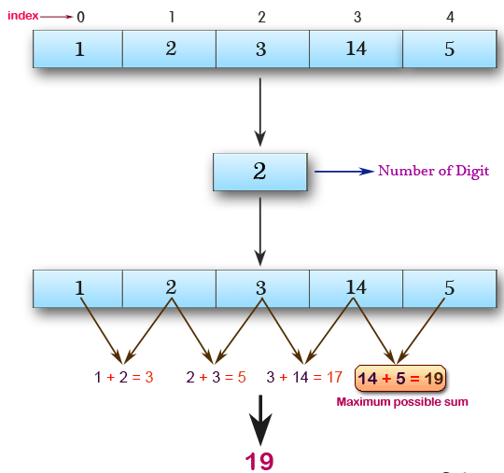

console.log(array_max_sum([1, 2, 3, 14, 5], 2))

console.log(array_max_sum([2, 3, 5, 1, 6], 3))

console.log(array_max_sum([9, 3, 5, 1, 7], 2))

**Sample Output:**

19  
12  
12