Time Management Web App
High Level Requirements Document
Version 1.0
September 25th, 2025

Project Identification

Project: | Time Management Web App
Prepared By: | Sokmontrey Sythat  Ahmed Ashoor  Jonathan Cao  Samuel Browne
Document Version: | 1.0
Published Date: | 2025-09-25

Contributors
The following individuals contributed to this document.
Name | Title
Sokmontrey Sythat | Project Manager / Developer
Ahmed Ashoor | Software Architect / Developer
Jonathan Cao | UI/UX / Developer
Samuel Browne | Assistant Project Manager, Engineer, QA, InfoSec

Distribution
This document is distributed to all the following people.
Name | Title
Sokmontrey Sythat | Project Manager / Developer
Ahmed Ashoor | Software Architect / Developer
Jonathan Cao | UI/UX / Developer
Samuel Browne | Assistant Project Manager, Engineer, QA, InfoSec

Referenced Documents
This document refers to the following materials
Version number | Title | Author | Date | Source / Location

Revision History

Version Number | Revision Date | Summary of Changes | Modified by
[Note: It is recommended that drafts be numbered 0.1 to 0.9, and that the first approved version be numbered 1.0. Thereafter, new version numbers will depend upon changes: 1.01, 1.1, etc for minor updates, 2.0, 3.0 etc for major changes.]

TABLE OF CONTENTS
1. BUSINESS CONTEXT DIAGRAM 3
2. REQUIREMENTS SCOPE STATEMENTS 4
3. HIGH LEVEL BUSINESS REQUIREMENTS SIGN-OFF 5

- Business Context Diagram
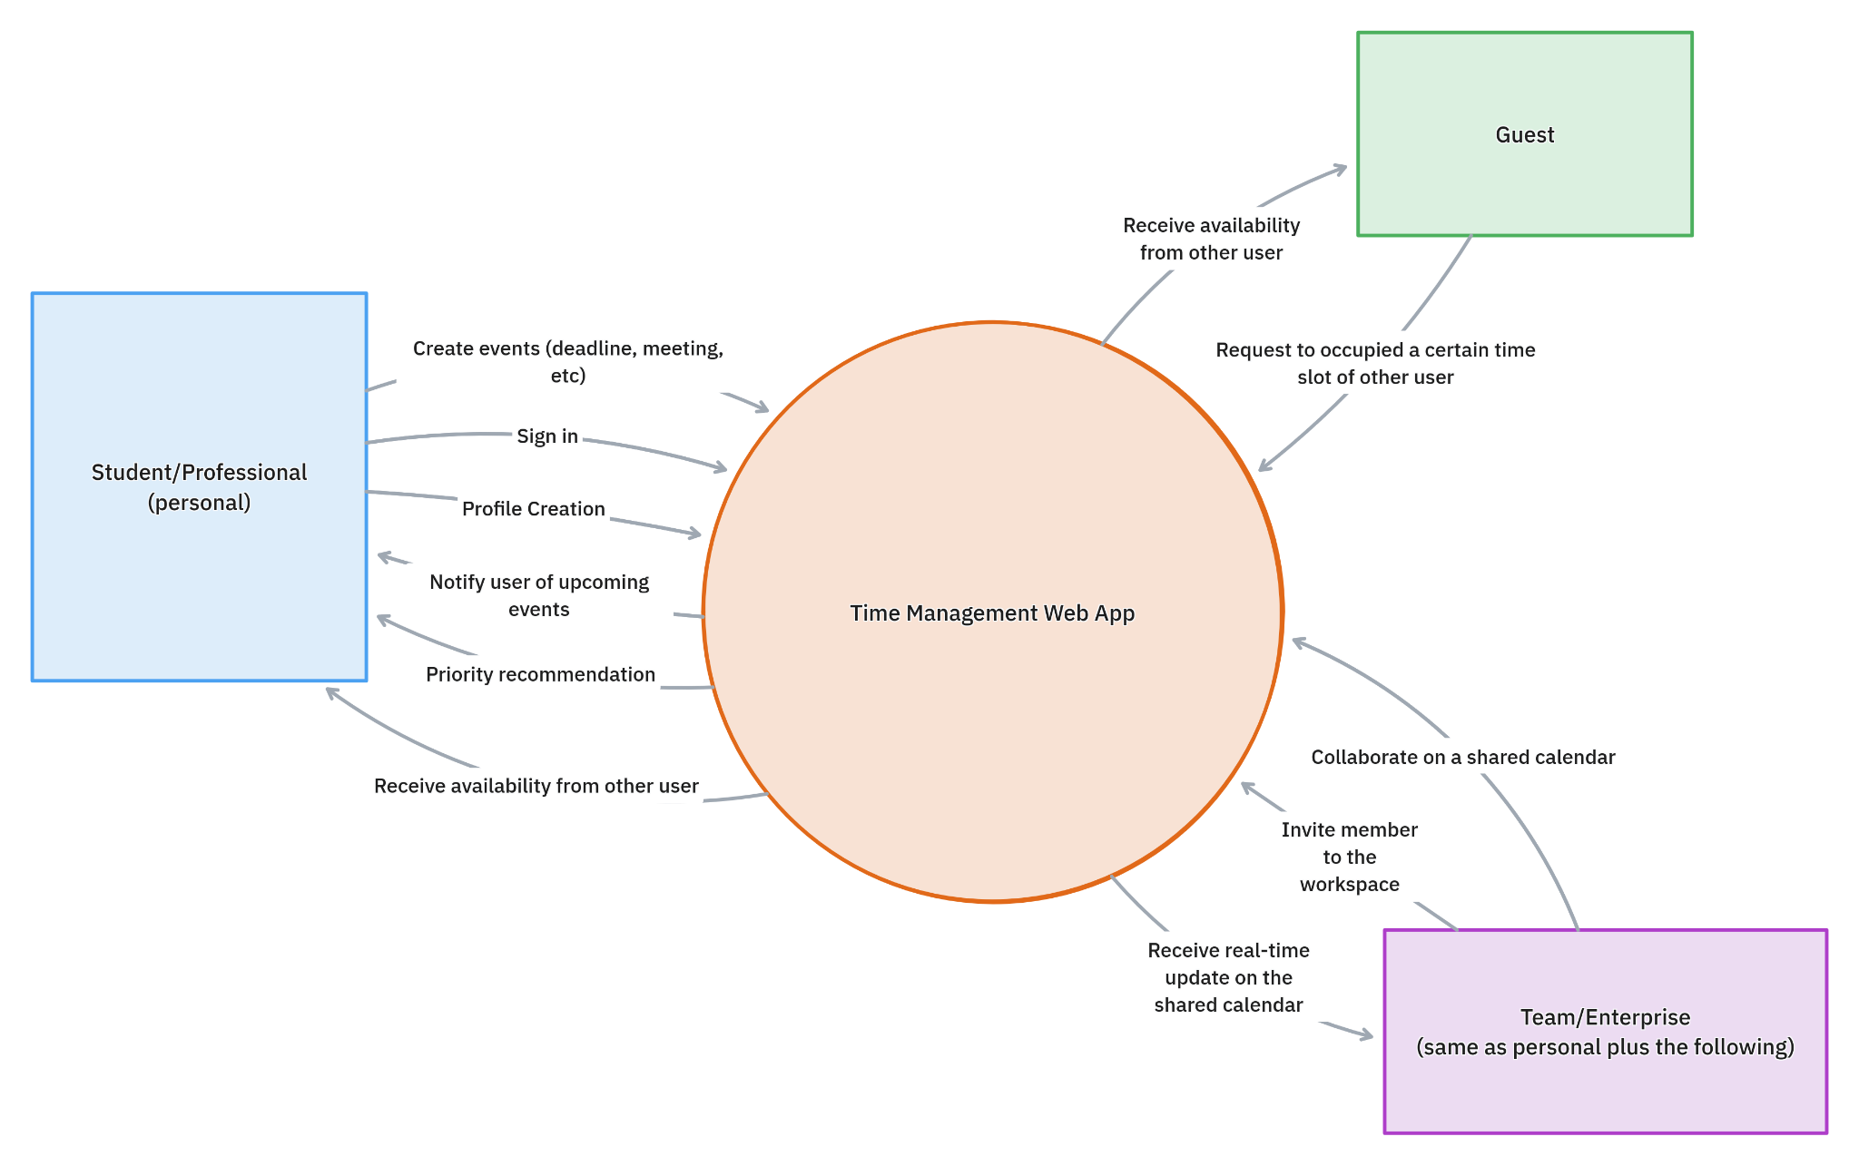

Requirement Scope Area | Description
Time Management Application | Our Project is responsible for providing all features listed in the scope of our application.This is the main point of usability for all users of the application, thus allowing for:  • Personal user: Create task, track progress and share availability  • Guest: Receive availability link, check for common time, and book time slot with other users  • Team/Enterprise: create meetings, deadlines and notes as well as allocate time for said events.

External Entity | Description
Student/ Professional | Individuals use the app to manage tasks,schedules,meetings, and deadlines.They can create tasks, set recurring schedules, track progress with prioritization, and share availability with peers planning.
Guest | Non-registered users who access shared availability links to book meetings or appointments with registered users. They can open availability links, select a time slot , and submit booking requests.
Team/Enterprise | A group of users (Student/Professional) working together on a project who use the app for the real-time collaborative time-management workspace.

Information Flows | Description
Sign Up/Sign in | Users can create a personal account and sign in with their credential to manage personal data and have their input sync across devices.
Profile Creation | Users can create and configure their profiles to get started on the platform with basic information. They can also provide preferences for better experience with the application
Create event | Users can create events both recurring and not recurring. These events include deadlines, meetings, classes, exams.
Priority Recommendation | Based on questions asked to users during the signup process, our project will be able to assign priority to each event and notify users about events in priority order.
Availability request | Guest users will be able to send requests to users and our project will be able to find availability in the users calendar.
View User Availability | A guest (non-registered) user or registered user can receive and view other user availability when shared.
- Requirements Scope Statements
HLR# | Description | Priority  (H, M, L)
 | The system must allow users to create, edit, delete, and track tasks/events. | H
 | The system must support recurring schedules for classes, meetings, and tasks. | H
 | The system must provide customizable (daily, weekly, monthly) view | M
HLR04 | The system must include a priority recommendation for task management. | M
HLR05 | The system must send reminders,notifications for upcoming events or deadlines. | M
HLR06 | The system must allow user to share their current availability with other users | L
HLP07 | The system must allow user to view the shared availability from other other users and find common available time | L

- High Level Business Requirements Sign-Off
The undersigned acknowledge their agreement with the contents of Version 1.0 of the High-Level Requirements document for Time Management Web App.

Following approval of this document, requirements changes will be governed by the project’s change management process, including impact analysis and appropriate reviews and approvals, under the general control of the Project Plan and according to company policy. Approved Change Request Documents, if present, will be attached to this Requirements Document as updates.

Name | Project Role and  Functional Area | Date Signed
Sokmontrey Sythat | Project Manager / Developer | Sep 24th, 2025
Ahmed Ashoor | Software Architect / Developer | Sep 24th, 2025
Jonathan Cao | UI/UX / Developer | Sep 24th, 2025
Samuel Browne | Assistant Project Manager / Engineer / QA / InfoSec | Sep 24th, 2025

