TMWA
Document: F25_T01_MockUp

Table of content

Table of content 1
Team Introduction 1
Figma Workspace 2
Figma Link: Figma 2
Components and branding 2
Prototype 3
Screens 4
Landing page 4
Register Page 5
Login Page 5
On-boarding Page 6
Get start modal 6
Main Dashboard Page 7
Main Dashboard with sidebar minimized 7
User select a different date on the calendar 8
Create new event with start template modal 8
Dashboard week view for better details 9
Sharing modal 9
Availability sharing popup 10
Collaborative workspace 10
Profile modal popup 11
Setting modal 11

Team Introduction
Ahmad Ashoor
Jonathan Cao
Sokmontrey Sythat
Samuel Browne

Figma Workspace

Figma Link: Figma

Components and branding
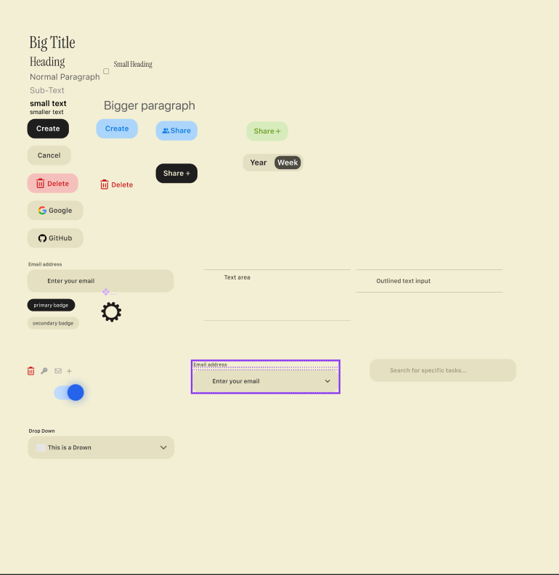

Prototype
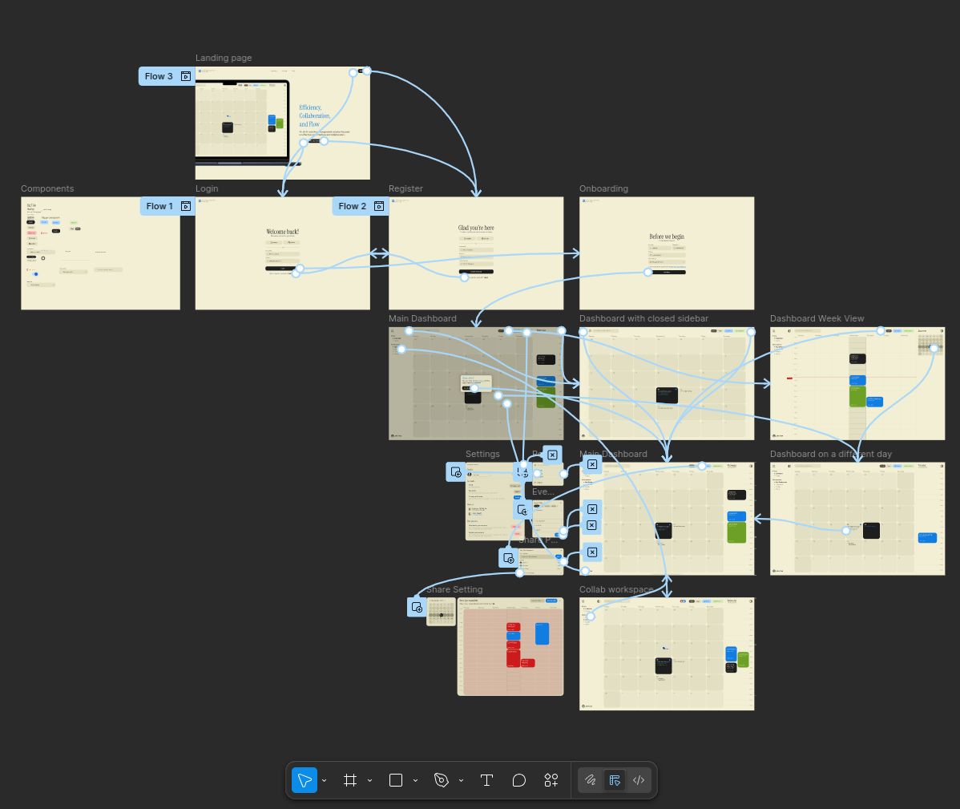

Screens

Landing page
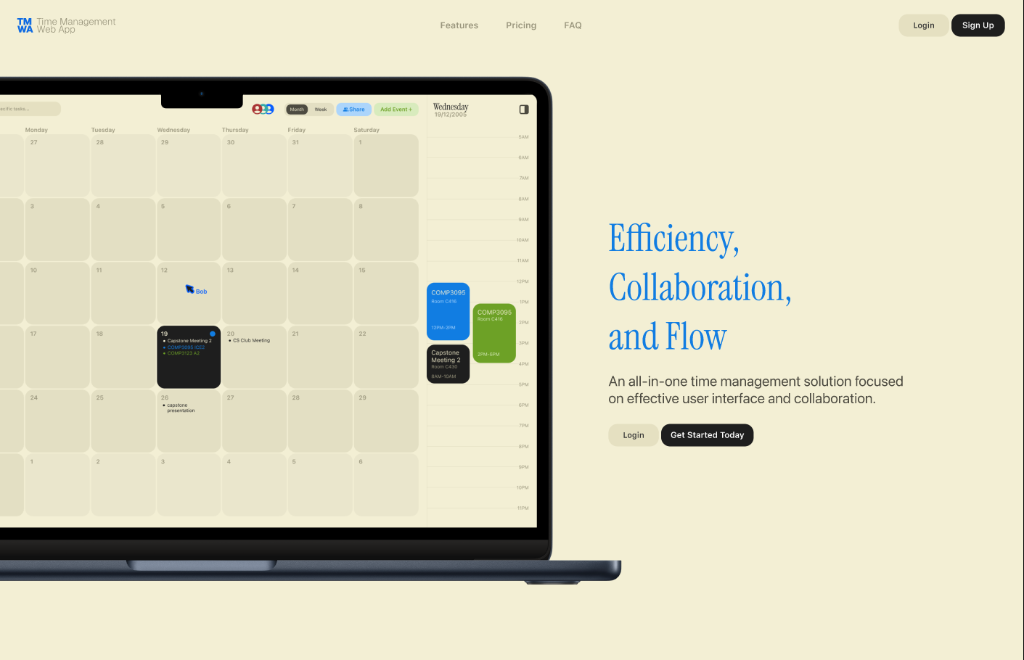

Register Page
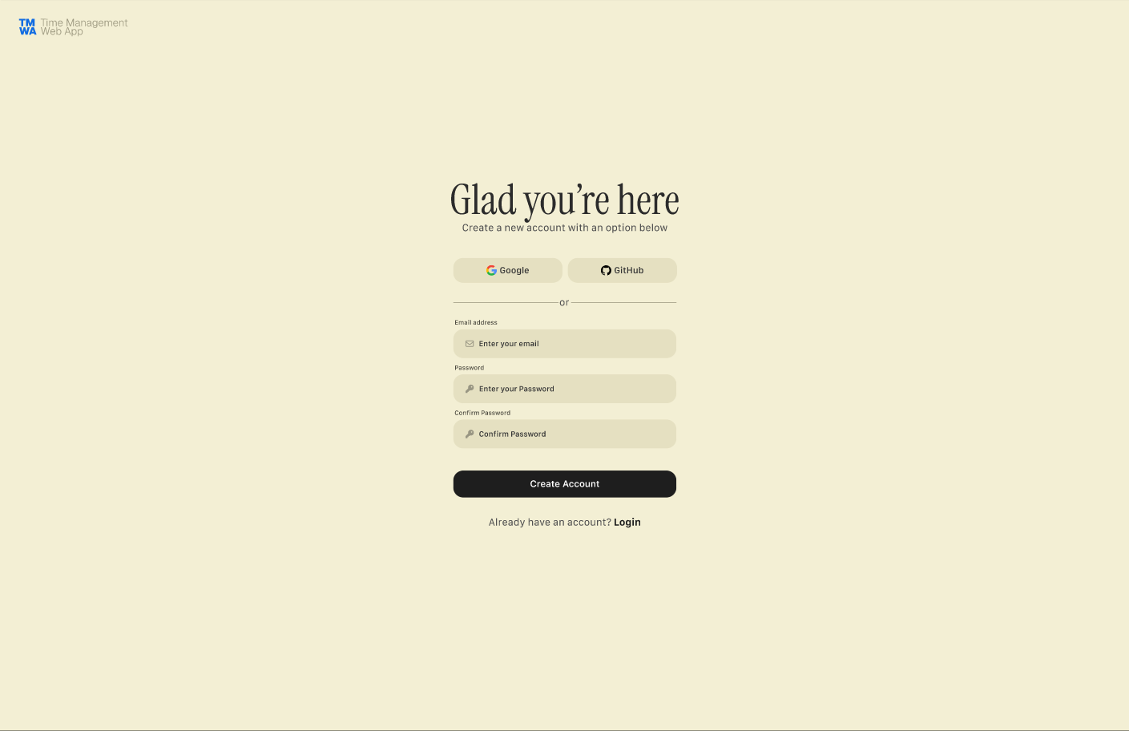

Login Page
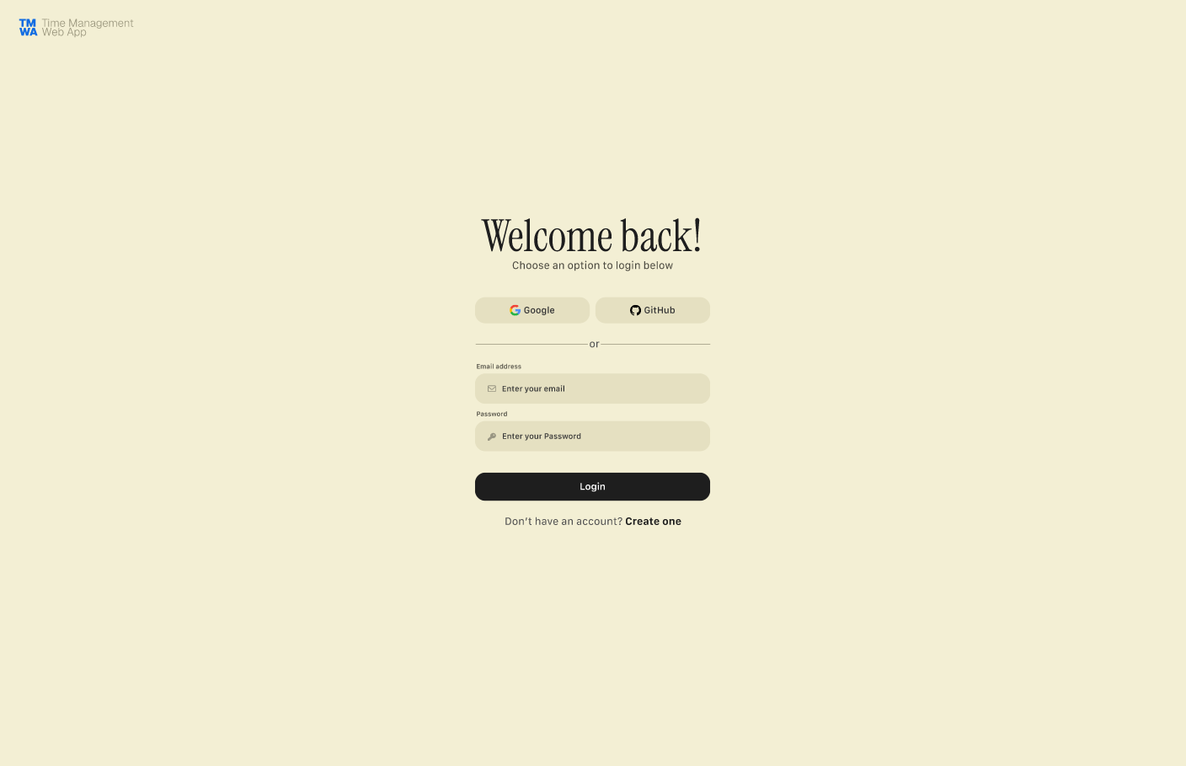

On-boarding Page
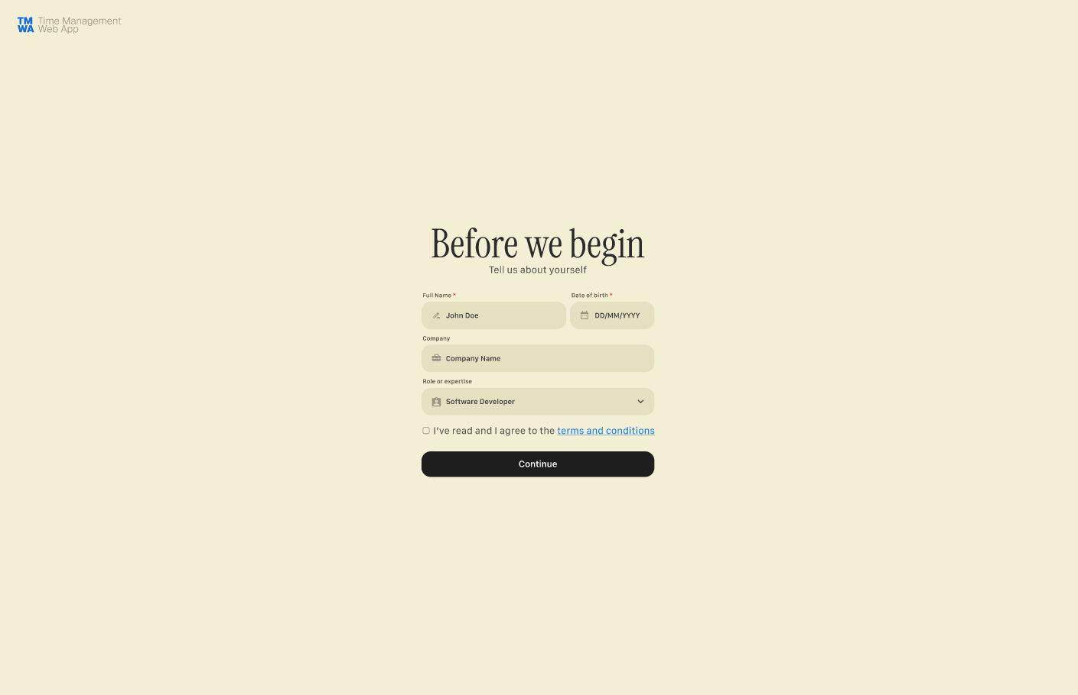

Get start modal
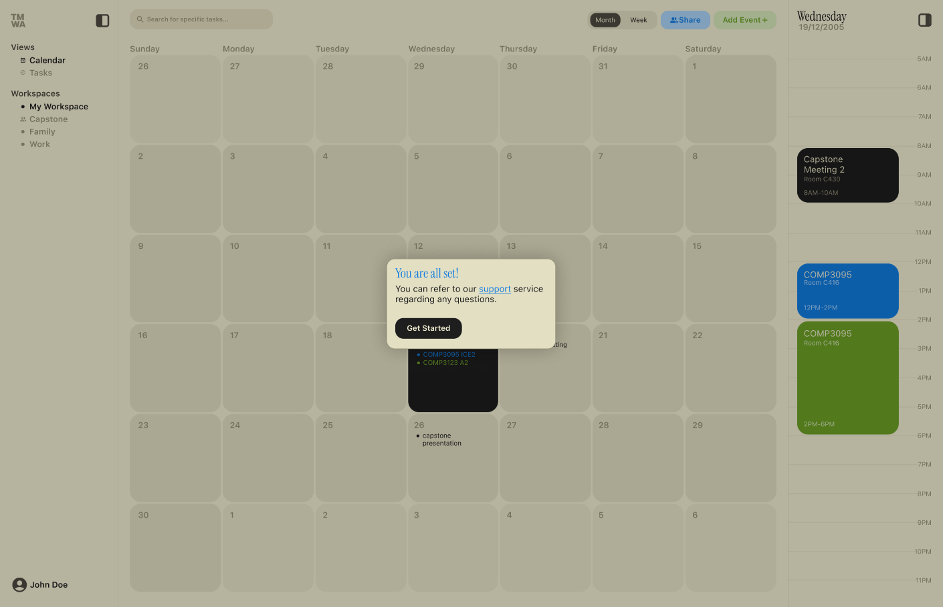

Main Dashboard Page
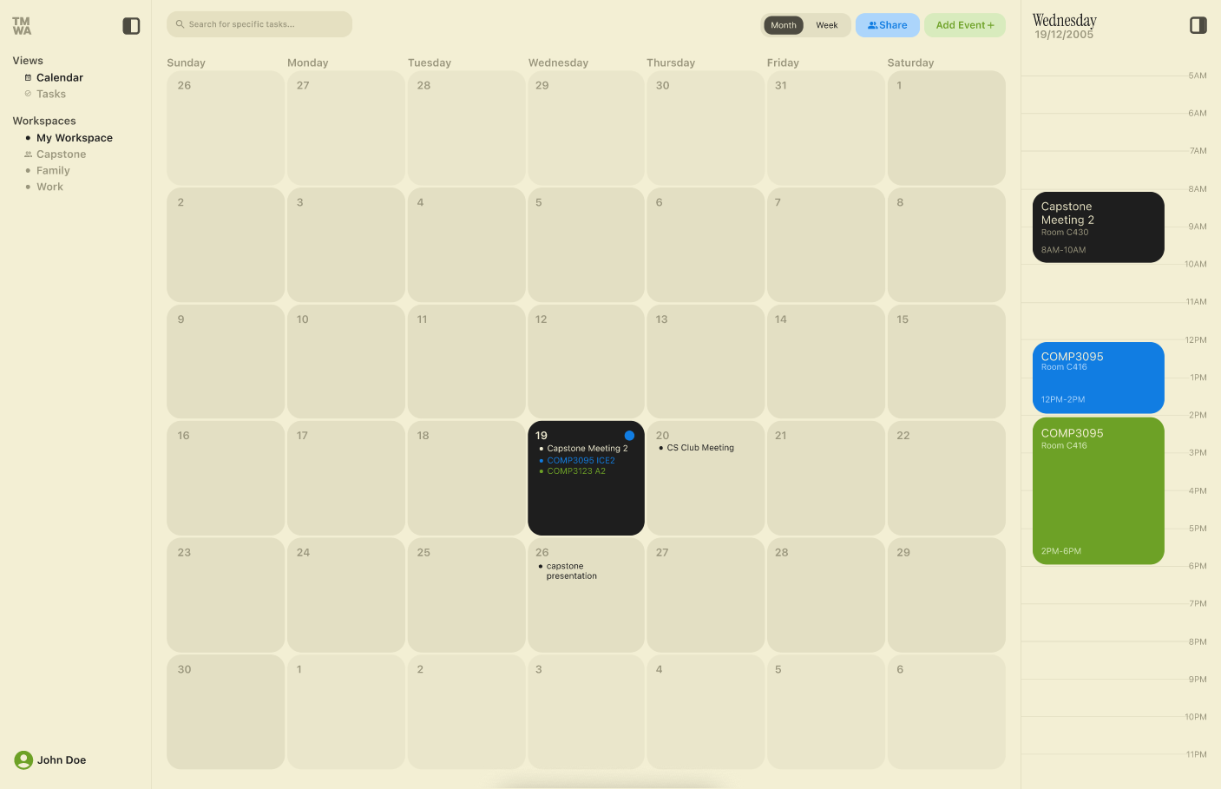

Main Dashboard with sidebar minimized
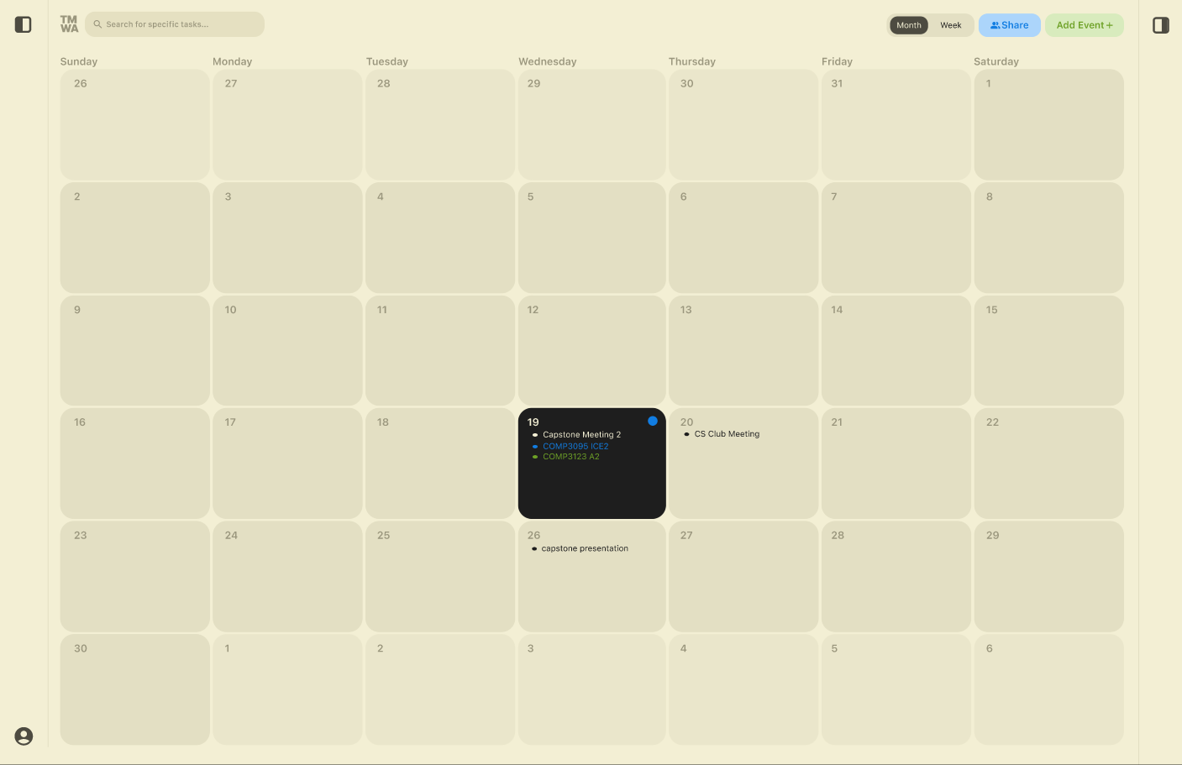

User select a different date on the calendar
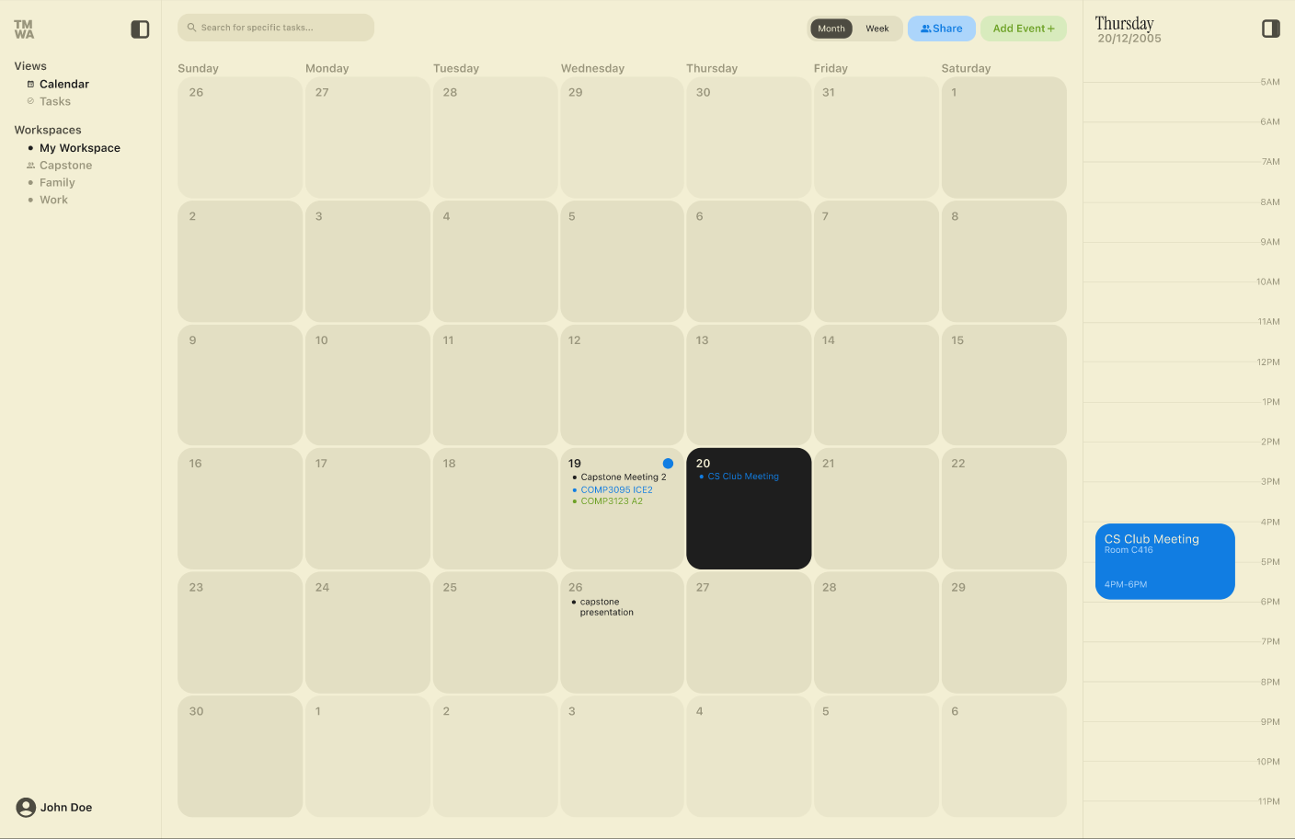

Create new event with start template modal
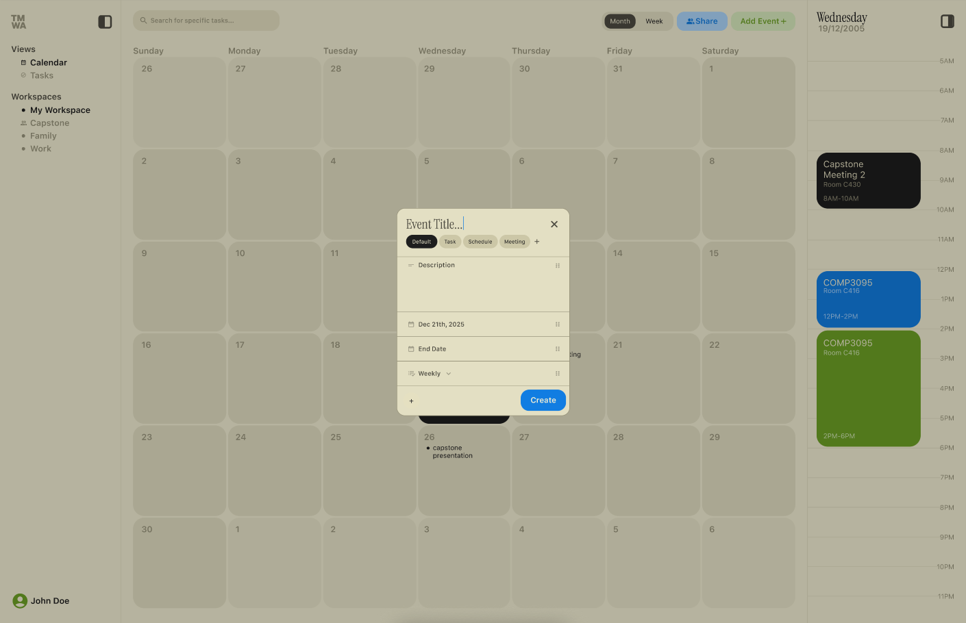

Dashboard week view for better details
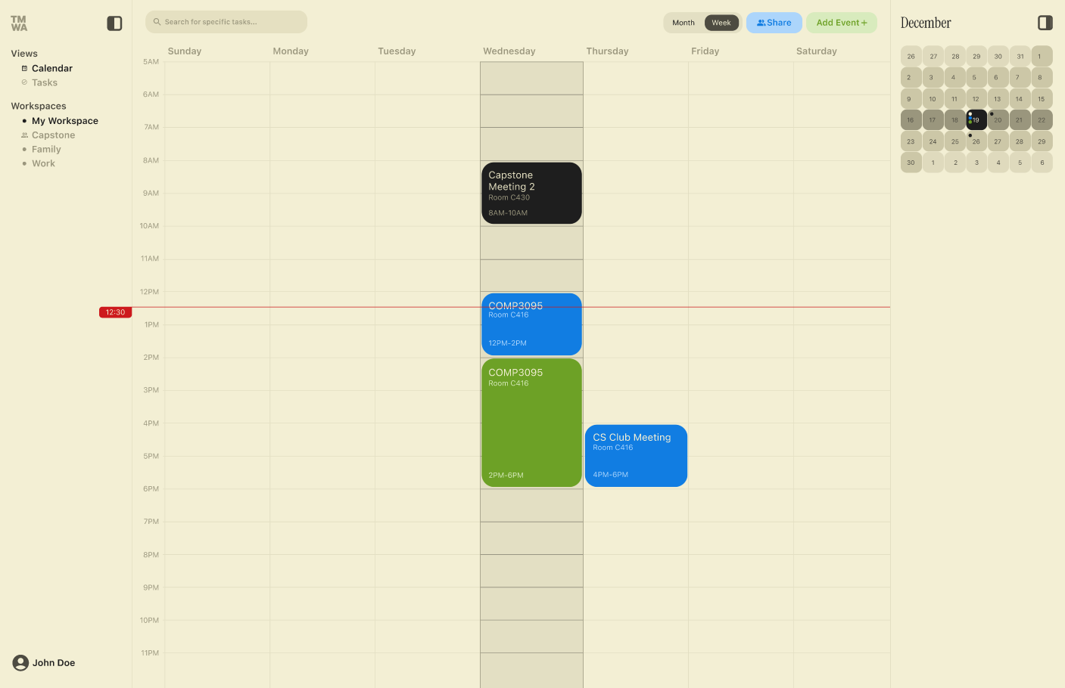

Sharing modal
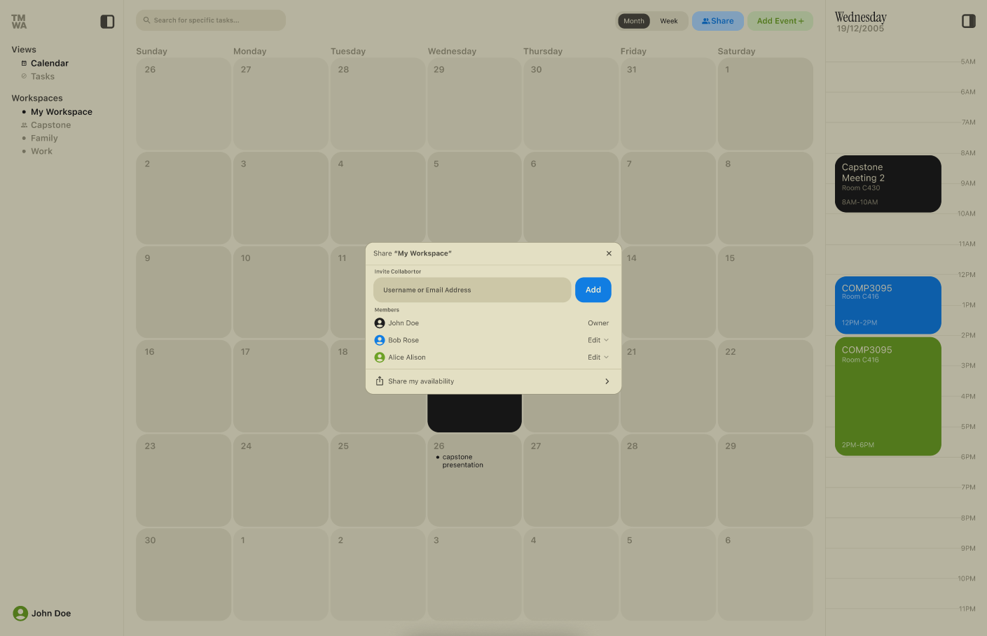

Availability sharing popup
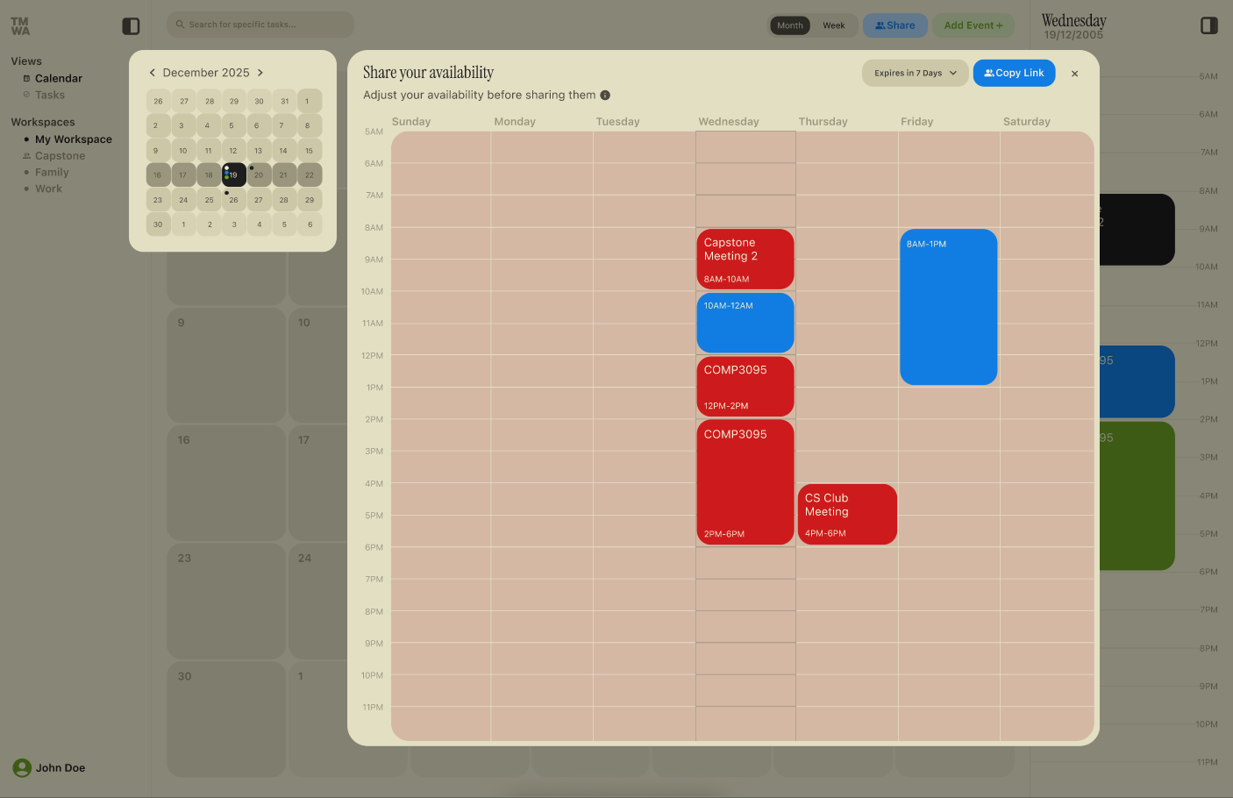

Collaborative workspace
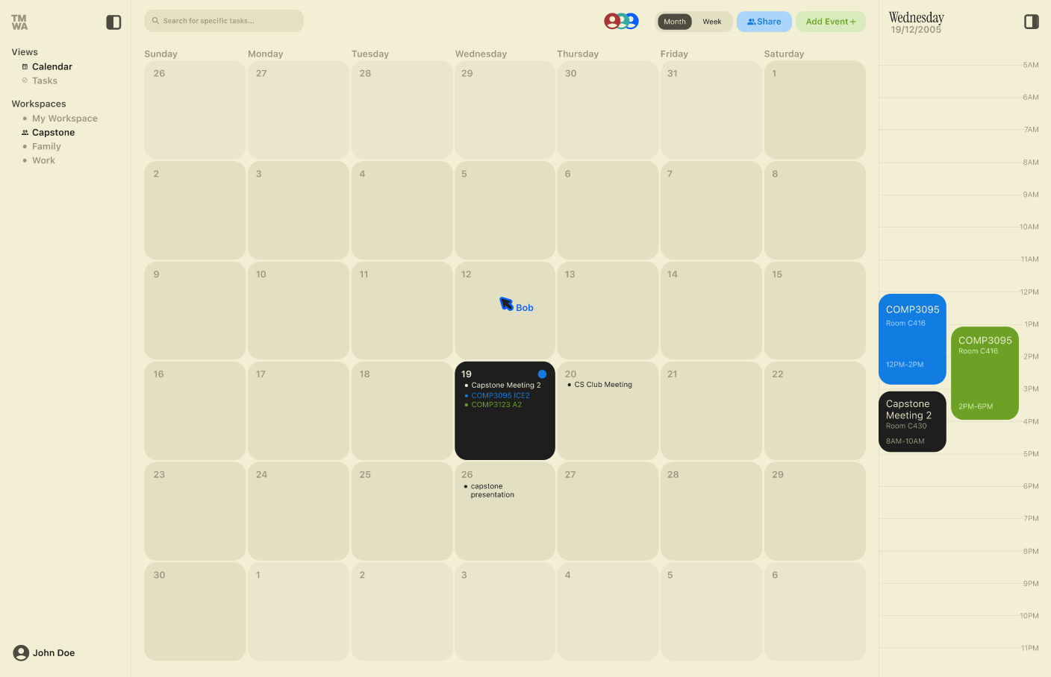

Profile modal popup
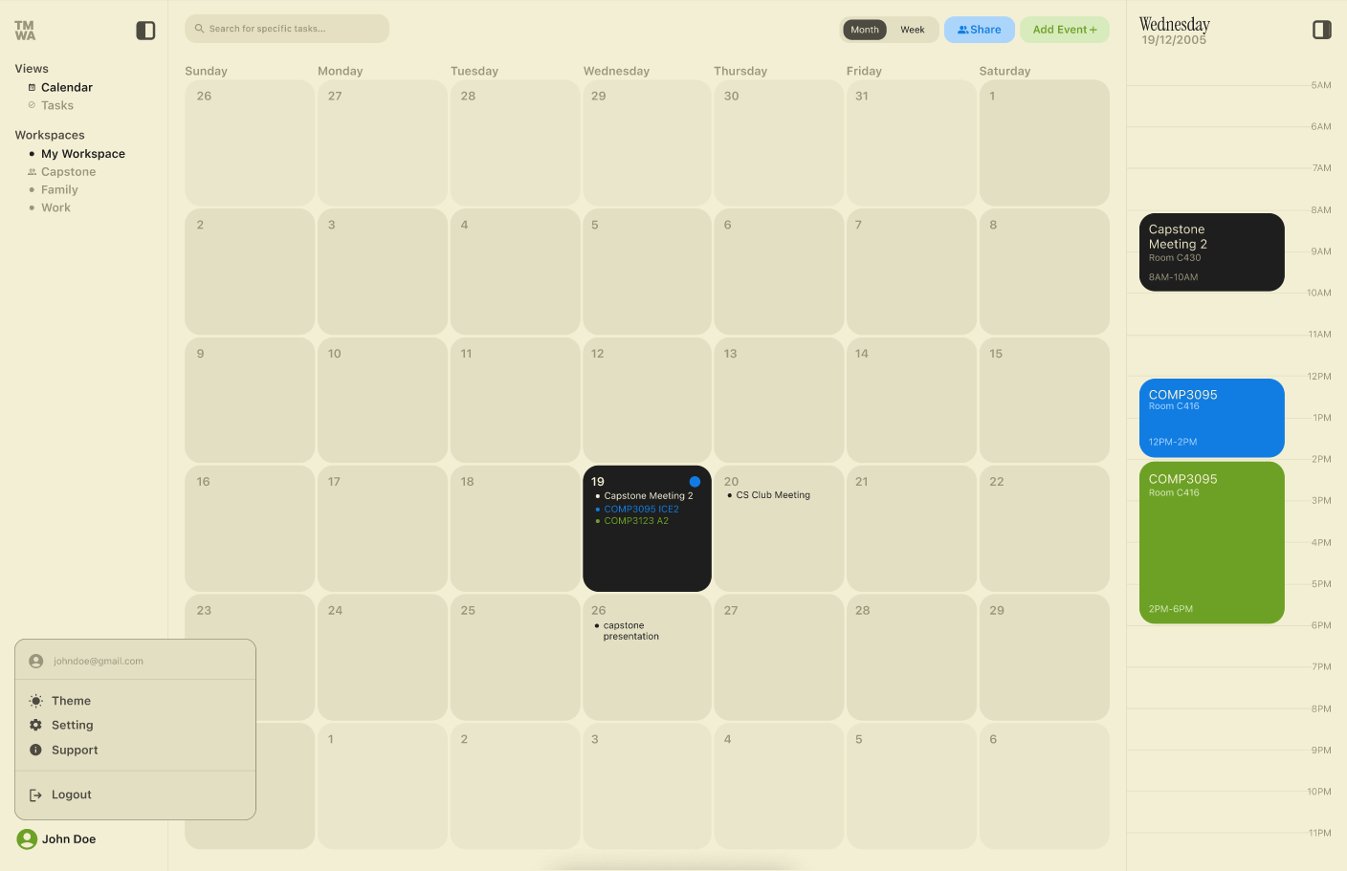

Setting modal
