Project Plan

Time Management Web App

Primary Instructor | Anjana Shah
Team Member | Sokmontrey Sythat
Team Member | Samuel Browne
Team Member | Jonathan Cao
Team Member | Ahmed Ashoor

Document Revision History

Revision # | Date

Table of Contents

1. Executive Summary 2
2. Project Approvers, Reviews and Distribution List 3
3. Scope 4
4. Deliverables 4
5. Assumptions 4
6. Dependencies 5
7. Risk Management 5
8. Communication 5
9. Task Listing (WBS- Work Breakdown Structure) 6
10. Gantt Chart 6
11. Milestones 7
12. RAM – Responsibility Assignment Matrix 7
13. Approval 8

1. Executive Summary

The following describes the project to be executed.

Objective | - Develop a web application with efficient user interface  - Provide time management, priority recommendation, and task allocation features  - Facilitate schedule sharing and synchronize workspace between users within constrained resources (time and budget)
Corporate Goals Addressed | - Improve productivity of individuals with a time management system focused on effective, non-blockage UI.  - Connect collaborators across the industry to a single time management solution.
Planned Start Date | September 15th, 2025
Planned End Date | March 27th, 2026

2. Project Approvers, Reviews and Distribution List

Approvers, reviewers and distribution list

Project Role | Name | E-mail | Date
Project Manager | Sokmontrey Sythat | sokmontrey.sythat@georgebrown.ca | 01/10/2025
Consultant | Anjana Shah | ashah@georgebrown.ca | 01/10/2025
Software Architect | Ahmed Ashoor | ahmed.ashoor@georgebrown.ca | 2/10/2025
UI/UX | Jonathan Cao | jonathan.cao@georgebrown.ca | 01/10/2025
Quality Assurance Engineer | Samuel Browne | samuel.browne@georgebrown.ca | 01/10/2025

3. Scope

Define the sum total of all of its products and their requirements or features.

In Scope | Out of Scope
Web platform | Natural language base interface
Share feature | Mobile platform
Common availability finder
Time recommendation

4. Deliverables

This project will deliver the following.

Deliverable | Description
Web platform | A web app where the user can use our app. The app will have have calendar interface
Share feature | This will allow the user to share their calendar as well as use our app to find a time that works for both users
Common availability finder | This feature will allow the user to find a common time(time where both users are available) and then let the user block that time off.
Time recommendation | This feature will recommend a time when the user is making a new event

5. Assumptions

This project makes the following assumptions;

- Users are seeking new time management system
- Users are facing blockage with their current time management solution due to ineffective user interface.
- Users require collaborative features such as schedule sharing, common time finder, and real-time collaboration.

6. Dependencies

The following are the internal and external dependencies that will have to be acknowledged and addressed;

- Team availability: each team member must complete a consistent amount of hours per week throughout the planning/development phase
- Database and server: server hosting and data storage service is required for certain features of the platform and to ensure that it is widely accessible from most of our users.
- Task sequencing: development requires successful completion of all tasks during and after the planning phase.
- Third party software library and framework: development requires stable, opensource, and secure third party solutions for the implementation of specific features.
- Development environment and software license: integrated development environment and development tools may require subscription.

7. Risk Management

Potential Risk | Severity (H/M/L) | Likelihood (H/M/L) | Management Strategy
Estimate project timeline | M | H | Understand the high-level view of the project to estimate development time
Front-end and Back-end integration | H | M | Design a comprehensive system architecture that includes every aspect of the software.
Challenging UI development | M | M | Development of a comprehensive mockup and UI/UX design before the start of the technical development.
Software error and issues | M | M | Following software development best practices and focusing on implementing application testing ranging from unit to integration testing.
Competition from existing platforms | L | M | Difference the app by focusing on collaborative feature and improving user experience

8. Communication

Reporting

The following reports will be produced;

Report | Audience | Frequency
Sprint minutes | Stakeholders and Consultants | Weekly
Project statement | Stakeholders and Consultants | Once
User Stories | Stakeholders and Consultants | Once
Team Charter | Stakeholders and Consultants | Once
Project Plan | Stakeholders and Consultants | Quarterly
Product Backlog | Stakeholders and Consultants | Monthly
Sprint Backlog | Stakeholders and Consultants | Monthly
System Requirements | Stakeholders and Consultants | Quarterly
System Design | Stakeholders and Consultants | Quarterly
Wireframes | Stakeholders and Consultants | Once
Technical Requirements | Stakeholders and Consultants | Bi-Annually

Meetings

The following meetings/communication will be established;

Meeting | Purpose | Attendees | Frequency
Standup meeting | - explain project progress  - plan upcoming deliverables  - assign task to team members | All of the team | weekly
Team meeting/parallel working | Collaborate on current feature and helping each other | Team members that are free to work together | As needed

9. Task Listing (WBS- Work Breakdown Structure)
The following resource proposal template summarizes the resource hours committed to this project, upon final approval of this document.

Reference | Tasks | Duration | Dependency
A | Project Vision, Business Requirements, Personas, User Stories. | 2 WEEKS | -
B | Project Plan, Team Charter, Scope, Duration. | 2 WEEKS | A
C | System Requirements, Analysis & Design Portfolio. | 2 WEEKS | B
D | Wireframes, Prototype, Technical Requirements. | 3 WEEKS | C
E | Presentations & Final Report (Oct–Dec). | 2 WEEKS | A-B

10. Gantt Chart
Create a detailed Gantt Chart from your Task Listing(Use any software tool and paste the image or upload as a separate file that can be opened as pdf/doc/xls)

Below is an example: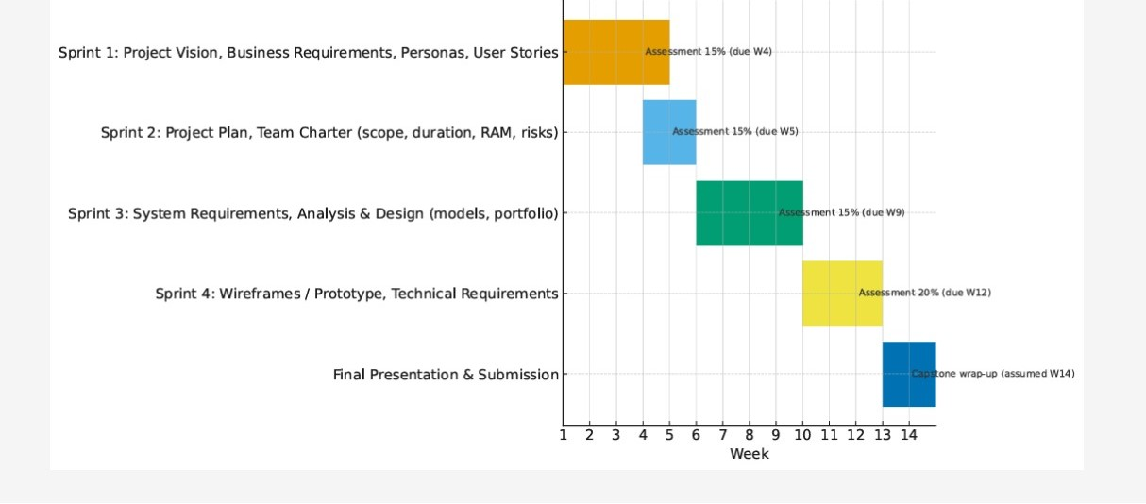

11. Milestones

Major Activity or Milestone | Estimated Milestone Target date | Owner/Reviewer Team Members
Project Vision, Business Requirements, Personas, User Stories. | Week 4 | Sokmontrey  Ahmed  Samuel  Jonathan
Project Plan & Team Charter. | Week 6 | Ahmed  Sokmontrey Samuel  Jonathan
System Requirements, Analysis & Design portfolio. | Week 9 | Ahmed  Sokmontrey Samuel  Jonathan
Wireframes/Prototype, Technical Requirements. | Week 12 | Jonathan  Ahmed  Samuel Sokmontrey

12. RAM – Responsibility Assignment Matrix

Create a RAM from your Task Listing. A sample is shown below:

Tasks | Sokmontrey | Jonathan | Samuel | Ahmed
Project Timeline Management | P | S | S | S
Design Software Architecture | P | S | S | P
Low-level architecture (code design) | P | S | P | S
Design UI/UX mockup | S | P | S | S
QA/Testing | S | S | P | P
P = Primary S= Secondary

13. Approval

The signatures below indicate their approval of the contents of this document.

Project Role | Name | Signature | Date
Project Manager | Sokmontrey Sythat | S.S | 28/09/2025
UI/UX | Jonathan Cao | J.C | 28/09/2025
Quality Assurance Engineer | Samuel Browne | S.B | 28/09/2025
Software Architect | Ahmed Ashoor | A.A | 28/09/2025

