
Hönnunar skýrsla

ROBOTC

Electro, the Magnet Bot!

Efnisyfirlit
Hér
Dæmi:

Við gerðum vélmenni sem keyrði um á braut og færði hluti frá einni hlið til annara með rafsegli. Við notuðum línuskanna til að stjórna hvert hann fór og takka til að passa upp á að snúnings armurinn skemdi ekki neitt. Rafsegulinn gerðum við sjálfir úr kopar vír og járn kjarna.

Vélbúnaður
Mótorar: 3 VEX 393 mótorar
Línuskannar: 3
Takkar: 2
Controller: 1
Fjasteríng: 1
Dekk: fjögur miðstór
Tannhjól: 6 miðstór, 1 stórt og 1 smátt

Verkáætlun hér
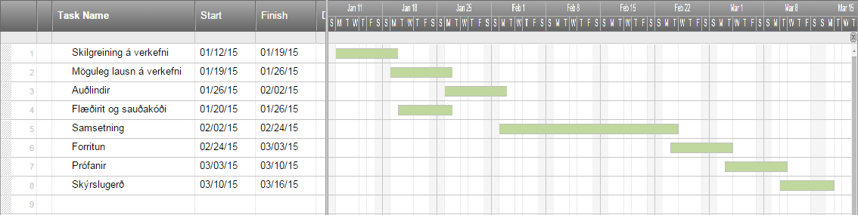

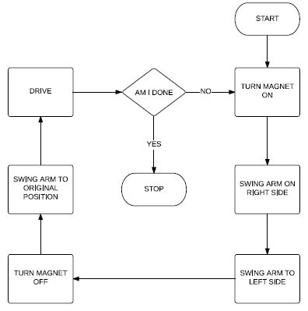

Prófanir
Hér setjið þið inn lýsingu á prófunum á vélmenni þ.e er hvað hann á að gera og hvernig gékk.
Dæmi:
- Færa áfram um smá spöl eftir línu
- Færa arm til hægri og kveikja á rafsegli
- Færa arm til vinstri og slökkva á rafsegli
- Repeat

Lokaorð
Ef vélmenni væri stærra, þá gæti það verið notað sem vélmenni til að hreinsa burt málm rusl af svæði... svo lengi sem að lína sé á jörðinni sem vélmennið getur fylgt. Annars, gagnslaust. Hinsvegar ef honum yrði breitt dálítið þá væri mögulega hægt að fynna not fyrir vélmennið.

Viðauki
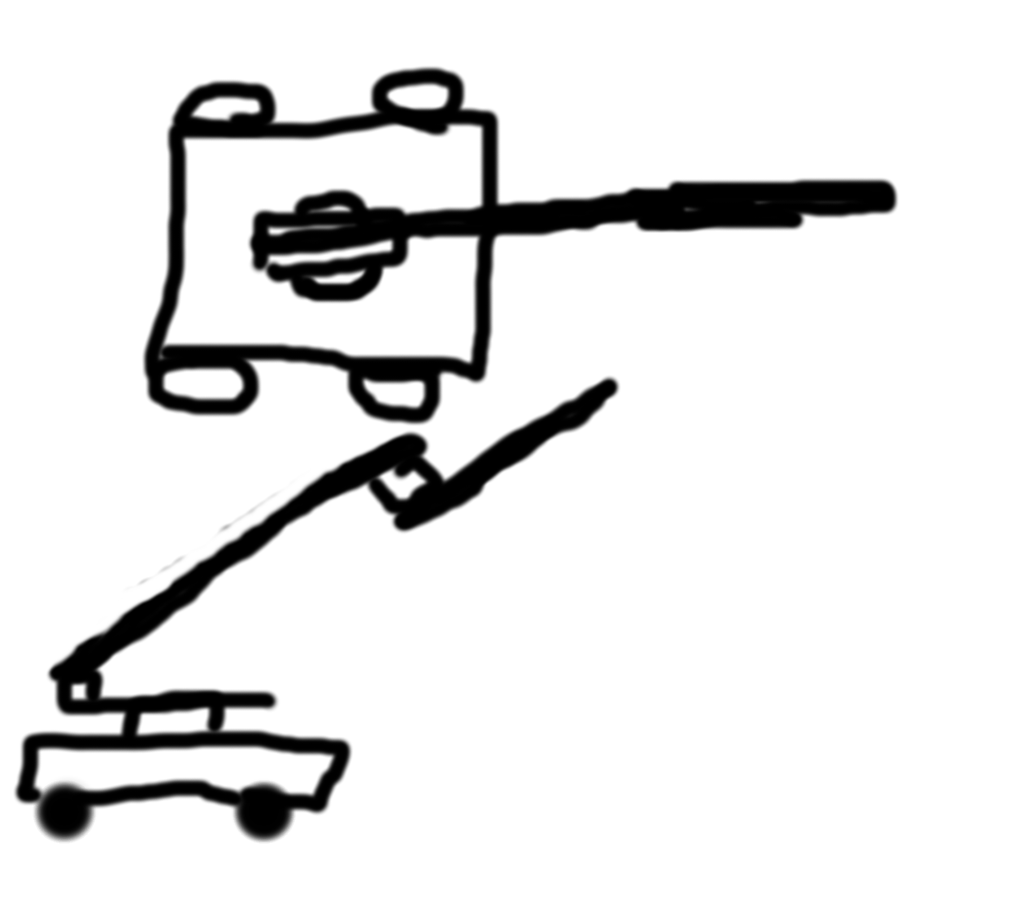
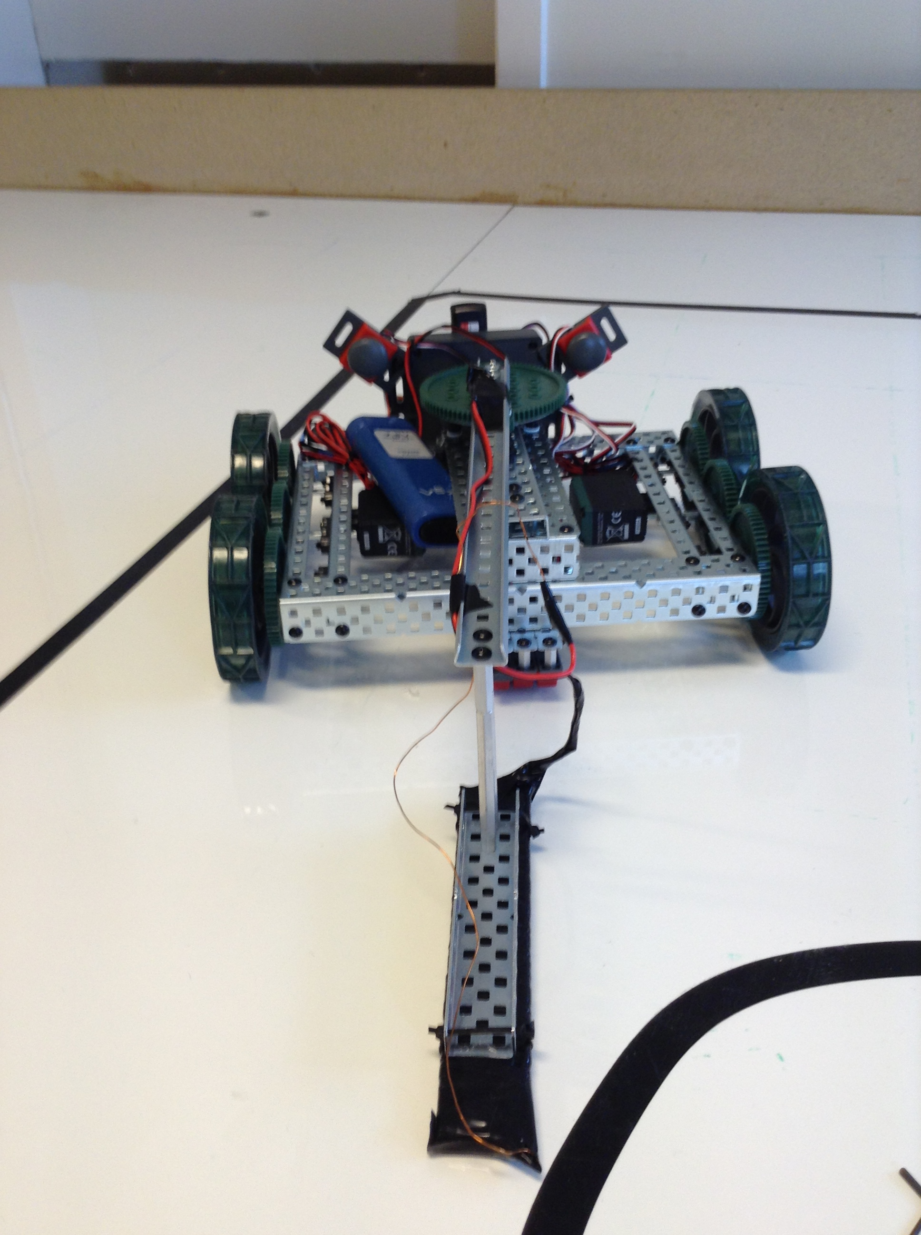
12/01/15
Day one:
It started like most stories, with an idea. they started thinking of robots, how they wanted them to be, what they wanted them to do and why they wanted them to do it.

13/01/15
Day two:
They decided on a robot. They wanted it to clean up piles of metal.

19/01/15
Day three:
They drew the diagrams an decided what they would need to build it.

20/01/15
Day four:
And so, the time came that they had to wait for the items to arrive.

26/01/15
Day five:
And still they waited and waited.

27/01/15
Day six:
And waited and waited.
02/02/15
Day seven:
Finally, the items arrived and they started assembling the robot.

03/02/15
Day eight:
And so, the pair kept going. They built the robots body and started on its arm support. It was a simple design but they both thought it would do well.

09/02/15
Day nine:
They started on the arm and programmed it.

10/02/15
Day ten:
They put on some sensors and programmed the driving mechanism.

16/02/15
Day eleven:
They didn't get enough sleep, so the did nothing productive that day.

17/02/15
Day twelve:
They put the sensores on and programmed the robot. It was a sight.

23/02/15
Day thirteen:
Nothing much was done that day.

24/02/15
Day fourteen:
They made the electromagnet.

02/03/15
Day fifteen:
Little tinkering and such.

03/03/15
Day sixteen:
Some more tinkering and fixes.

16/03/15
Day seventeen:
The one was sick, made some improvements on the bot.

24/03/15
Day eighteen:
And even more fixes and tinkerings, and the getting back of the things that were stolen from us.

13/04/15
Day ninteen:
Some finishing touches were made.

14/04/15
Day twenty:
Bugfixing was had.

20/04/15
Day twenty one:
Finishing touches and evidence gathering and then there was the report.

Kóði:

#pragma config(Sensor, in2, lineFollowerRIGHT, sensorLineFollower)
#pragma config(Sensor, in3, lineFollowerCENTER, sensorLineFollower)
#pragma config(Sensor, in4, lineFollowerLEFT, sensorLineFollower)
#pragma config(Sensor, dgtl10, LeftButan, sensorTouch)
#pragma config(Sensor, dgtl11, RightButan, sensorTouch)
#pragma config(Motor, port3, leftMotor, tmotorVex393, openLoop, reversed)
#pragma config(Motor, port4, rightMotor, tmotorVex393, openLoop)
#pragma config(Motor, port5, ElctroDeMagnet, tmotorVex393, openLoop)
#pragma config(Motor, port10, armMotor, tmotorVex393, openLoop)
//*!!Code automatically generated by 'ROBOTC' configuration wizard !!*//

task main()
{
int threshold = 505;
while(1 == 1)
{
if(vexRT[Btn6U] == 1)
{
bool t = true;
int b = 0;
while(t == true){
bool g = true;
int b = 0;
while(g == true){
while(b < 32000){
// RIGHT sensor sees dark:
if(SensorValue(lineFollowerRIGHT) > threshold)
{
// counter-steer right:
motor[leftMotor] = 25;
motor[rightMotor] = -25;
b++;
}
// CENTER sensor sees dark:
else if(SensorValue(lineFollowerCENTER) > threshold)
{
// go straight
motor[leftMotor] = 30;
motor[rightMotor] = 30;
b++;
}
// LEFT sensor sees dark:
else if(SensorValue(lineFollowerLEFT) > threshold)
{
// counter-steer left:
motor[leftMotor] = -25;
motor[rightMotor] = 25;
b++;
}
if(vexRT[Btn6D] == 1){
t = false;
b = 32000;
}
}

motor[leftMotor] = 0;
motor[rightMotor] = 0;

while(SensorValue[RightButan] == 0){
motor[ElctroDeMagnet] = 127;
motor[TopWheel] = 20;
if(vexRT[Btn6D] == 1){
t = false;
break;
}
}

while(SensorValue[LeftButan] == 0){
motor[ElctroDeMagnet] = 0;
motor[TopWheel] = -20;
if(vexRT[Btn6D] == 1){
t = false;
break;
}
}
motor[ElctroDeMagnet] = 127;
g = false;
}

}
}

if(vexRT[Btn8D] == 1)
{
motor[ElctroDeMagnet] = 127;
}
if(vexRT[Btn8U] == 1)
{
motor[ElctroDeMagnet] = 0;
}

//Driving Motor Control
motor[leftMotor] = vexRT[Ch3] / 2;
motor[rightMotor] = vexRT[Ch2] / 2;
//Arm Control
if(vexRT[Btn8R] == 1)
{
if(SensorValue[RightButan] == 1)
{
motor[TopWheel] = -40;
wait1Msec (10);
}
else
{
motor[TopWheel] = 40;
}
}
else if(vexRT[Btn8L] == 1)
{
if(SensorValue[LeftButan] == 1)
{
motor[TopWheel] = 40;
wait1Msec (10);
}
else
{
motor[TopWheel] = -40;
}
}
else
{
motor[TopWheel] = 0;
}
}
}

Heimildir
http://robotc.net/

