Introduction to ChatGTP Integration in RStudio

Abby Muricho Onencan

2024-04-01

## Introduction to ChatGTP Integration in RStudio

*Welcome to the “Introduction to ChatGPT Generative AI Integration in R Programming” course! This course is designed for beginners interested in integrating generative AI technology, particularly OpenAI’s GPT-3.5 and GPT-4 LLMs, into the R programming language ecosystem. Through interactive sessions, you’ll gain hands-on experience in using generative AI (ChatGTP) to enhance R coding proficiency and streamline data analytics workflows.*

*This course consists of three sessions:*

* Session 1: Setup and Package “askgpt”and “air”
* Session 2: Exploring ChatGPT Tools for R
* Session 3: Enhancing Workflow with AI Assistants

#### 1. Configuring OpenAI API Key

To utilize the default AI service from OpenAI, follow these steps

1. [Sign up here](https://platform.openai.com/) to create an OpenAI account and obtain an API key.
2. [Create an OpenAI API key](https://platform.openai.com/account/api-keys) to use with the ChatGPT sessions.
3. Save the API key in RStudio in a text file.

* **Note:** Ensure valid payment details are entered into your OpenAI account for API functionality.

#### **2. Generative Pretrained Model (GPT)**

***A Nested set of technologies from AI to transformers***

ChatGPT falls under the group LLM known as transformers (Generative Pretrained Transformers)

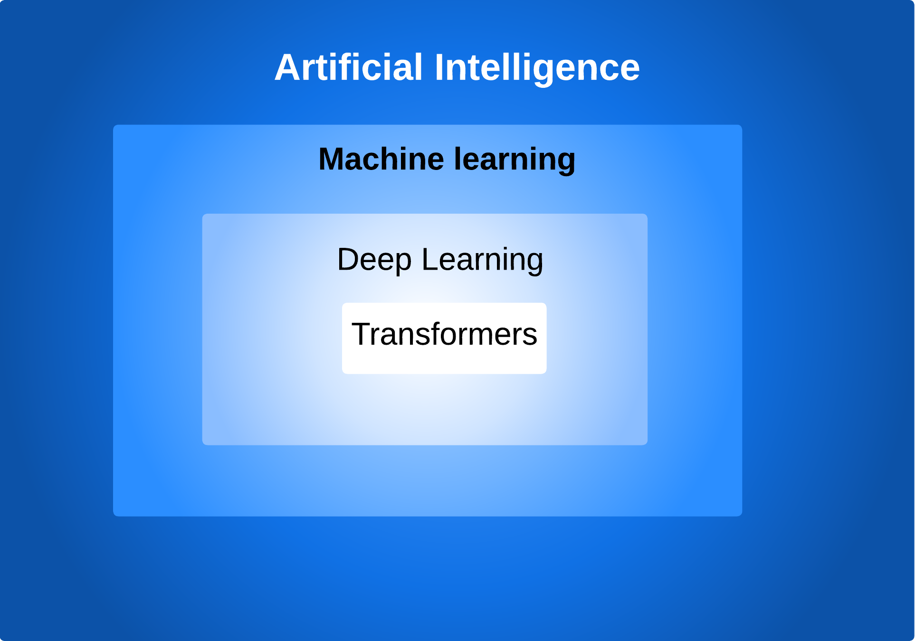

A Nested set of technologies from AI to transformers

***Essential concepts for using OpenAI API***

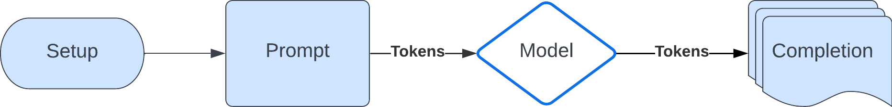

Essential concepts for using OpenAI API

* **Prompt**
  + The input text you put into the GPT models
  + Have a chat format
  + Input and output messages stored in a list
* **Models**
  + GPT-4 Turbo
  + GPT-4
  + GPT-3.5 Turbo (free)
  + Assistants API (Code interpreter and Retrieval)
  + Fine-tuning models (for creating custom models by fine-tuning base models)
  + Embedding models (advanced search, clustering, and topic modeling)
  + Base models (davinci-002 and babbage-002)
  + Image models (DALLB7E 2 and 3)
  + Audio models (Whisper for transcription / translation and TTS / TTS HD)
* **Tokens**
  + Words or parts of words
  + API requests paid based on the number of tokens (input and output)

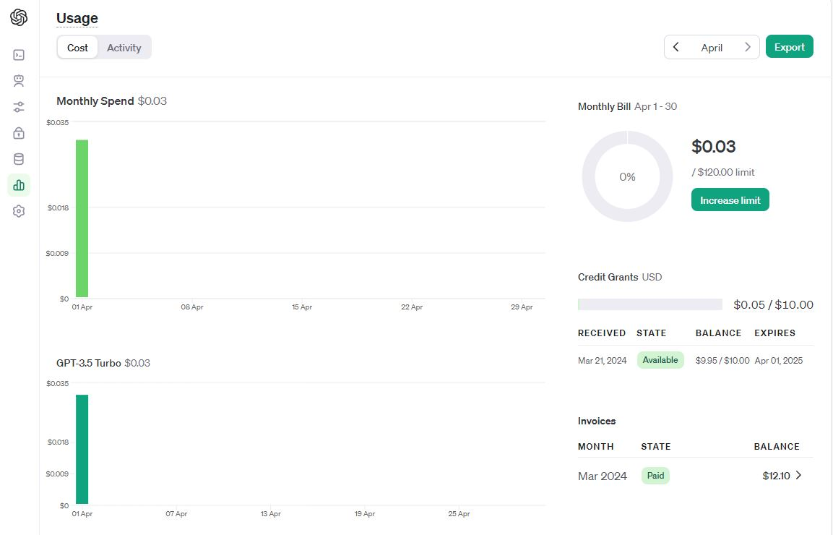

Tracking Monthly Usage