5/25/2022

XYZ Network Project

Youssef Moustafa 20104848

Anas Magdy 20104847

Khaled Alaa 20108424

Youssef Hatem 20108429

Mahmoud Ahmed 20104039

🡪Brief Description

XYZ Associated Limited is a small-medium sized company that has branches in different cities including:

* Cairo Branch which consists of 2 buildings: Main and Admin Buildings. Where there are a total of 38 Hosts divided as:
* 18 R&D (x2) 36
* 9 Sales & Marketing (x2) 18
* 6 Admin (x2) 12
* 5 Remote Sales (x2) 10

And each may require a VLAN for it. There exist also 5 servers which have their vlan.

* Alex Branch where it consists of offices in the 3rd & 4th floor where:
* 3rd Floor has some S/W Developers & Managers.
* 4th Floor has a seminar, server, meeting rooms.
* Estimated total of 34 Hosts
* 6th of October Branch which consists of a 4-story building: a ground floor and other 3 floors. And the other 3 floors consist of different devices as follows:
* 1st Floor contains several devices for S/W developers, Managers, Admin Staff. (Estimated 6 hosts)
* 2nd Floor contains 3 seminar rooms. (Each room 100 hosts)
* 3rd Floor which is a data center with several servers and devices to administer it. (Estimated 10 hosts)
* Estimated total of 316 hosts

Each branch has several devices where they are connected through switches and each branch is connected with each other through routers, and the router in the main (Cairo) branch is connected to internet router.

🡪Cables Summary

* Cairo Branch:
* 44 Straight (135 meters) (10 EGP/meter)
* 6 crossovers (24 meter) (25 EGP/meter)
* Alex Branch:
* Est. 36 straight (108 meters)
* Est. 3 crossover (12 meters)
* 6th October Branch:
* Est. 319 straight (957 meters)
* 15 crossovers (60 meters)
* Others:
* 3 serial DCE/DTE (536,000 meters) (33 EGP/meter)
* 1 crossover (4 meter)
* **Total Price: Est. 17,702,500 EGP**

🡪Logic Design Summary

* The Diagram is in the “XYZProject.pkt” cisco packet tracer file.
* No. of Routers: 4
* No. of Switches: 14
* Total Used IP Addresses: 404 => (with growth) 442
* Max IP Addresses possible: 832
* Spare IP’s: 390
* Network Addresses & No. of Hosts per network:
* 159.10.9.0/24 Cairo Branch…43 Hosts
* 159.10.7.0/23 6th of October Branch…317 Hosts
* 159.10.10.0/26 Alexandria Branch…35 Hosts
* Cairo Diagram:

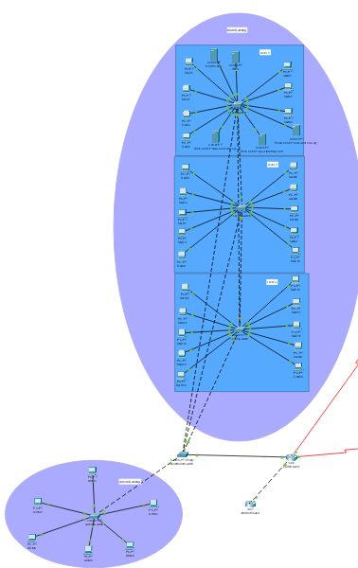

* Alex Diagram:

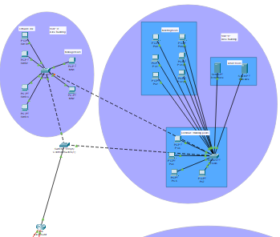

* 6th October Diagram:

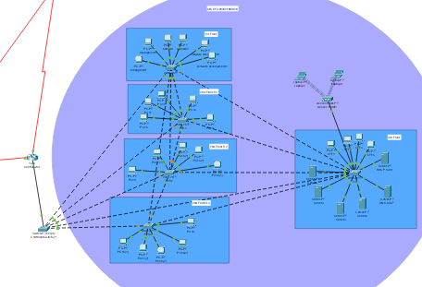

* Inter-Router Connection:

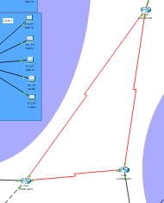

🡪IP Addressing

|  |  |  |  |  |
| --- | --- | --- | --- | --- |
| **Network Name** | **#Hosts required** | **Max possible hosts** | **Network address** | **Subnet mask** |
| 6th October network | 317 | 510 | 159.10.7.0**/23** | 255.255.254.0 |
| Alex network | 40 | 62 | 159.10.10.0**/26** | 255.255.255.192 |
| **Cairo network** | **81** | **254** | **159.10.9.0/24** | **255.255.255.0** |
| Cairo-R&D | 36 | 62 | 159.10.9.0**/26** | 255.255.255.192 |
| Cairo-Sales | 18 | 30 | 159.10.9.64**/27** | 255.255.255.224 |
| Cairo-Admin | 12 | 14 | 159.10.9.96**/28** | 255.255.255.240 |
| Cairo-Remote | 10 | 14 | 159.10.9.112**/28** | 255.255.255.240 |
| Cairo-Servers | 5 | 6 | 159.10.9.128**/29** | 255.255.255.248 |
|  |  |  |  |  |
| Alex-6 Oct | 2 | 2 | 159.10.10.64**/30** | 255.255.255.252 |
| Cairo-6 Oct | 2 | 2 | 159.10.10.68**/30** | 255.255.255.252 |
| Cairo-Alex | 2 | 2 | 159.10.10.72**/30** | 255.255.255.252 |

🡪Routing Protocol

* RIP Version 2
* As it works with classless networks while Version 1 works with classful networks only

🡪VLANS

|  |  |  |  |  |
| --- | --- | --- | --- | --- |
| **VLAN No./Name** | **Branch** | **IP Address** | **Range** | **Gateway** |
| VLAN 10/RD | Cairo | 159.10.9.0**/26** | 159.10.9.1-159.10.9.62 | 159.10.9.1 |
| VLAN 20/Sales | Cairo | 159.10.9.64**/27** | 159.10.9.65-159.10.9.94 | 159.10.9.65 |
| VLAN 30/Remote | Cairo | 159.10.9.112**/28** | 159.10.9.113-159.10.9.126 | 159.10.9.113 |
| VLAN 40/Server | Cairo | 159.10.9.128**/29** | 159.10.9.129-159.10.9.134 | 159.10.9.129 |
| VLAN 99/Admin | Cairo | 159.10.9.96**/28** | 159.10.9.97-159.10.9.110 | 159.10.9.97 |
| VLAN 1/Default | Alex | 159.10.10.0**/26** | 159.10.10.1-159.10.10.62 | 159.10.10.1 |
| VLAN 1/Default | 6th October | 159.10.7.0**/23** | 159.10.7.1-159.10.8.254 | 159.10.7.1 |

🡪Switches

|  |  |  |  |  |
| --- | --- | --- | --- | --- |
| **Switch Name** | **Branch** | **#Ports** | **IP** | **Price** |
| AdminSwitch | Cairo | 24 | - | 2,000 EGP |
| Level1Switch | Cairo | 24 | 159.10.9.110 | 2,000 EGP |
| Level2Switch | Cairo | 24 | 159.10.9.109 | 2,000 EGP |
| Level3Switch | Cairo | 24 | 159.10.9.108 | 2,000 EGP |
| ControllerSwitch | Cairo | 24 | - | 2,000 EGP |
| Floor3Switch | Alex | 24 | - | 2,000 EGP |
| Floor4Switch | Alex | 24 | - | 2,000 EGP |
| ControllerSwitch | Alex | 24 | - | 2,000 EGP |
| F1 | 6th October | 24 | - | 2,000 EGP |
| F2R1 | 6th October | 128 | - | 50,000 EGP |
| F2R2 | 6th October | 128 | - | 50,000 EGP |
| F2R3 | 6th October | 128 | - | 50,000 EGP |
| F3 | 6th October | 24 | - | 2,000 EGP |
| ControllerSwitch | 6th October | 24 | - | 2,000 EGP |
| **Total Price** | **172,000 EGP** | | | |

🡪Routers

|  |  |  |
| --- | --- | --- |
| **Router Name** | **Branch** | **Price** |
| CairoRouter | Cairo | 30,000 EGP |
| AlexRouter | Alexandria | 30,000 EGP |
| 6thOctoberRouter | 6th October City | 30,000 EGP |
| InternetRouter | Cairo | 30,000 EGP |
| **Total Price** | **120,000 EGP** | |

🡪ADMIN Details

* Vlan name: VLAN99
* Password 1: cisco
* Password 2: class
* Switches: Level1Switch, Level2Switch, Level3Switch

**Total Price of Project: 17,994,500 EGP (EST. 18,000,000 EGP)**