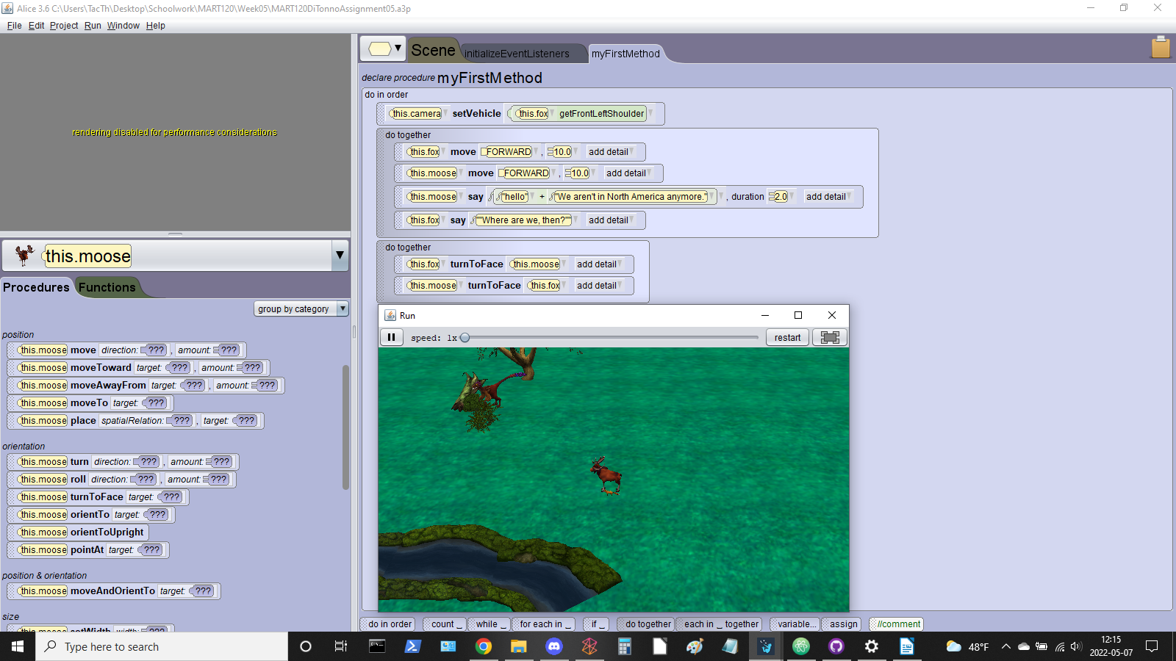
This was originally meant to be the instructions for the .a3p file that I wanted to submit for my homework, but I can’t seem to get my project to work. Every time I attempt to run my animation, I get a message in the scene window that says “rendering disabled for performance considerations.” The pop-out windows appears with my scene, but the scene does not run and nothing happens. As a test, I tried to change the speed at the top of the window; I assumed that it was just running slowly, and I tried to increase the speed to see if anything would happen. No dice.
I’ll include a screenshot for clarity:

I will try this again when I can, but for now, I think it’s best for me to move on to other homework.

