Software Project Management Plan
for
Team 3

March, 2026
Version 1

Team Members:
David Le
Jonny Yu,
Mackenzie Lin,
Diego Mayne

1 INTRODUCTION

1.1 Project Overview

Eater AI is a smart restaurant ordering platform designed to enhance the dining experience by integrating QR-based ordering and AI-powered recommendations.

Customers can scan a QR code placed on their table to automatically access the restaurant menu without manually entering a table number. The system identifies the table and allows customers to browse menu items, interact with an AI assistant for food recommendations, and place orders directly from their mobile devices.

The system also provides dashboards for staff and administrators. Staff can view incoming orders in real time and update their status, while administrators can manage menu items, categories, and restaurant settings.

This project aims to simulate a real-world restaurant digital transformation system using modern web technologies and AI integration.

1.2 Goals and Objectives

The main goals of Eater AI are:

- Provide a seamless ordering experience using QR code scanning
- Eliminate manual table input to improve user experience
- Reduce waiting time for customers
- Enable real-time order management for staff
- Provide an AI assistant to help customers choose meals
- Build a scalable and modern full-stack web application

Objectives include:

- Develop a fully functional frontend and backend system
- Integrate AI (Gemini API) for food recommendations
- Implement real-time updates using Socket.IO
- Ensure responsive and user-friendly UI
- Deliver a working MVP suitable for demonstration and portfolio

2 START PLAN

2.1 Team Organization

The team follows an Agile-inspired structure with clear role distribution:

AI engineering- Jonny Yu: System architecture, backend logic, AI integration
Frontend Developer - Diego Mayne: UI development, customer app
Backend Developer – David Le: API development, database integration
QA / Documentation – Mackenzie Lin: Testing, documentation, reporting

Team communication is conducted via:

- Discord / Slack
- GitHub for version control
- Weekly meetings for progress tracking

2.2 Development Tool Selection

Frontend:
- React (Vite)
- TailwindCSS
- Axios
- React Router

Backend:
- Node.js (Express.js)
- MongoDB (Mongoose)
- JWT Authentication
- Socket.IO

AI Integration:
- Google Gemini API

Tools:
- GitHub (version control)
- Postman (API testing)
- Swagger (API documentation)
- VS Code (development)

3 WORK PLAN

3.1 Project Tasks

The project is divided into major phases:

- Requirement Analysis
- System Design
- Backend Development
- Frontend Development
- AI Integration
- Testing and Debugging
- Deployment
- Documentation

3.2 Team Member Responsibilities

Jonny Yu:
- Design system architecture
- Implement backend core logic
- Integrate AI assistant
- Coordinate team tasks

Diego Mayne:
- Develop frontend UI
- Implement customer pages (menu, cart, chat)
- Connect frontend with backend APIs

David Le:
- Build backend APIs (orders, menu, auth)
- Manage database schema and models
- Implement real-time features (Socket.IO)

Mackenzie Lin:
- Perform testing (manual and functional)
- Identify bugs and issues
- Prepare documentation and reports

3.3 Gantt Chart
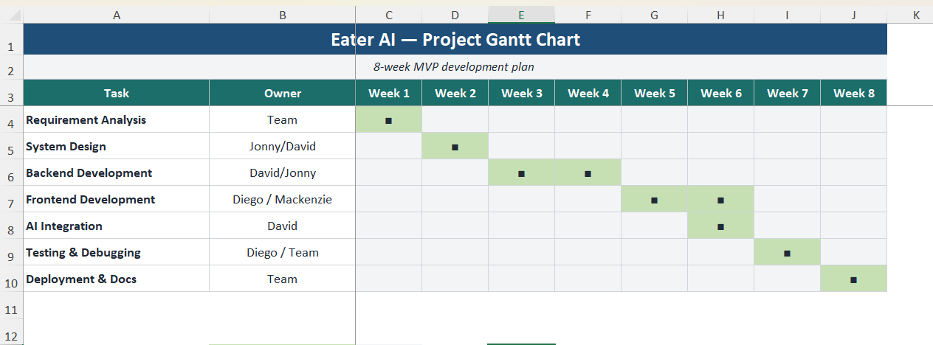

4 PROJECT DELIVERABLES

4.1 Software

The final software will include:

Customer Application:
- QR code-based table detection
- Menu browsing
- Cart and checkout
- AI assistant for recommendations

Staff Dashboard:
- View real-time orders
- Update order status

Admin Dashboard:
- Manage menu and categories
- Configure table settings
- View analytics

Backend System:
- RESTful API
- Authentication system
- Database integration
- Real-time communication

4.2 User Guide

The user guide will include:

Customer Guide:
- How to scan QR code
- How to browse menu
- How to use AI assistant
- How to place an order

Staff Guide:
- How to log in
- How to view and update orders

Admin Guide:
- How to manage menu items
- How to configure tables
- How to view analytics

Revision History
Version | Date | Name | Description
1 |  |  | Initial Document

