Written Report

12-11-23

Subject: PyCitySchools Analysis by Jon Haas

The Analysis of the PyCitySchools reveals the requested information about the schools and draws two conclusions. The two conclusions are listed at the bottom of this report.

The Analysis:

Overall District Summary: 15 schools with 39,170 students with overall passing % of 65.2%.

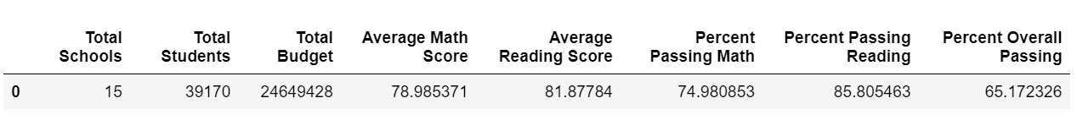

Individual Schools Summary: In general District schools are much larger than Charter schools with a much lower passing percentage.

Top 5 schools by overall passing percentage (reading and math): Top 5 schools are all Charter with over 90% passing percentage.

Bottom 5 schools by overall passing percentage (reading and math): Bottom 5 schools are all District schools with barely over a 50% passing percentage.

Math Scores by Grade: Scores stay pretty consistent per grades stay for every school.

Reading Scores by Grade: Scores stay pretty consistent per grades stay for every school.

Scores by Spending Range: More spending per student does not equate to higher scores. In fact the inverse.

Scores by school size: Small and Medium schools do much better than large schools.

Spending Summary: Charter schools scores are much higher than District schools with lower spending cost per student.

School Type Summary: Charter schools have a much higher passing rate than District schools.

Conclusion:

1. Charter Schools have much higher passing rates than District schools on generally lower budgets per student.
2. Charter Schools are much smaller than District Schools which would appear to correlate to higher passing rates and lower budgets per student.