HumanizeJS
Created by Chris Rink.
An example can be run from the examples/test.html

Deployment.
- Add humanizeJS.jar as a library in your project.
- Copy ‘Resources\humanize’ folder to your application’s ‘\Resources’ folder.

Customization/Repackaging.

- New functions can be added to the’ src\humanize\content\humanize\humanize.js’
- Create/Copy function declaration from ‘src\humanize\config\humanize’ folder. New function declarations shouldn’t include content for humanize or moment.js
- Package by using 7zip to package the humanize and META-INF folders in the ‘\src’ location.
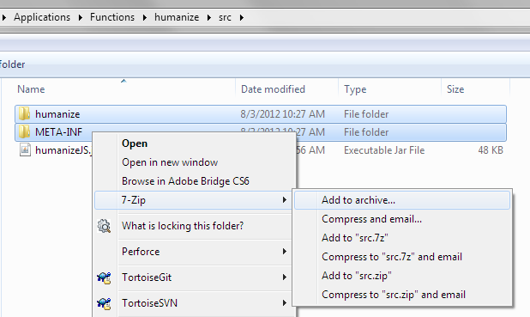
- Rename archive to use jar extension.

