School Management System

Group B

Jonathan Edwards

07/28/2024

- Project Vision and Description
An management system that houses a database with information regarding students, professors and courses. This school management system will have a user interface for each individual to log in with unique credentials to access the system's information.
- Database:
  - The database will house the information of the professors, students, courses, and administrative personnel associated with the school.
  - The database will have login information for each individual.
  - The database will have permissions for individuals to access data depending on their permissions status.
  - Establish relational data that can be de-identified to protect the privacy of the staff and students.
- User Interface:
  - Each user will have a log in with information pertaining to their given roles
    - Professors:
      - See the current and upcoming courses they are teaching.
      - See the students attending their course and the grades they have.
      - See their personal information and
    - Students:
      - See the current and future courses they have scheduled.
      - See the grades they have in each course current and completed
      - See contact information for faculty and specific departments at the school
    - Administrators:
      - See all information on each student and professor such as contact information
      - See tuition enrolment information, help tickets and scheduled updates to the system
The project side will include
- Establishing a database with the capability to handle the needs of students, professors and administrators
- UI that can update new data on the database, such as updating personal information, adding grades to the database, and changing or course info.
- Proper security practices followed to maintain data integrity and contingencies in place for attacks
- Security system that restricts access based on the user's role. Such as students are unable to change grades but can update personal info, teachers can change students grades and update their own personal info. And administrators can see and update what they need to for students and themselves
- A way to remove users so they can’t change data if they are no longer affiliated with the school.

Project Timeline:
- Sprint 0: Planning and Requirements Gathering:
  - Sprint planning: Stakeholder meetings for requirements gathering
  - Definition of project scope, objectives and deliverables
  - Establish a project plan and timeline
- Sprint 1: Designing System
  - Sprint Goal: Establishing system Architecture and design documents
  - Developing plans and mockups for UI.
  - Sprint Review: reviewing design documents with stakeholders.
- Sprint 2-6: Development
  - Sprint Goals: Implementing key systems.
    - Sprint 2: Student Information Management module.
    - Sprint 3: Student Performance Management module.
    - Sprint 4: Professor Information Management module.
    - Sprint 5: Classroom Management module.
    - Sprint 6: Additional Features such as user authentication, dashboards, reports, notification systems, or others as established during requirements gathering.
  - Sprint Stand-ups: Short, messaged meetings to ensure team members align and identify any implementations.
  - Reviews: Working with stakeholders to demonstrate systems for feedback
  - Retrospectives: Reflection with team on what went well and what could be improved on for future sprints
- Sprint 7: Testing
  - Goals: to establish testing for codes, integration, and user acceptance.
  - Fix identified bugs and issues, cataloging others if necessary
  - Review: understanding testing results and fixes.
- Sprint 8: Deployment and training:
  - Goals: Deployment of systems within the live environment
  - Providing training sessions (1 day training) for teachers, staff, and students.
  - Review: Reviewing deployment and outcomes.
- Sprint 9: Review and documentation
  - Goals: Review project outcome align with stakeholders
  - Preparing final project documentation, cataloging information, and providing user manuals
  - Review: Establishing approval from stakeholders

Development Team: Tina Ellington, Daniel Dia
- The development team develops and designs the UI with relation to the project scope.
- The development team will create a database and an additional backup database to create reliable access to information.
- The development team will establish security protocols to prevent data leaks or breaches by:
- Allocating permissions of personnel.
- Creating secure password login for each individual.
- Have routine checks on the system for fraudulent activity.
Product Owner: Jonathan Edwards
- The Product Owner will be responsible for gathering all of the requirements given by the School administrators and stakeholders
- Creates a straight forward product backlog that is in line with the needs of users by establishing user stories and acceptance criteria.
- Will consider user stories and maintain the expectation and define what needs to be built and tested.
- Plans the implementation of each requirement on a prioritized basis.
- Reviews and revises sprint iterations
Scrum Master: Nathanial Drake
- The Scrum Master will assist the development team with applying Scrum theory.
- Assists the product owner with the scope and design of the system, as well as the backlog.
- Ensures a clear vision is established with the product's goals and user requirements.
- Organizes Scrum meetings, planning to include sprint planning and reviews, daily meetings and retrospective reviews.
- Tracks the progress of the Product owner and Development team.
Collaboration Methodology
- Collaboration will include daily updates and weekly meetings on Fridays to establish progress, plans, as well as areas of concerns.
- Sprint Meetings will be held to plan the work to be completed.
- Sprint Reviews will be held at the end of each sprint to gather feedback from shareholders. This includes a retrospective view of what went well and what could be improved towards future sprints.
- Collaboration would be using Discord, Teams, Emails and Schools messaging systems to utilize shared resources and outsourcing our strengths.

The Definition of “Done”
- Database:
  - A fully established database with student, professor and administrative information is implemented .
  - The database follows security practices and contains software for malicious attacks.
  - The database follows permission hierarchies that restrict access to users not able to see the data.
- User Interface:
  - Each personnel has access to a log in that will show the required information that individual may need.
  - The UI consistently updates with new grades, updates personnel information and course information.
  - The UI updates personnel of information regarding tuition, upcoming course requirements and scheduling.

- Product Design
Class Diagram:
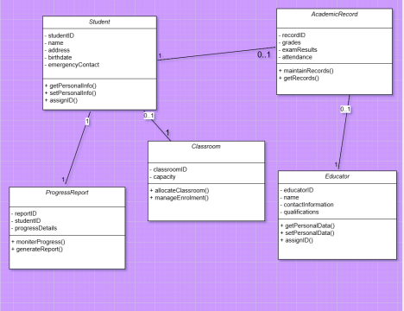
The class diagram that is shown above describes the structure of a system and is a representation of the following classes:
Student:
★ Attributes include studentID, name, address, birthdate, and emergency contact. ★ Methods include getPersonalInfo() , setPersonalInfo() and assignID.
Educator:
★ Attributes include educatorID, name, contact information, and qualifications. ★ Methods include getPersonalData(), setPersonalData(), and assignID.
Classroom:
★ Attributes include classroomID and capacity
★ Methods include allocateClassroom() and manageEnrollment
AcademicRecord:
★ Attributes include recordID, grades, examResults, and attendance
★ Methods include maintainRecords() and getRecords()
ProgressReport:
★ Attributes include reportID, studentID, and progressDetails
★ Methods include monitorProgress() and generateReport()
The relationships between the classes are as follows:
Students have a one-to-many relationship with Academic record, as well as a one-to-one relationship with ProgressReport. Educator teaches multi[le AcademicRecors entries, and the Classroom is associated with multiple students.
Activity Diagram for user log in:
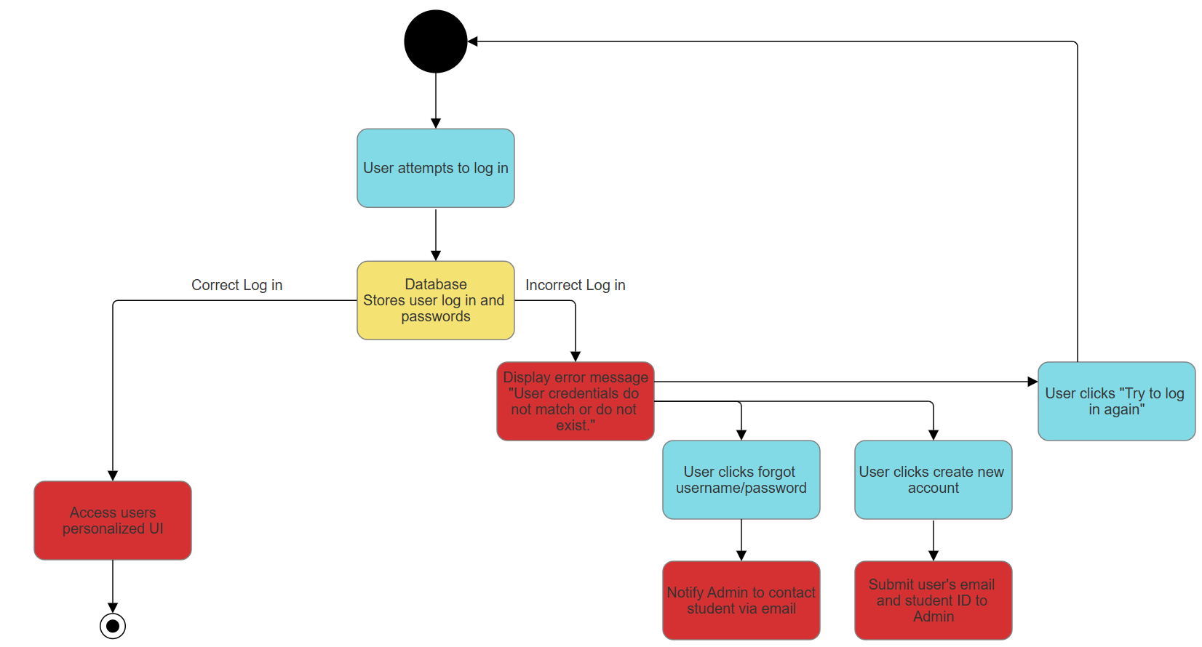
The user will see a display prompting them to log in. The credentials entered will be checked by a database to see if the information exists and if the username matches the password provided. If this is the case, the user will access their personalized UI. If the credentials do not match the database, they will be prompted with an error message stating “User credentials do not match or do not exist”. The user could attempt to log in again, click a link labeled forgot username/password, or click create a new account. If the user clicks the forgot username/password link, the administration team will be notified and respond via an email. If the user clicks create a new account, the user will need to enter an email and student id, which will be sent to the administration office.
Backend security Diagram:
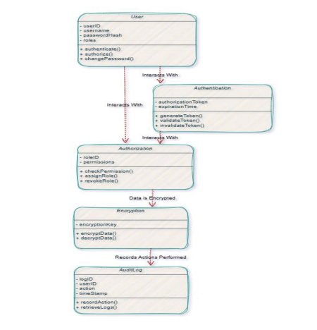
The purpose of the backend security diagram shown above is to provide a representation of the security measures and architecture of the systems backend. In this diagram there are five security classes listed below with their attributes and methods. Included for this diagram is a description of the relationships between the classes. The five classes are as follows:
- User:
  - Attributes include – userID, username, passwordHash, and roles
  - Methods include - authenticate(), authorize(), and changePassword()
- Authentication:
  - Attributes include – authToken and expiryTime
  - Methods include - generateToken(), validateToken() and invalidateToken() Authorization:
  - Attributes include – : roleID and permissions
  - Methods include - checkPermission(), assignRole() and revokeRole()
- Encryption:
  - Attributes include – encryptionKey
  - Methods include - encryptData() and decryptData()
- AuditLog:
  - Attributes include – logID, userID, action, and timestamp
  - Methods include - recordAction() and retrieveLogs()
The relationships between the classes are that the user interacts with authentication to acquire login and token management, the user also interacts with authorization for the purpose of checking permissions. The user's data is encrypted throughout the entire process and the AuditLog records all of the actions that are performed by the user. Having proper security measures in place that adhere to industry standards is a vital part of any system and should be monitored and updated on a regular basis.

Use Case Diagram for the Admin and Educator:
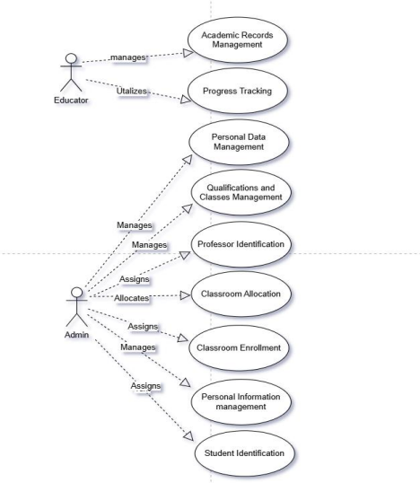
In the use case diagram illustrated above there are two actors, an educator and an Administrator. The Educator is responsible for academic records management by the collection and management of students' detailed personal information as well as monitoring and making reports of students' academic progress through progress tracking. The administrator is responsible for managing personal data, the qualifications for educators and subjects they are assigned to teach. The administrator collects and manages students' detailed personal information. The system administrator assigns the educator's unique identification number, classroom enrollment to ensure that the limit of 20 students per class is maintained, and the assignment of a unique identification for each student. The administrator is also responsible for the efficient allocation of classrooms.

Use Case Diagram for the UI:
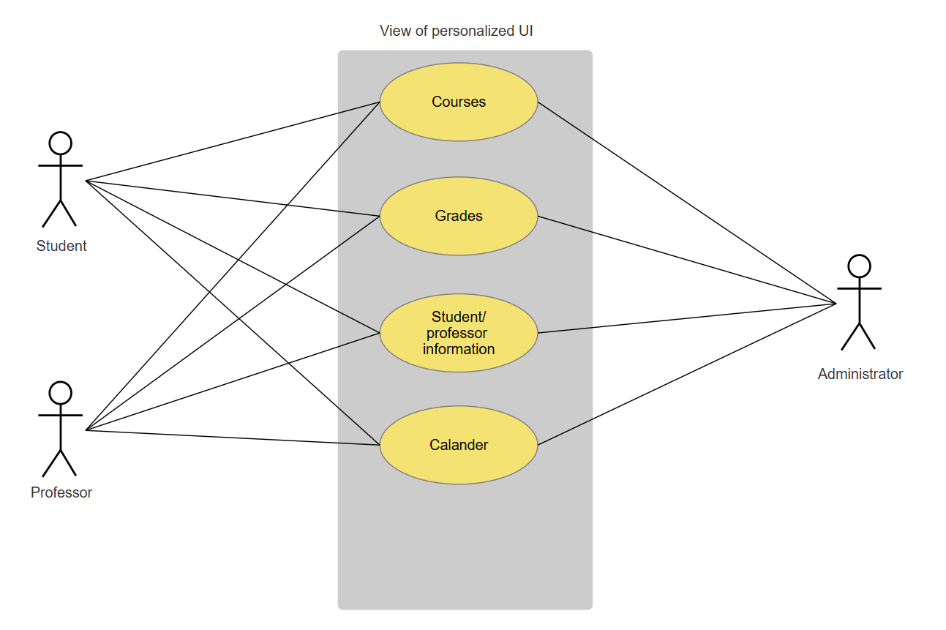
The Use case diagram above shows each actor that will use the school management system. Each user will have a unique view that pertains to their given role. For instance, the Student actor will see the Courses information, grades, professor information and calendar that pertains to them. The current professors' information that they have as well as past professors, and the same for courses. With regard to the professors, they will see the same thing as the student, but with their own modified view. The courses they teach, the students who currently attend those courses, and their information such as email and grades. The administrator can see the view of all of them, like who is taking and teaching what class, their contact information and the schedule for each professor and student for upcoming and current classes.
Sequence Diagram for a User requesting grades and Student/Professor information:
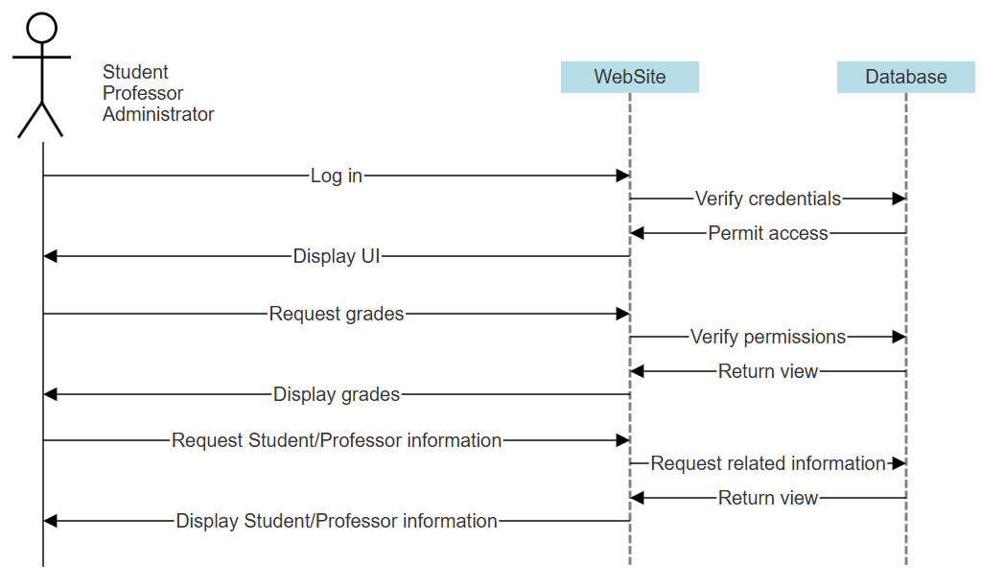
The sequence diagram above shows the interaction of a user requesting key information from the website. This in turn will seek certain permissions from a database, checking to see whether the specific user has access to certain students' information. A student can only see his or her own grades and classes. A professor can see all of the current students' grades and contact information that are taking his or her courses. And an Administrator can see all grades current and past, and all contact information for all students and professors.

