Git assignment 3:

NOTE: I did this assignment with the partner before finishing git1 + 2, thus, hello_world.txt was created during this assignment.
NOTE 2: on Q 22 I reset my repository (there were some issues) and recreated hello_world_2.txt instead of hello_world.txt

- git version 2.39.2
- jonnyds
- did it!
- https://github.com/Jonnyds/Repo_jonny
- git remote add repo_jonny https://github.com/jonnyds/repo_jonny.git
- git remote -v

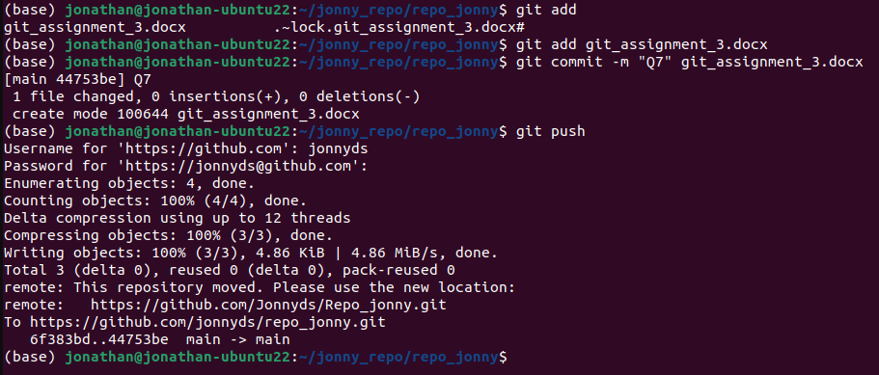

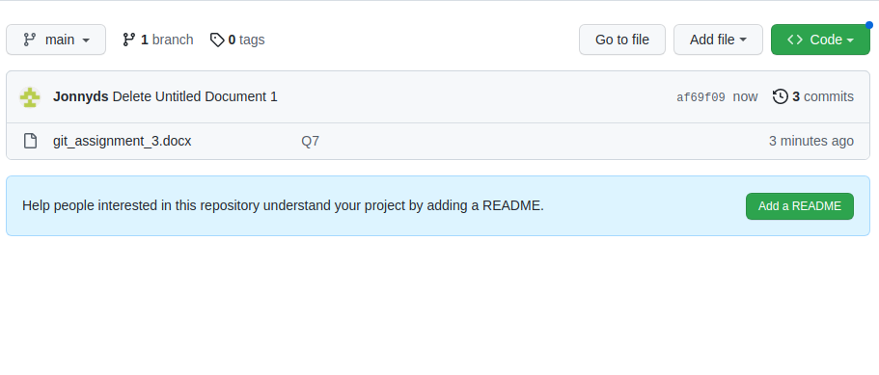
- DarShabi
- Done!
- git clone https://github.com/DarShabi/ITC_Git3_Assignment.git

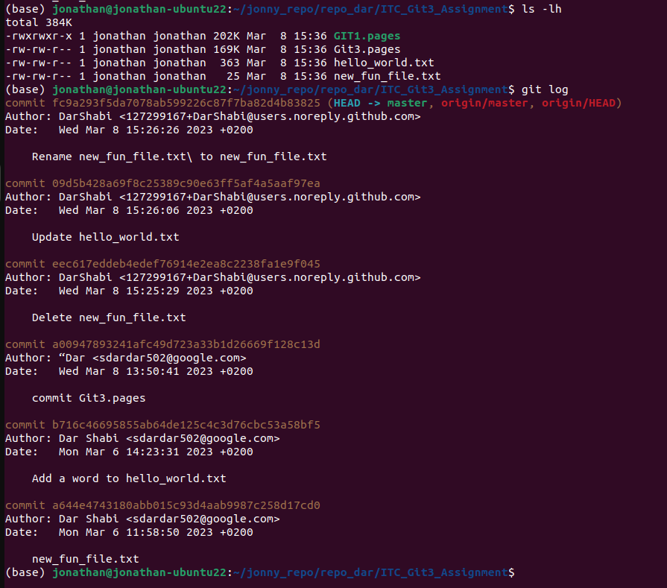

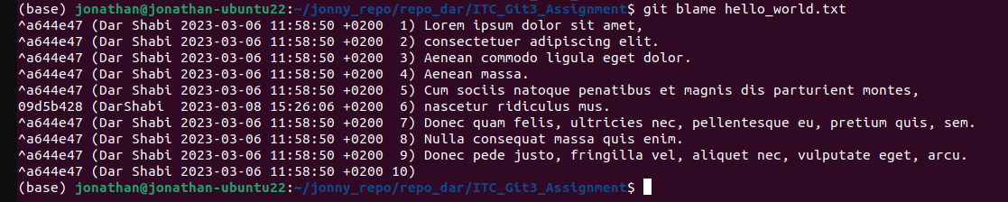

- nano hello_world.txt

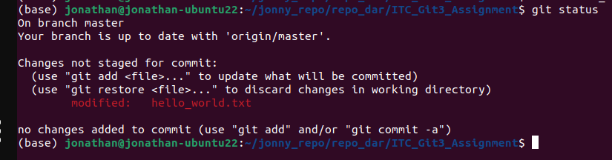

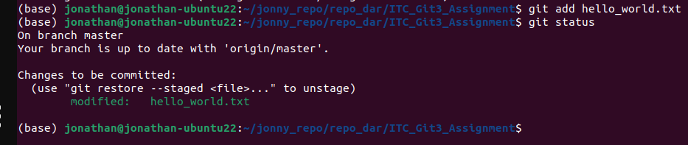

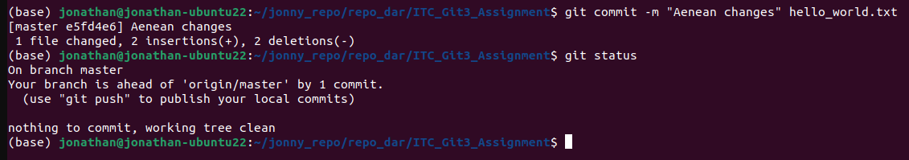

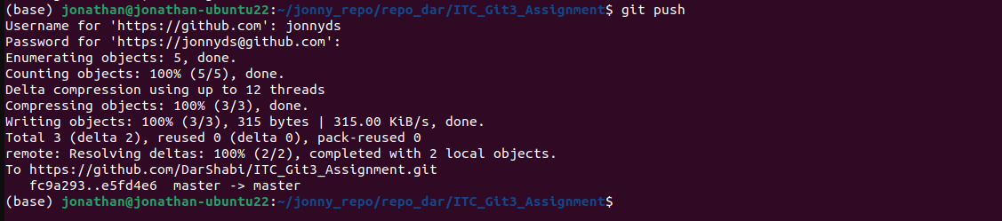

- yes:
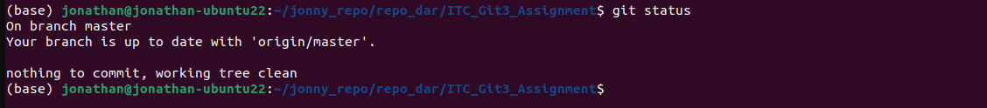

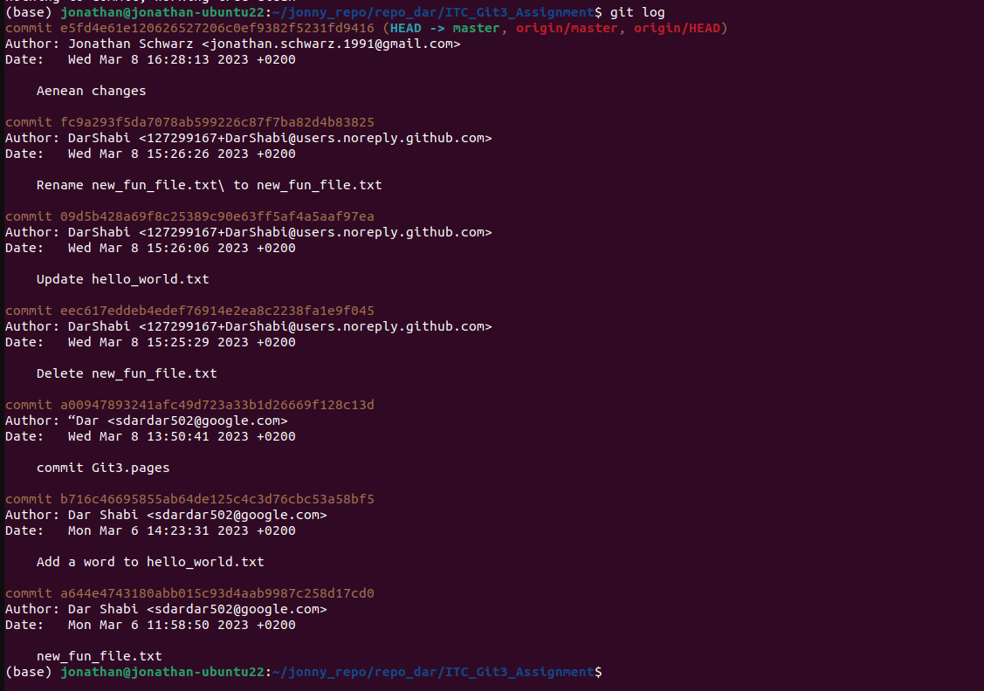

- done
- git rejected the push becuase there is a conflict.

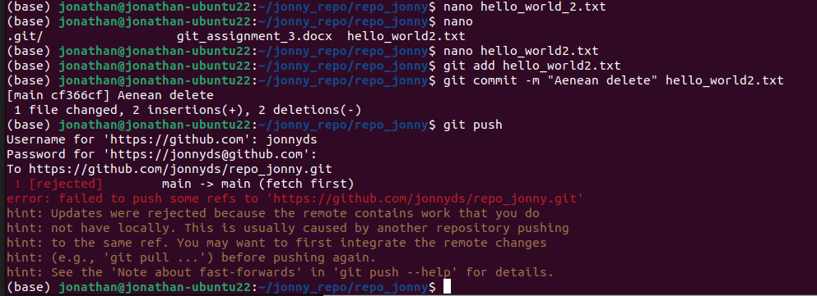

- Git couldn’t pull from remote repository since there is a conflict between the local file and files on repository (merge failed), it couldn’t merge changes from two different branches.

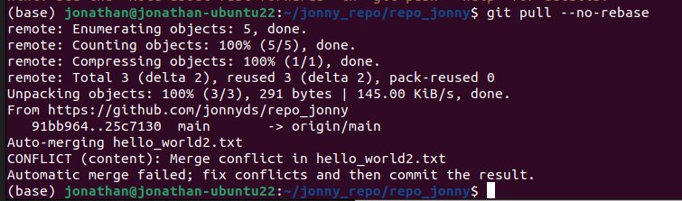

- We have unmerged branches (the file was modified from 2 different branches)

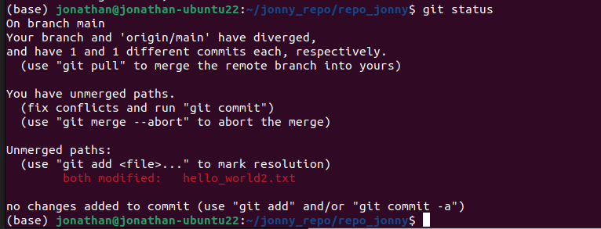

- yes, it does since we changed the files in two different branches.

