# 

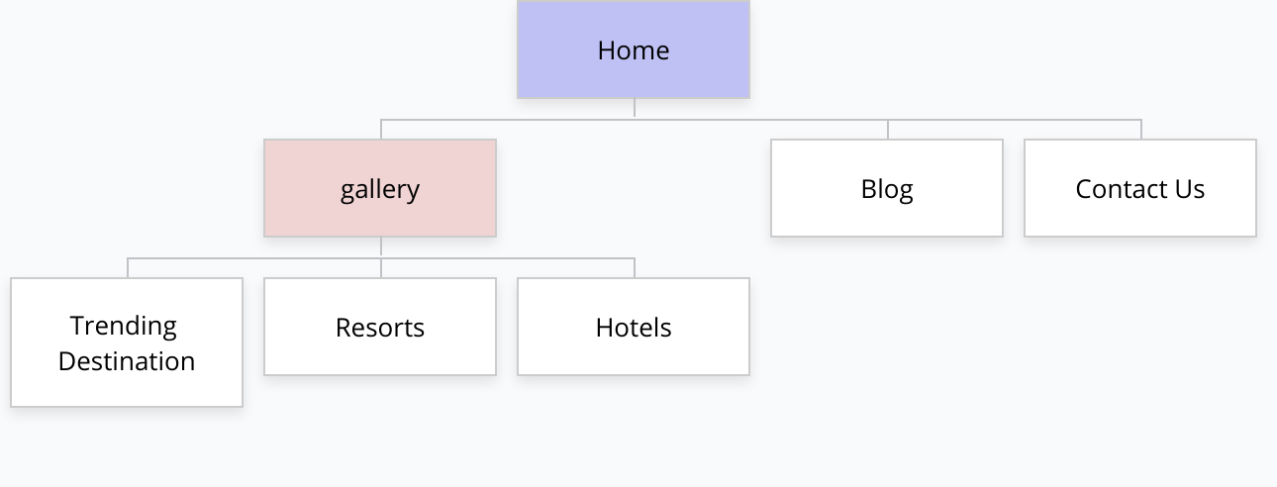Web Map

Who is the site for?

* The website is for travelers and people who seeks to find different places to explore.

What do they expect to find or do there?

* The website will show different places including some trending places featured in social media, celebrities . It will also show some hotels and resort .

Is this website’s primary aim to inform ,to sell or to amuse?

* Yes, the website could probably advertise some places .

Does the website need to clearly convey a brand’s core message , or is it part of a wider branding strategy with its own focus.?

* The main focus of the website is about travel destinations “Tara Gala” that conveys the words ,”Lets go out and have some fun” .

What competitor sites , if any exist and how should this site be inspired by different than those competitors?

* Similar websires uses a “Booking platform” this website may support that function but instead I will just put hyperlinks to other booking platforms that already existed such as booking.com or trivago.

Wire Frame – Homepage

