Jonothan Meyer
Machine Learning
Assignment 1 -Simple Linear Gradient Descent
2/17/20

3)
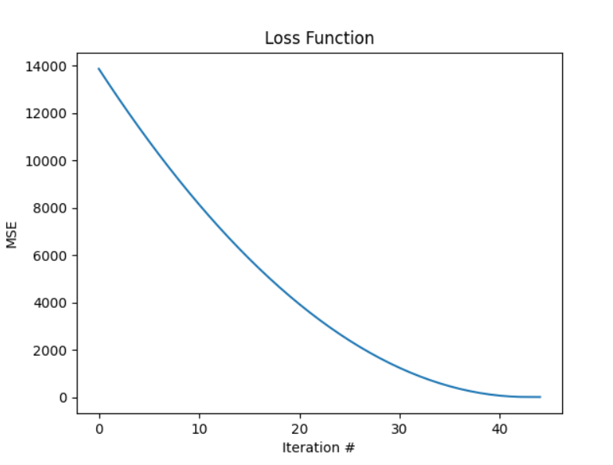

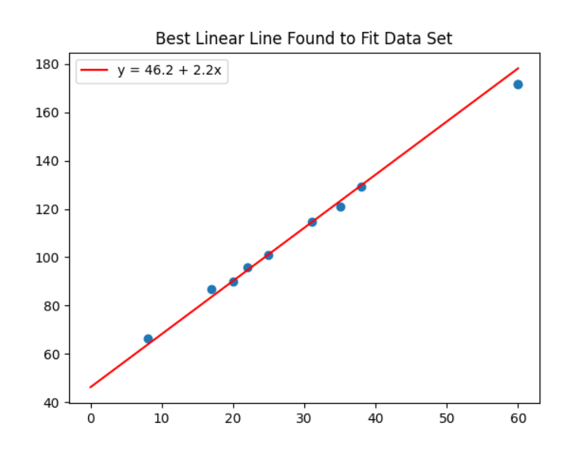
4) My gradient descent terminated only after a certain number of iterations were completed. Through each iteration it compares the MSE of a given slope/intercept with that of all permutations of incremented and decremented slope/intercept and accepts whichever values provide the lowest possible MSE as it progresses through each iteration. Since the program only terminates after all iterations are completed, it was found that after the optimized linear regression line was found the program oscillates around those ideal values until the amount of iterations is completed and the program terminates.

5) The learning rate and number of iterations affect my program in terms of accuracy and time to execute. A higher learning rate will allow the program to take larger "steps" toward the ideal regression line in a fewer number of iterations, however by doing this the program sacrifices accuracy as it is only able to return as close to +/- learning_rate margin of the true ideal linear regression line. Lowering the value of the learning rate and increasing the number of iterations does the opposite: it increases the accuracy of the found regression line, further minimizing MSE, but takes longer to execute, as it must go through more iterations.

6)
